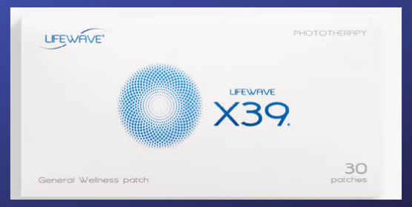
X39 = Foundation Patch for EVERYONE
Patches are worn 12 hours on, 12 hours off.
ONE SLEEVE = 30 patches

Become a PREFERRED CUSTOMER or a BRAND PARTNER to receive wholesale prices (see back)
X39 + Pick any ADD-ON patches for various HEALTH issues...
Patch Name | Best Used For | Retail | Wholesale | Bundle Kits
X39 | EVERYONE’S BASE | $149.95 | $99.95 | w/X49/89.50
X49 | The Performance Patch | $149.95 | $99.95 | w/X39/89.50
Aculife | The HORSE/PET Patch | $79.95 | $69.95 | $49.95
Aeon | Major Inflammation | $79.95 | $69.95 | $49.95
Alavida | Beauty Sleep & Skin | $79.95 | $69.95 | $49.95
Carnosine | Circulation/Mental Clarity | $79.95 | $69.95 | $49.95
Energy Enhancer | Energy/Endurance | $79.95 | $69.95 | $49.95
Glutathione | Detox/Organ Cleansing | $79.95 | $69.95 | $49.95
Icewave | Pain | $79.95 | $69.95 | $49.95
Silent Nights | Trouble Sleeping | $79.95 | $69.95 | $49.95
SP6 | Cravings/Weight/Hormones | $79.95 | $69.95 | $49.95

Choose what fits your needs the best. Cancel anytime. Upgrade anytime.
Retail Customer | Preferred Customer | Brand Partner
Pay full price | Free | $25 annual fee
Purchase desired products | Pay WHOLESALE when you set up a monthly subscription.  Easy cancellation. Preferred Customer Plus allows you to earn free product samples. | Receive the BEST possible prices on all patches. Earn commission on all referrals. $25 fee is waived on year 1 if you purchase an enrollment kit.

Perks of Becoming a Brand Partner…
~ Refer others and get your own patches paid for
~ Partner with the company and build a side-business for whatever reason you may have to fuel extra income.
~Commissions and bonuses are paid directly into your account.

WHERE TO LEARN MORE:
LoveYourPatch2.com
WHAT TO ORDER:
We recommend X39 as your base. From there you can add any support patches depending on your health needs. Your Brand Partner will help you.
HOW TO ORDER:
Whoever taught you about the patches is YOUR Brand Partner. You will purchase using their website so they properly receive the referral commission.
NOTE: Becoming a BRAND PARTNER is a smart move. Here are the ENROLLMENT KITS available to all Brand Partners. There is no obligation to share with others, but you are in the right position to earn should you choose to. Regardless, you get the best perks!
ONE-TIME ENROLLMENT KITS…
Starter | Core | Advanced | Advanced + | Premium
$25 | $295 | $535 | $975 | $1,750
Purchase all patches at wholesale. | Enrollment fee waived for 1st year. | Enrollment fee waived for 1st year. | Enrollment fee waived for 1st year. | Enrollment fee waived for 1st year.
Commission options if you choose to share  with others. | Commission options if you choose to share  with others. | Commission options if you choose to share  with others. | Commission options if you choose to share  with others. | Commission options if you choose to share  with others.
Receives 0 Sleeves | 3 Sleeves of X39 (Or 6 Support)  Or Mix & Match | 6 Sleeves of X39 (Or 12 Support)  Or Mix & Match | 11 Sleeves of X39 (Or 22 Support)  Or Mix & Match | 20 Sleeves of X39 (Or 40 Support)  Or Mix & Match

IMMEDIATELY AFTER ORDERING:
Go to loveyourpatch2.com
Look for the AFTER YOU ORDER section. This is for your benefit and guidance. Sign up for the 7-day email series so we can send you one email every day for 7 days. The emails will teach you HOW to use the patches correctly. By the time your patches arrive you will know just what to do! The email will come from jodi@loveyourpatch2.com
We are so excited for you!

