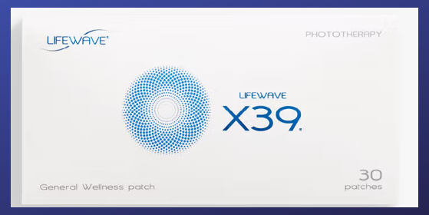
X39 = Foundation Patch for EVERYONE
Retail= $149.95 for 30-day supply (+ tax + shipping)
Brand Partner = Wholesale prices ($79.95 - $99.95)

ONE SLEEVE = A 30-Day supply of patches.
X39 + Pick any ADD-ON patches for various HEALTH issues...
 |  | Per Sleeve | Per Sleeve
Patch Name | Best Used For | Retail Price | Wholesale
X39 | EVERYONE’S BASE | $149.95 | $99.95
X49 | The Performance Patch | $149.95 | $99.95
Aculife | The HORSE Patch | $79.95 | $69.95
Aeon | Major Inflammation | $79.95 | $69.95
Alavida | Beauty Sleep | $79.95 | $69.95
Carnosine | Circulation/Mental Clarity | $79.95 | $69.95
Energy Enhancer | Energy/Exercising | $79.95 | $69.95
Glutathione | Detox/Organ Cleansing | $79.95 | $69.95
Icewave | Pain | $79.95 | $69.95
Silent Nights | Trouble Sleeping | $79.95 | $69.95
SP6 | Cravings/Weight | $79.95 | $69.95

Want more patches for less? Become a Brand Partner and get wholesale prices. How? Purchase an ENROLLMENT kit…
Starter | Core | Advanced | Premium
$25 | $295 | $535 | $1,750
Website allows you to purchase all patches at wholesale. | Enrollment fee waived for 1st year. | Enrollment fee waived for 1st year. | Enrollment fee waived for 1st year.
Commission options if you choose to share  with others. | Commission options if you choose to share with others. | Commission options if you choose to share with others. | Commission options if you choose to share with others.
Receives 0 Sleeves | Receive 3-6 Sleeves | Receive 6-12 Sleeves | Receive 20-40 Sleeves

NOTE: Even if you only want ONE sleeve, it is still cheaper to do the starter + your sleeve + tax + shipping rather than paying retail. You choose.

WHERE TO LEARN MORE:
LoveYourPatch2.com
HOW TO ORDER:
On loveyourpatch2.com scroll to the very bottom and find your Brand Partner. Click on their link. From there…
- If you are buying retail, click on SHOP and pick your favorite patches.
- If you are signing up as a BRAND PARTNER (to receive wholesale prices and the option to earn commissions) do NOT click SHOP. Instead, click JOIN. Follow the prompts. If you need help picking the best patches for you ask your brand partner. We recommend X39 for everybody. From there you can add any support patches depending on your health needs. An enrollment kit makes it easy to buy multiple patches for the best price. You can always upgrade to a higher kit later and you only pay the difference in cost… plus you get the difference in patches!
IMMEDIATELY AFTER ORDERING:
We have a 7-day email series to help teach you how to get the most out of your patching experience. You will receive one email every day for 7 days. The email will come from jodi@loveyourwater2.com. By the time your patches arrive you will know just what to do! To sign up for those emails, go to:
new2patching.com
HOW AND WHERE TO PLACE YOUR PATCH:
YouTube is an excellent place to learn how/where to place the patches. The one we recommend the most is simply putting in the search LIFEWAVE X39 PATCH or LIFEWAVE (whatever patch you got) PATCH and there is a short video to show you how. We also highly recommend subscribing to DR STACI’s YouTube channel as she is a great teacher!
INTERESTED IN SELLING: If you have a desire to earn commissions by referring others, you can at least get your own patches paid for…. or more. Just let your brand partner know and they will train you on some business basics.

