For Immediate Release: April 2026

RC10 Retro 80’s Ultra Champ #6050

1:10 Scale 2WD Electric Off Road Competition Buggy Kit

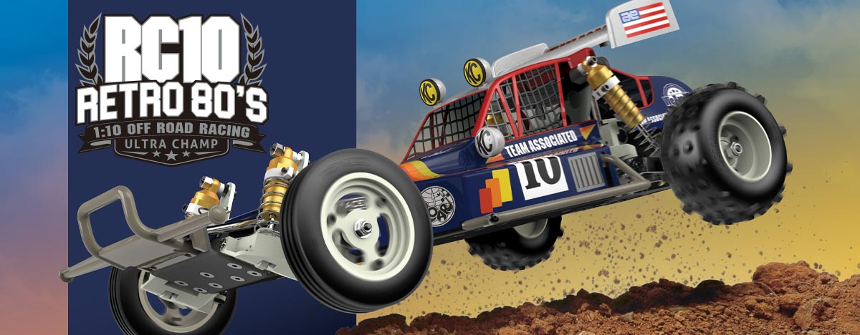
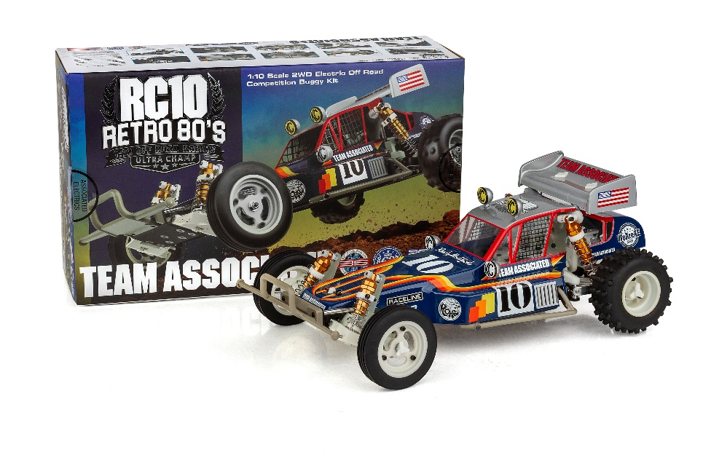
ELECTRIC ■ OFF ROAD ■ 1:10 SCALE ■ 2 WHEEL DRIVE ■ KIT

The NEW Team Associated Ultra Champ revives the soul of the original RC10 with authentic design, premium materials, and unmistakable 80’s style. Built on a true RC10 platform, the Ultra Champ features aluminum trailing arm rear suspension for period-correct performance and iconic handling characteristics that defined an era of 1:1 off-road racing.

Retro-inspired styling is brought to life with a new molded front bumper and side guards, blending vintage looks with modern durability. At its core is the legendary Stealth® A.T.C. transmission with ball differential, delivering smooth, efficient power transfer and proven reliability. Featuring genuine Team Associated white molded and dyable plastics from front to back.

High-end details complete the package, including threaded steel turnbuckles for precise adjustability, gold anodized aluminum long-travel shocks for classic performance and looks, and a factory-correct Protech body set with authentic decals that capture the unmistakable spirit of the box art imagery.



The Ultra Champ isn’t just a throwback—it’s a celebration of where RC racing began.

FEATURES
SPECIFICATIONS

Power | Electric
Terrain: | Off-Road
Body Style: | Buggy
Scale Size: | 1:10 Scale
Assembly Level: | Kit
Length: | 381mm (15in)
Width: | 226.8mm (8.93in)
Wheelbase: | 267.7mm (10.54in)
Weight: | varies
Internal Gear Ratio: | 2.25:1
Drive | 2WD
- 80’s Retro themed RC10 Classic
- New molded side guards
- New molded front bumper
- New CNC rear arm mounts with set screws
- New molded rear bulkheads
- New aluminum rear arm mount plates
- Hardened rear driveshafts
- New forged aluminum rear trailing suspension arms
- Long travel, fluid-filled anodized aluminum coil-over shocks
- Sealed 3-gear Stealth A.T.C. transmission
- High-torque ball differential
- Exceptional ground clearance with low center of gravity
- Front and rear tires with 3-piece racing wheels
- Clear Protech body with cutout templates
- Fiberglass shock towers
- Full metal ball bearings
- Fits 6-cell NiMH and 2S LiPo battery packs

*Final width, length and weight will vary based on electronics, tire configuration, wing position and vehicle setup.

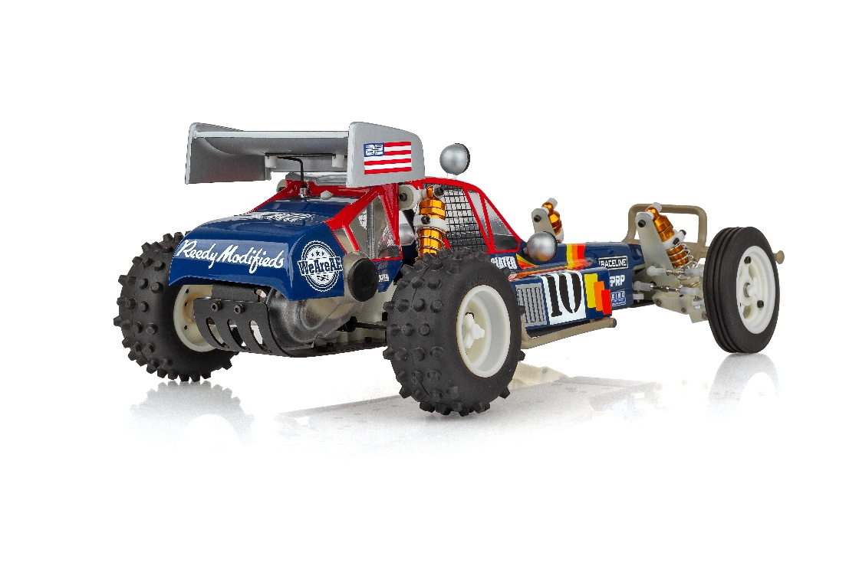
Recommended Electronics:

- Battery (#27604 ZAPPERS SG6 4800mAh 135C 7.6V SHORTY)
- Motor (#27481 REEDY SONIC 540-SP5 13.5T BRUSHLESS MOTOR)
- ESC (#27016 BLACKBOX 610R COMPETITION ESC)
- Servo (#27171 REEDY RS1606HD LOW-PROFILE BRUSHLESS HI-SPEED SERVO
- Charger (#27203 REEDY 1416-C2L DUAL AC/DC COMPETITION BALANCE CHARGER)

Other Helpful Items:

- Body Scissors (AE Part # 1737)
- FT Wrench Set (AE Part #1519)
- Hobby Knife
- Needle Nose Pliers
- Wire Cutters
- Soldering Iron
- Calipers or a Precision Ruler

UPC | Part No. | Description | MSRP | MAP | Pieces Per Case | Origin | Available
784695060500 | 6050 | RC10 Retro 80’S: Ultra Champ | $515.99 | $349.99 | 6 | TW | April
Download all zipped photos here: https://www.rc10.com/RC10UltraChampImages/ (11.76MB). Link is active for 30 days. Please refer to our MAP Policy here: https://img2c.associatedelectrics.com/pdf/map-policy.pdf

