For Immediate Release: April

RIVAL MT10 Factory Team Kit #20524

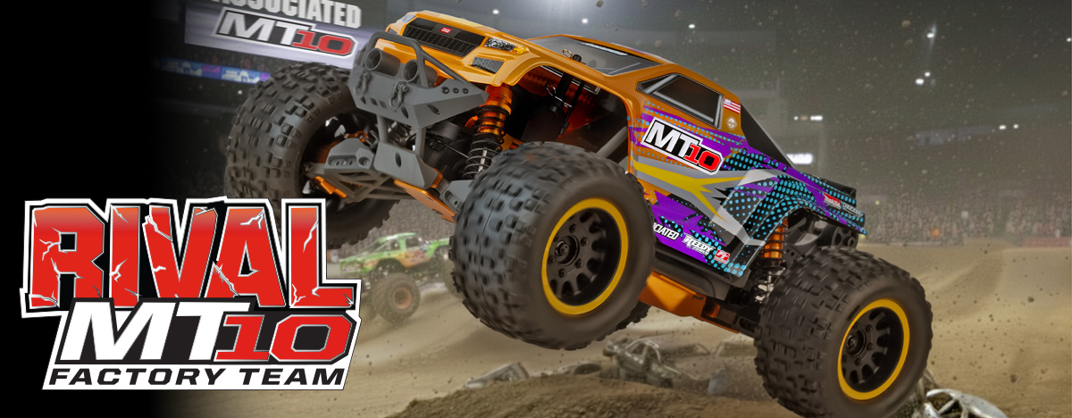

ELECTRIC ■ OFF ROAD ■ 1:10 SCALE ■ 4 WHEEL DRIVE ■ KIT

Team Associated is proud to bring you the latest version in the Monster Truck line up. The RIVAL MT10 Factory Team is a powerful, purposeful and built to last 1/10th scale monster truck. Robust shaft drive and center differential. Power is something you will never lack.

The RIVAL MT10 Factory Team features a long travel independent suspension that is managed by four fluid-filled big bore adjustable coil-over shocks, giving the RIVAL MT10 Factory Team the ability to roll over just about anything in its path. Giant aggressive monster truck tires provide maximum traction, letting the RIVAL MT10 FT claw through the toughest terrain with ease. The 4WD drivetrain includes three sealed gear differentials that transfer the power through durable Steel CVA drive shafts to both ends of the truck.

Whether you’re smokin’ tires on the asphalt, rippin’ through the lawn or tearin’ up a dirt field, Team Associated has you covered with the all new RIVAL MT10 Factory Team!
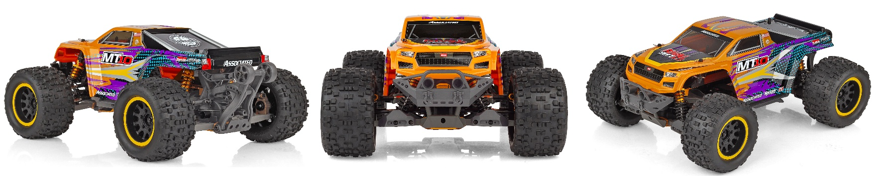


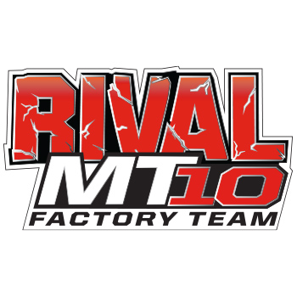
HIGHLIGHTS

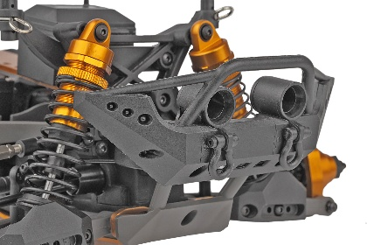
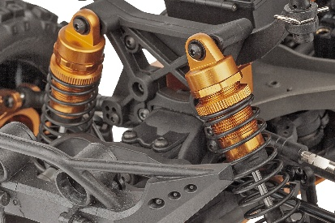
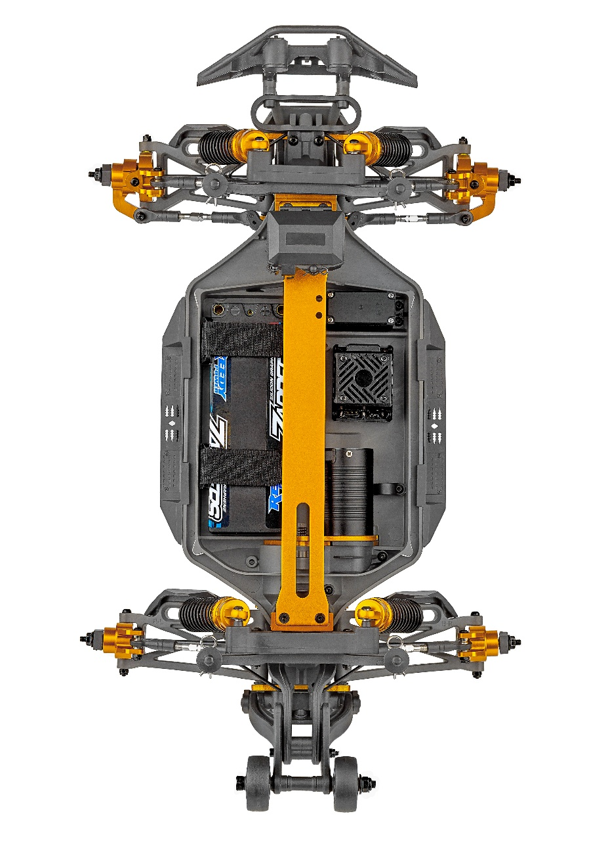

Durable, impact-absorbing front bumper with LED mounts
Threaded, Aluminum, Gold, oil-filled, coil over shock absorbers
:

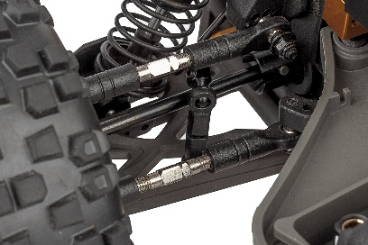
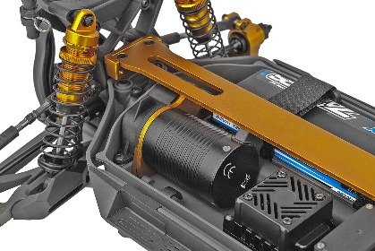

4mm heavy-duty adjustable steel turnbuckles
New Gold Aluminum top deck chassis support

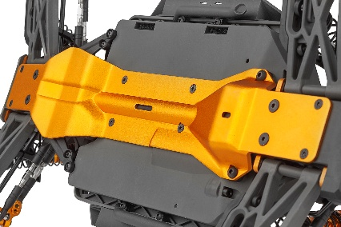

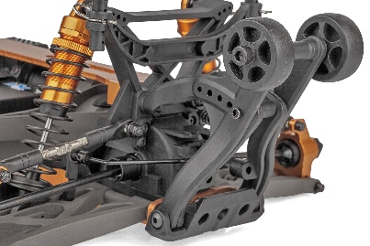

New Gold Aluminum Bottom Chassis support
Rugged adjustable wheelie bar

Due to ongoing R&D, photos may not match the final kit. Vehicle shown on these pages equipped with items NOT included in KIT: Reedy motor, battery, ESC, servo, and receiver not included. Assembly and painting required

FEATURES |  | SPECIFICATIONS
Power Source: | Electric
Terrain: | Off-Road
Body Style: | Monster Truck
Scale Size: | 1:10 Scale
Assembly Level: | Kit
Length: | 507mm (19.96in)
Width: | 325mm (12.8in)
Wheelbase: | 285mm (11.22in)
Weight: | 2800g (6.17lbs)
Internal Gear Ratio: | 2.85:1
Drive: | 4WD

*Final length, width and weight will vary depending on the
electronics, body, wheels and tires used to complete the kit.

• Clear Body with New Livery Decal Sheet
• CVA Driveshafts front and rear
• Gold Anodized Aluminum parts throughout
• New Gold Aluminum Bottom Chassis support
• New Gold Aluminum top deck chassis support
• CNC Gold Caster Blocks
• CNC Gold Steering Spindles
• Three sealed gear differentials
• 12mm hex wheels inspired by Method Race Wheels
• Four-wheel independent suspension
• Threaded, Aluminum, Gold, oil-filled, coil over shock absorbers
• 4mm heavy-duty adjustable steel turnbuckles
• Steel center drive shaft
• Rugged adjustable wheelie bar
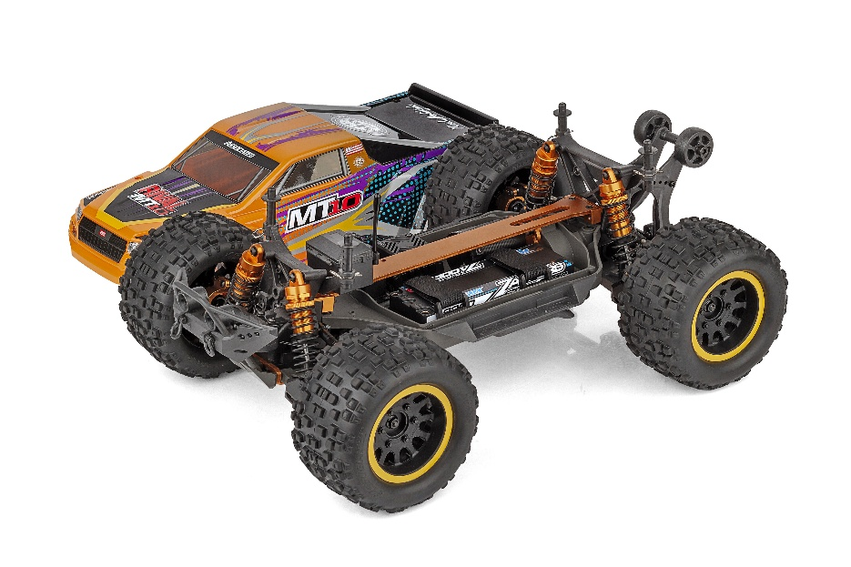
• Durable, impact-absorbing front bumper with LED mounts

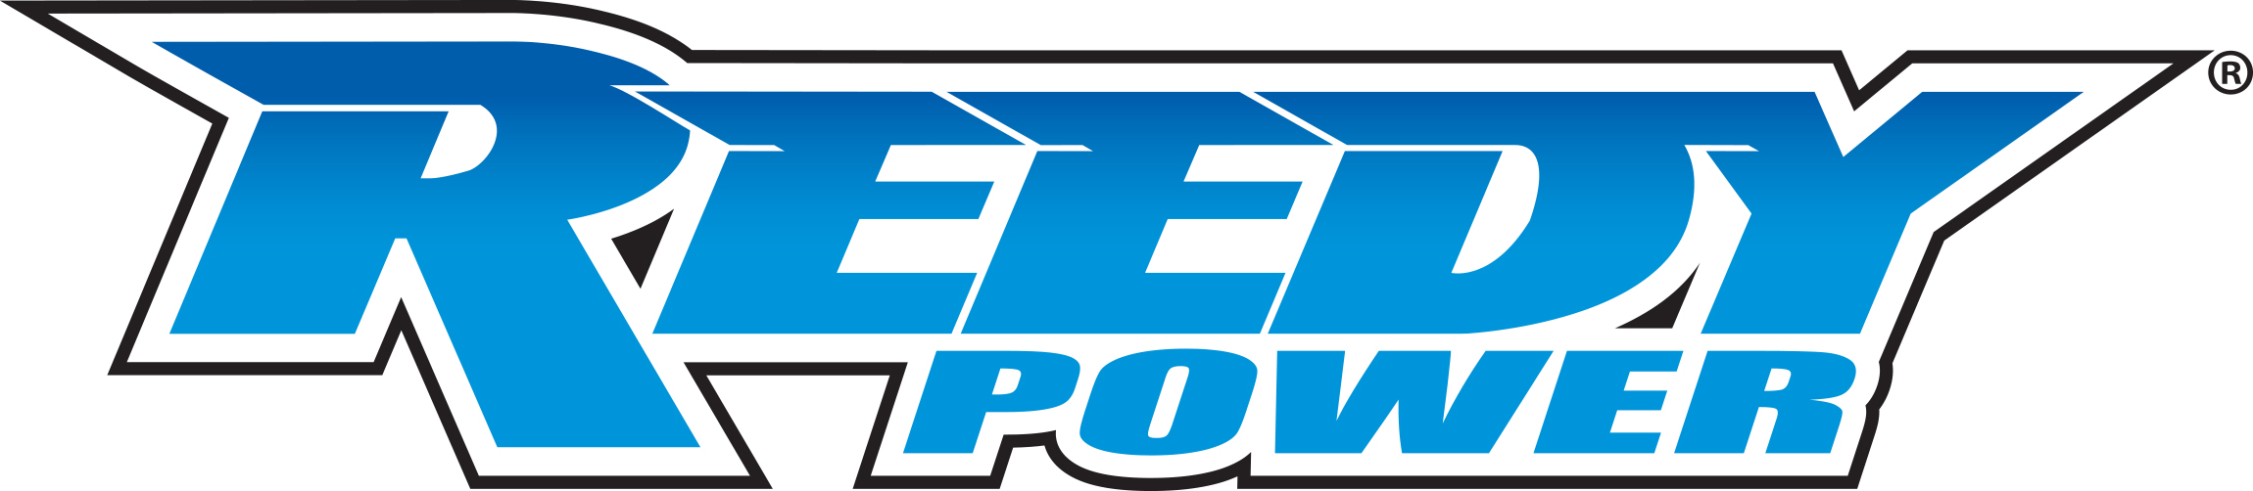
Recommended Electronics:

• Motor (#907 Reedy 540-SL4 Sensorless Brushless Motor)
• ESC (#27018 Reedy SC600-BL2 Sensorless Brushless ESC)
• Battery (#755 Blackbox 610R Competition ESC)
• Servo (#27172 Reedy RT2007HD Low-Profile Brushless
Hi-Torque Servo)
• Charger (#27203 Reedy 1416-C2L Dual AC/DC Competition Balance Charger

Other Helpful Items:

• Body Scissors (AE Part # 1737)
• FT Wrench Set (AE Part #1519)
• Hobby Knife
• Needle Nose Pliers
• Wire Cutters
• Soldering Iron
• Calipers or a Precision Ruler

Items required for operation: ESC, Motor, Receiver, Transmitter, Servo, suitable NiMh or 2S/3S LiPo battery for vehicle, and a charger.

 |  |  |  | CATALOG INFORMATION
UPC | Part No. |  | Description |  | MSRP | MAP | Case QTY | Origin | Available
784695301351 | 20524 |  | MT10 FACTORY TEAM KIT |  | $529.99 | $359.99 | 2 | CN | May
Download all zipped photos here: https://www.rc10.com/MT10FactoryTeamImagesPR/ (14.5 MB). Link is active for 30 days.
Please refer to our MAP Policy here: https://img2c.associatedelectrics.com/pdf/map-policy.pdf

