For Immediate Release: July 2026

RC10 4WD Factory Team Kit #6055
1:10 Scale 4WD Electric Off Road Competition Buggy Kit

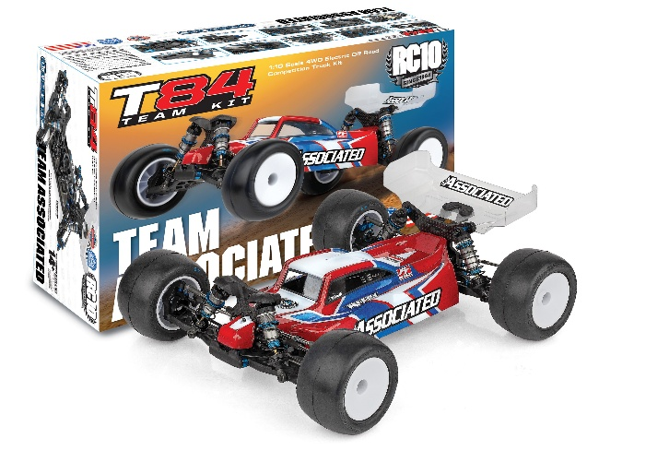
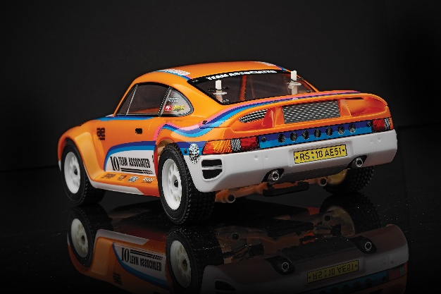
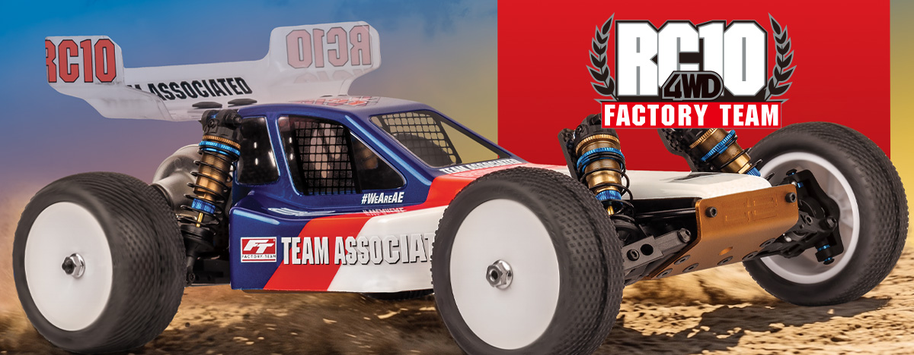

ELECTRIC ■ 1:10 SCALE ■ 4 WHEEL DRIVE ■ OFF ROAD ■ KIT
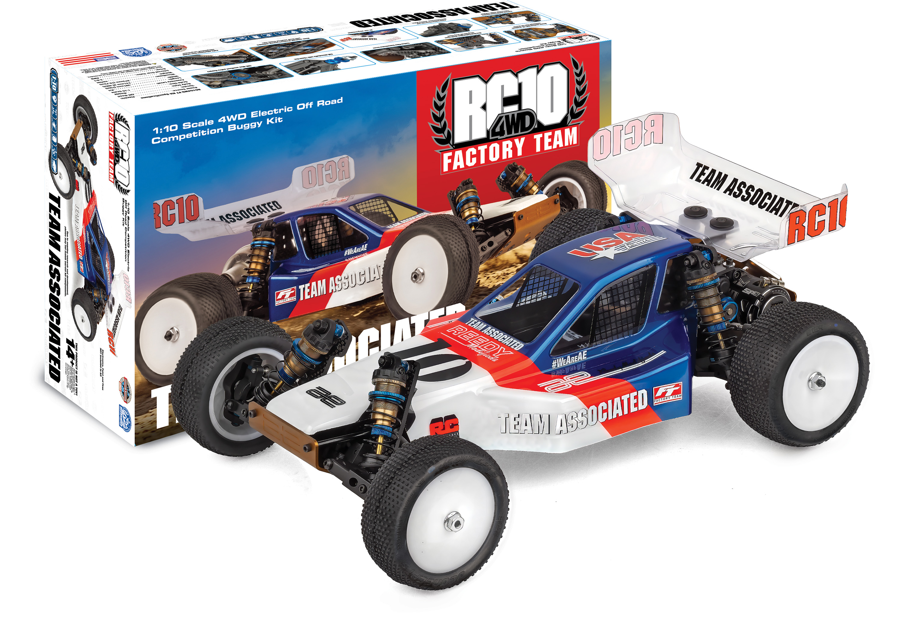

With over 40 years of racing heritage, the RC10 platform remains an icon, now evolved by the AREA 51 Factory Team to dominate
modern tracks.

This ultimate edition features a bronze anodized 6061-T6 aluminum monocoque chassis paired with Kashima coated 13mm Big Bore shocks and low CG carbon fiber towers for elite handling.

The Team Associated RC10 4WD Factory Team is Engineered for Victory!
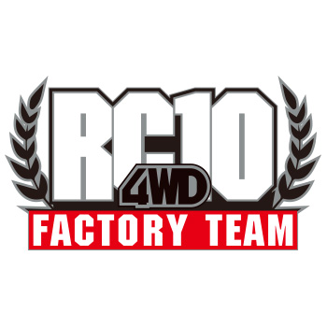
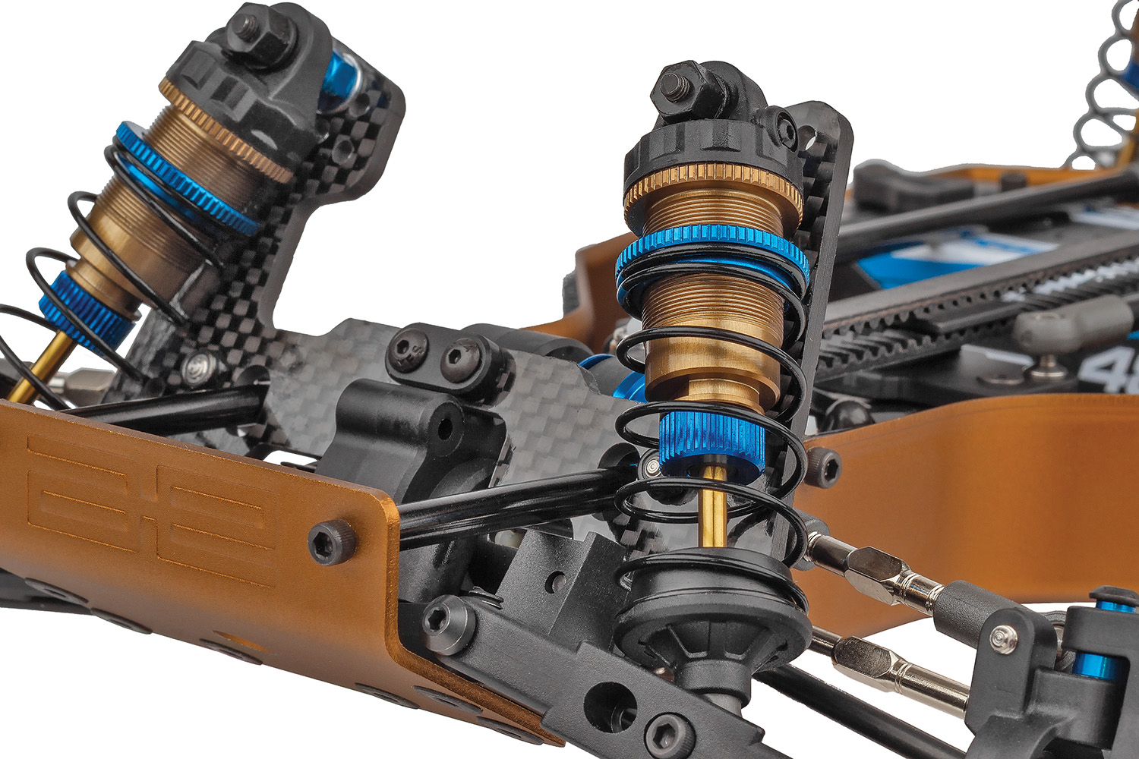
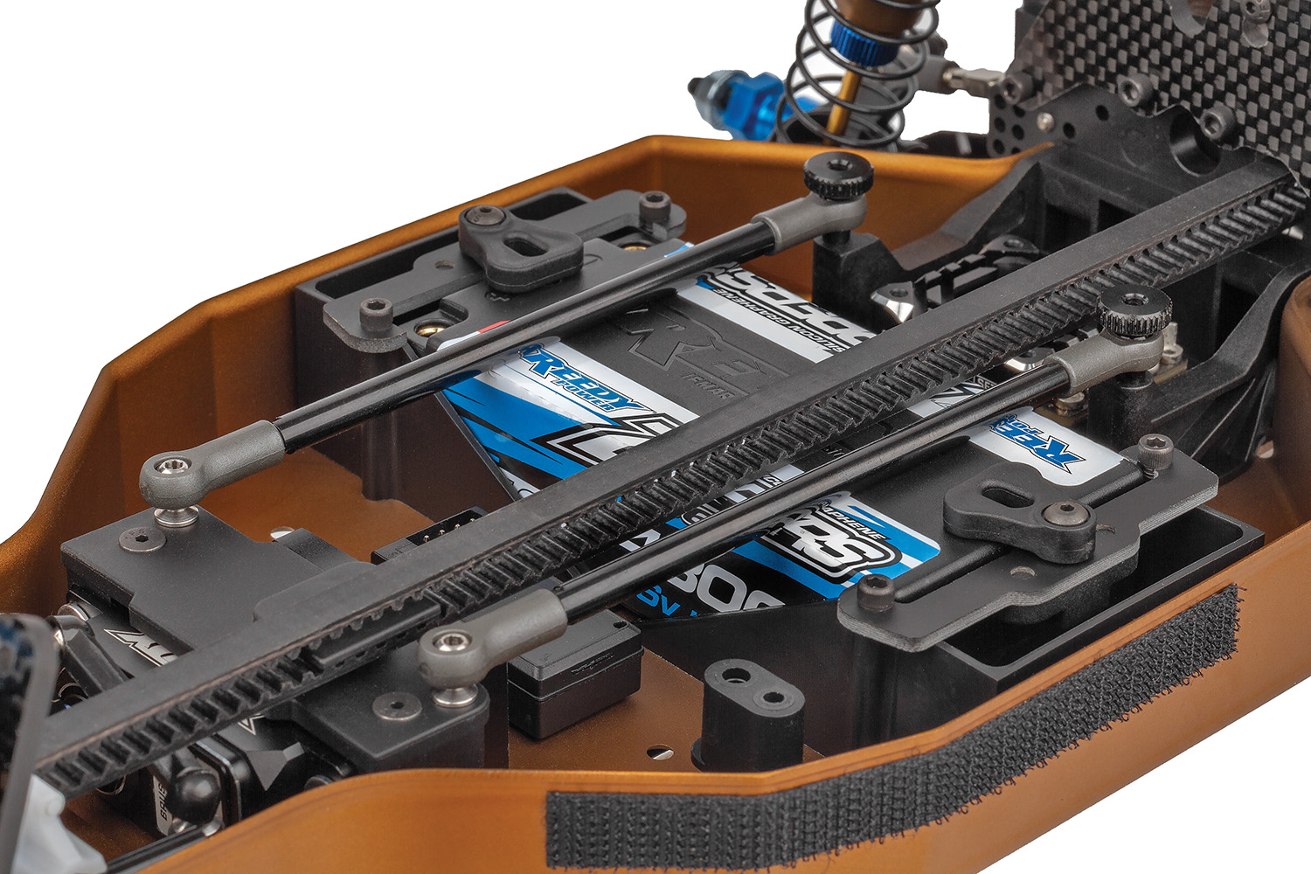
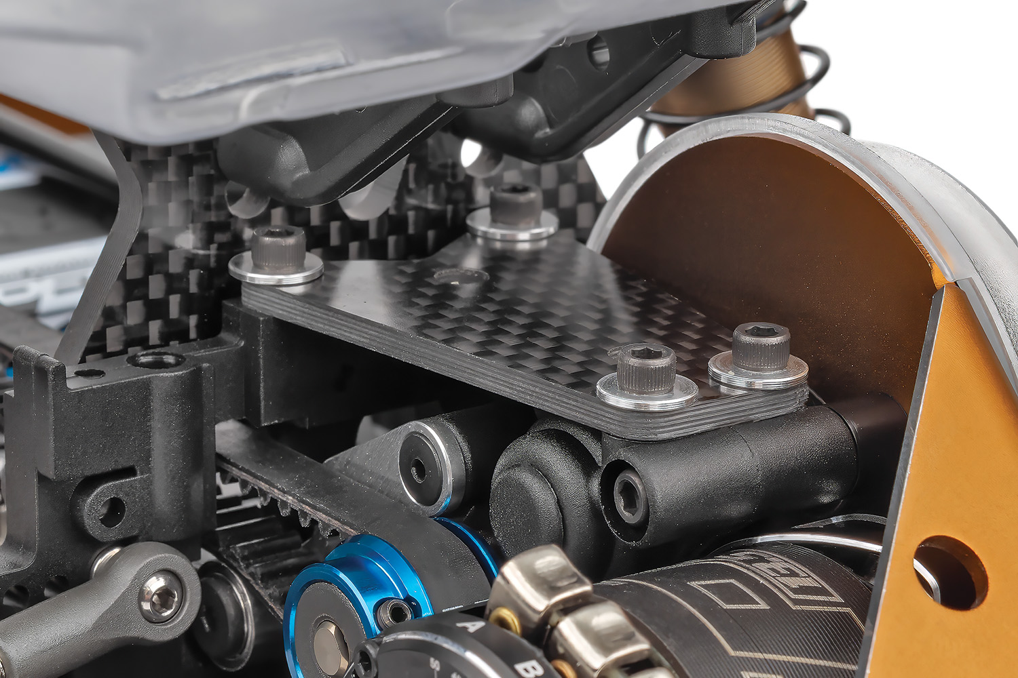

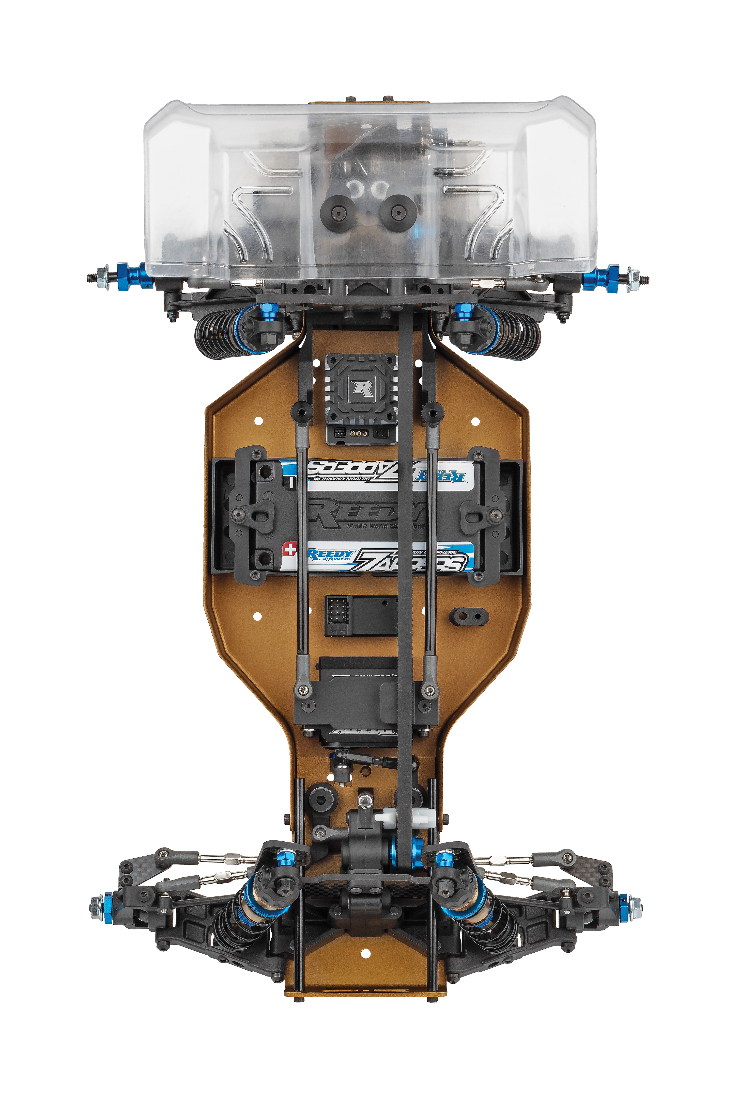

Bronze anodized 6061-T6 aluminum monocoque 4wd tub chassis
Kashima coated 13mm Big Bore factory team shocks

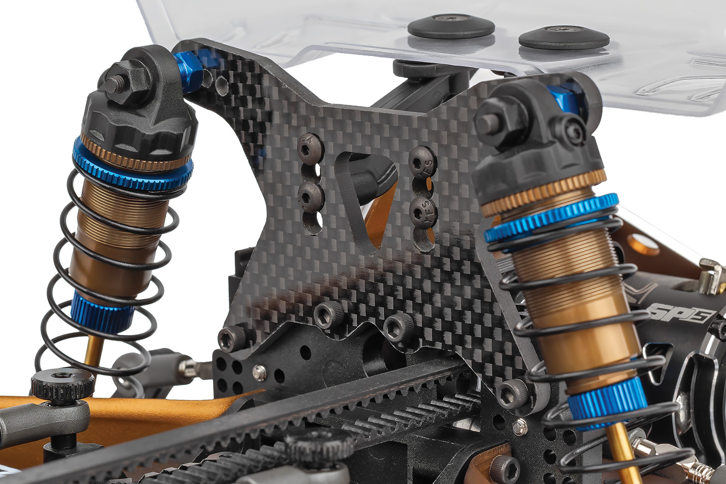

Carbon Fiber
transmission brace
New rear Carbon Fiber shock tower integrates B6 wing mount

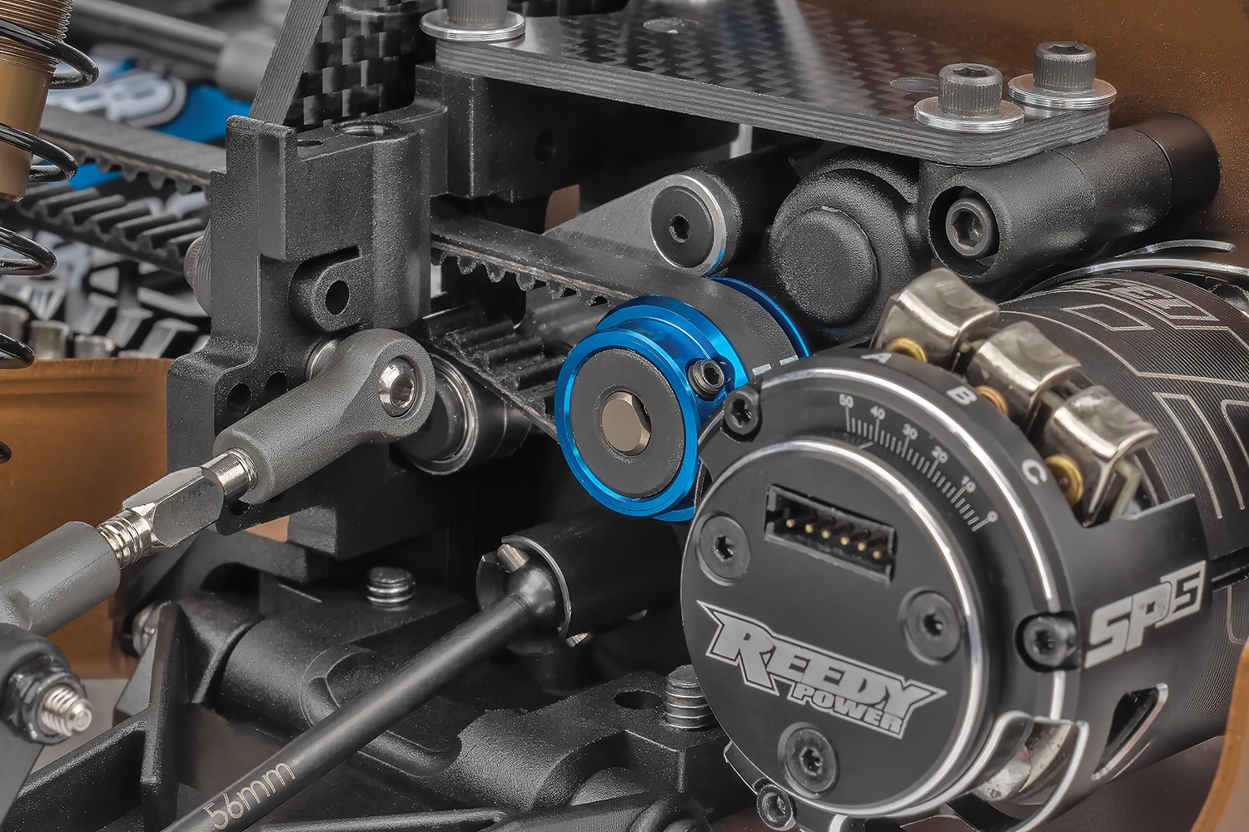
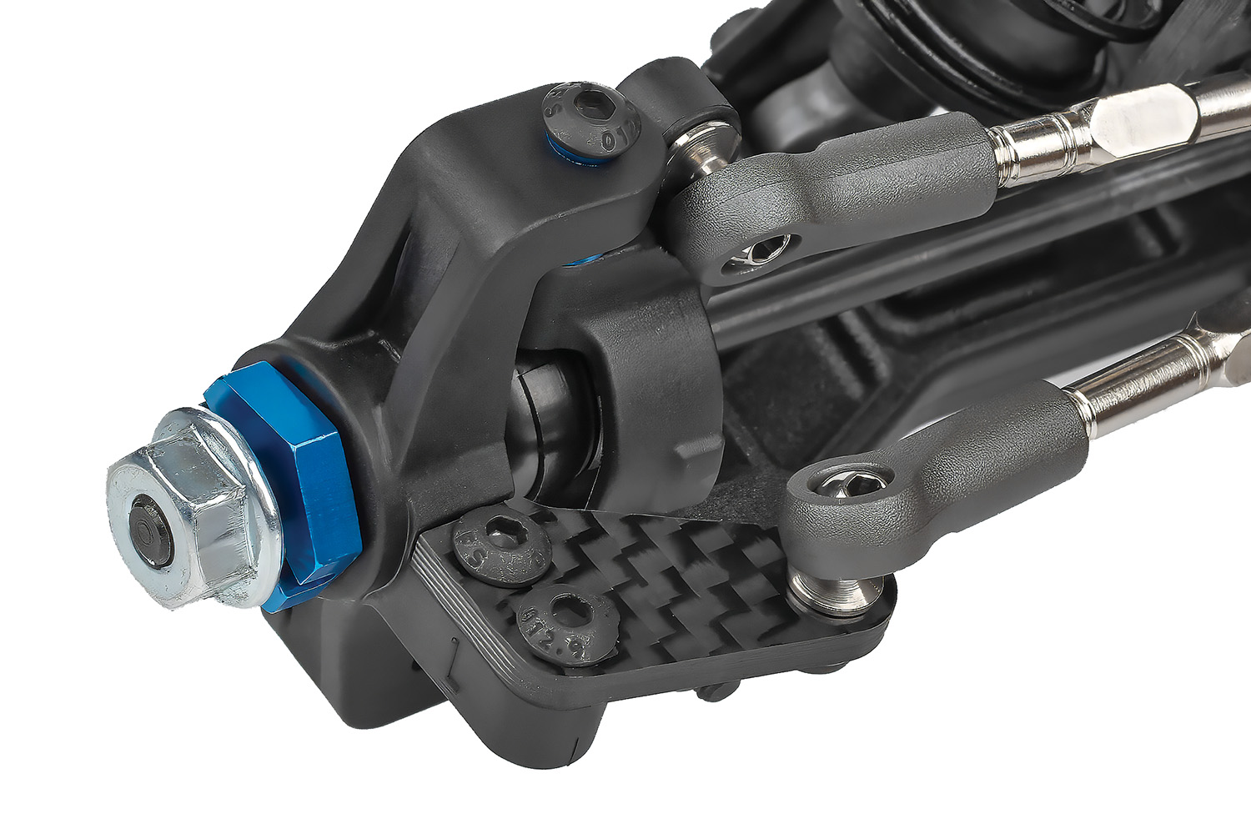

Factory Team 12mm hex and
New Carbon Fiber steering plates

CNC Blue anodized
pulley flanges

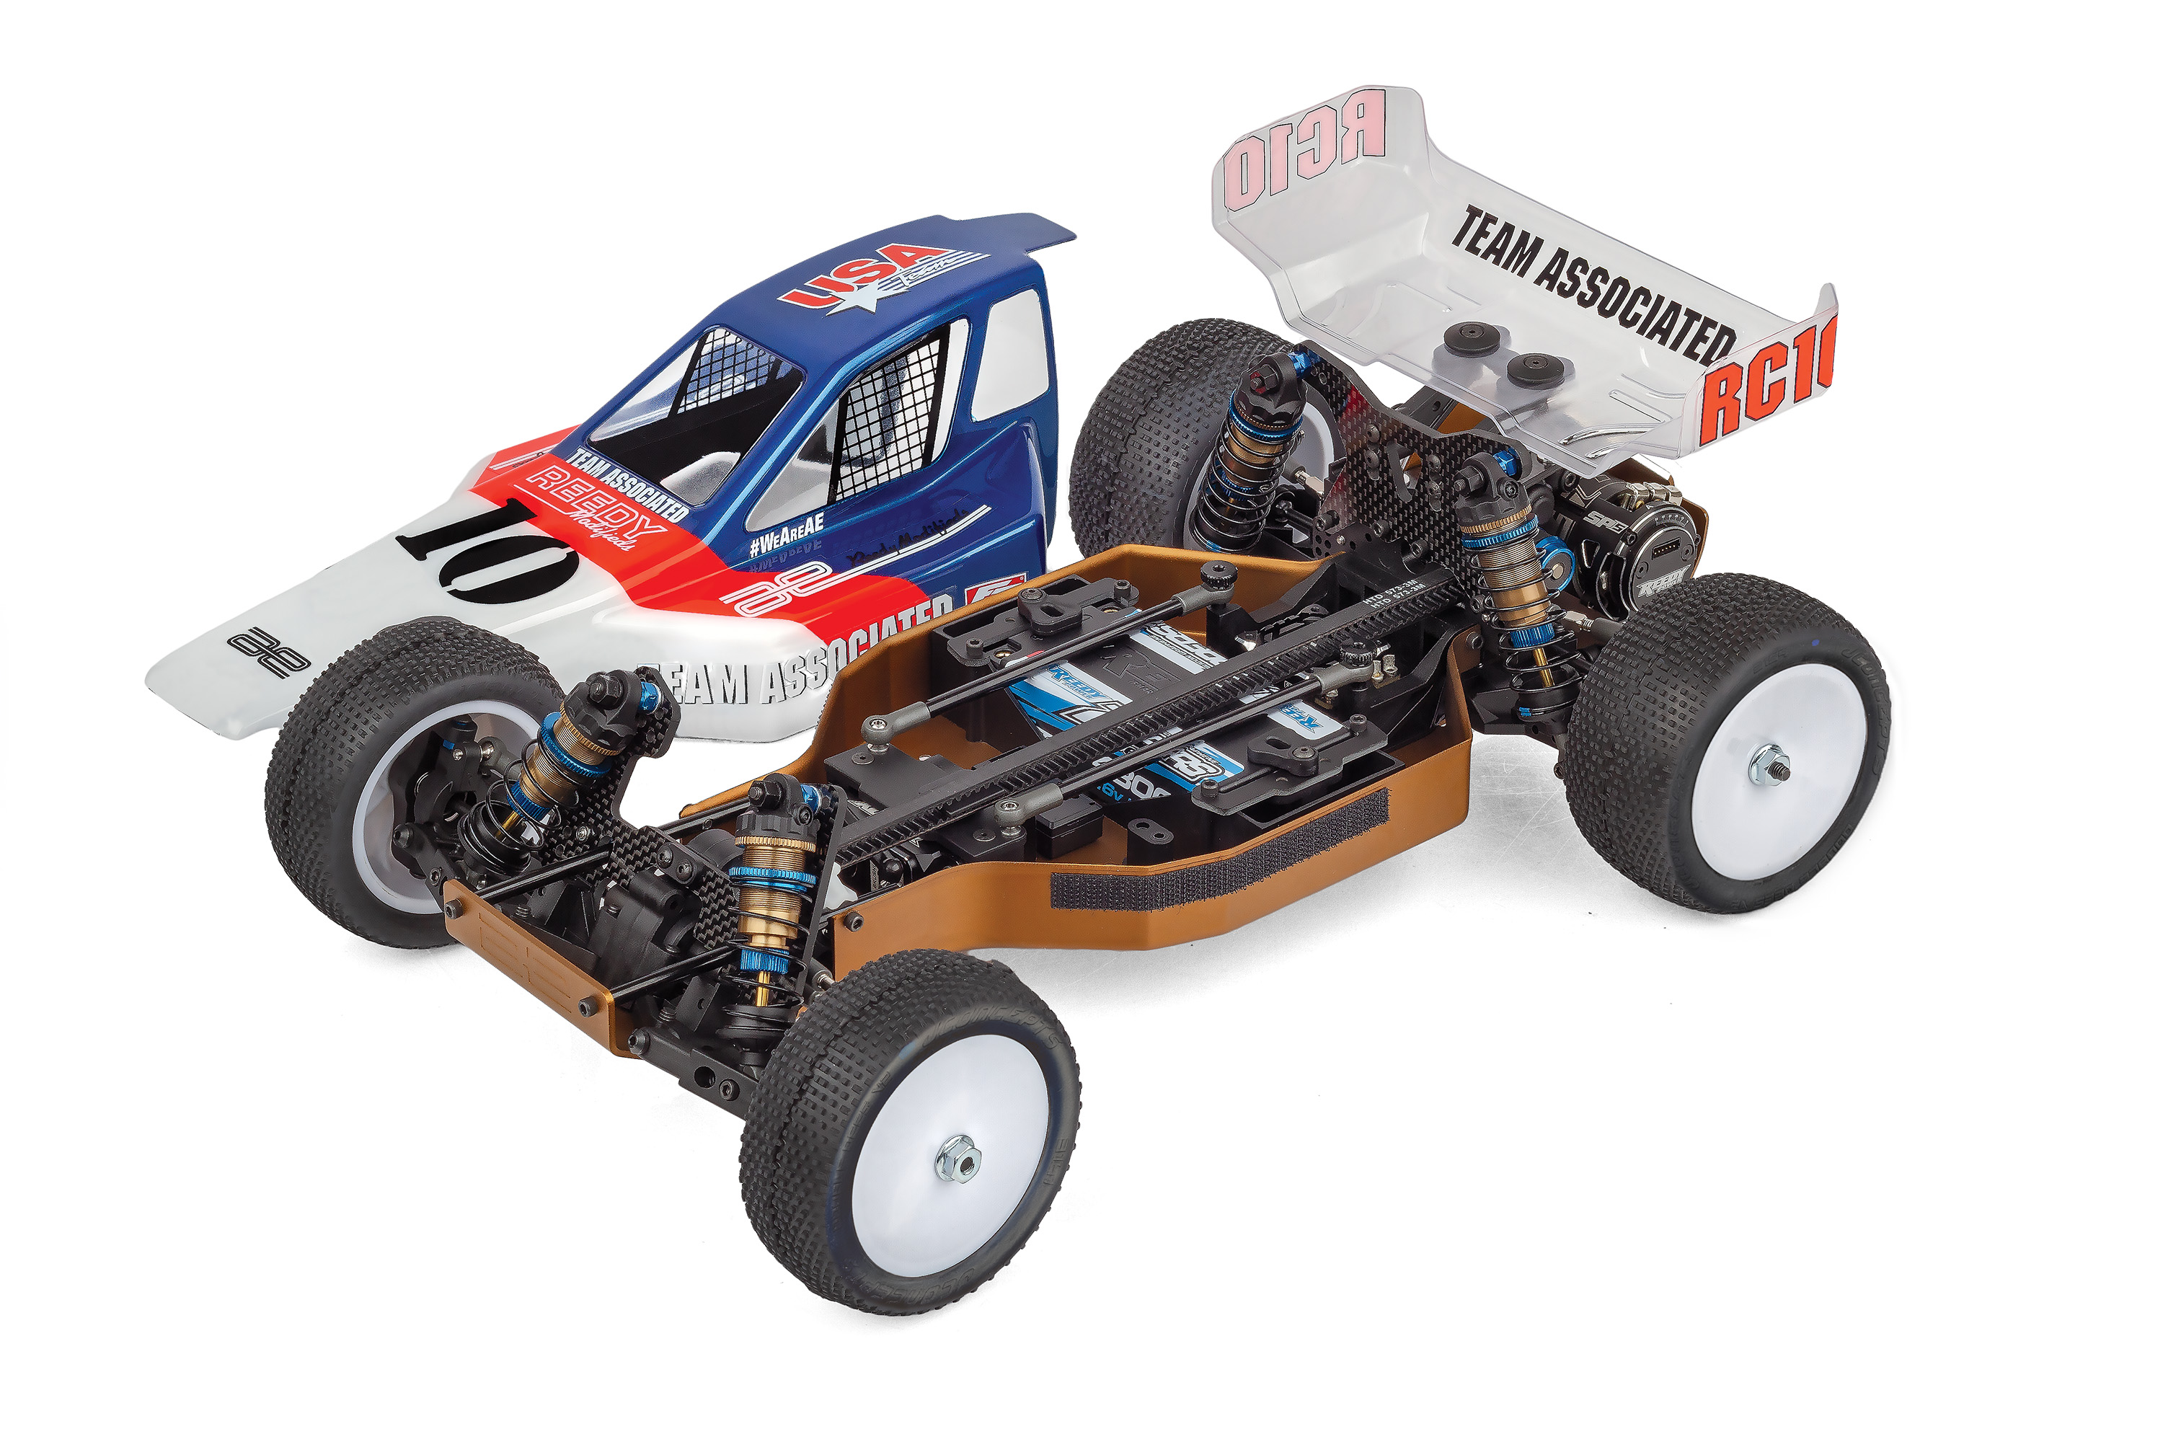

The race-proven Stealth transmission and V2 slipper clutch provide a durable powerhouse. Completed with
all-black plastics, a sleek Mirage Pro body, and a B7 rear wing, this kit delivers a factory level setup that seamlessly blends vintage soul with cutting
edge performance.

* Final width, length and weight will vary based on electronics, tire configuration, wing position and vehicle setup.
FEATURES
  SPECS

Recommended Electronics:

- Bronze anodized 6061-T6 aluminum monocoque 4wd tub chassis
- Bronze anodized nose plate and cut motor plate
- Exclusive black anodized nose tubes
- Black anodized aluminum chassis stiffeners
- Black anodized thumb nuts
- All black plastics
- New Mirage Pro clear lexan body
- B7 rear wing included
- Factory Team captured hinge pins all around
- New Carbon Fiber steering plates
- New Rear Carbon fiber shock tower integrates
B6 wing mount
- Kashima coated 13mm big bore factory team
shocks included
- New lower CG carbon fiber front and rear shock towers (Big bore compliant)
- Factory Team 12mm hex front axle and rear CVA’s
- B84 12mm hex white wheels included
- Carbon Fiber transmission brace
- CNC Blue anodized pulley flanges
- New servo mount and belt guide system
- Fully adjustable four-wheel independent suspension
- Race proven front and rear Stealth transmissions
- Adjustable ball differentials front and rear
- Exceptional ground clearance with low center of gravity
- Precision bearings throughout
- Adjustable heavy duty 3.5mm turnbuckles and ball cups all around
- Front and rear CVA driveshafts with 12mm Hex front
and rear
- Durable low friction center belt and tension system
- Long front arm geometry
- New front caster and spindle assembly designed for RC104WD
- Updated rear bulkhead and chassis stiffener
- HD Metric Ball Studs throughout
- Race Proven V2 Slipper Clutch System
- All new 4wd Worlds style Specific Bell Crank system

Scale Size: | 1:10
Terrain: | Off-road
Power Source: | Electric
Length: | 381mm (15in)
Width​: | 241mm (9.49in)
Weight: | Varies*
Wheelbase: | 273mm (10.75in)
Internal Gear Ratio: | 2.6:1
Drive: | 4WD
Body Style: | Buggy
Assembly Level: | Kit
- Servo: #27172 (Reedy RT2007HD Low-Profile Brushless
Hi-Torque Servo)
- Battery: #27612 (STOCKSTAR 5800mAh 7.4V 160C Shorty)
- ESC: #27016 (Blackbox 610R Competition ESC)
- Motor: #27481 (Sonic 540-SP5 13.5T Brushless Motor)
- Charger: #27203 (Reedy 1416-C2L Dual AC/DC Competition Balance Charger)

Other Helpful Items:

- Body Scissors (AE Part # 1737)
- FT Wrench Set (AE Part #1519)
- Hobby Knife
- Needle Nose Pliers
- Wire Cutters
- Soldering Iron
- Calipers or a Precision Ruler

Items required for operation:

Motor, Battery, Charger, Servo, ESC, Radio. Assembly and painting required.

CATALOG INFORMATION
Motor, battery, ESC, servo, receiver, paint, tires and radio. Assembly and painting required

UPC | Part No. | Description | MSRP | MAP | Pieces Per Case | Origin | Available
784695060555 | 6055 | RC10 4WD Factory Team Kit | $719.99 | $479.99 | 6 | TW | July
CATALOG INFORMATION
Download all zipped photos here: https://www.rc10.com/RC104WDFTImages/ (10.3MB) Link is active for 30 days.
Please refer to our MAP Policy here: https://img2c.associatedelectrics.com/pdf/map-policy.pdf

