For Immediate Release: November

The RC12L #4022
1:12 Scale Electric Competition RC Car

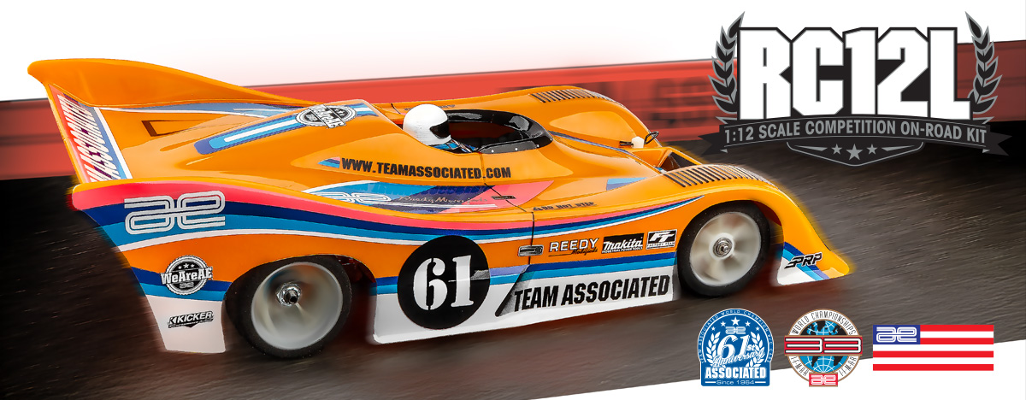

ELECTRIC ■ ON-ROAD ■ 1:12 SCALE ■ 2 WHEEL DRIVE ■ KIT

THE MAKINGS OF A WORLD CHAMPION
The most thoroughly engineered and purpose-built 1:12 scale car ever developed by Team Associated, the RC12L won the IFMAR World Championship in its first year of competition.

Designed for the most serious of 1:12 scale road racers, the RC12L features several notable departures from our World and National Champion RC12L.

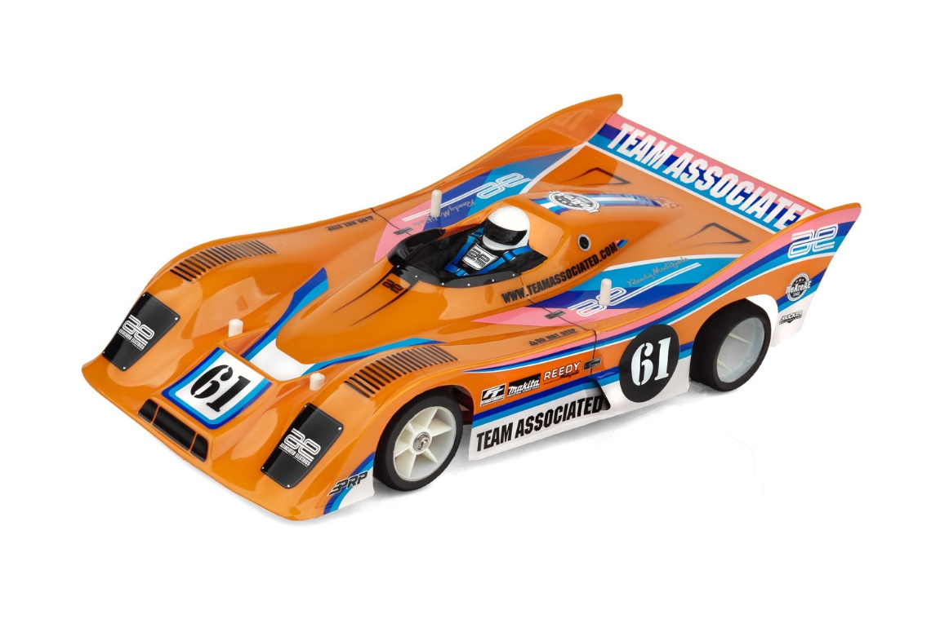

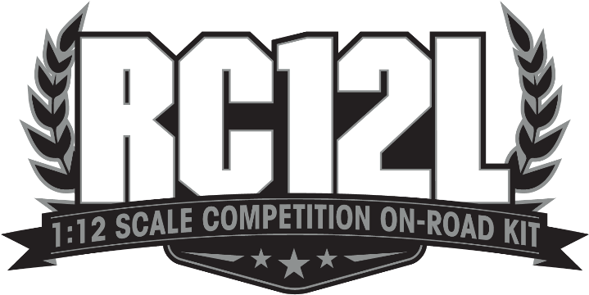

The all-new Team Associated RC10GB 2WD Off-Road Buggy is a groundbreaking release that pays tribute to two of the most iconic vehicles in RC history while blazing an entirely new trail of its own.

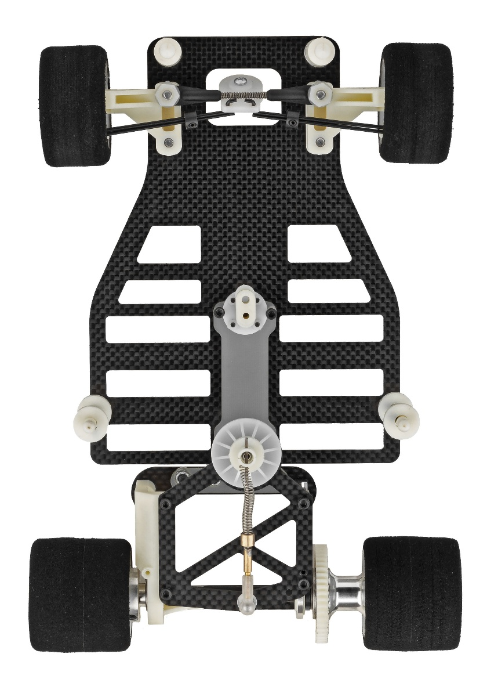
In 1986 the RC12L was the most technically advanced and balanced 1:12 car in the industry. An all-new ball joint T-bar/rear pod design centers the motor weight and provides precise tweak adjustment. Saddle-pack NiCd/NiMH mounting is also used to shift the weight distribution for better turn-in under power.

Ideal for indoor carpet tracks, the RC12L is tuned to asphalt racing with independent coil-spring front suspension.

Superlight racing wheels contributed considerably to the RC12L’s reduced weight and improved response. A full range of tire compounds, coil springs and gear ratios are also available for fine tuning.

Originally there were two RC12L kits, a carbon fiber Pro model and standard fiberglass. The World Champion winning carbon fiber version uses graphite for the chassis and rear pod and includes alloy motor mount and ball bearings (7).

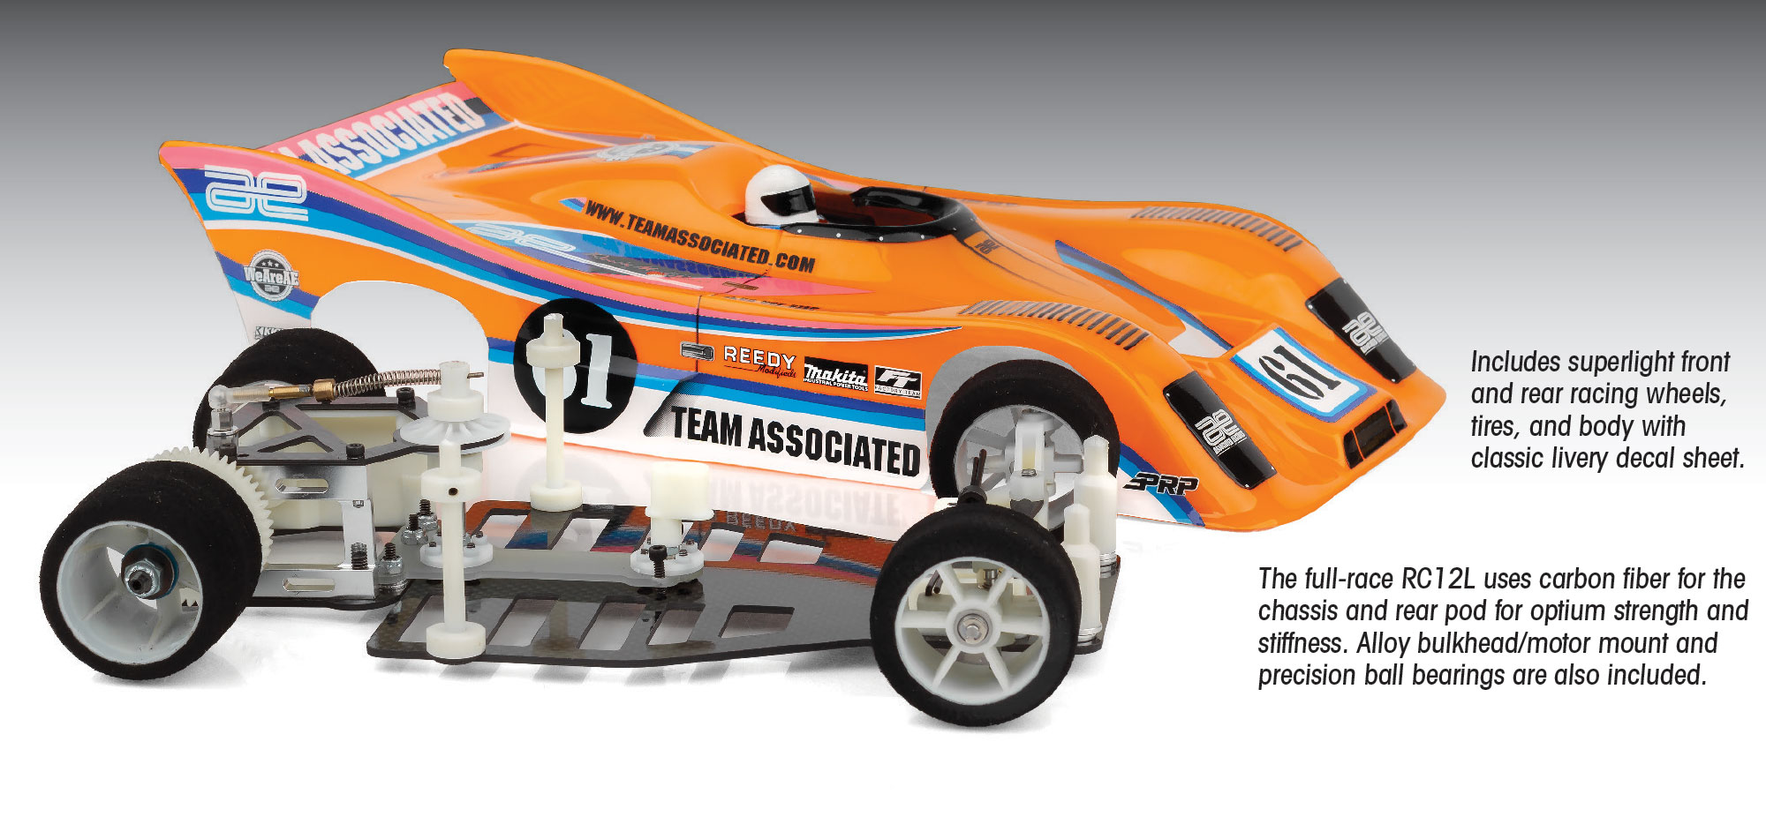

TEAM ASSOCIATED RC12L: A WORLD CHAMPION ICON OF 1/12-SCALE RACING

The Team Associated RC12L is one of the most legendary 1/12-scale electric on-road pan cars ever produced. Released in 1983, it was designed by Roger Curtis (RC) and Gene Husting as an evolution of the RC12E, introducing a lighter, stiffer chassis and refined suspension geometry that gave racers unprecedented corner speed and precision. The “L,” attributed to both “LOSI”, after Gil Losi Jr., who designed the all-new ball joint T-bar/rear pod, and “Linear” reflecting its smooth, predictable handling that quickly became the new benchmark in competitive 1:12-scale racing.

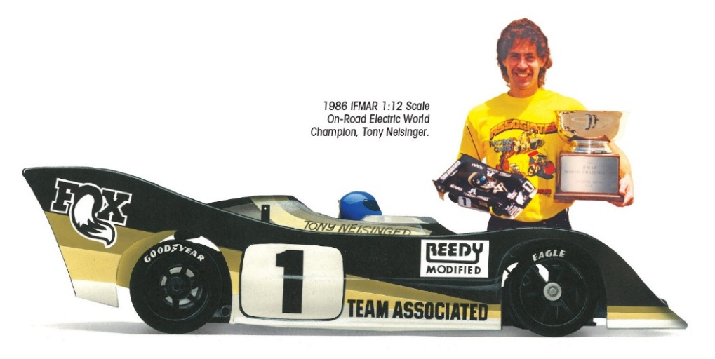

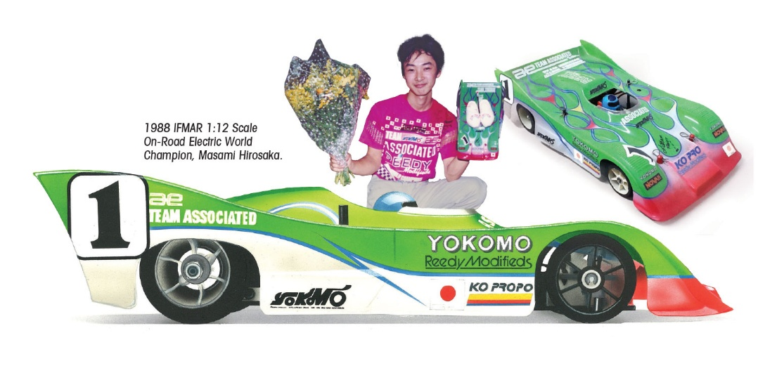
From its debut, the RC12L dominated the racing scene, winning countless ROAR National Championships during the 1980s and becoming the car of choice for serious competitors. It also achieved global recognition with back-to-back-to-back IFMAR World Championship victories. In 1986, Tony Neisinger captured the IFMAR World title in Anaheim, California, driving the RC12L to victory on home soil. In 1988, Masami Hirosaka secured his first IFMAR World Championship in England with the same platform, marking the beginning of his legendary career. And, in 1990 Chris Doseck won the World Championship with the RC12L in Singapore.

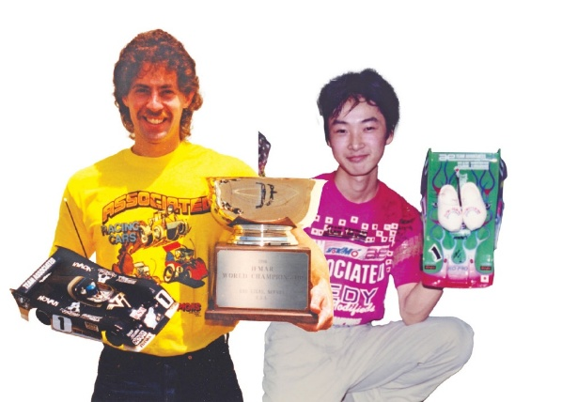

With victories by drivers such as Tony Neisinger Masami Hirosaka, Chris Doseck along with a few others, the RC12L cemented its reputation as a groundbreaking design. Its combination of innovation, speed, and championship success made it one of Team Associated’s most influential cars, setting the standard for 1:12-scale racing worldwide.

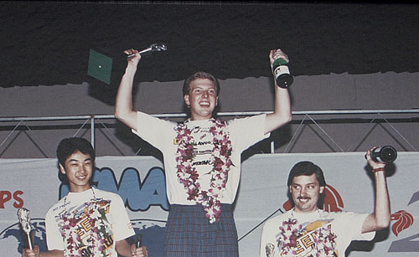

FEATURES
- Ball joint supported T-bar for controlled flex
- 360 degree adjustable shock dampener
- Super light front and rear racing wheels
- T.o.J. clear body included
- Racing foam tires included (un-mounted)
- 32 pitch spur gear and pinion included
- Natural white molded parts throughout
- Full ball bearings included
- Exclusive vintage decal sheet

- True reproduction of the original RC12 released in 1986
- Carbon fiber chassis
- Carbon fiber damper plate
- Carbon fiber lower bracket
- Authentic RC12 front suspension geometry for even tire wear
- Coil spring sliding suspension
- Adjustable rear axle height
- CNC machined alloy rear bulkhead (right side)
- Varilok differential
- Countersunk chassis
- Cap bolt tweak adjusters for precise load settings

ITEMS NEEDED TO COMPLETE |  | SPECIFICATIONS
Scale | 1/12
Power | Electric
Length | 14in (356mm)
Width | 6.5in (165mm)
Weight | Varies
Wheelbase | 12.2inches (310mm)
Internal Ratio | Shaft 1:1
- R/C two channel surface frequency radio system
- Electronic Speed Control (ESC)
- R/C Electric Motor
- Steering Servo
- Peak detection battery charger
- 6 Cell NiCad Battery (3x3 saddle pack style)
- 2mm Hex Driver (AE #1501)
- 5.5mm Hex Driver (AE #1507)
- Thread Lock (AE #1596)
- Polycarbonate specific paint
- Soldering Iron

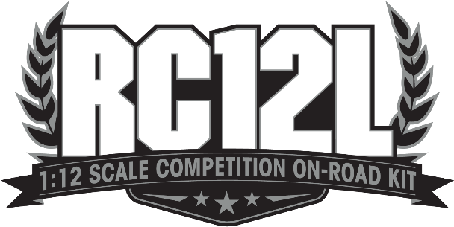
Available:

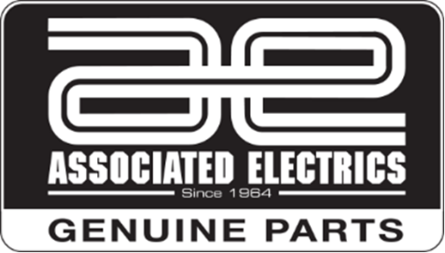

CATALOG INFORMATION
UPC | Part No. | Description | MSRP | MAP | Pieces Per Case | Origin | Available
784695040229 | 4022 | RC12L GRAPHITE KIT | $429.99 | $289.99 | 6 | TW | Now
Download all zipped photos here: https://rc10.com/RC12Limages/ (1.21MB) Link is active for 30 days.
Please refer to our MAP Policy here: https://img2c.associatedelectrics.com/pdf/map-policy.pdf

