For Immediate Release: August 2026

RC24 ZOOM Rally RTR #20210

1:24 Scale 4WD Ready-to-Run Electric Rally Car

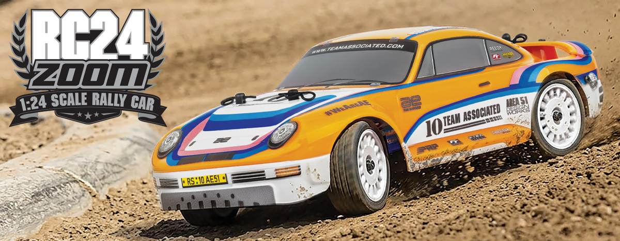

ELECTRIC ■ 1:24 SCALE ■ 4 WHEEL DRIVE ■ READY-TO-RUN
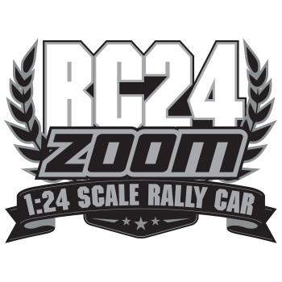
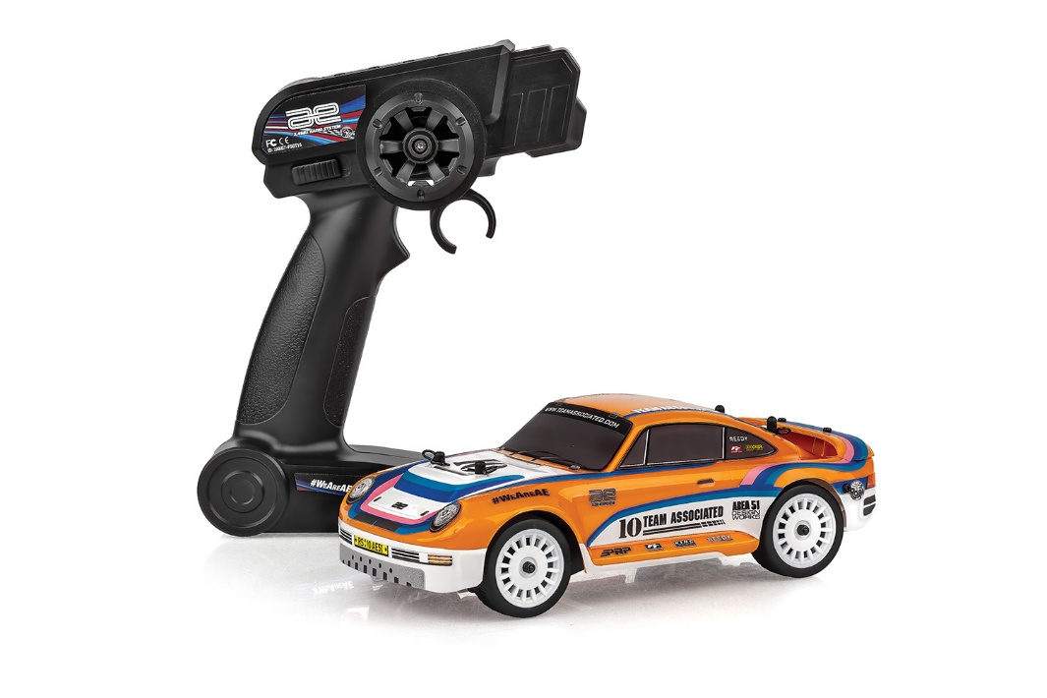
Get ready to tear up the track with the RC24 ZOOM Rally, the ultimate micro-racer designed for serious performance. Built on a durable molded chassis with steel hinge pins and independent suspension, this rally car handles jumps and bumps with ease, while the high-traction all-terrain tires and gear differentials ensure maximum grip on any surface. It comes fully loaded with a stunning painted Lexan body, ball bearings for smooth efficiency, and a precision micro servo already installed.

Whether you’re a beginner or a seasoned pro, the RC24 is ready to run right out of the box with a 2.4GHz transmitter, 1S LiPo battery, and USB charger. Best of all, this isn’t just a toy—it’s a hobby-grade machine featuring replaceable parts and compatibility with Race spec Reedy microelectronics, allowing you to upgrade and maintain your ride for years of high-speed action.
Ready-to-run fun, on an
upgradable platform!

FEATURES
  SPECS
• Durable Lexan Body
• Painted and decaled body
• 2 in 1 micro esc + receiver system
• 2.4ghz transmitter with batteries included
• 1S Lipo battery included
• Micro servo included and installed
• Hobby grade replaceable parts throughout
• Independent suspension
• Spare parts available
• USB Lipo charger included
• Race spec Reedy microelectronics can be installed
• Durable gear differentials
• Ball bearings included
• High Traction All Terrain tires
• Durable molded chassis
• Steel Hinge pins all around

Scale | 1:24
Body Style: | Rally Car
Power | Electric
Length | 194mm (7.6in)
Width | 95mm (3.7in)
Weight | Varies
Wheelbase | 119mm (4.7in)
Drive | 4WD
Assembly Level: | Ready-To-Run*
Terrain | Street / Hard Dirt

* Final width, length and weight will vary based on electronics, tire configuration, wing position and vehicle setup.

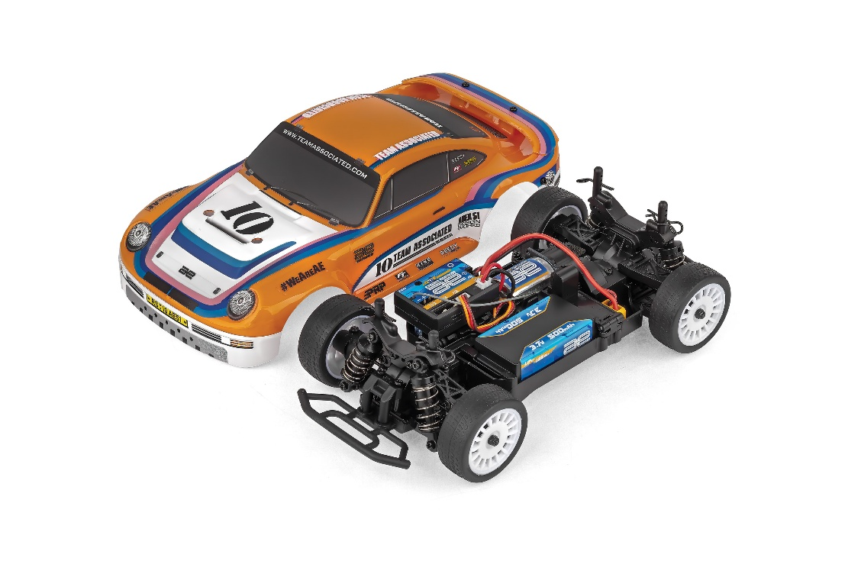

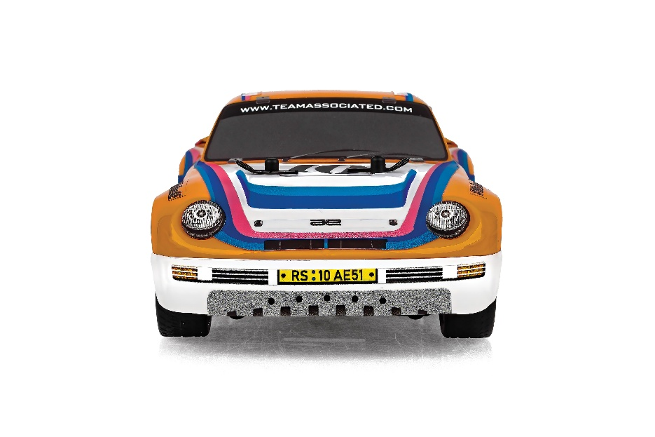

CATALOG INFORMATION

UPC | Part No. | Description | MSRP | MAP | Pieces Per Case | Origin | Available
784695202108 | 20210 | RC24 ZOOM Rally RTR | $164.99 | $109.99 | 12 | TW | August

Download all zipped photos here: https://www.rc10.com/RC24ZoomRallyRTRImages/ (9.1MB) Link is active for 30 days.
Please refer to our MAP Policy here: https://img2c.associatedelectrics.com/pdf/map-policy.pdf

