For Immediate Release: June 2026

RC10T Factory Team Kit #7004
1:10 Scale 2WD Electric Off Road Competition Truck Kit

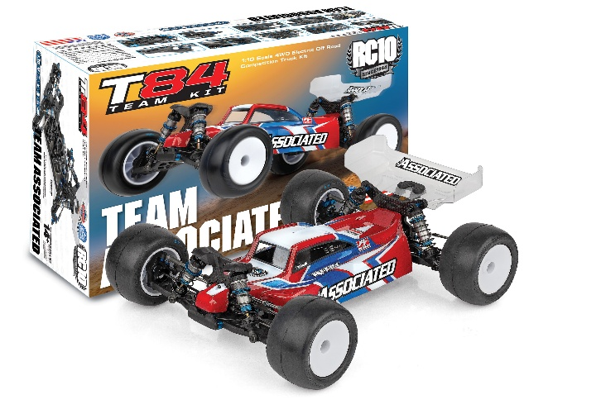
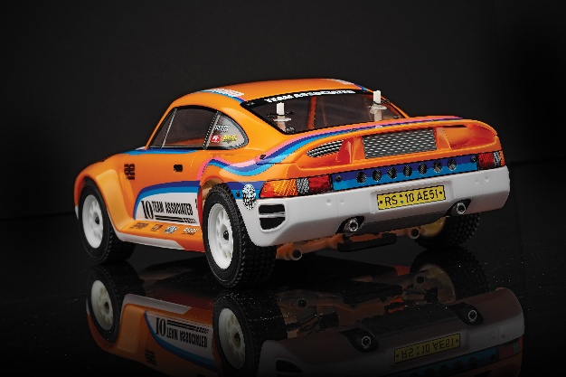
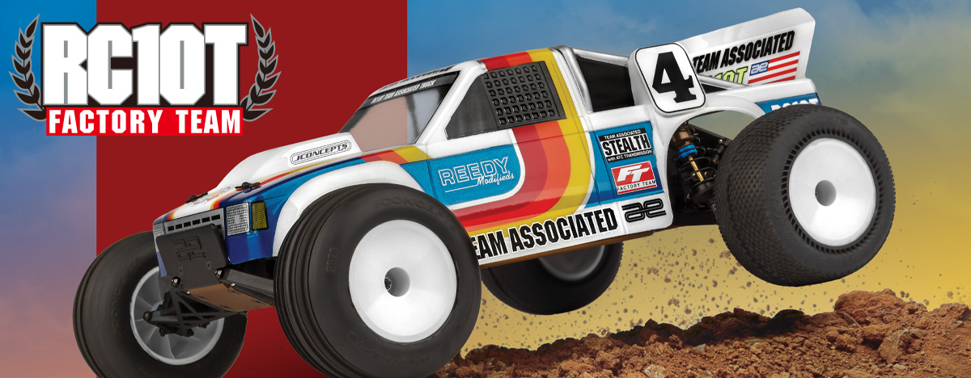

ELECTRIC ■ 1:10 SCALE ■ 2 WHEEL DRIVE ■ OFF ROAD ■ KIT

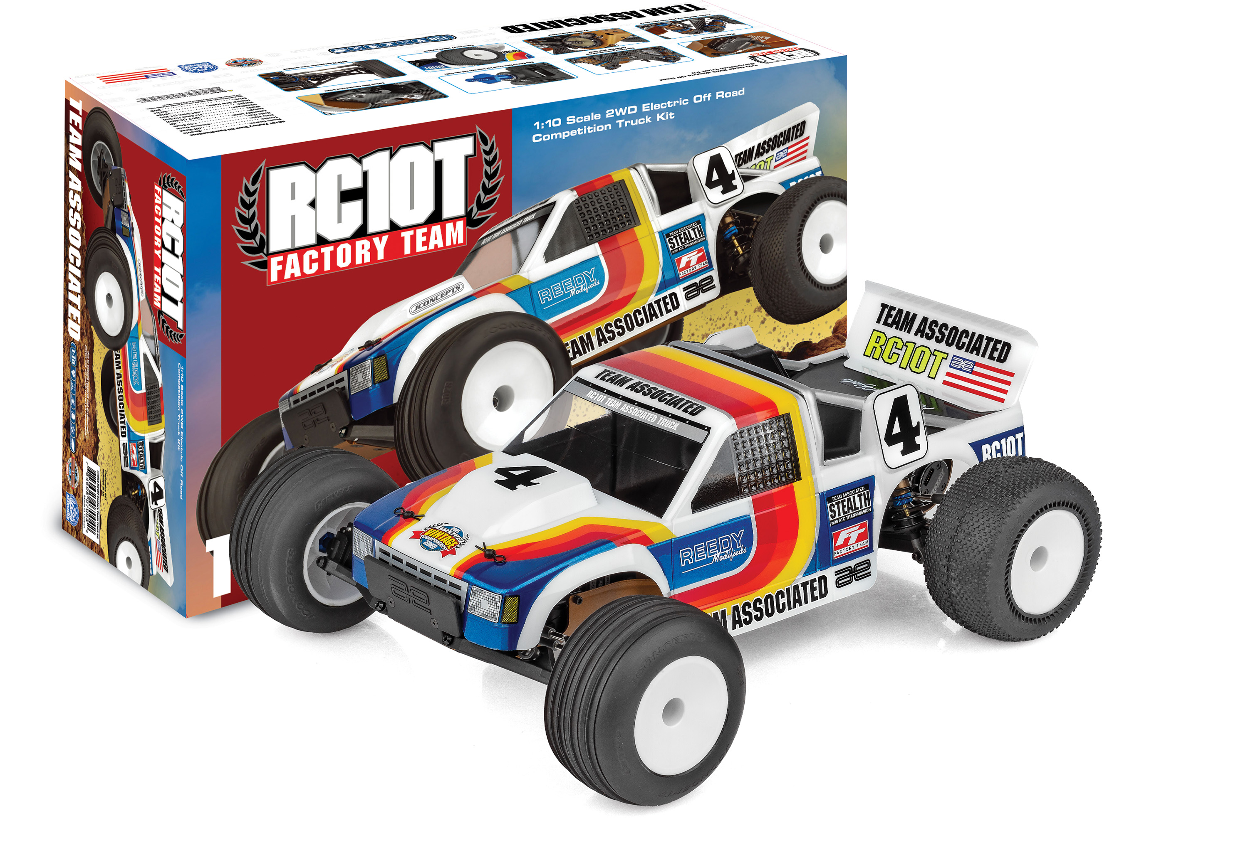
With over 40 years of racing heritage and countless World Championships, the RC10 platform stands out as one of the best performing 10th scale chassis of all time.

Today’s R/C tracks demand a lot from a vintage platform and the AREA 51 Factory Team has been hard at work creating the ultimate RC10T for today’s tracks. The features in this kit are exactly how our Factory Team drivers setup their RC10T’s for modern racing. With big bore shocks, captured hinge pins, 12mm wheel hex’s, exclusive chassis color, and more, this is an RC10T like never before.
The Team Associated RC10T Factory Team is Engineered for Victory!
FEATURES
  SPECS
Scale Size: | 1:10
Terrain: | Off-road
Power Source: | Electric
Length: | 396.7 (15.62in)
Width​: | 317.5mm (12.5in)
Weight: | Varies*
Wheelbase: | 284.5mm (11.2in)
Internal Gear Ratio: | 2.25:1
Drive: | 2WD
Body Style: | Stadium Truck
Assembly Level: | Kit
* Final width, length and weight will vary based on electronics, tire configuration, wing position and vehicle setup.
- New Factory Team front and rear carbon fiber front shock towers (big bore compatible)
- New Factory Team 12mm hex front steering block
- New Factory Team 12mm hex front axle and rear CVA’s
- 12mm Hex T7 wheels included
- B7 Servo mount included
- Heavy Duty Metric Ball Studs
- Carbon fiber transmission brace
- Heavy Duty Ball Cups and 3.5mm adjustable turnbuckles
- New Factory Team captured hinge pins all around
- Kashima coated 13mm big bore factory team shocks included
- All Black plastics
- Full ball bearings included
- Bronze color anodized chassis, noseplate and motorplate
- New Factory Team RC10T logo decal sheet
- V2 slipper system included
- RC10 T2 suspension arms included

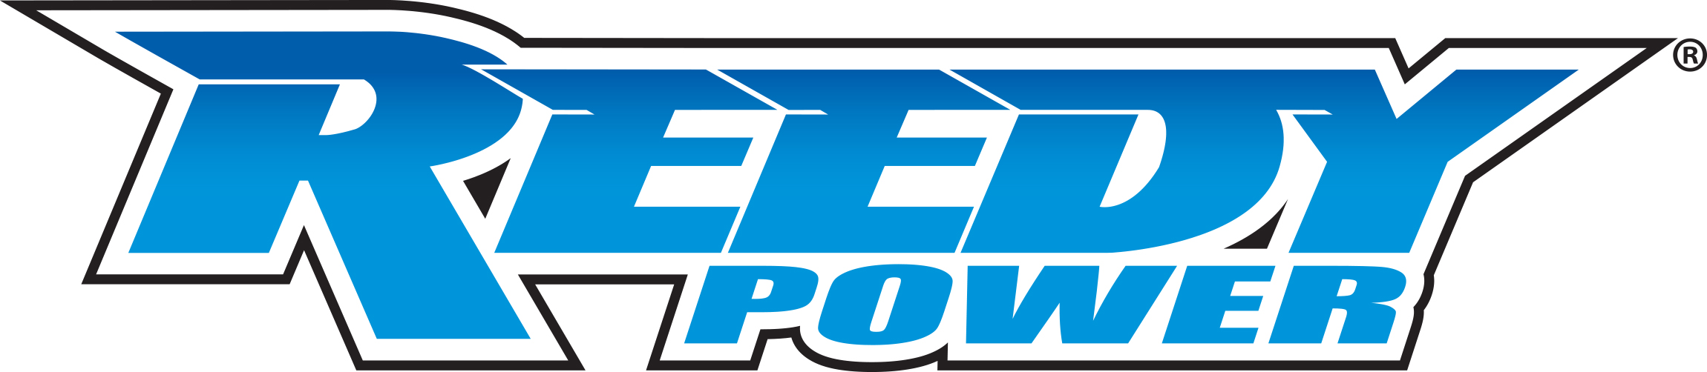
Recommended Electronics:

- Servo: #27172 (Reedy RT2007HD Low-Profile Brushless
Hi-Torque Servo)
- Battery: #27612 (STOCKSTAR 5800mAh 7.4V 160C Shorty)
- ESC: #27016 (Blackbox 610R Competition ESC)
- Motor: #27481 (Sonic 540-SP5 13.5T Brushless Motor)
- Charger: #27203 (Reedy 1416-C2L Dual AC/DC Competition Balance Charger)

Other Helpful Items:
- Body Scissors (AE Part # 1737)
- FT Wrench Set (AE Part #1519)
- Hobby Knife
- Needle Nose Pliers
- Wire Cutters
- Soldering Iron
- Calipers or a Precision Ruler

Items required for operation:
Motor, Battery, Charger, Servo, ESC, Radio. Assembly and painting required.

CATALOG INFORMATION
Motor, battery, ESC, servo, receiver, paint, tires and radio. Assembly and painting required

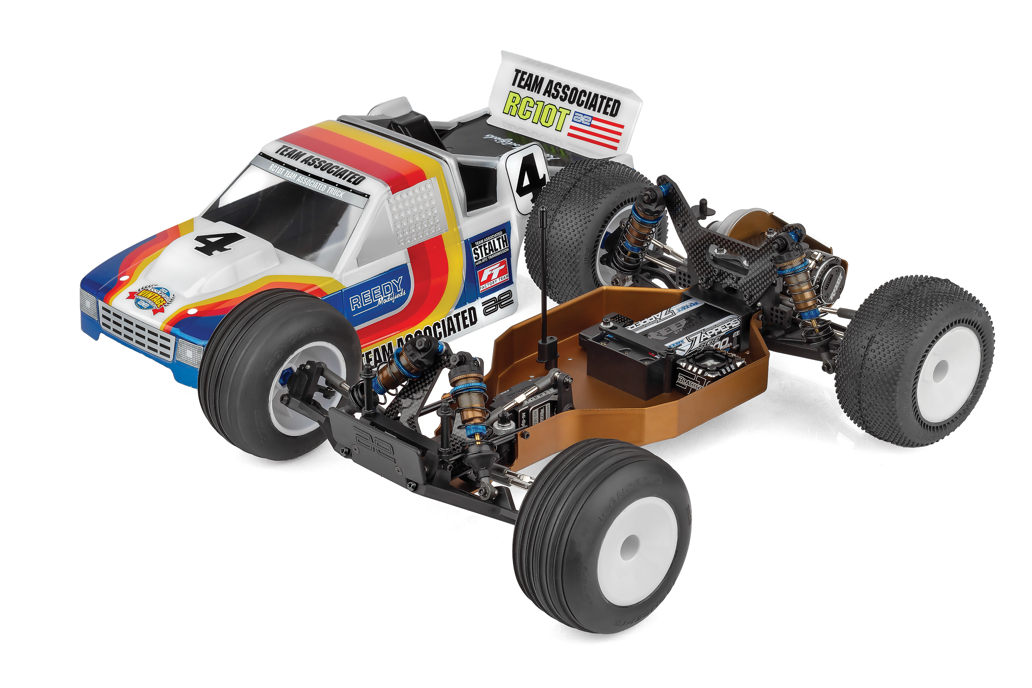



CATALOG INFORMATION
UPC | Part No. | Description | MSRP | MAP | Pieces Per Case | Origin | Available
784695070448 | 7004 | RC10T Factory Team Kit | $689.99 | $449.99 | 6 | TW | July
Download all zipped photos here: https://www.rc10.com/RC10TFTImages/ (10.2MB) Link is active for 30 days.
Please refer to our MAP Policy here: https://img2c.associatedelectrics.com/pdf/map-policy.pdf

