For Immediate Release: April

New! Reedy Power Premium Blend T-Shirts and Pullover Hoodies
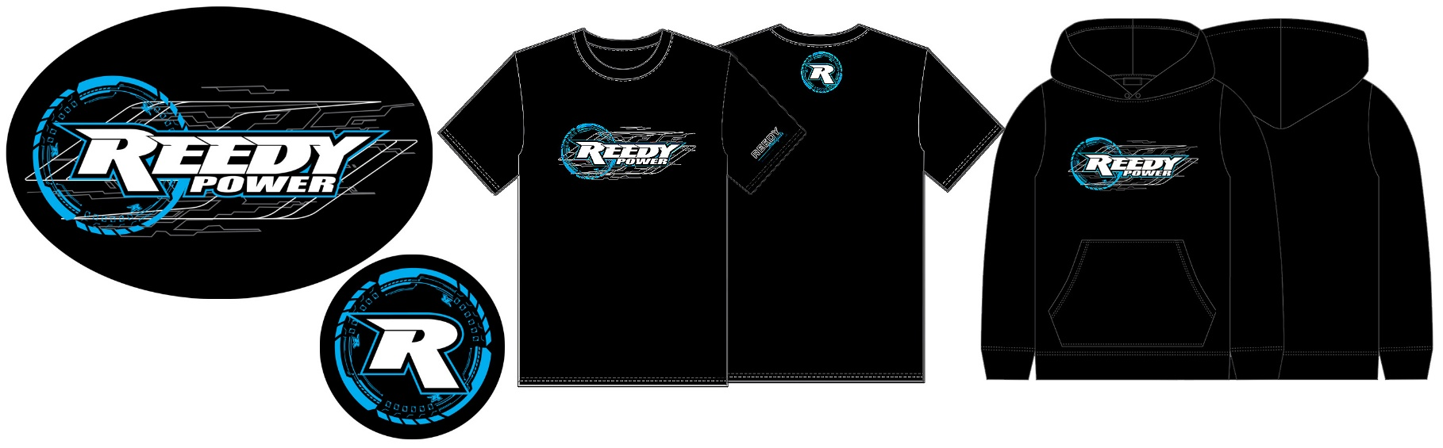

Reedy Power, the leading name in high-performance RC motors and electronics, proudly releases its latest line of premium polyester/cotton blend T-shirts and pullover hoodies. Designed for racers, hobbyists, and loyal fans, the new gear combines everyday comfort with the durability and style that enthusiasts expect.

The new W26 collection features a high-quality polyester/cotton blend fabric that delivers the perfect balance of softness, breathability, and long-lasting wear. The T-shirts offer a comfortable, athletic fit while the pullover hoodies provide warmth and versatility for cooler days at the track or late-night wrench sessions.

Wear the same gear as the Reedy racing team and proudly display your favorite power source!

Key features include:

- Soft, breathable, and durable premium poly/cotton blend
- Bold, high-quality graphics
- Machine washable and built to withstand repeated wear and washing
- Wide range of sizes to fit the entire R/C community

Reedy Power’s W26 apparel collection is now available for purchase at hobby shops, online retailers, and at www.ReedyPower.com.

UPC | Part No. | Description | MSRP | MAP | COO | Available
784695 972339 | 97233 | Reedy S26 T-Shirt, Black, SM | 32.99 | 27.99 | US | 
784695 972346 | 97234 | Reedy S26 T-Shirt, Black, MD | 32.99 | 27.99 | US
784695 972353 | 97235 | Reedy S26 T-Shirt, Black, LG | 32.99 | 27.99 | US
784695 972360 | 97236 | Reedy S26 T-Shirt, Black, XL | 32.99 | 27.99 | US
784695 972377 | 97237 | Reedy S26 T-Shirt, Black, 2XL | 32.99 | 27.99 | US
784695 972384 | 97238 | Reedy S26 T-Shirt, Black, 3XL | 39.99 | 33.99 | US
784695 972391 | 97239 | Reedy S26 T-Shirt, Black, 4XL | 39.99 | 33.99 | US
784695 971868 | 97186 | Reedy W26 Pullover Hoodie, Black, SM | 63.99 | 54.99 | US
784695 971875 | 97187 | Reedy W26 Pullover Hoodie, Black, MD | 63.99 | 54.99 | US
784695 971882 | 97188 | Reedy W26 Pullover Hoodie, Black, LG | 63.99 | 54.99 | US
784695 971899 | 97189 | Reedy W26 Pullover Hoodie, Black, XL | 63.99 | 54.99 | US
784695 971905 | 97190 | Reedy W26 Pullover Hoodie, Black, 2XL | 63.99 | 54.99 | US
784695 971912 | 97191 | Reedy W26 Pullover Hoodie, Black, 3XL | 63.99 | 54.99 | US
784695 971929 | 97192 | Reedy W26 Pullover Hoodie, Black, 4XL | 63.99 | 54.99 | US

