For Immediate Release: December

DC10 Classic Kit #30135

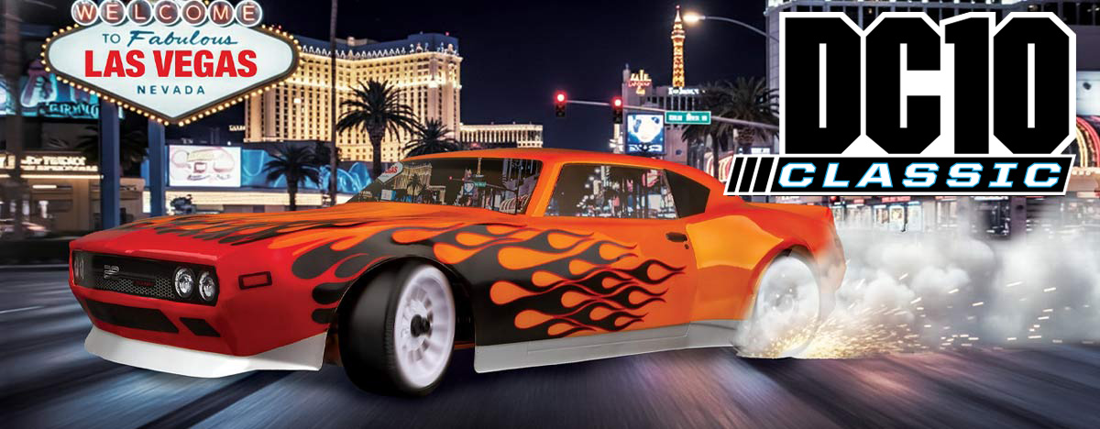

ELECTRIC ■ ON ROAD ■ 1:10 SCALE ■ 2 WHEEL DRIVE ■ KIT

The DC10 Classic – Where Going Sideways Becomes an Art Form!

Since 1964, Team Associated has proven to be the leader in the world of competition racing, and now born from our on-road racing legacy, we have engineered the DC10 Classic that sets new standards.

In the thrilling world of RC drifting, balance is everything, and the DC10 delivers precision like never before. With an arsenal of suspension and chassis tuning options at your fingertips, you can fine-tune your ride to perfection.

From camber and caster adjustments to kingpin inclination (KPI) and the exact placement of your motor, servo and battery. Whether you’re a seasoned drifter or just starting to explore the exhilarating world of RC drifting, the DC10 Classic Kit is your ticket to one of the fastest-growing categories in RC racing!

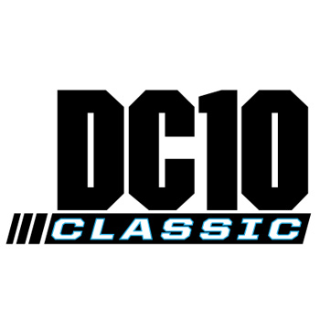
HIGHLIGHTS

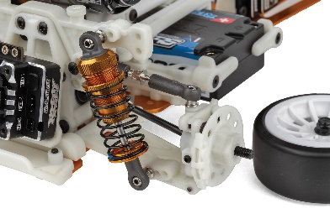
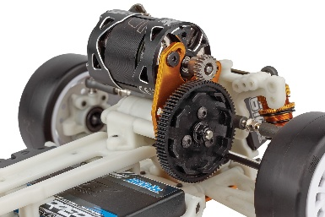
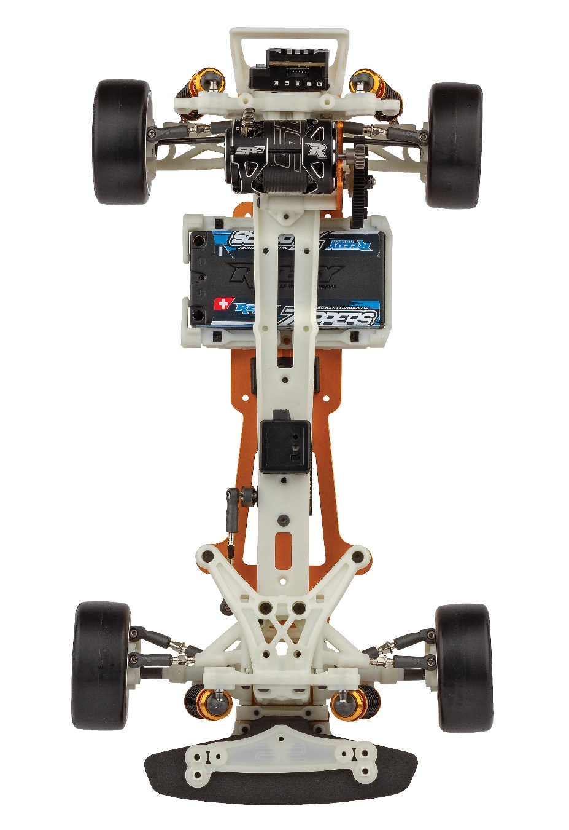

New silver adjustable turnbuckles
High and low motor mounting capabilities

:
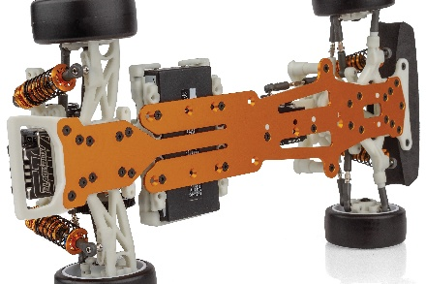

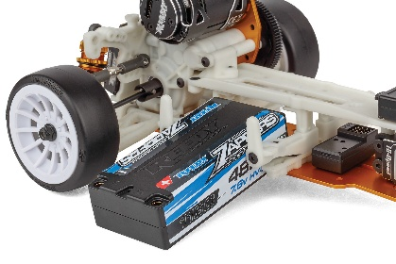

New 2mm gold anodized aluminum
flex chassis

Adjustable battery placement

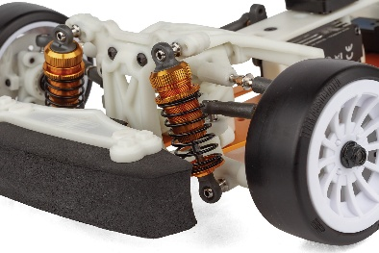

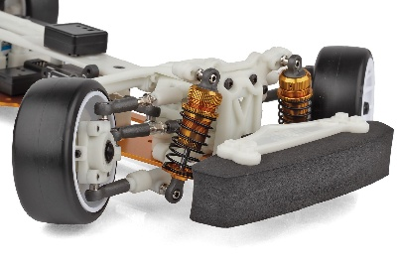

Gold anodized aluminum threaded shocks

Maximum steering throw

Due to ongoing R&D, photos may not match the final kit. Vehicle shown on these pages equipped with items NOT included in KIT: Reedy motor, battery, ESC, servo, and receiver not included. Assembly and painting required

MORE FEATURES |  | SPECIFICATIONS
Scale | 1:10
Power | Electric
Width | Varies*
Length | Varies*
Weight | Varies*
Wheelbase | 259-332mm/ 10.2”-13”
Transmission Ratio | 2.6:1
Drive | 2WD

ITEMS NEEDED TO COMPLETE

• New 2mm gold anodized aluminum flex chassis Included
• Classic white molded (dyeable) plastics throughout
• Gold Anodized aluminum threaded shocks
• Gold anodized motor plate
• Adjustable battery placement
• Fully tunable Ackermann plates
• Easy-to-adjust camber
• High and low motor mounting capabilities
• Adjustable offset wheel hexes
• Adjustable servo mount locations
Items required for operation: ESC, Motor, Receiver, Transmitter, Servo, suitable NiMh or 2S/3S LiPo battery for vehicle, and a charger.

OTHER HELPFUL ITEMS

• Precision rubber-sealed ball bearings throughout
• Rear mounted electronic speed control (ESC) plate
• Adjustable rear anti-squat and toe-in
• Competition, low friction Team Associated drift tires included
- Silicone Shock Fluid (Refer to catalog for complete listings)
- Silicone Diff Fluid (Refer to catalog for complete listings)
- Body Scissors (AE Part #1737)
- Easy-to-adjust camber
- Reamer / Hole Punch
- FT Wrench Set (AE Part #1519)
- Hobby Knife
- Needle Nose Pliers
- Wire Cutters
- Soldering Iron
- Calipers or a Precision Ruler

• Maximum steering throw for optimal control drifting through turns
• Easy-to-tune caster adjustments can be made without tools
• White Team Associated Drift wheels included
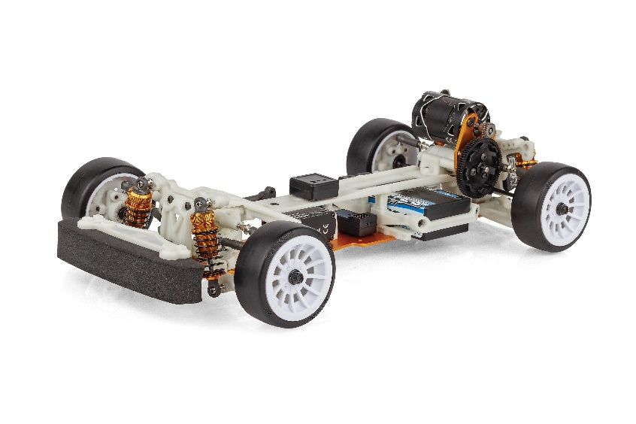
• New Silver adjustable turnbuckles
• All new clear muscle car style body

 |  |  |  | CATALOG INFORMATION
UPC | Part No. |  | Description |  | MSRP | MAP | Case QTY | Origin | Available
784695301351 | 30135 |  | DC10 Classic Kit |  | $339.99 | $229.99 | 4 | TW | December

Download all zipped photos here: https://www.rc10.com/DC10ClassicImagesPR/ (6.7 MB). Link is active for 30 days.
Please refer to our MAP Policy here: https://img2c.associatedelectrics.com/pdf/map-policy.pdf

