For Immediate Release: September 2026

FT 4.5mm Short Nut Driver #21694
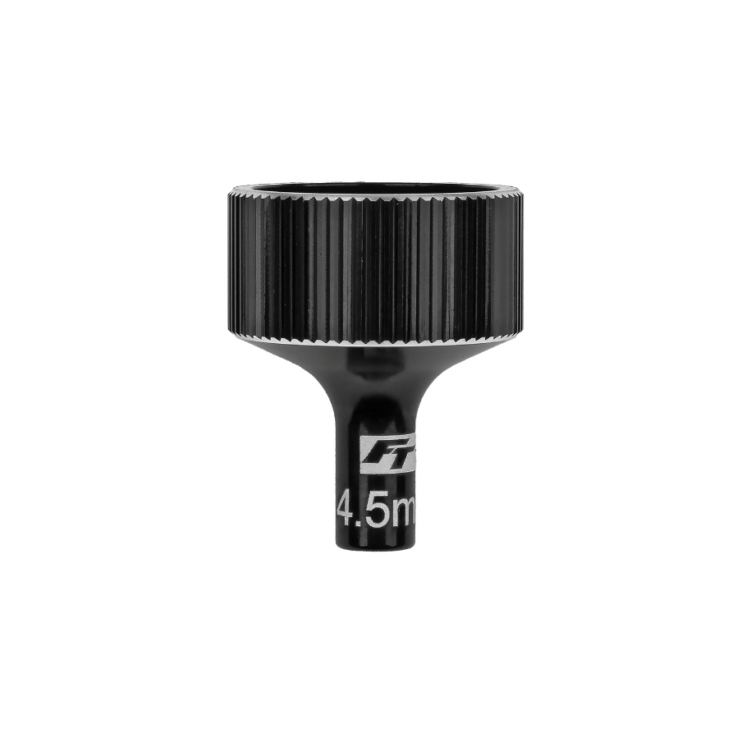
New from Factory Team is the 4.5mm short nut driver. This tool is used primarily for wheel nuts on 1:28 and 1:24 scale vehicles. Made from aluminum, anodized black, and laser etched for easy identification.

(Pictured: #21694 FT 4.5mm Short Nut Driver)

Compatible with:
20165/20168/20169/20200

UPC | Part No. | Description | MAP | MSRP | Origin | Available
784695216945 | 21694 | FT 4.5mm Short Nut Driver | $15.29 | $17.99 | TW | 

