**For Immediate Release:** **July 2025**

**#81672 FT Aluminum Capped Wheel Nuts, 17mm**

Factory Team presents the new FT aluminum capped wheel nuts, 17mm! Say no more to dirt and grime getting stuck near your set screw for your wheel hex pin. Crafted from high quality aluminum and anodized with our signature blue, let everyone know your style both on and off track.

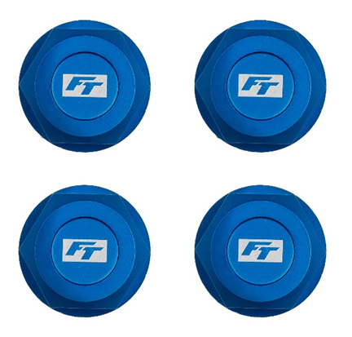

|  |  |  |  |  |  |  |
| --- | --- | --- | --- | --- | --- | --- |
| **UPC** | **Part No.** | **Description** | **MAP** | **MSRP** | **Origin** | **Available** |
| 784695816725 | 81672 | FT Aluminum Capped Wheel Nuts, 17mm | $22.94 | $26.99 | CN | Now |

Compatible with:

RC8B4.1, RC8B4.1e, RC8T4, RC8T4e