For Immediate Release: September 2026

RC10 Custom Race Car 6x6 #30146
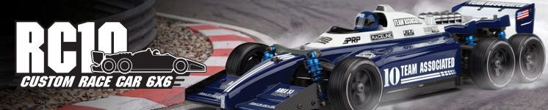

ELECTRIC ■ 1:10 SCALE ■ 6 WHEEL DRIVE ■ KIT

Champions by Design

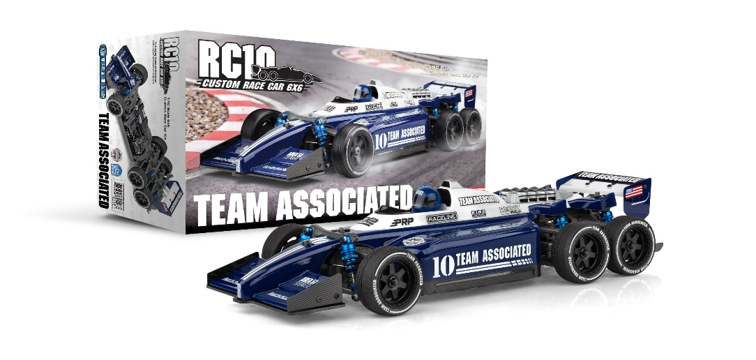
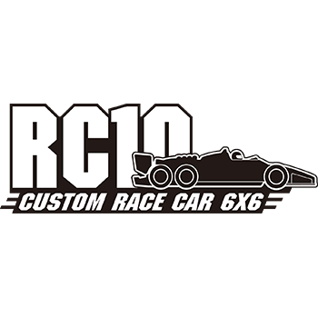
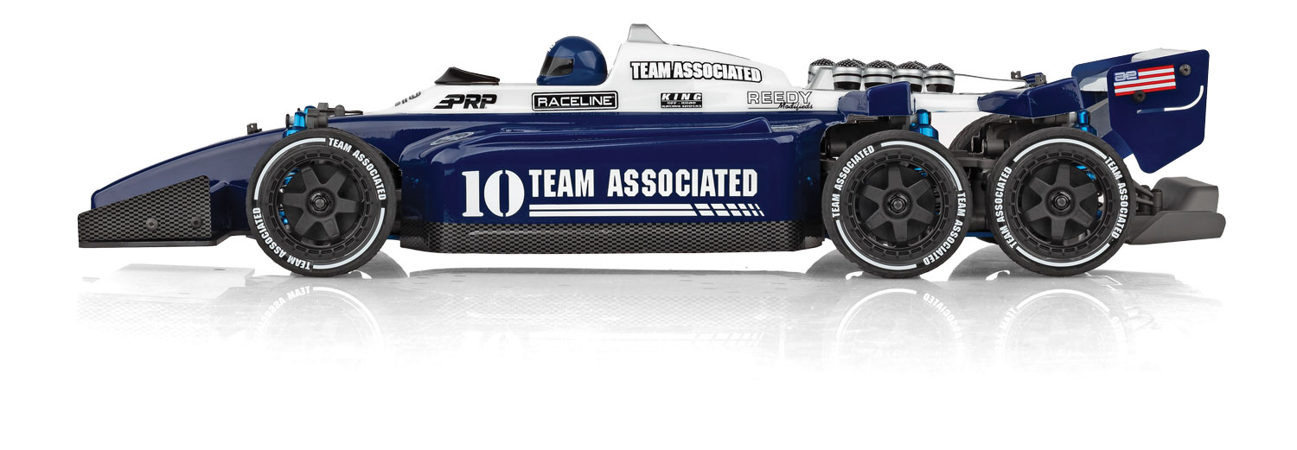
We are excited to introduce the RC10 6x6 Custom Race Car Kit, a groundbreaking addition to our lineup that combines innovation with high-performance design. This comprehensive kit boasts a range of exceptional features, including durable gray plastic parts, a striking new 6x6 formula inspired body set, and a robust 6x6 plastic gearbox set. It also includes a 6x6 diffuser set with body accessories, a sleek blue anodized aluminum chassis plate, and high-quality Factory Team ball end set. For enhanced control and precision, the kit features aluminum turnbuckles, blue anodized shocks, and a blue anodized motor plate. Completing the package are black wheels, adding both style and functionality. Build the ultimate 6x6 vehicle with the RC10 6x6 Custom Race Car Kit!

FEATURES
  SPECS
Scale | 1:10
Power | Electric
Length | 465mm/18.3” *
Width | 190mm/7.48” *
Weight | Varies*
Wheelbase | 259-332mm/ 10.2”-13”
Transmission Ratio | 2.6:1
Drive | 6WD  *Final length, width and weight will vary depending on the  electronics, body, wheels and tires used to complete the kit.
• Exclusive gray molded parts throughout
• New detailed clear polycarbonite 6x6 Formula racing body set
• Driver helmet included
• New front and rear racing wings
• 6x6 gearbox set and 3 sealed differentials
• New 6x6 aluminum blue chassis plate
• Heavy-duty turnbuckles
• Adjustable front and rear toe
• Blue anodized aluminum shock parts
• Blue anodized aluminum motor plate
• Black racing wheels and high-grip tires
• Full ball bearings throughout
• Heavy duty drive shafts all around
• Fully independent suspension


Recommended Electronics:

• Servo: #27172 (Reedy RT2007HD Low-Profile Brushless
Hi-Torque Servo)
• Battery: #27612 (STOCKSTAR 5800mAh 7.4V 160C Shorty)
• ESC: #27016 (Blackbox 610R Competition ESC)
• Motor: #27481 (Sonic 540-SP5 13.5T Brushless Motor)
• Charger: #27203 (Reedy 1416-C2L Dual AC/DC Competition Balance Charger)

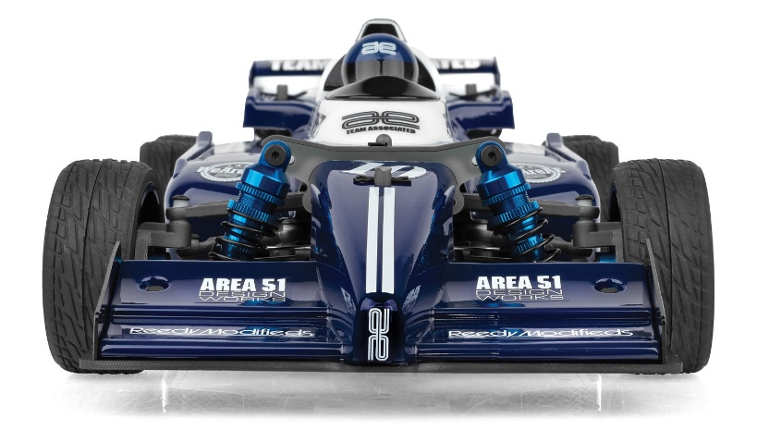

OTHER HELPFUL ITEMS

• Silicone Shock Fluid (Refer to catalog for complete listings)
• Silicone Diff Fluid (Refer to catalog for complete listings)
• Body Scissors (AE Part # 1737)
• Reamer / Hole Punch
• FT Wrench Set (AE Part #1519)
• Hobby Knife
• Needle Nose Pliers
• Wire Cutters
• Soldering Iron
• Calipers or a Precision Ruler


Items required for operation:
ESC, Motor, Receiver, Transmitter, Servo, suitable NiMh or 2S/3S LiPo battery for vehicle, and a charger.

CATALOG INFORMATION

UPC | Part No. | Description | MSRP | MAP | Pieces Per Case | Origin | Available
784695301467 | 30146 | RC10 Custom Race Car 6x6 | $559.99 | $379.99 | 4 | TW | Now
Download all zipped photos here: https://rc10.com/RC106X6CustomRaceCarImages/ (2.87MB). Link is active for 30 days.
Please refer to our MAP Policy here: https://img2c.associatedelectrics.com/pdf/map-policy.pdf

