For Immediate Release: September 2026

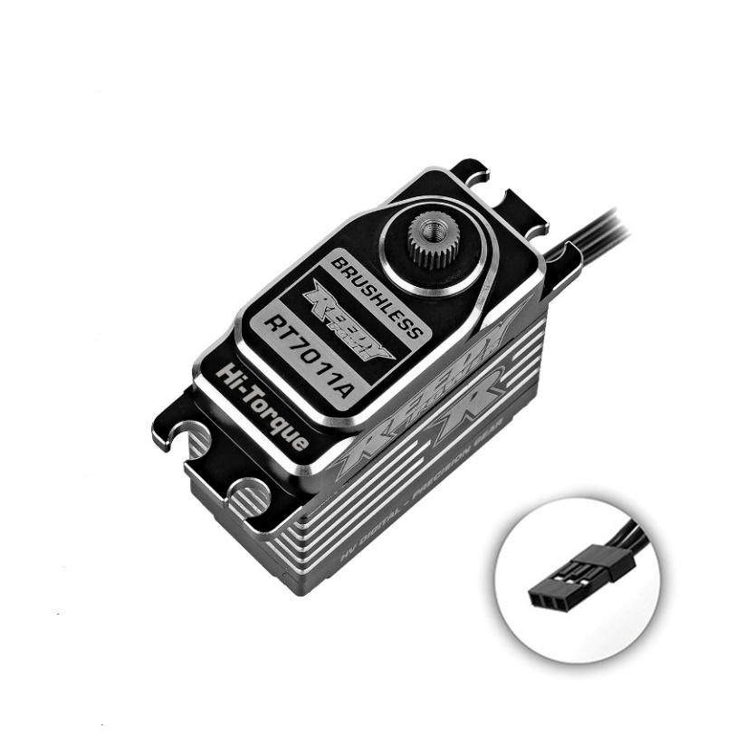
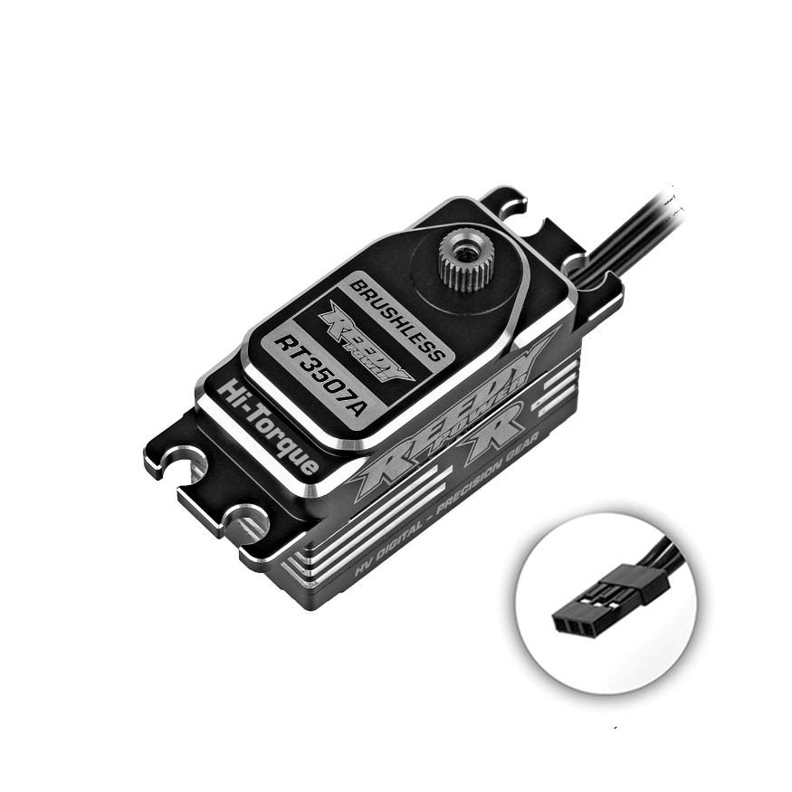
NEW! Reedy Power RT3507A (Low Profile) and RT70011A (Standard) Competition Servos

Reedy Power is thrilled to announce two new competition servos, which combined, cover all 1:10 to 1:8 racing needs. Reedy Power is synonymous with power, reliability and consistency with countless hours spent developing the very best servos for the TEAM. It’s not an accident we have 30 IFMAR World Championships. They were MADE by hard fought battles and determination in the face of competition. We have no doubt that these new servos will add to that historic number.

For more information, visit www.reedypower.com or contact your local hobby shop.

Reedy Power RT3507A, LP Brushless High-Torque HV Servo, #27179
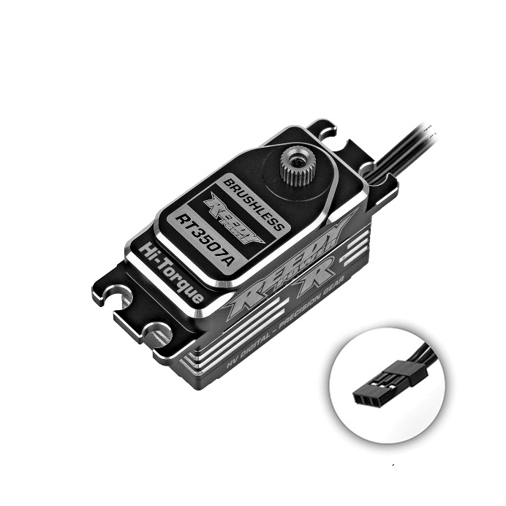
Designed for 1:10 racing, when space and weight-savings are at a premium, the Reedy Power RT3507A servo is the choice for off-road and on-road competition by offering a low-profile design, high speeds and maximum torque.
Features:
- High voltage
- Low-profile
- 25-tooth Spline
- Steel Gears
- Precision ball bearings
- Brushless motor
- Full CNC aluminum case with integrated heat sink
- High speed: .065 - 0.1 sec/60 degrees (8.4V - 6.0V)
- Extreme torque: 486.1 oz-in – 305.5 oz-in (8.4V – 6.0V)

Reedy Power RT7011A, Brushless High-Torque HV Servo, #27180

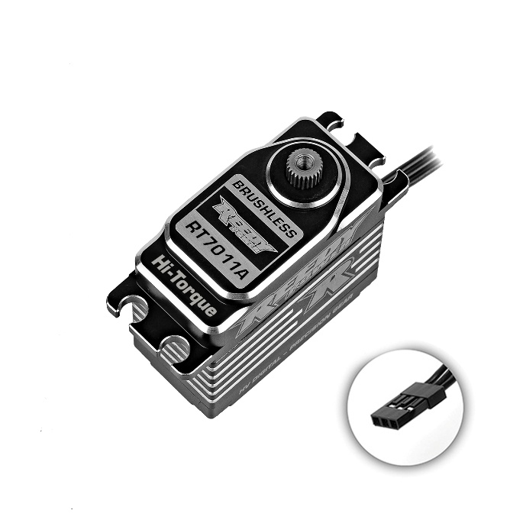
Ideal for 1:8 and 1:10 racing, the Reedy Power RT70011A servo offers extreme torque, efficient power delivery and the durability of steel gears. Optimized for both steering and throttle/brake applications.

Features:
- High voltage
- Standard Size
- 25-tooth Spline
- Steel Gears
- Precision ball bearings
- Brushless motor
- Full CNC aluminum case with integrated heat sink
- High Speed: 0.11 - 0.16 sec/60 degrees (8.4V - 6.0V)
- Extreme Torque: 972.1 oz-in - 624.9 oz-in (8.4V - 6.0V)

Specifications:

Model |  | RT3507A | RT7011A
Part # |  | 27179 | 27180
Input (V) |  | 6.0 - 8.4 | 6.0 - 8.4
Motor |  | Brushless | Brushless
Speed  (sec/60°) | 6.0V | 0.1 | 0.16
Speed  (sec/60°) | 7.4V | 0.08 | 0.13
Speed  (sec/60°) | 8.4V | 0.065 | 0.11
Torque  (kg-cm/in-oz) | 6.0V | 22/306 | 45/625
Torque  (kg-cm/in-oz) | 7.4V | 28/389 | 55/763
Torque  (kg-cm/in-oz) | 8.4V | 35/486 | 70/972
Dimensions (mm) |  | 40.8 x 20.2 x 25.6 | 40.3 x 20.2 x 37.6
Weight (g) |  | 53 | 81
Spline |  | 25 | 25

UPC | Part No. | Description | COO | MSRP | MAP | Available
784695271791 | 27179 | REEDY RT3507A LP BRUSHLESS HI-TORQUE HV SERVO | TW | $261.99 | $156.99 | 
784695271807 | 27180 | REEDY RT7011A BRUSHLESS HI-TORQUE HV SERVO | TW | $286.99 | $171.99

