For Immediate Release: October 2026

RC28 ZOOM Jay Halsey RTR #20171
1:28 Scale 2WD Electric Ready-to-Run Buggy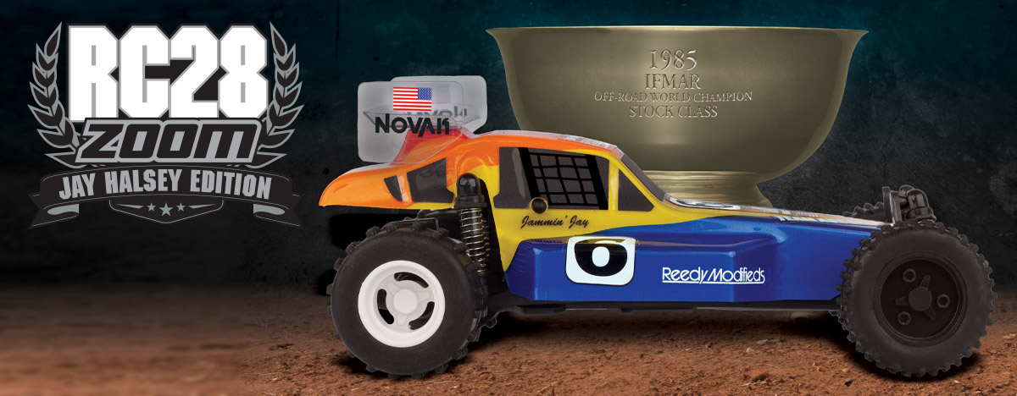

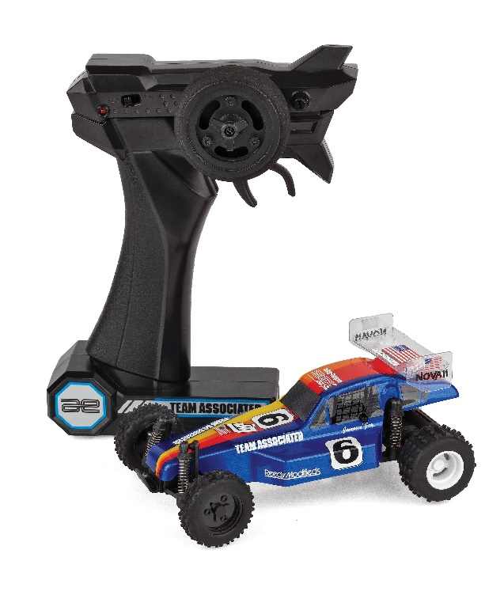
ELECTRIC ■ 1:28 SCALE ■ 2 WHEEL DRIVE ■ READY-TO-RUN
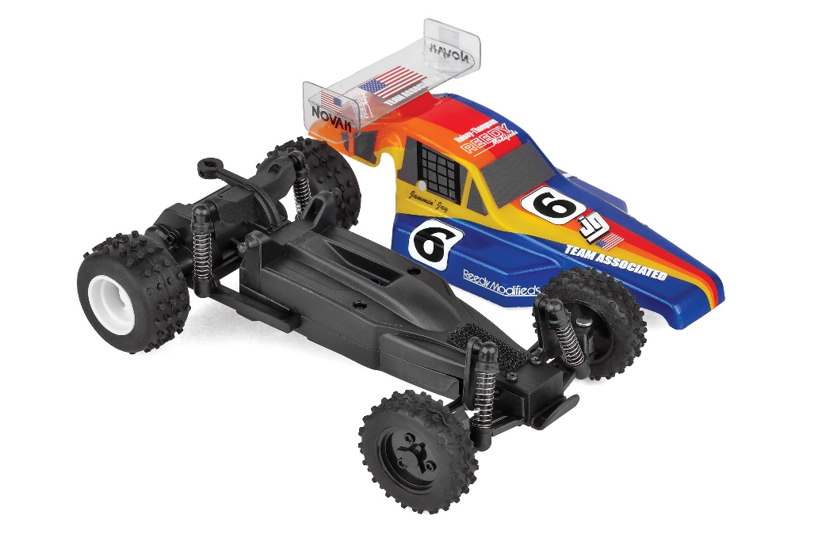

The NEW Team Associated RC28 ZOOM is a scale replica of the iconic “Jammin” Jay Halsey RC10 Team Kit! This RC28 ZOOM looks great and drives smooth thanks to a powerful electric motor and capable drivetrain.

The included 2.4 GHz transmitter allows complete control enabling you to navigate around, through and over obstacles with ease! With its off-road stance and rubber tires, the RC28 ZOOM handles like no other vehicle in its category.

The vehicle’s integrated battery is easily recharged with the included USB-C cord. So the RC28 ZOOM is ready to go right out of the box! Just charge and drive!


THE FIRST 2WD OFF ROAD
WORLDS WINNER!
Only eight months after its release on July 11, 1985, the legendary RC10 driven by Jammin’ Jay Halsey claimed victory as the first IFMAR 2WD Stock World Champion. It was at this inaugural edition of the IFMAR 1:10 Electric Off-Road World Championships in Del Mar California where history was made.

At the time Jay didn’t know how important the race was and how legendary the buggy he drove would become. Looking back, he now realizes the impact it made in RC history; not only for Team Associated, but for himself as well. Racing for Team Associated allowed him to travel the world attending different races. It’s what helped him get where he is today, working in the television and
film industry.

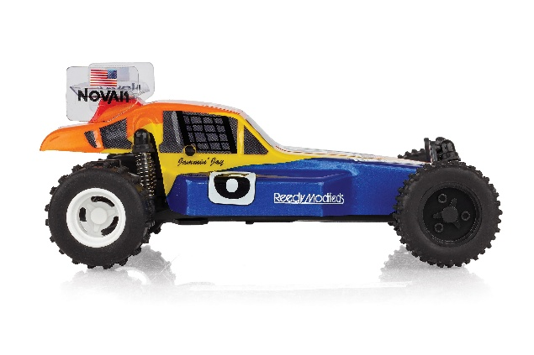
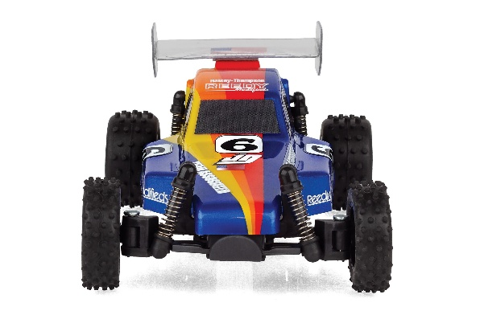
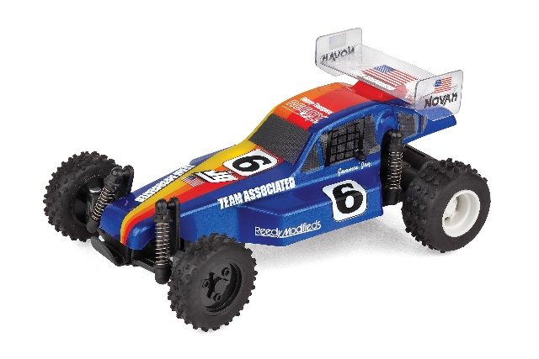

Now you can own a piece of that history with this very first ever kit release of that famous buggy and build a replica of that legendary worlds-winning paint scheme you remember as a kid. So get the winning edge and build your very own RC10 Jay Halsey Edition buggy!

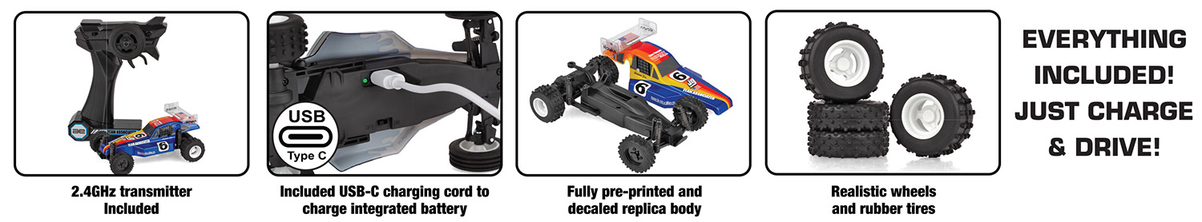

• 2.4GHz transmitter Included
• Included USB-C charging cord to charge
integrated battery
• Fully pre-printed and decaled RC10 buggy
replica body
• Realistic wheels and rubber tires
• Everything included in the box -- just charge and go!


*This vehicle is fully assembled and ready to run right out of the box. Some models may require a battery and/or charger.

FEATURES
  SPECS

*This vehicle is fully assembled and ready to run right out of the box. Some models may require a battery and/or charger.

Scale | 1:28
Body Style: | Buggy
Power | Electric
Length | 143mm (5.63in)
Width | 86mm (3.39in)
Weight | 76.2g (0.17lbs)
Wheelbase | 101.5mm (4in)
Drivetrain | 2WD
Assembly Level: | Ready-To-Run*
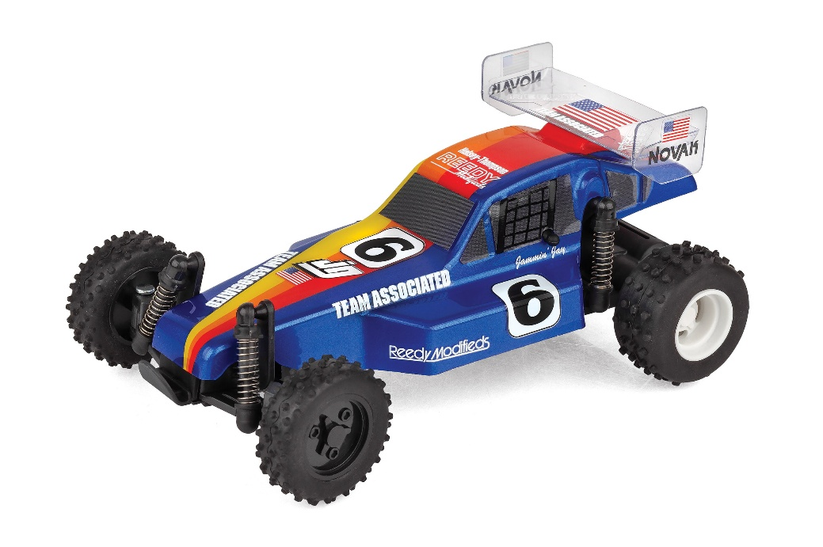




CATALOG INFORMATION

UPC | Part No. | Description | MSRP | MAP | Pieces Per Case | Origin | Available
784695201712 | 20171 | RC28 Zoom Jay Halsey RTR | $69.99 | $44.99 | 12 | TW | Now
Download all zipped photos here: https://www.rc10.com/RC28ZoomJAYHalseyImages/ (2.7MB). Link is active for 30 days. Please refer to our MAP Policy here: https://img2c.associatedelectrics.com/pdf/map-policy.pdf

