For Immediate Release: December 2025

RC28T ZOOM RTR #20167

1:28 Scale 2WD Electric Ready-to-Run Truck

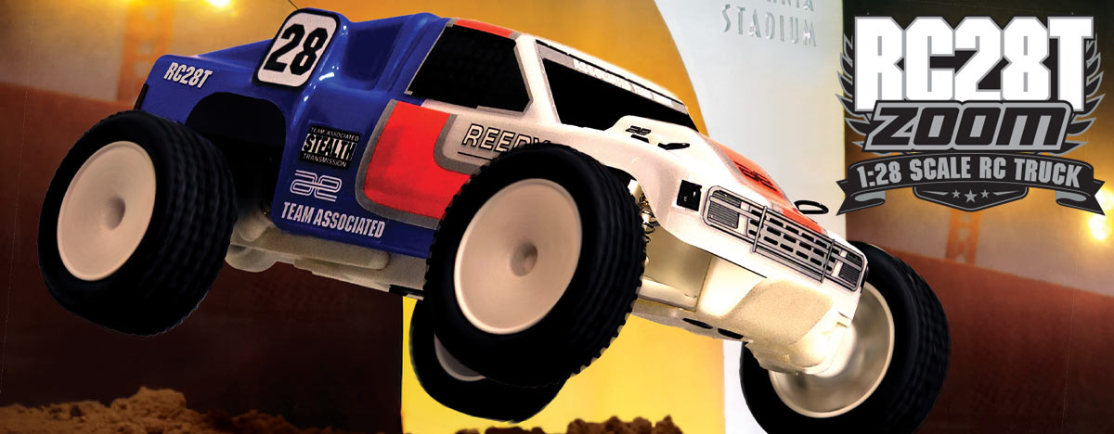

ELECTRIC ■ 1:28 SCALE ■ 2 WHEEL DRIVE ■ READY-TO-RUN
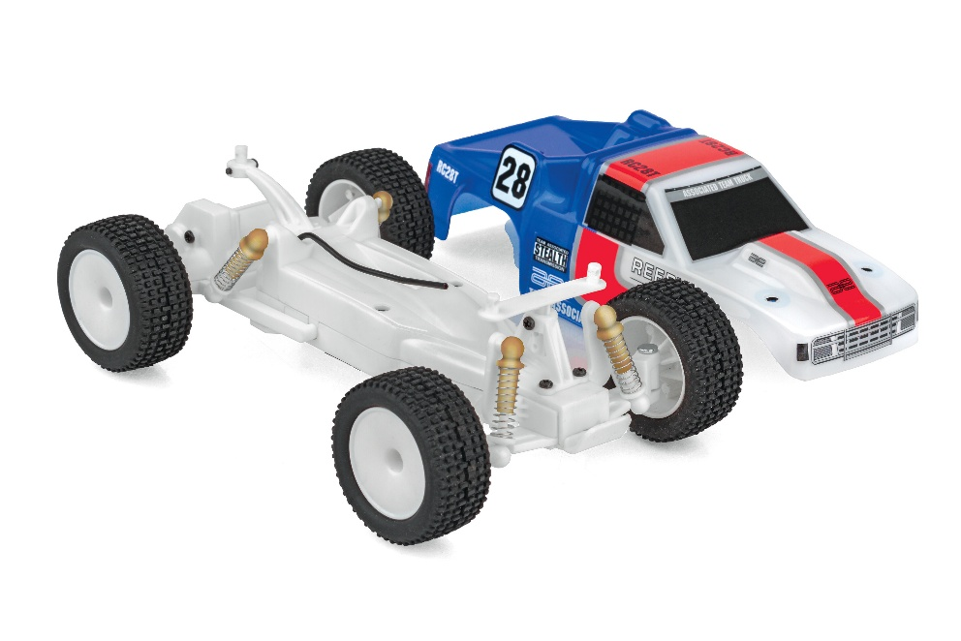
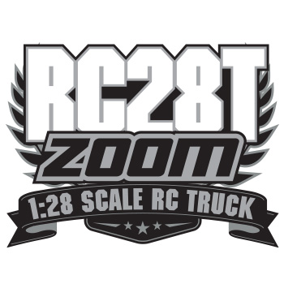
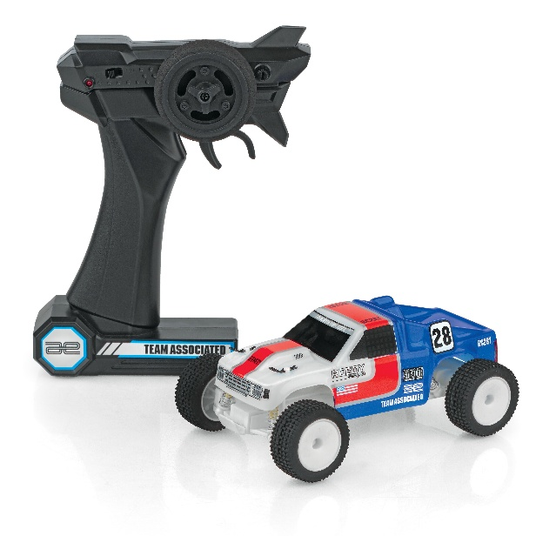
The NEW Team Associated RC28T ZOOM is a scale replica of the iconic RC10T Classic Kit! This RC28T ZOOM looks great and drives smooth thanks to a powerful electric motor and capable drivetrain.

The included 2.4 GHz transmitter allows complete control enabling you to navigate around, through and over obstacles with ease! With its rubber tires, the RC28T ZOOM handles like no other vehicle in its category.

The vehicle’s integrated battery is easily recharged with the included USB-C cord. So, the RC28T ZOOM is ready to go right out of the box! Just charge and drive!
FEATURES
  SPECS
• 2.4GHz transmitter Included
• Included USB-C charging cord to charge
the integrated battery
• Fully pre-printed and decaled RC10T Truck
replica body
• Realistic wheels and rubber tires
• Everything included in the box -- just charge and go!

Scale | 1:28
Body Style: | Truck
Power | Electric
Length | 143mm (5.63in)
Width | 86mm (3.39in)
Weight | 76.2g (0.17lbs)
Wheelbase | 101.5mm (4in)
Drivetrain | 2WD
Assembly Level: | Ready-To-Run*

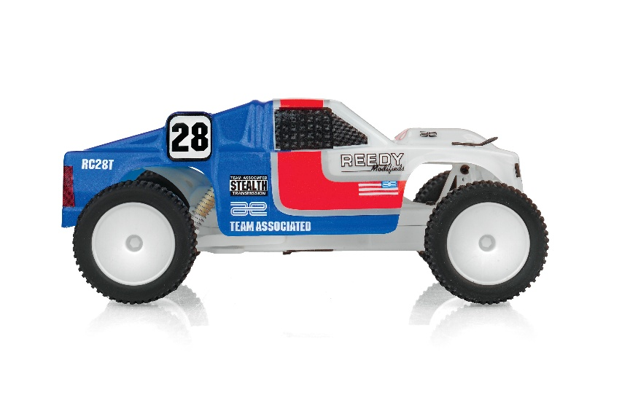

* This vehicle is fully assembled and ready to run right out of the box.



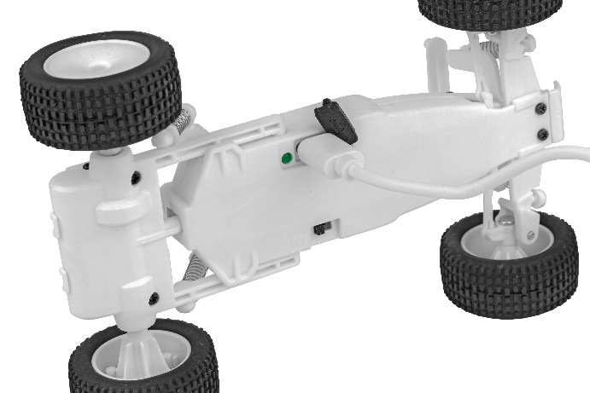

CATALOG INFORMATION

UPC | Part No. | Description | MSRP | MAP | Pieces Per Case | Origin | Available
784695201675 | 20167 | RC28T Zoom RTR | $99.99 | $59.99 | 12 | TW | January

Download all zipped photos here: https://www.rc10.com/RC28RC28TImageszip/(4.47MB). Link is active for 30 days.
Please refer to our MAP Policy here: https://img2c.associatedelectrics.com/pdf/map-policy.pdf

