g

For Immediate Release: March 2026

#70041 Pro2 SC10sw RTR - Black
1:10 Scale Ready-To-Run 2WD Electric Off-Road Short Course

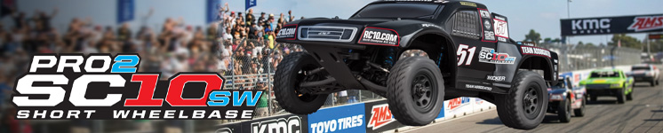

ELECTRIC ■ OFF-ROAD ■ 1:10 SCALE ■ 2 WHEEL DRIVE ■ RTR

Pro2 Short Course Racing!
The Pro2 SC10SW short course truck is based on the 9-time ROAR Short Course National Championship-winning trucks, featuring a water-resistant high-power Reedy brushless speed control and 3300kV brushless motor, a 2.4GHz 2-channel radio system as well as our DVC (Dynamic Vehicle Control) receiver unit with built-in adjustable digital gyro. Add to that a Reedy Power metal-gear, digital high-torque servo and a water-resistant enclosed receiver box. All of this packaged together in an outstanding factory-finished blue and white body. And to keep you sticking to the terrain, this SC10SW short wheelbase beast will keep you cornering with the included high-grip all-terrain tires and lightweight wheels. The time for tearing up the track is now.

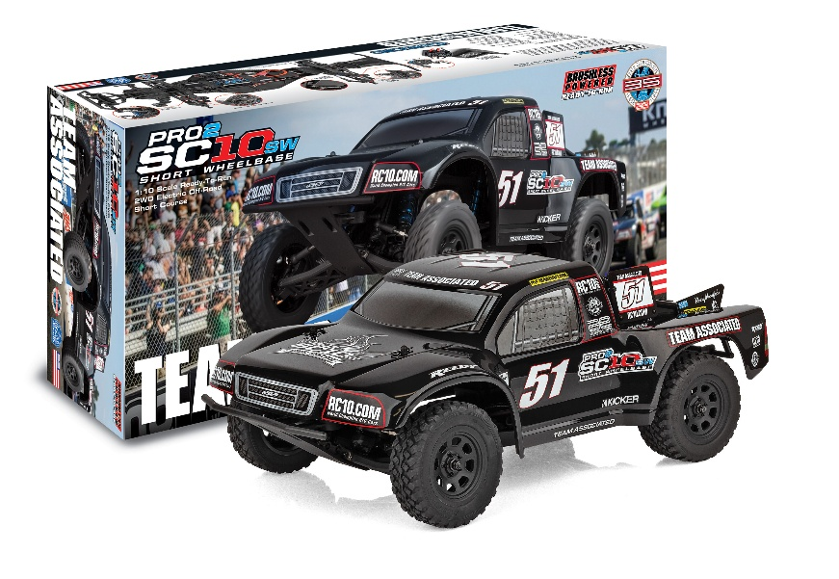

Team Associated’s new Pro2 SC10SW short course truck is a detailed and fun-to-drive Ready-to-Run RC truck. Based on our championship-winning Short Course truck, the Pro2 SC10SW features some of the latest features in racing. A durable lightweight aluminum top shaft, rugged steel turnbuckles and adjustable suspension geometry give the Pro2 SC10SW the ultimate in handling on all terrain. This makes it a perfect platform for short course racing!

FEATURES |  | SPECIFICATIONS
- Durable and lightweight aluminum top shaft
Scale | 1:10
Assembly Level | Ready-To-Run*
Length | 492.4mm (19.39in)
Width | 252mm (9.92in)
Weight | Varies*
Wheelbase | 227.8mm (8.97in)
Internal Gear Ratio | 2.6:1
Drive | 2WD

*This vehicle is fully assembled and ready to run right out of the box. Some models may require a battery and/or charger.

OTHER HELPFUL ITEMS

- Body Scissors (AE Part # 1737)
- FT Wrench Set (AE Part #1519)
- Hobby Knife
- Needle Nose Pliers
- Wire Cutters
- Soldering Iron
- Calipers or a Precision Ruler

Items needed:
Four AA batteries for radio, suitable NiMh or 2S/3S LiPo battery (Reedy Part #751) for vehicle, and a charger (Reedy Part #27201).

- Low center-of-gravity molded composite chassis with hook-and-loop battery straps that accommodate both NiMH and 2S and 3S LiPo battery packs
- Metric hardware throughout
- 22 precision rubber-sealed ball bearings
- Impact-absorbing front and rear bumpers
- Adjustable body mounts
- Rear CVA drive shafts for more reliability
- 2.6:1 ratio gearbox with heavy-duty sealed gear differential and externally adjustable slipper clutch
- Rugged steel turnbuckles for adjustable camber and front toe-in
- Adjustable suspension geometry
- Vertical ball ends for roll center adjustments, front
and rear
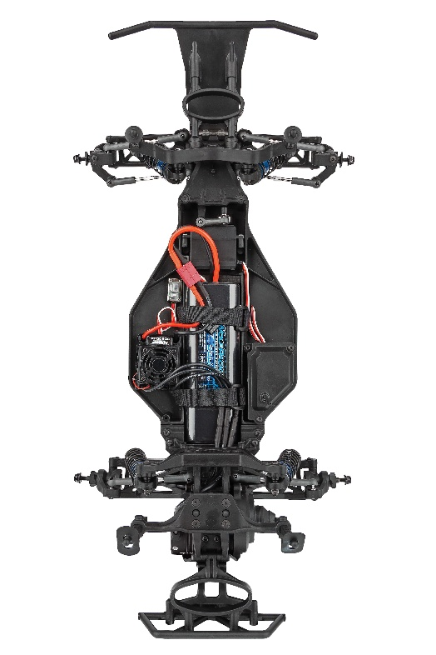

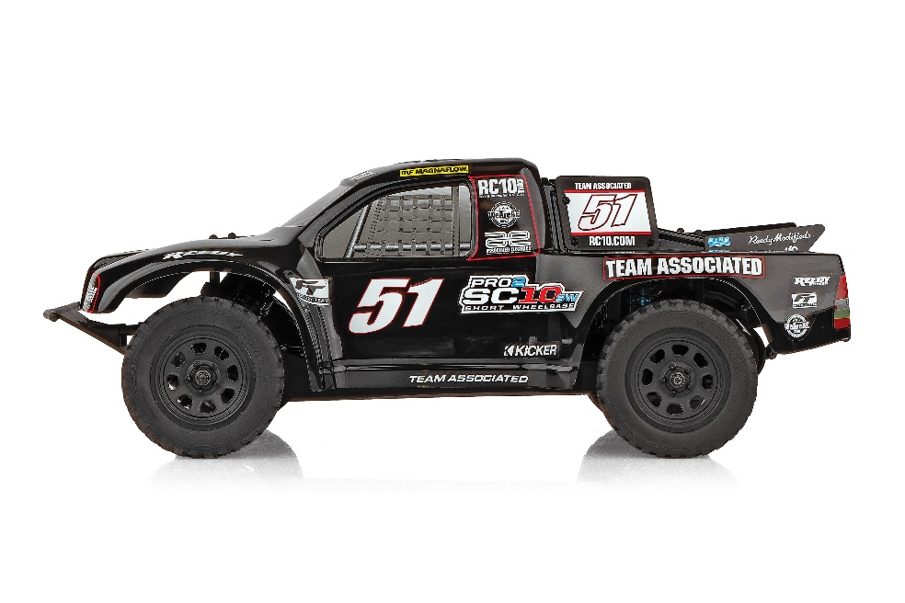

Shown with battery and charger, which are sold separately

CATALOG INFORMATION
UPC | Part No. | Description | Pieces Per Case | Origin | MSRP | MAP | Available
784695700413 | 70041 | PRO2 SC10 SWB, BLACK | 2 | TW | $489.99 | *$329.99 | March 26
*MAP will be $299.99 through 4/30/2026, as an introductory price. Afterwards, it will revert to $329.99, as stated above.
Download all zipped photos here: https://rc10.com/Pro2SC10swBlackimages/ (8.7MB). Link is active for 30 days.
Please refer to our MAP Policy here: https://img2c.associatedelectrics.com/pdf/map-policy.pdf

