For Immediate Release: September 2026

RC10B84.1 Team Kit #90058
1:10 Scale 4WD Electric Off Road Competition Buggy Kit

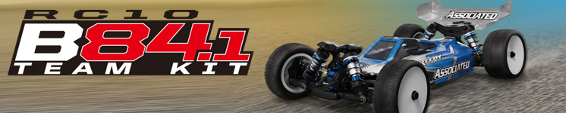

ELECTRIC ■ OFF ROAD ■ 1:10 SCALE ■ 4 WHEEL DRIVE ■ KIT

The Team Associated RC10B84.1 is Engineered
for Victory!

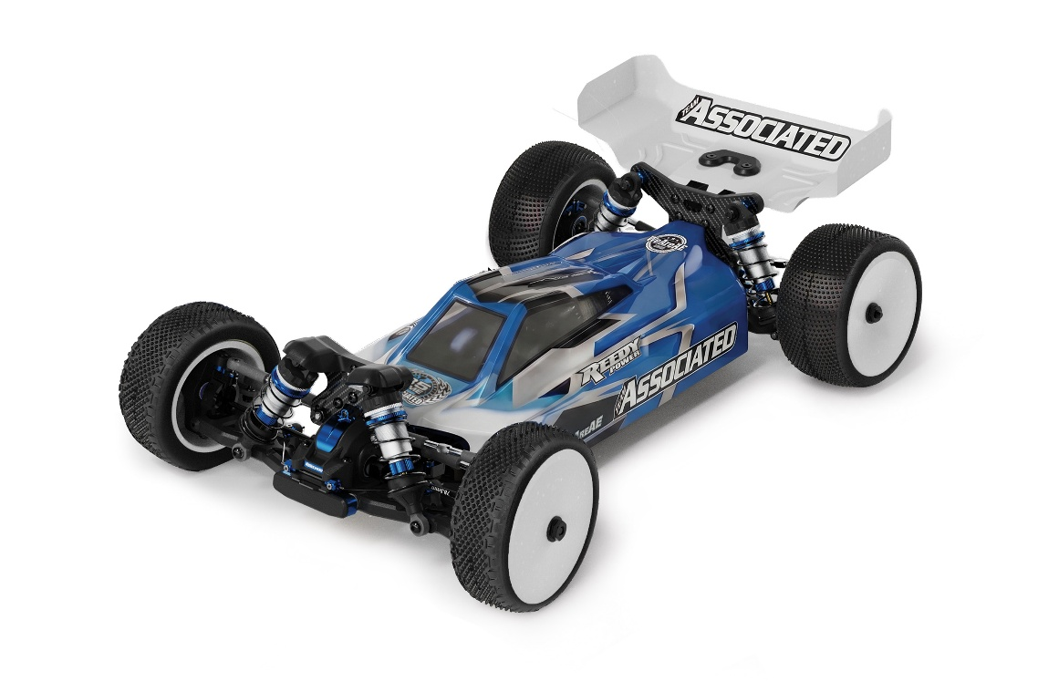

Unleash unparalleled performance with the RC10B84.1, a 1/10-scale 4WD buggy engineered for precision, speed, and racetrack victories.

Designed with cutting-edge features, this competition machine delivers superior handling and control. Its molded height-adjustable gearboxes ensure optimized drivetrain efficiency. V2 Steering posts and bellcranks ensure reduced vertical movement in the steering rack, keeping your lines tight at every corner.

Fine-tune your setup with chassis bracing adjustments, giving you the flexibility to adapt to each track you race on. The RC10B84.1 allows for precise weight distribution and chassis balance, letting you push the limits with confidence.

Enhanced aerodynamics come standard with a low-profile body and two rear wing mount heights. The RC10B84.1 is finished with shock tower covers, 3.5mm turnbuckles and ballcups, and 13mm big-bore shocks, providing the ultimate blend of strength, precision, and performance, the RC10B84.1 is your key to placing at the top of the podium!

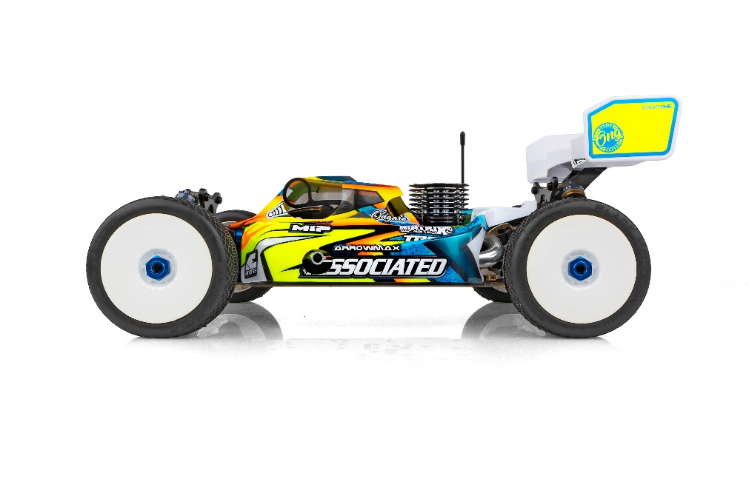



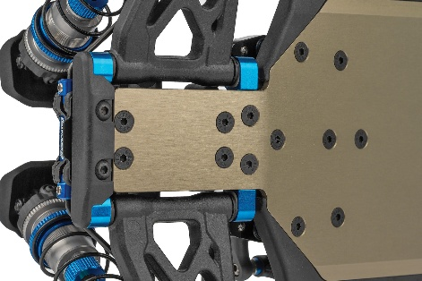
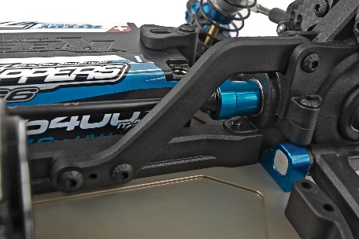

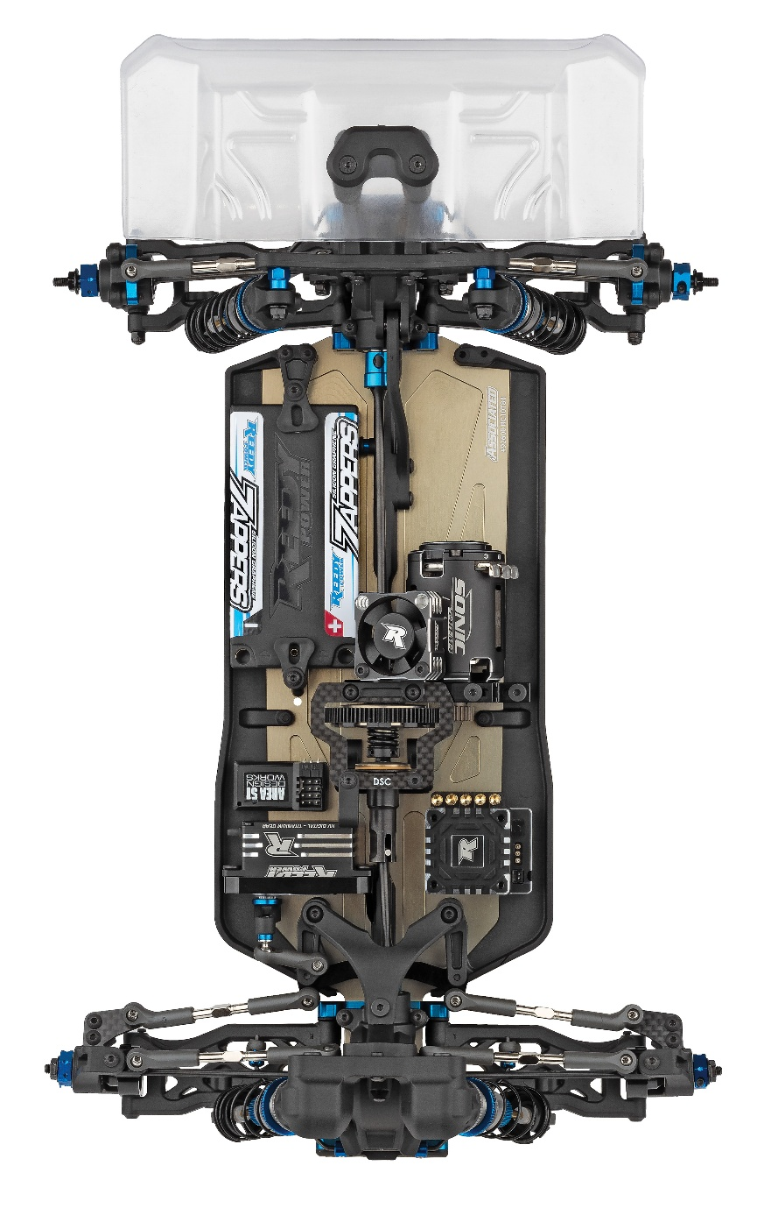

Chassis Bracing: Fine tune chassis flex characteristics with upper and lower chassis bracing front and rear
Wide Tongue Chassis for Improved Durability

V2 Side Rails to Account for Wide Tongue Chassis

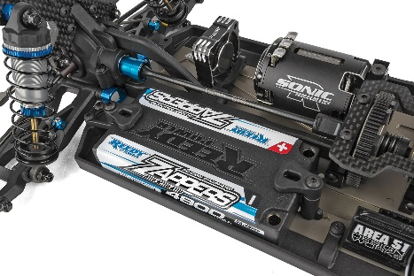
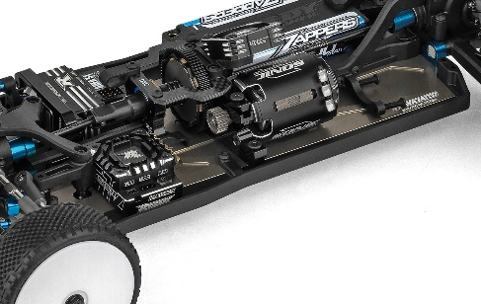

102mm Center CVA Dog Bone Included

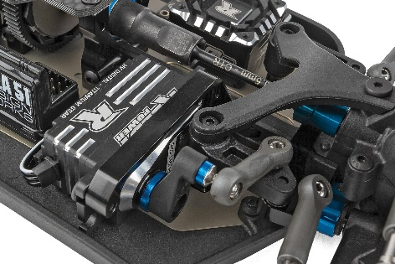
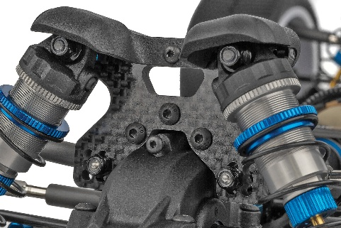

V2 Steering Posts and Bellcranks to Reduce Vertical Movement in the Steering Rack
Molded Front Shock Tower Cover for 73mm arm
Shock Tower

- Wide Tongue Chassis for Improved Durability
- V2 Side Rails to Account for Wide Tongue Chassis
- Wide A and B Mounts
- 73mm Gull Wing Front Arm Suspension
- Carbon Fiber Front Shock Tower for 73mm arm Geometry
- Molded Front Shock Tower Cover for 73mm arm Shock Tower
- V2 Steering Posts and Bellcranks to Reduce Vertical Movement in the Steering Rack
- Long HD Differential Outdrives for the Rear Differential
- 66mm Rear CVA Bones
- New A and D mount 0.7mm shims
- Molded Front Bumper with Optional Bumper That Covers Anti-roll Bar Mounts
- Molded Height-Adjustable Gearboxes Front and Rear with Additional +2 Rear Gearbox for High-Grip Conditions
- Optimized Steering Bellcranks and Rack: improved bumpsteer control at all ride heights
- Chassis Bracing: Fine tune chassis flex characteristics with upper and lower chassis bracing front and rear
- Standard and HRC (High Roll Center) Rear Hubs Included
- Insert adjustable caster block with 0, +/-1, and +/-2 degree inserts included
- Forward and Back Motor Positions: used for further weight bias adjustment
- Highly Adjustable Battery Holder with Thumb Tabs: allows for easy battery removal and fine tuning of
weight bias
- 2.5mm Thick Tapered 7075-T6 Aluminum Chassis with 10 Degrees of Kickup and Improved Departure Angle
- Decoupled Slipper Clutch Included
- Aluminum Center-Mounted Servo Mount
- Two heights Included for Rear Wing Mount
- 7-inch Rear Wing
- Low-Profile Body
- 3.5mm Turnbuckles and Ballcups
- 13mm Big-Bore Shocks
Items required for operation:
Motor, Pinion Gear, ESC, Servo, Transmitter and Receiver, Tires, Wheels, Polycarbonate specific paint

Recommended Electronics:

- Servo: #27179 (Reedy Power RT3507A, LP Brushless High-Torque HV Servo)
- Battery: #27611 (STOCKSTAR 5000mAh 7.4V 160C LCG Shorty)
- ESC: #27016 or #27017 (Blackbox 610R Competition ESC)
- Motor: #27481 (Sonic 540-SP5 13.5T Brushless Motor)
- Charger: #27203 (Reedy 1416-C2L Dual AC/DC Competition Balance Charger)

Other Helpful Items:

- Body Scissors (AE Part # 1737)
- FT Wrench Set (AE Part #1519)
- Hobby Knife
- Needle Nose Pliers
- Wire Cutters
- Soldering Iron
- Calipers or a Precision Ruler

* Final length, width and weight will vary depending on the electronics, body, wheels and tires used to complete the kit.

Scale | 1:10
Power | Electric
Drive | 4WD
Length (w/Wing): | Varies*
Width | Varies*
Weight | Varies*
Wheelbase | Varies*
Internal Gear Ratio: | 2.50:1
Type: | Off Road
Chassis: | Machined aluminum
Suspension: | Independent Front and Rear

FEATURES |  | SPECIFICATIONS
UPC | Part No. | Description | MSRP | MAP | Pieces Per Case | Origin | Available
784695900585 | 90058 | RC10B84.1 Team Kit | $939.99 | $639.99 | 6 | TW | September

Download all zipped photos here: https://rc10.com/B84.1TeamKitImages/ (8.24MB). Link is active for 30 days.
Please refer to our MAP Policy here: https://img2c.associatedelectrics.com/pdf/map-policy.pdf

