For Immediate Release: July 2026

RC8T4.2 Team Kit #80957
1:8 Scale 4WD Nitro Off Road Competition Truggy Kit

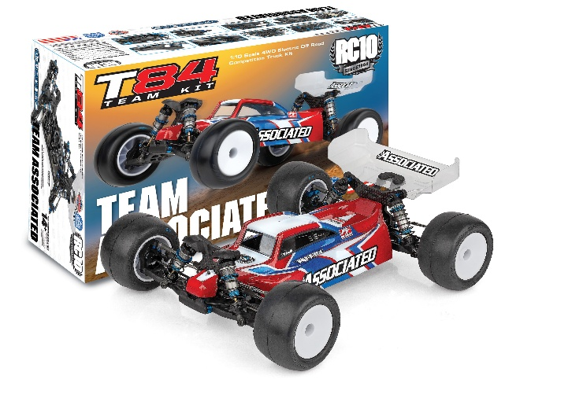
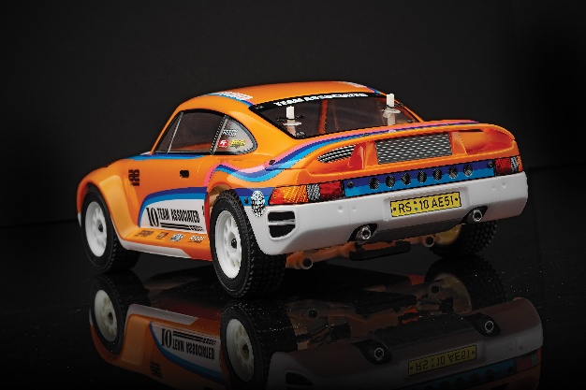
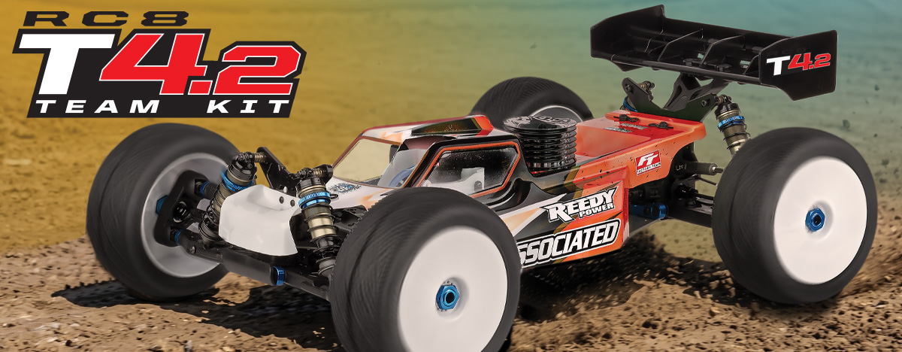

NITRO ■ 1:8 SCALE ■ 4 WHEEL DRIVE ■ OFF ROAD ■ KIT
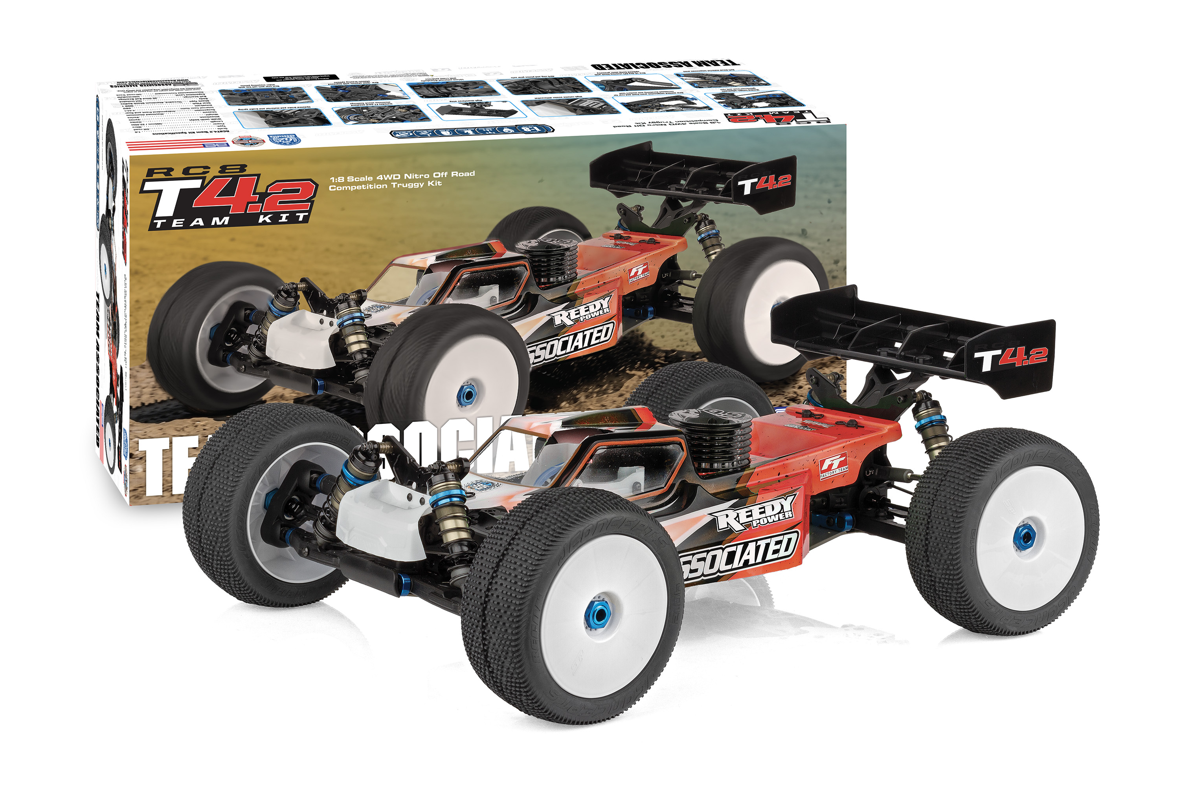
1:8 scale off road racing is one of the hobby’s most challenging disciplines; it requires a high standard and demands attention to detail.

The latest development to come from Associated Electrics’ Area 51 is designed to push boundaries of performance and build upon the number of accolades accumulated by the RC8 series.

PUSHING THE BOUNDARIES
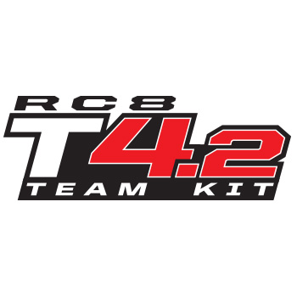

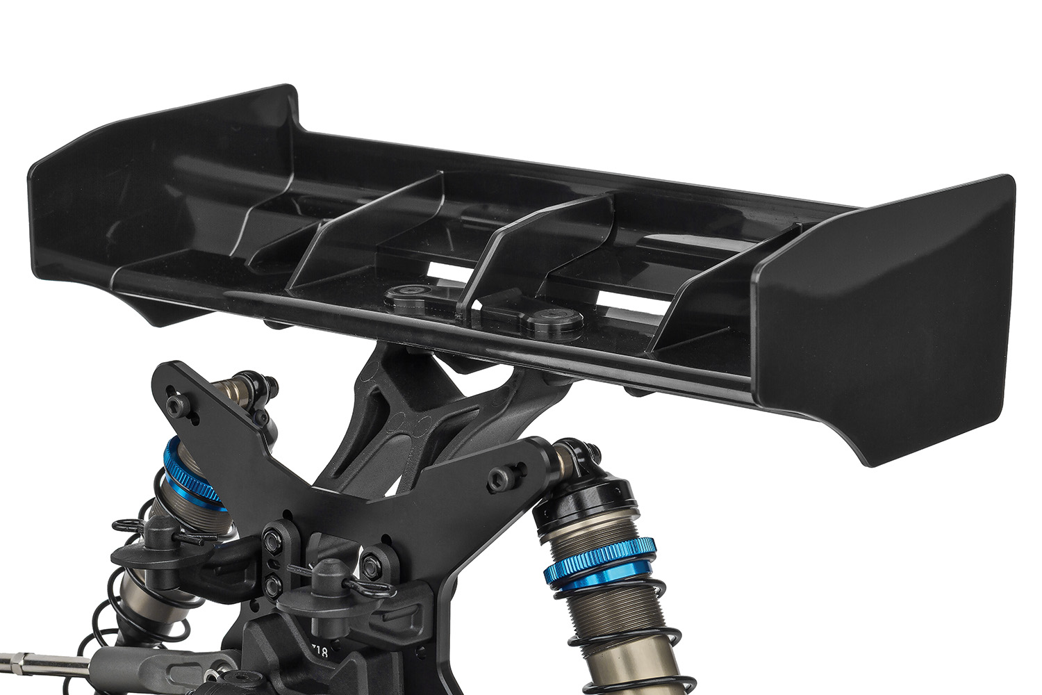
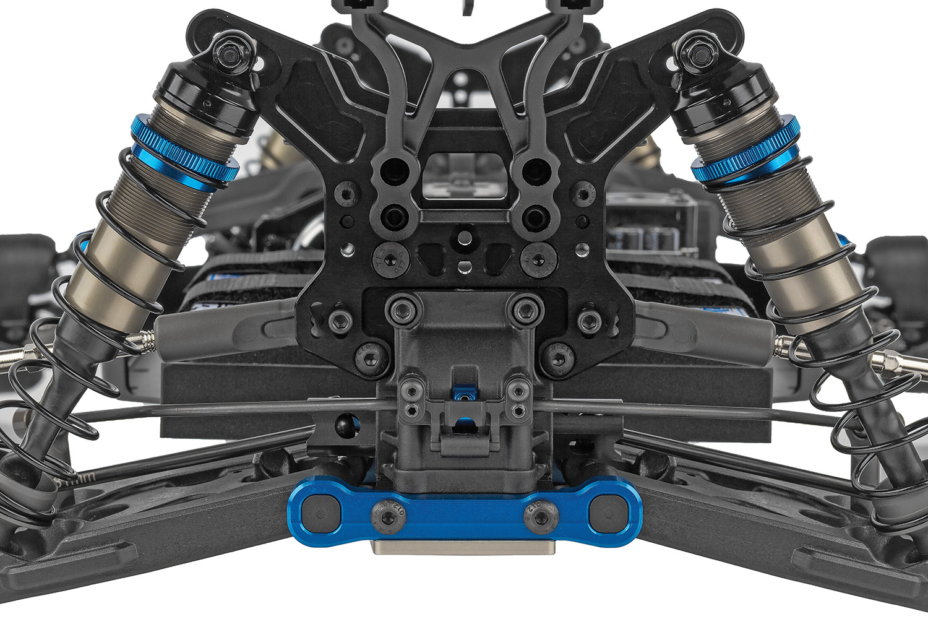

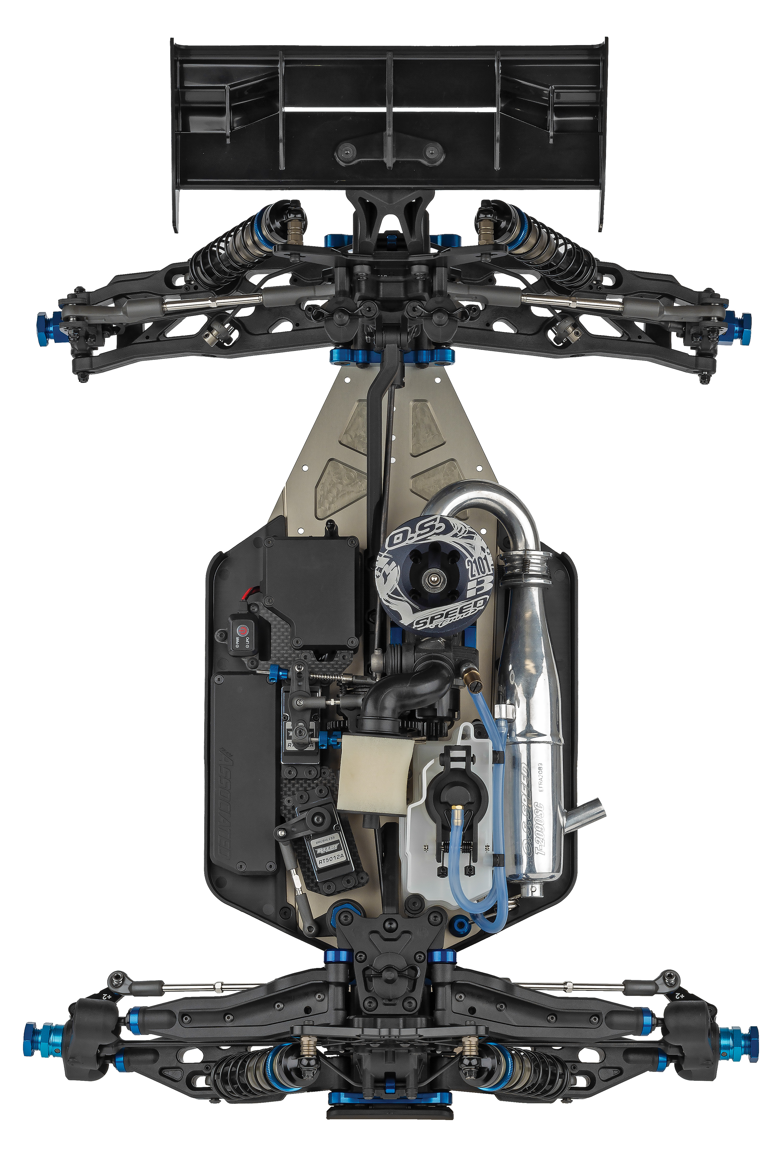

High downforce
wing
New rear anti-roll bar with wider mounting points

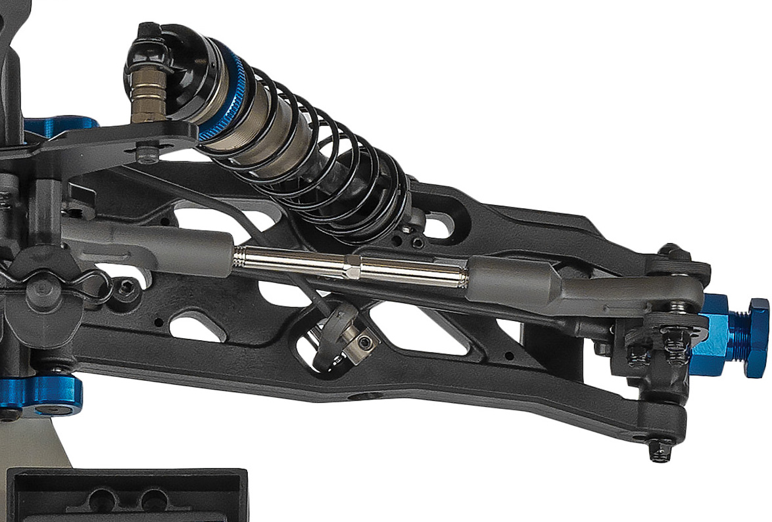
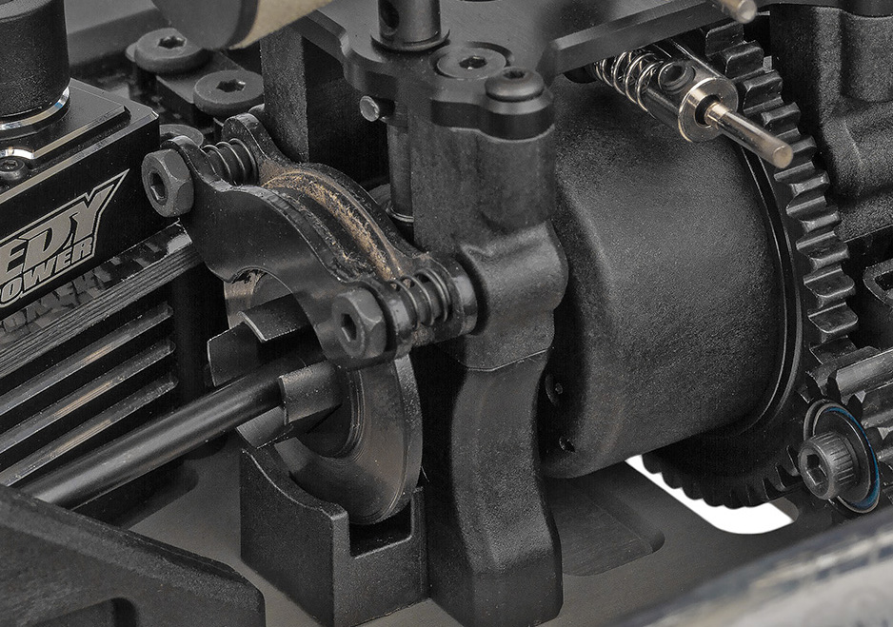

New molded suspension arms front and rear

Updated brake pad material and brake spring

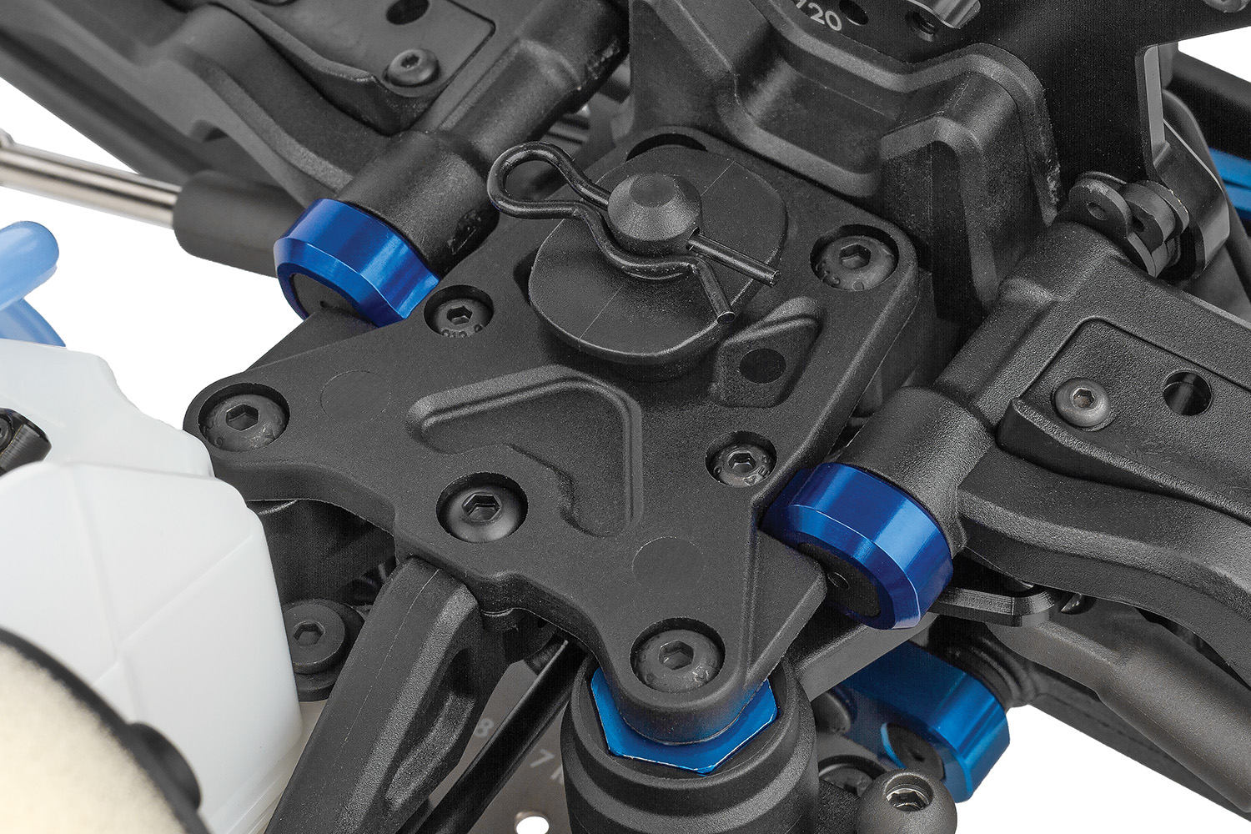
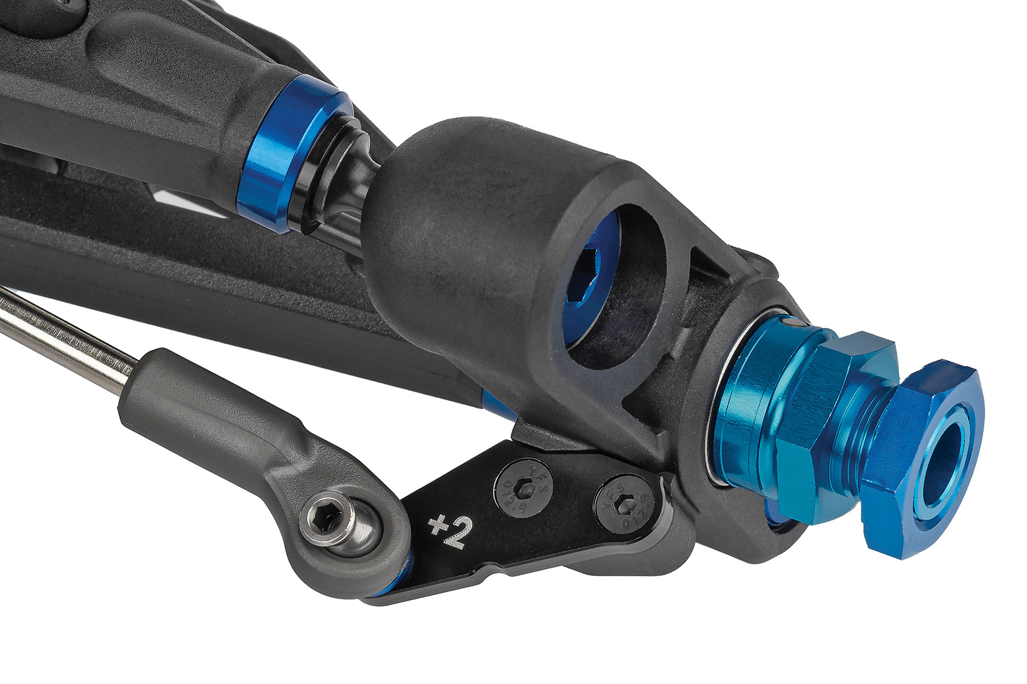

New -4mm chassis with improved chassis bracing options
New 16deg KPI steering block with updated bump steer geometry

Due to ongoing R&D, photos may not match final kit. Vehicle shown on these pages equipped with items NOT included in kit: engine, pipe and header, transponder, servos, receiver, wheels, tires. Assembly and painting required.
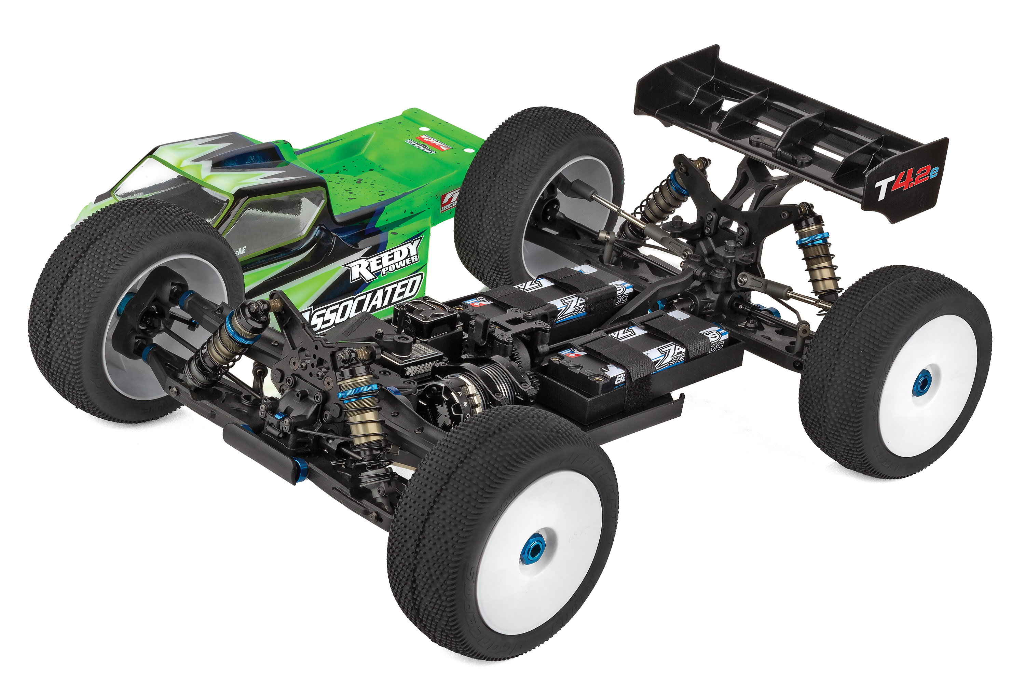
* Final width, length and weight will vary based on engine, electronics, tire configuration, wing position and vehicle setup.
FEATURES
  SPECS
Scale | 1:8
Type | Off-road
Power | Nitro
Length | 560mm / 22.05in
Width ​(with body)​ | Varies*
Weight | Varies*
Wheelbase | Varies*
Internal Gear Ratio | 4.44:1
Drivetrain | 4WD
Chassis | Machined Aluminum
Suspension | Independent Front and Rear
Gear Pitch | MOD 1
Shock Type | Threaded, Aluminum Shock Bodies
Body | Not Included
Ball bearings | 26 Oiled Ball Bearings
Experience Level | Intermediate
Recommended Environment: | Off-road Track
- Molded height-adjustable gearboxes front and rear
- Updated shock towers for height-adjustable gearboxes that feature more body mount height options
- New molded suspension arms front and rear for increased durability and modern look
- New 16deg KPI steering block with updated bump
steer geometry
- New rear anti-roll bar with wider mounting points
- New -4mm chassis with improved chassis bracing options (Nitro only)
- New molded top plate included
- High-volume center differential
- High-downforce wing
- Includes FT hard-anodized aluminum shock bushings
- Updated brake pad material and brake spring
- 40/9 ring and pinion gear sets included
- 131mm universal driveshafts with 17mm outdrives
- 19mm and 20mm diameter HTC internal differential
gear sets included
- Bladder and emulsion style shock seals included
- FT hexes and grooved pins included

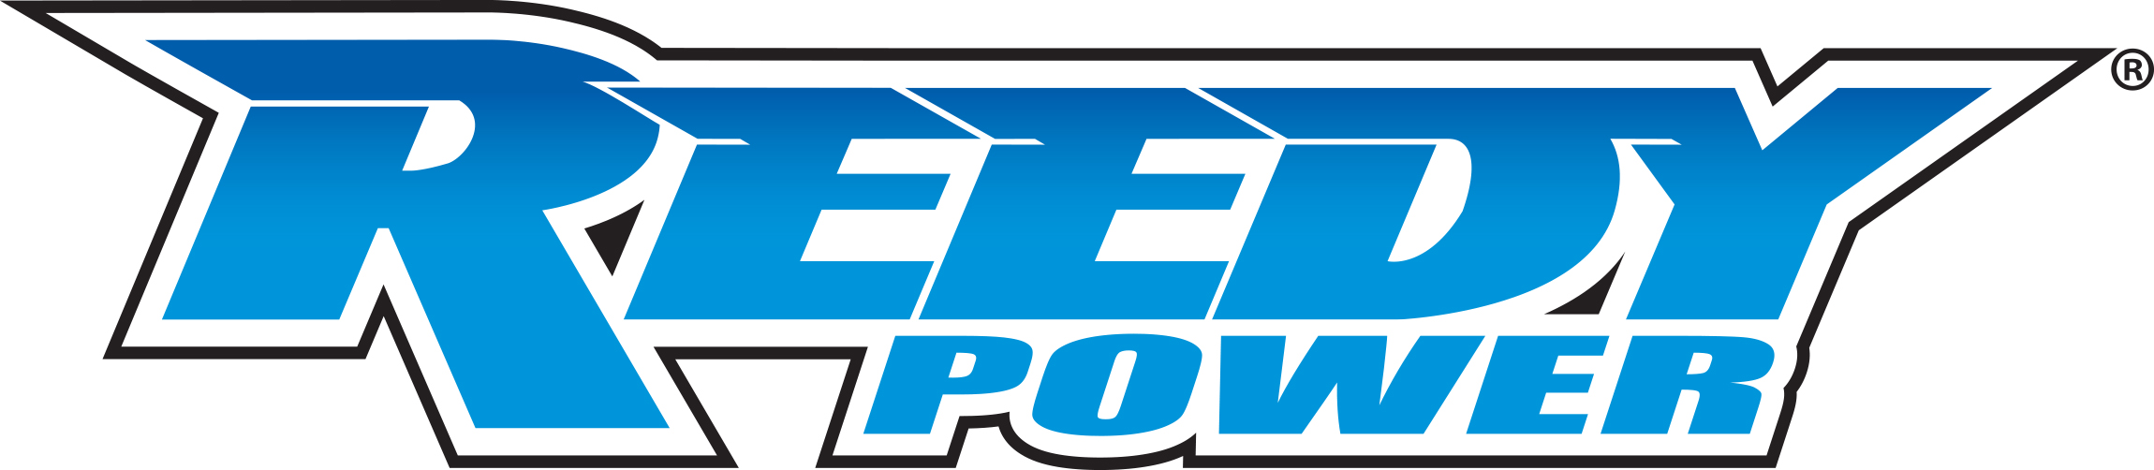
Recommended Electronics:

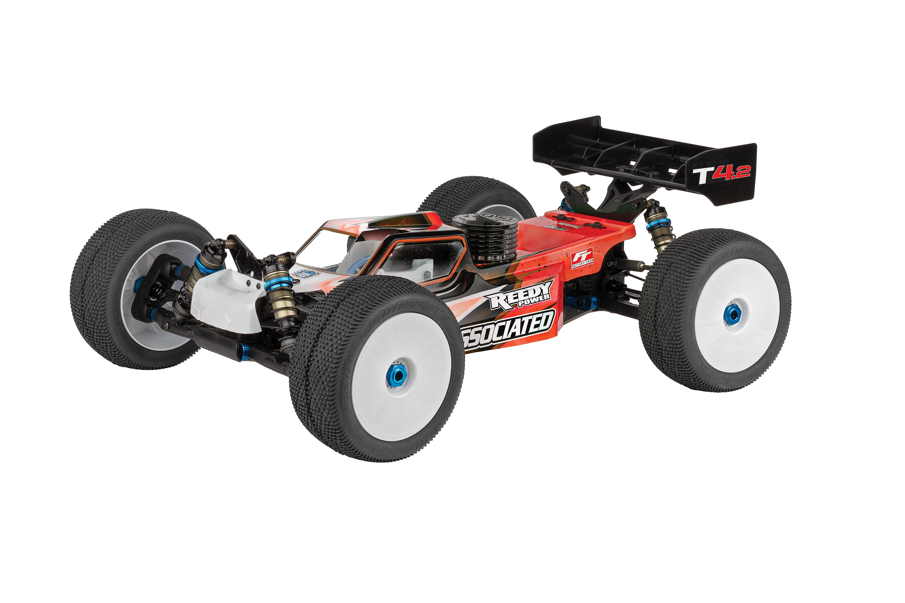
- Servo (#27168 REEDY RS4008A Hi-Speed HV Servo)
- Battery (#27313 Reedy LiPo Pro 2400mAh 7.4V TX/RX Battery, flat)
- Charger (#27203 Reedy 1416-C2L Dual AC/DC Competition Balance Charger)
- Accessories (#27035 Reedy Electronic Power Switch)
(#27377 Reedy Glow Igniter, 3000mAh)

Other Helpful Items:
- Body Scissors (AE Part # 1737)
- FT Wrench Set (AE Part #1519)
- Hobby Knife
- Needle Nose Pliers
- Wire Cutters
- Soldering Iron
- Calipers or a Precision Ruler

Items required for operation:

CATALOG INFORMATION
Nitro Motor, Batteries, Servo, Receiver, Paint, Wheels, Tires, 1:8 Body and Radio. Assembly and painting required.
CATALOG INFORMATION
Motor, battery, ESC, servo, receiver, paint, tires and radio. Assembly and painting required
UPC | Part No. | Description | MSRP | MAP | Pieces Per Case | Origin | Available
784695809574 | 80957 | RC8T4.2 Team Kit | $1,099.99 | $729.99 | 4 | TW | August
Download all zipped photos here: https://rc10.com/RC8T42Images/ (10.3 MB) Link is active for 30 days.
Please refer to our MAP Policy here: https://img2c.associatedelectrics.com/pdf/map-policy.pdf

