FOR IMMEDIATE RELEASE

June 18, 2025

Thornhill R/C Racing Circuit – Hutto, TX

Brandon Rose Wins ROAR National Title Driving Reedy Powered RC8T4e
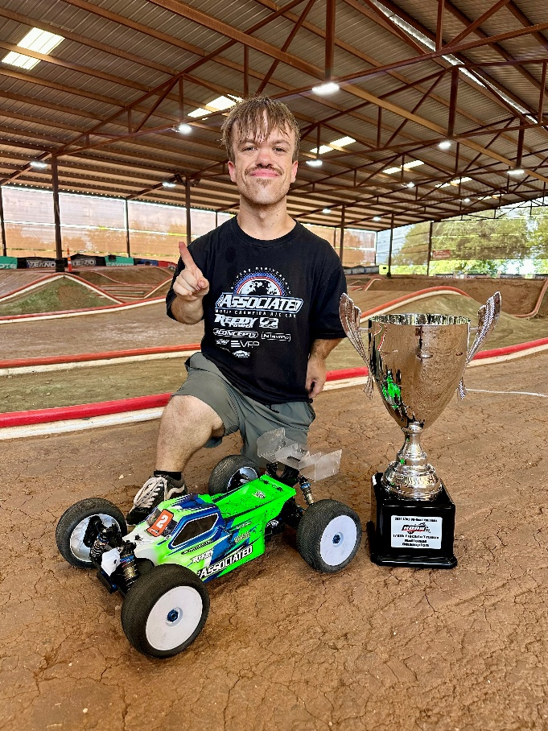
Congratulations to Team Associated and Reedy Power driver Brandon Rose on winning his first ROAR National Championship! Brandon, a native of Texas, drove his Reedy Powered RC8T4e to the Electric Truggy National Championship for a very popular win at Thornhill R/C Racing Circuit in Hutto, TX.

Throughout qualifying, Rose kept his Team Associated eTruggy towards the front and actually tied for the overall top qualifying position. Starting second on the grid, Rose made quick work of TQ Ryan Maifield to leap into the lead in both A1 and A2. Holding off pressure from two of the best racers in the world, Dakota Phend and Ryan Maifield, Rose defended his position and claimed a crowd roaring victory to earn his first National Championship.

Making its competitive debut, Rose used the soon to be released Reedy Blackbox 880R ESC. This is Reedy’s first new 1:8 ESC since the debut of the 850R in 2017 and it is already a National Champion! Brandon powered the 880R with Reedy Zapper 6800 mAh batteries and a Reedy Sonic 900 2100kv motor. Congratulations B-Rose!

Products Used:

#80952 – RC8T4e Team Kit w/Gearbox Upgrade Kit
#27496 – Reedy Sonic 900 Competition 1/8 Buggy Motor 2100kV
#27601 – Reedy Zappers SG6 6800mAh 135C 7.6V LP Stick
#27203 – Reedy 1416-C2L Dual AC/DC Competition Balance Charger
#27457 – Reedy HV 30mm Aluminum Motor Fan
#27392 – Reedy Grip Bullets 5mm x 14mm, silver, qty 2
#27107 – Reedy 95mm Y-Connector, Black

