For Immediate Release: August 2025

New! Reedy Power 400mAh 60C 7.4V 1:28 LiPo Battery
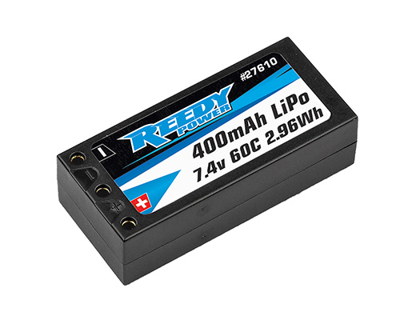
(Pictured: Reedy Power 400mAh 60C 7.4V 1:28 LiPo Battery)

Reedy Power, a leading name in RC performance electronics, is proud to announce the launch of its latest battery, a 400mAH 60C 7.4V LiPo designed specifically for 1:28 micro racing enthusiasts. Engineered for maximum power, durability, and efficiency, this cutting-edge battery is set to redefine performance standards in the increasing competitive world of 1:28 micro racing.

An impressive 60C rating and 400mAh capacity provides explosive power and run time across all 1:28 racing classes. Weighing just 18g, this lightweight battery ensures optimal vehicle handling, making it ideal for racers seeking a competitive edge over an entire lap.

A high quality, durable hard case helps prevent damage while embedded 2mm socket connectors keep power robbing resistance to a minimum.

LiPo battery technology continues to evolve, and Reedy Power is committed to bringing improved performance to the masses.

.
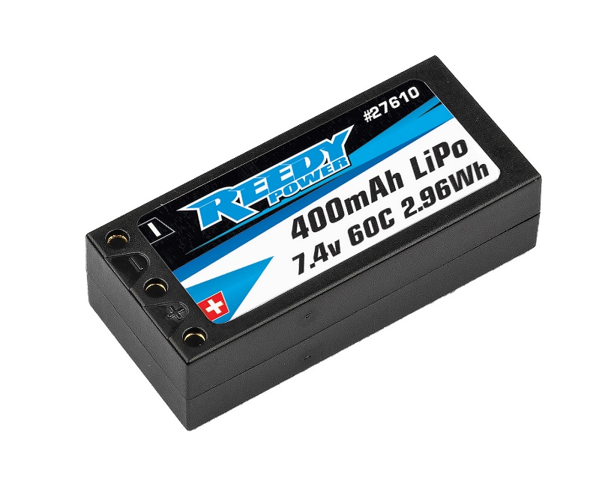
Features

- State-of-the-art LiPo chemistry
- Updated formulation and construction
- Heavy-duty internal construction
- High capacity
- Reduced IR with elevated average voltage
- Proven reliability and cycle-life
- Durable hard case with low-resistance connectors

Specifications
Model Number | 27610
Capacity | 400mAh
Voltage | 7.4V (2S)
Dimensions (mm) | 44.5x20x12.3
Max. Charge Rate | 1.2A
Discharge Current | 60C
Weight (g) | 18
Socket | 2mm/2mm (included)

UPC | Part No. | Description | MSRP | MAP/Web | Origin | Available
784695276109 | #27610 | Reedy Power 400mAh 60C 7.4V 1:28 Stick | $36.99 | $22.99 | CH | Aug. ‘25

