For Immediate Release: October 2026

RC10 Retro 80s Ultra Rider 2WD #6060



ELECTRIC ■ OFF ROAD ■ 1:10 SCALE ■ 2 WHEEL DRIVE ■ KIT
The RC10 Ultra Rider 2WD isn’t just a tribute; it’s a high-performance celebration of engineering that defined a decade.

Combining the iconic aesthetics of the 1980s with modern Team Associated precision, the RC10 Ultra Rider 2WD is built for those who remember the thrill of the first dirt jump and those ready to experience it for the first time.

VINTAGE SOUL.
MODERN STRENGTH.

Iconic Front and Rear Trailing Arms: At the heart of the RC10 Ultra Rider 2WD is the legendary front front and rear trailing arm suspension. This unique design captures the authentic look and feel of the era’s most innovative race cars and provides a nostalgic driving experience.

Signature Aluminum Shocks: It wouldn’t be a classic without the bling. Our race-proven, oil-filled shocks offer buttery-smooth damping and that unmistakable “Team Associated” performance.

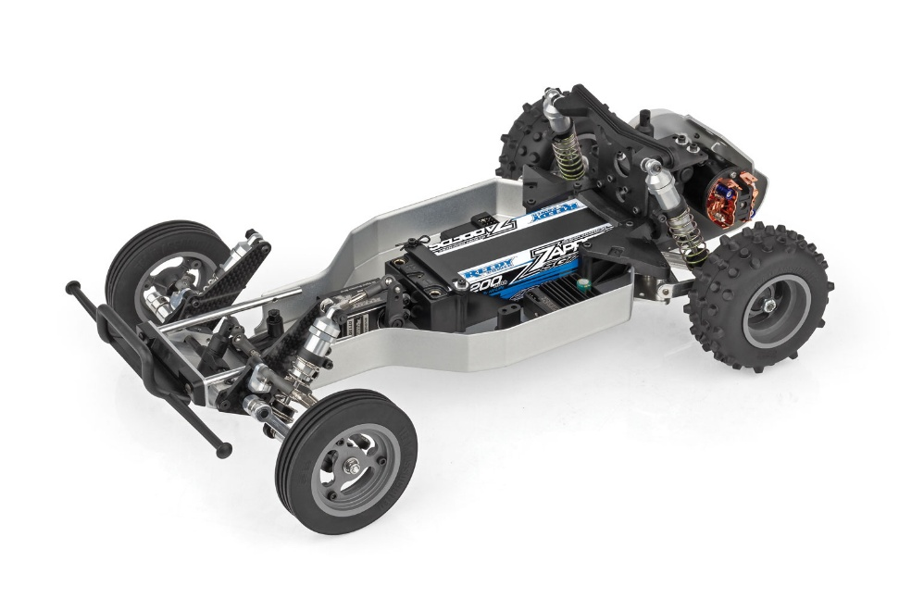

Full Independent Suspension: Don’t let the vintage vibes fool you. With fully independent front and rear suspension geometry, the RC10 Ultra Rider 2WD soaks up bumps and sticks the landings with the poise of a modern champion.

From the aggressive stance to the sleek, period-correct body lines, every inch of the Ultra Rider is designed to turn heads and stir up memories of backyard battles and local track glory.

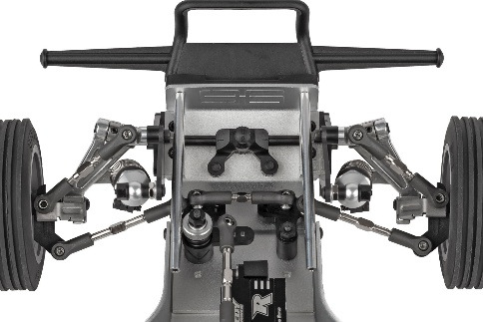
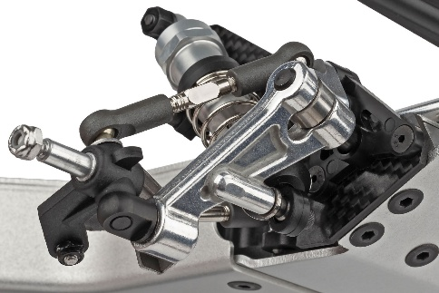



NEW front trailing arm king
pin design
NEW forged aluminum front
trailing arms

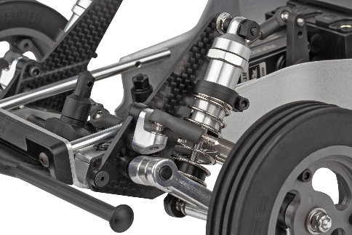
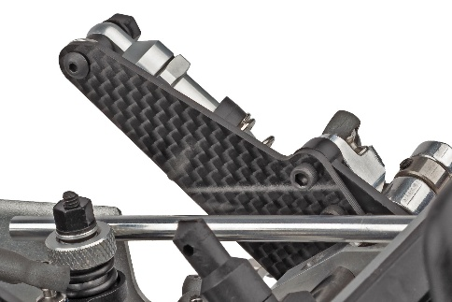

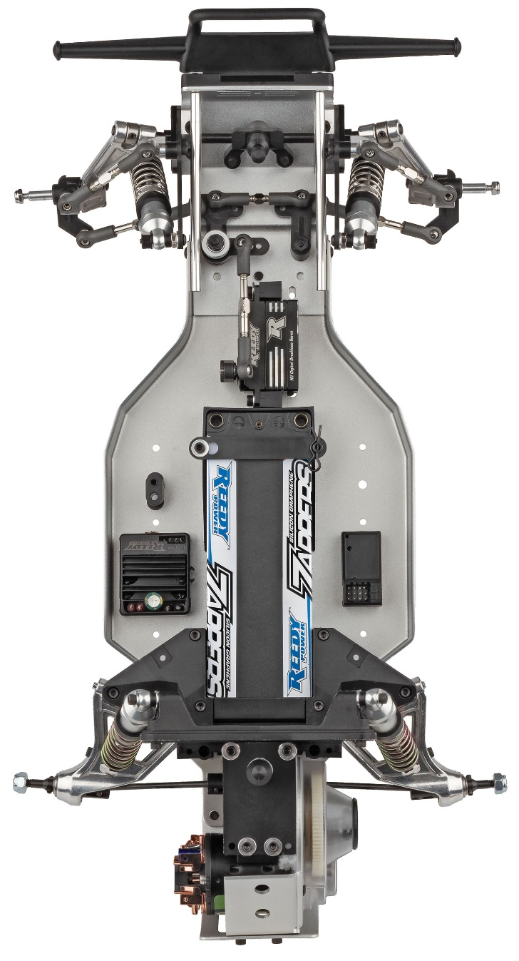

NEW CNC front arm mounts and upper link mounts
NEW carbon fiber front shock towers

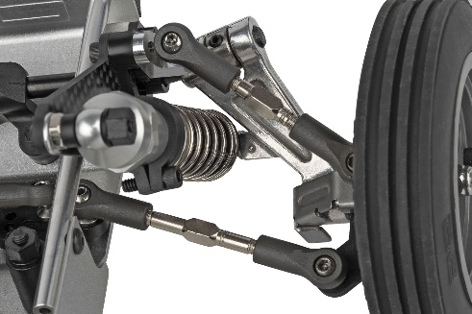
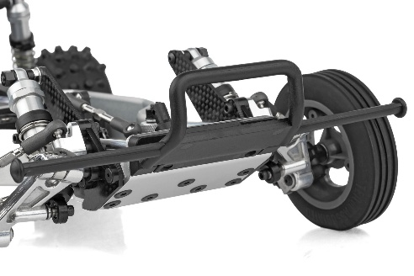

Heavy-duty turnbuckles and ball studs
NEW black molded front bumper

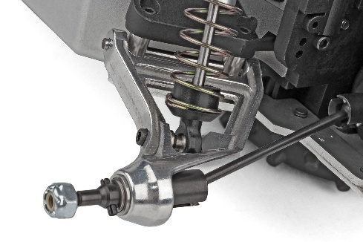
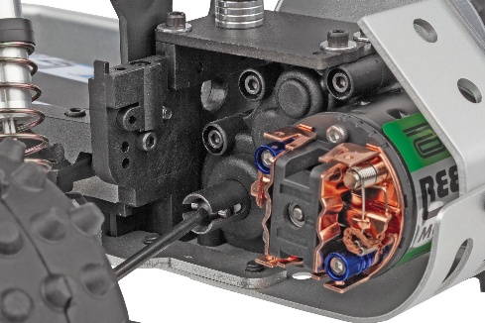

Forged aluminum rear arm and CNC arm mount
Sealed 3-gear Stealth A.T.C. transmission with high-torque ball differential

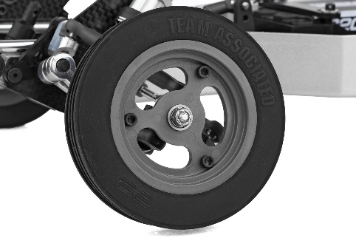

NEW gray 3-piece front and
rear wheels with ribbed front
and knobby rear tires
RC10 Ultra Rider 2WD Parts Available

* RC10 Ultra Rider 2WD Kit shown equipped with items NOT included in kit: Reedy motor, Reedy battery, Reedy ESC, Reedy servo, XP receiver, and paint. Assembly and painting required.

FEATURES
SPECIFICATIONS

• New CNC front arm mounts with set screws
• New molded rear bulkheads
• New front trailing arm king pin design
• New black molded front bumper
• New forged aluminum front trailing suspension arms
• Exclusive Silver wheels included
• Carbon Fiber front tower
• Heavy duty turnbuckles and ball studs
• Exclusive Silver chassis, nose plate and motor plate
• Aluminum rear arm mount plates
• Hardened rear driveshafts
• 80’s Retro themed RC10 Classic
• Retro molded side guards
• Forged aluminum rear trailing suspension arms
• Long travel, fluid-filled anodized aluminum coil-over shocks
• Sealed 3-gear Stealth A.T.C. transmission
• High-torque ball differential
• Exceptional ground clearance with low center of gravity
• Front and rear tires with 3-piece racing wheels
• Clear Protech body with cutout templates
• Driver figure, lights, and scale window net
• Fiberglass shock towers
• Full metal ball bearings
• Fits 6-cell NiMH and 2S LiPo battery packs
• CNC rear arm mounts with set screws

Power | Electric
Length | 381mm (15in)
Width | 226.8mm (8.93in)
Weight | Varies*
Wheelbase | 267.7mm (10.54in)
Internal Ratio | 2.25:1
Terrain | Off-Road
Assembly Level | Kit
Drive | 2WD
Scale Size | 1:10 Scale
Body Style | Buggy

*Final width, length and weight will vary based on electronics, tire configuration, wing position and vehicle setup.


Recommended Electronics:

- Battery (#27604 ZAPPERS SG6 4800mAh 135C 7.6V SHORTY)
- Motor (#27481 REEDY SONIC 540-SP5 13.5T BRUSHLESS MOTOR)
- ESC (#27016 BLACKBOX 610R COMPETITION ESC)
- Servo (#27171 REEDY RS1606HD LOW-PROFILE BRUSHLESS HI-SPEED SERVO
- Charger (#27203 REEDY 1416-C2L DUAL AC/DC COMPETITION BALANCE CHARGER)

Other Helpful Items:

- Body Scissors (AE Part # 1737)
- FT Wrench Set (AE Part #1519)
- Hobby Knife
- Needle Nose Pliers
- Wire Cutters
- Soldering Iron
- Calipers or a Precision Ruler

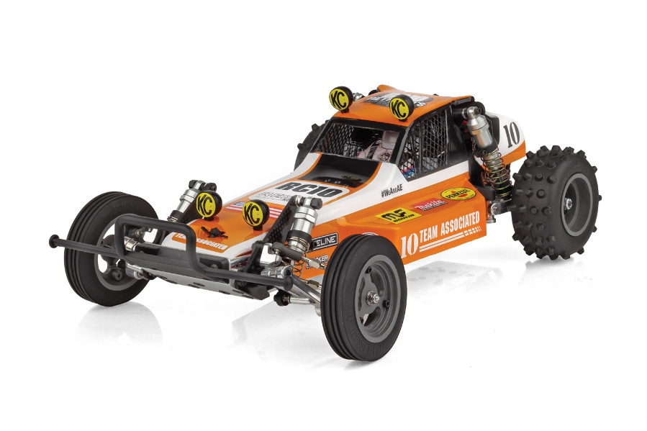

UPC | Part No. | Description | MSRP | MAP | Pieces Per Case | Origin | Available
784695060609 | 6060 | RC10 Ultra Rider 2WD Kit | $529.99 | $329.99 | 6 | TW | October
Download all zipped photos here: https://www.rc10.com/Ultrarider2WDImages/(2.73MB). Link is active for 30 days. Please refer to our MAP Policy here: https://img2c.associatedelectrics.com/pdf/map-policy.pdf

