For Immediate Release: April 2025

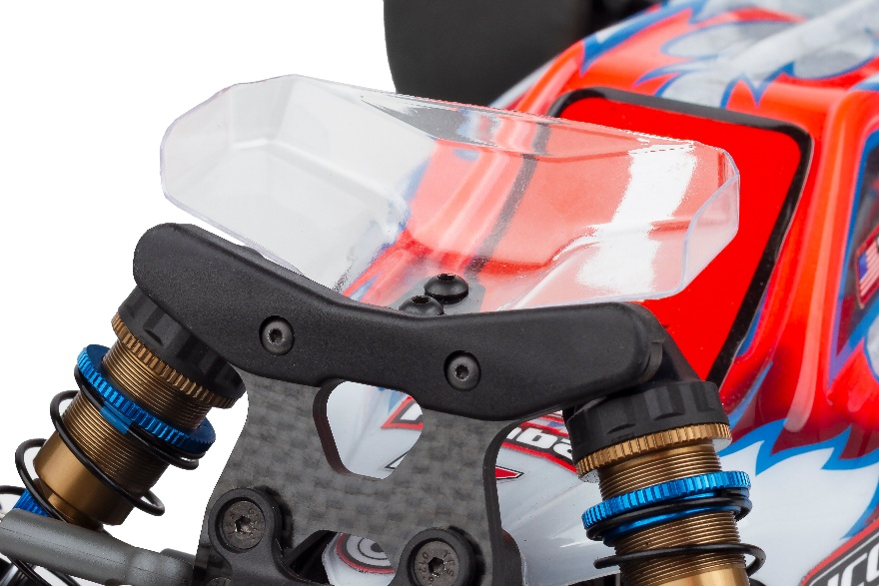
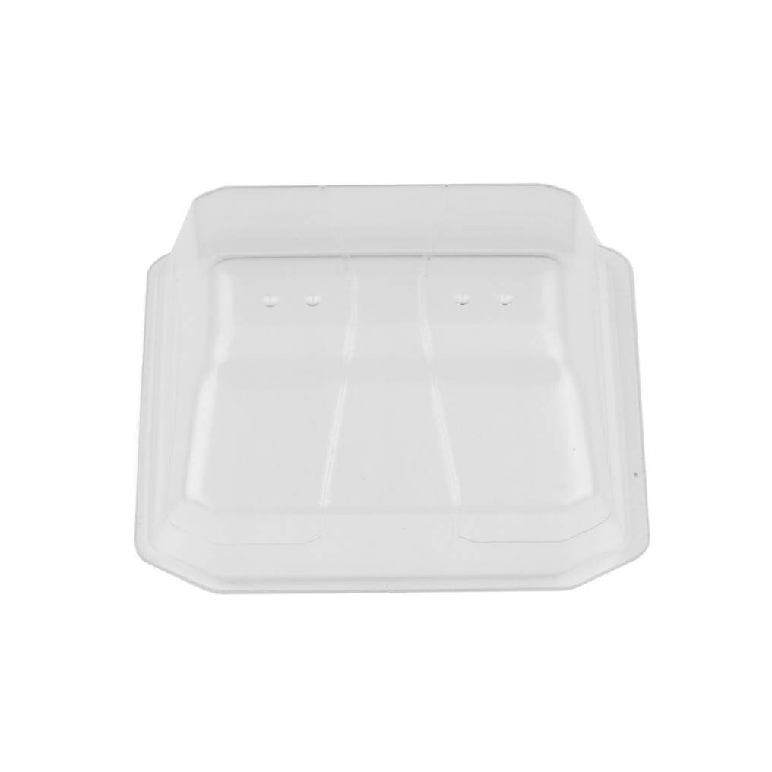
#92499 RC10B7 Upper Front Wing

(Pictured: #92499 RC10B7 Upper Front Wing)

Tune the aerodynamics of your 2wd buggy with the new B7 upper front wing. Installed using the #92487 upper wing mount, racers can now tune the airflow around the vehicle for optimal balance. Use the upper wing to gain overall stability and reduce turn-in.

Use the lower wing to increase turn-in and no wing for a default, neutral feel.

UPC | Part No. | Description | MAP | MSRP | Origin | Available
784695924994 | 92499 | RC10B7 Upper Front Wing | $9.99 | $9.99 | TW | 

