For Immediate Release: August 2026

RC10 Factory Team Blue Edition Kit #6058

1:10 Scale 2WD Electric Off Road Competition Buggy Kit

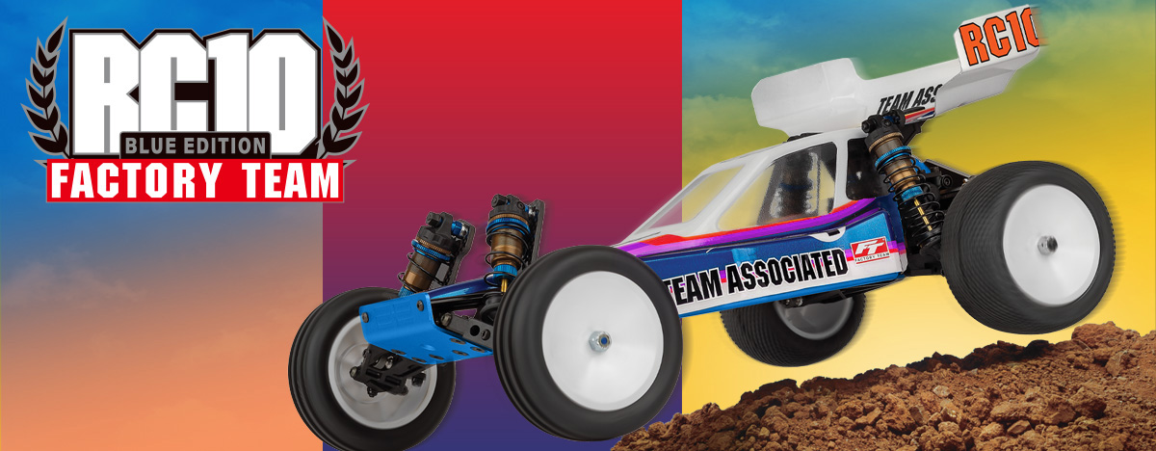

ELECTRIC ■ OFF ROAD ■ 1:10 SCALE ■ 2 WHEEL DRIVE ■ KIT

The Team Associated RC10FT is Engineered for Victory!

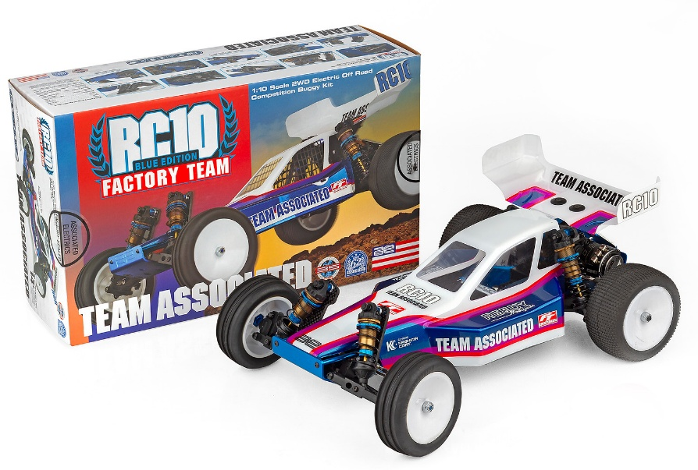

With over 40 years of racing heritage and countless World Championships, the RC10 platform stands out as one of the best performing 10th scale buggies of all time.

Today’s R/C tracks demand a lot from a vintage platform and the AREA 51 Factory Team has been hard at work creating the ultimate RC10 for today’s tracks.

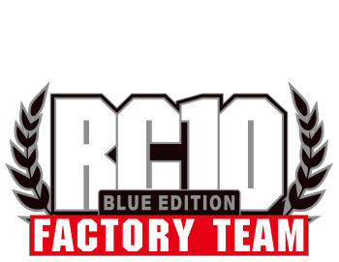

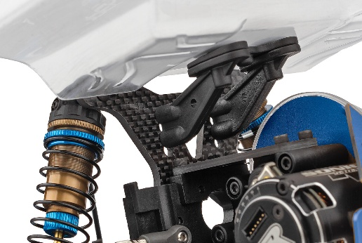
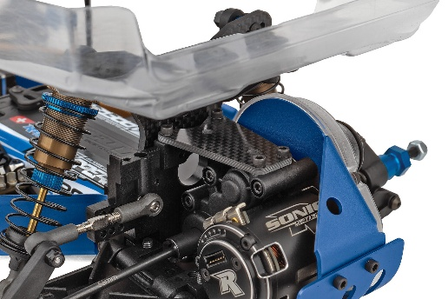

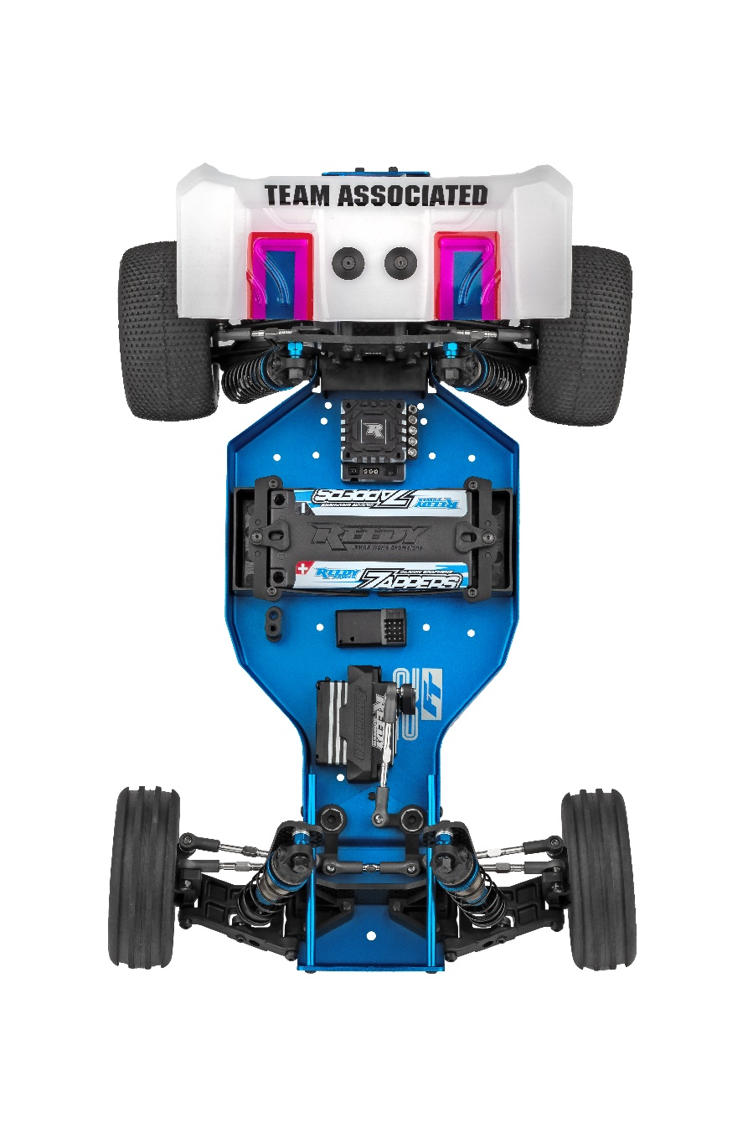

Rear shock tower integrates B6 rear wing mount
Carbon fiber transmission brace

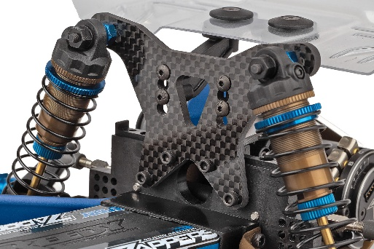
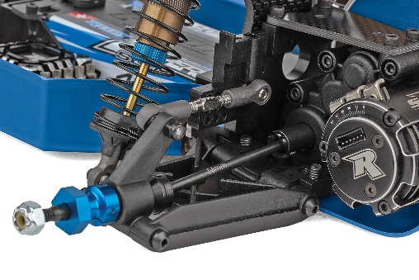

New Factory Team front and rear carbon fiber front shock towers*
56mm rear CVA’s with 12mm hex

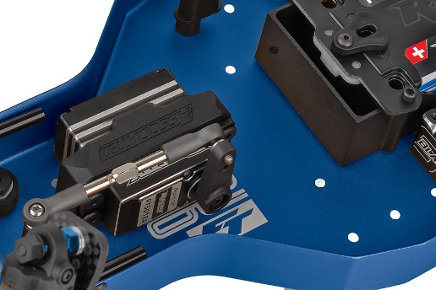
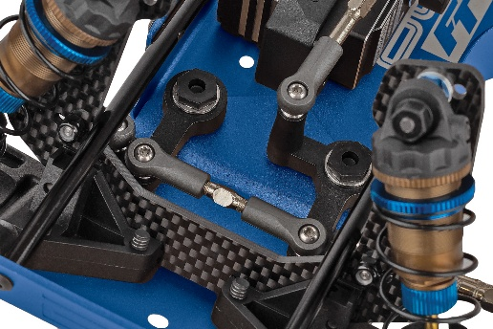

World’s Car bellcrank steering

B7 Servo mount included

*The new rear shock tower (#6796) lowers the shock mounting position by 3.5mm. This update is designed to achieve better clearance and provides a larger tuning window when using big bore shocks.
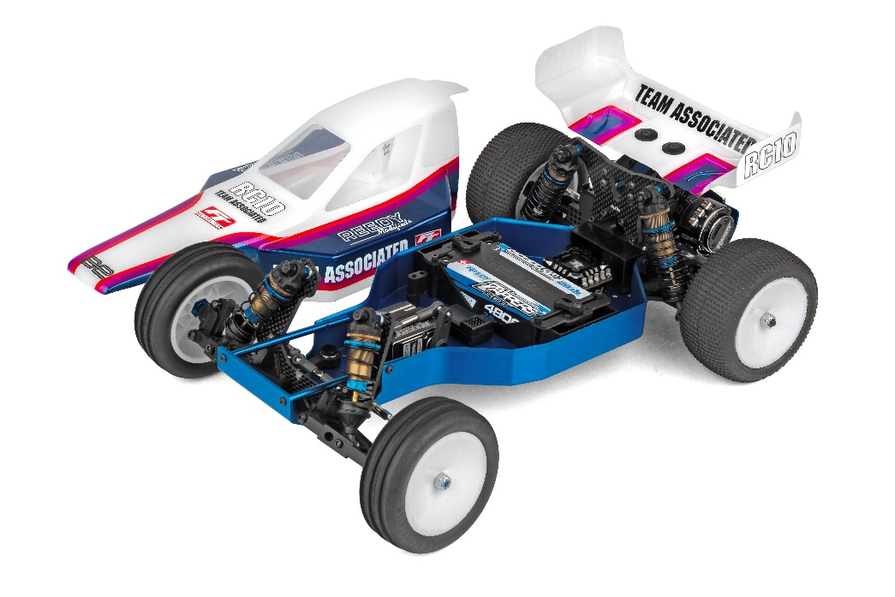

The features in this kit are exactly how our Factory Team driver’s setup their RC10’s for modern racing. With big bore shocks, captured hinge pins, 12mm wheel hex’s, exclusive chassis color, all new Mirage Pro body and more, this is an RC10 like never before.

”

FEATURES
SPECIFICATIONS

- New Mirage Pro vintage body
- New Factory Team front and rear carbon fiber front shock towers (big bore compatible)
- New rear shock tower integrates B6 rear wing mount
- B6 rear wing mount included
- Factory Team 12mm hex front steering block
- Factory Team 12mm hex front axle
- Factory Team 12mm Hex rear CVA’s included
- 12mm Hex B7 wheels included
- B7 Servo mount included
- Heavy Duty Metric Ball Studs
- Carbon fiber transmission brace
- Heavy Duty Ball Cups and 3.5mm adjustable turnbuckles
- New Factory Team captured hinge pins

Power | Electric
Length (w/Wing) | 380mm (15in)
Width | 226.8mm (8.93in)
Weight (Chassis only) | Varies*
Wheelbase | 266.7mm (10.54in)
Internal Ratio | 2.25:1
Power Source | Electric
Chassis | Machined aluminum
Assembly Level | Kit
Drive | 2WD
Suspension  *Final width, length and weight will vary based on electronics, tire configuration, wing position and vehicle setup. | Independent Front and Rear

- Kashima coated 13mm big bore Factory Team shocks included
- All Black plastics
- Full ball bearings included
- New Blue anodized chassis, noseplate and motorplate
- Clear RC10 B7 wing included
- New Factory Team vintage logo decal sheet
- V2 slipper system included
- Independent suspension with durable long front arms and refined geometry
- World’s Car bellcrank steering
- Body Velcro both sides of chassis

Recommended Electronics:

- Battery (#27604 ZAPPERS SG6 4800mAh 135C 7.6V SHORTY)
- Motor (#27481 REEDY SONIC 540-SP5 13.5T BRUSHLESS MOTOR)
- ESC (#27016 BLACKBOX 610R COMPETITION ESC)
- Servo (#27171 REEDY RS1606HD LOW-PROFILE BRUSHLESS HI-SPEED SERVO
- Charger (#27203 REEDY 1416-C2L DUAL AC/DC COMPETITION BALANCE CHARGER)

Other Helpful Items:

- Body Scissors (AE Part # 1737)
- FT Wrench Set (AE Part #1519)
- Hobby Knife
- Needle Nose Pliers
- Wire Cutters
- Soldering Iron
- Calipers or a Precision Ruler

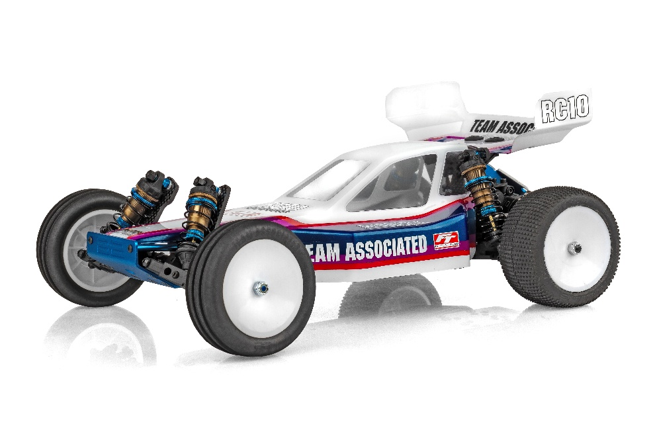

UPC | Part No. | Description | MSRP | MAP | Pieces Per Case | Origin | Available
784695060586 | 6058 | RC10 Factory Team Blue Edition | $647.99 | $439.99 | 6 | TW | End of August
Download all zipped photos here: https://www.rc10.com/RC10FTBlueImages/(11.33MB). Link is active for 30 days. Please refer to our MAP Policy here: https://img2c.associatedelectrics.com/pdf/map-policy.pdf

