For Immediate Release: August 2025

New! Reedy Blackbox 880R Competition 1:8 ESC
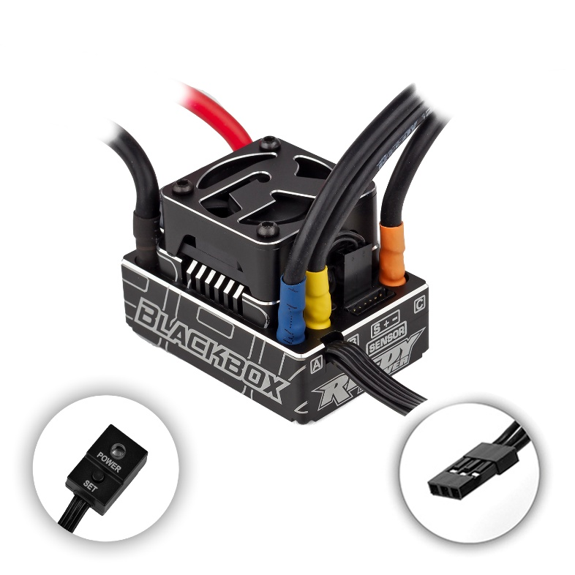
(Pictured: New! Reedy Blackbox 880R Competition 1:8 ESC)

Reedy Power, a legendary name in the RC racing industry with 30 IFMAR World Championship titles, proudly announces the launch of the Reedy Blackbox 880R Competition 1:8 ESC.

Track tested and competition proven, Reedy’s Blackbox 880R is a versatile and powerful ESC engineered for the extreme demands of 1:8 Buggy, Truggy, and 1:10 Short course competition. This state-of-the-art ESC delivers excellent throttle and brake feel, a wide range of adjustability, and robust hardware
for racers seeking maximum performance on track.

Reedy Power has always been about providing quality, high-performance products for racers whose goal is the top step of the podium” said Rick Hohwart, Reedy Power’s brand manager and 40-year RC industry veteran. “The 880R is the culmination of months of testing, delivering the power, control, and reliability that racers demand. Whether you’re an enthusiast racing at the local level or a pro racing at national and international competitions, this ESC is capable of winning”.

The Reedy Blackbox 880R Competition 1:8 ESC is now available for purchase at hobby shops, online retailers, and at www.ReedyPower.com.

.

Features
- CNC machined black aluminum case with integrated heat sink
- Fully adjustable brake, throttle, power, and safety functions*
- Precision throttle and brake control
- Ultra-low resistance FET board
- 32-bit microcontroller unit (MCU)
- Push-button power switch
- Solder tabs w/heavy-duty power wires
- Integrated power capacitors
- 30mm fan with CNC machined shroud
- RPM and ESC temp data logging*
- Firmware updateable*
*Requires Blackbox Programmer2

Specifications
Feature | Specification
Voltage Input | 2S-4S LiPo
Suggested Applications | 1:8 eBuggy/eTruggy,  1:10 4wd Short Course
Resistance (Ω) | 0.00043
Cont./Peak Current (A) | 180/700
Dimensions (mm) | 54 x 37 x 23
Motor Limit (4S) | 2400kV
Weight w/o wires & fan (g) | 45
BEC | Adjustable 6.0-7.4V/5A
Power Wires | 10-gauge silicone (battery) 12-gauge silicone (motor)
Fan | 30mm included

Default settings have been developed by our racing team for excellent performance out of the box, but the maximum potential of the 880R can be exploited by using the optional Blackbox Programmer2 to fine tune a wide variety of settings. In addition to working as a programmer, the Programmer2 functions as a LiPo battery voltage checker and as a USB firmware update device.

The 880R ESC includes two modes that can be modified and saved independently from one another. Standard mode offers a wide variety of tuning options while Expert mode takes it one step further and opens additional options for more experienced racers and/or racing classes that can take advantage of these advanced settings.

The following functions can be modified and saved using the Blackbox Programmer2:

Brake
Overall brake strength, frequency, drag brake, initial brake, and punch can be adjusted to perfect brake performance and feel in different vehicles and track conditions. A new brake mode selection offers a choice of three braking options to suit the driver’s personal preference and track conditions.

Throttle
Drive frequency, punch, initial throttle, current limit, and dead band adjustability make the ideal setup possible regardless of the type of motor chosen and the type of vehicle being raced.

Motor Power
Advanced timing settings are particularly useful on large or high grip tracks to achieve maximum acceleration and top speed. New soft power and coast settings create fine tuning options to adjust low-end power to suit various track conditions and drivability requirements. Standard tuning mode simplifies timing adjustments for less experienced racers or in newer users or in applications where advanced settings are not required.

Miscellaneous Control
Choose Forward/Brake or Forward/Brake/Reverse mode and adjust the BEC output voltage to fine tune servo speed to suit driver preference. Select the desired low voltage cutoff or disable it completely. The temperature at which the ESC cuts motor power due to overheating can also be adjusted or disabled. For vehicles that require it, reversing the rotation of the motor is possible.

Notes:
To program the Blackbox 880R, Programmer2 (#27027) with firmware EE460145 must be used. This version is already installed when purchasing the 880R/Programmer2 combo. Firmware updates and Blackbox Link version 2.7 can be found on the 880R product page at www.reedypower.com .

The full list of programmable functions can be found in the chart below:

 |  | Tuning Mode | Standard, Expert
Brake | 1A | Drag Brake | 0% - 12%, (2% increments), Custom 0% - 100% (1% Increments)
 | 1B | Brake Strgth | 40%-100% (5% Increments)
 | 1C | Init Brake | = Drag Brake, 0%-6% (2% increments), Custom 0% - 50% (1% increments)
 | 1D | Brake Freq | 500Hz, 1KHz, 1.5KHz, 2KHz, 2.5KHz, 3KHz, 4KHz, 6KHz, 8KHz, 12KHz, 16KHz
 | 1E | Brake Punch | Level 1-20
 | 1F | Brake Mode | Linear, Traditional, Hybrid
Throttle | 3A | Punch Ctrl | Level 1-30
 | 3B | Init Throttle | 0% - 40% (1% increments)
 | 3C | Drive Freq | 1KHz, 2KHz, 3KHz, 4KHz, 6KHz, 8KHz, 12KHz, 16KHz, 24KHz, 32KHZ
 | 3D | Deadband | 2% - 12% (1% increments)
 | 3E | Current Limit | 50% - 100% (1% increments)
Motor Power | Standard |  |  | Expert
 | 5A | Timing Level | Level 0 - 0° Blinky | 4A | BT Soft Pwr | 0° - 20° (1° increments)
 |  |  | Level 1 - 3° | 4B | BT Soft Rng | 0% - 75% (5% increments)
 |  |  | Level 2 - 6° | 4C | Coast Value | 0% - 20% (1% increments)
 |  |  | Level 3 - 9° | 4D | Turbo Timing | 0° Blinky - 20° (1° increments)
 |  |  | Level 4 - 12° | 4E | Turbo Delay | Off, 0.05s - 1.0s (.05s increments)
 |  |  | Level 5 - 15° | 4F | Slew Rate | 3°/0.1s - 30°/0.1s (1° increments), Instant
 |  |  |  | 4G | Release Rate | 3°/0.1s - 30°/0.1s (1° increments), Instant
Misc. Control | 6A | Run Mode | For/Brake, For/Brake/Rev
 | 6B | Reverse Power | 25%, 50%, 75%, 100%
 | 6C | Batt Cutoff | None, 3.2V/cell, 3.4V/cell
 | 6D | ESC Temp Cut | Off, 221F/105C, 257F/125C
 | 6E | Mot Rotation | Normal/Reverse
 | 6F | BEC Voltage | 6.0V-7.4V (.1V increments)
 | 6G | Reset Default | No/Yes

UPC | Part No. | Description | MSRP | MAP | COO | Available
784695270435 | 27043 | Blackbox 880R Competition 1:8 ESC | $389.99 | $233.99 | CN | 
784695270442 | 27044 | Blackbox 880R Competition 1:8 ESC w/Programmer2 | $444.99 | $269.99 | CN

