For Immediate Release: May 2026

RC8B4.2 Team Kit #80954
1:8 Scale 4WD Nitro Off Road Competition Buggy Kit

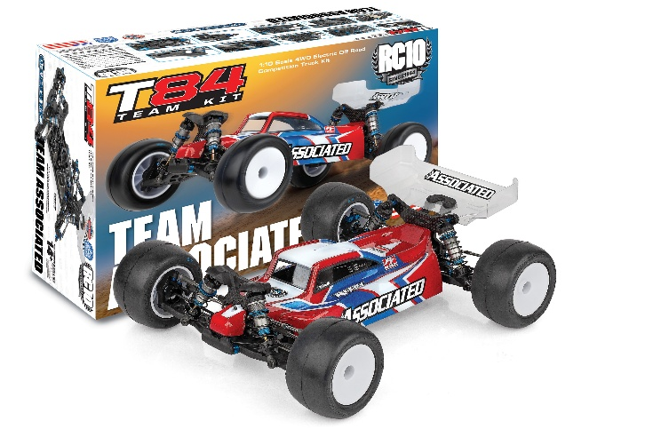
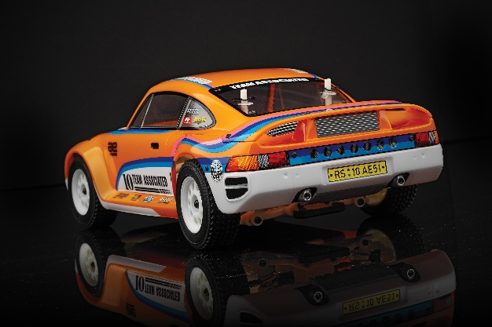
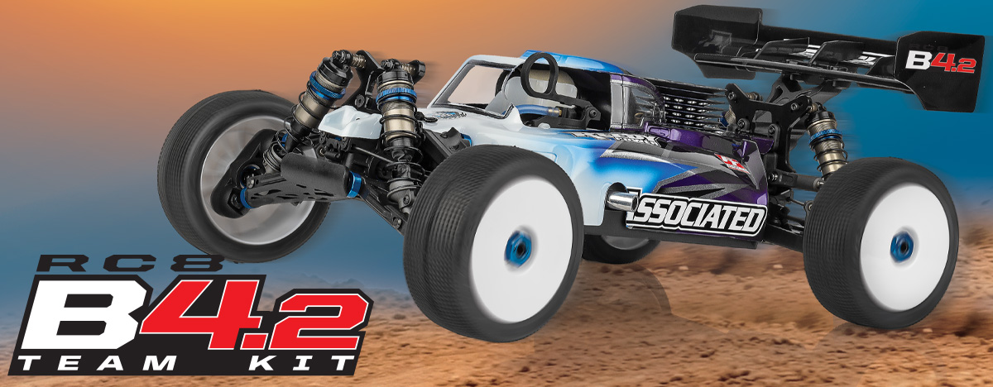

NITRO ■ 1:8 SCALE ■ 4 WHEEL DRIVE ■ OFF ROAD ■ KIT
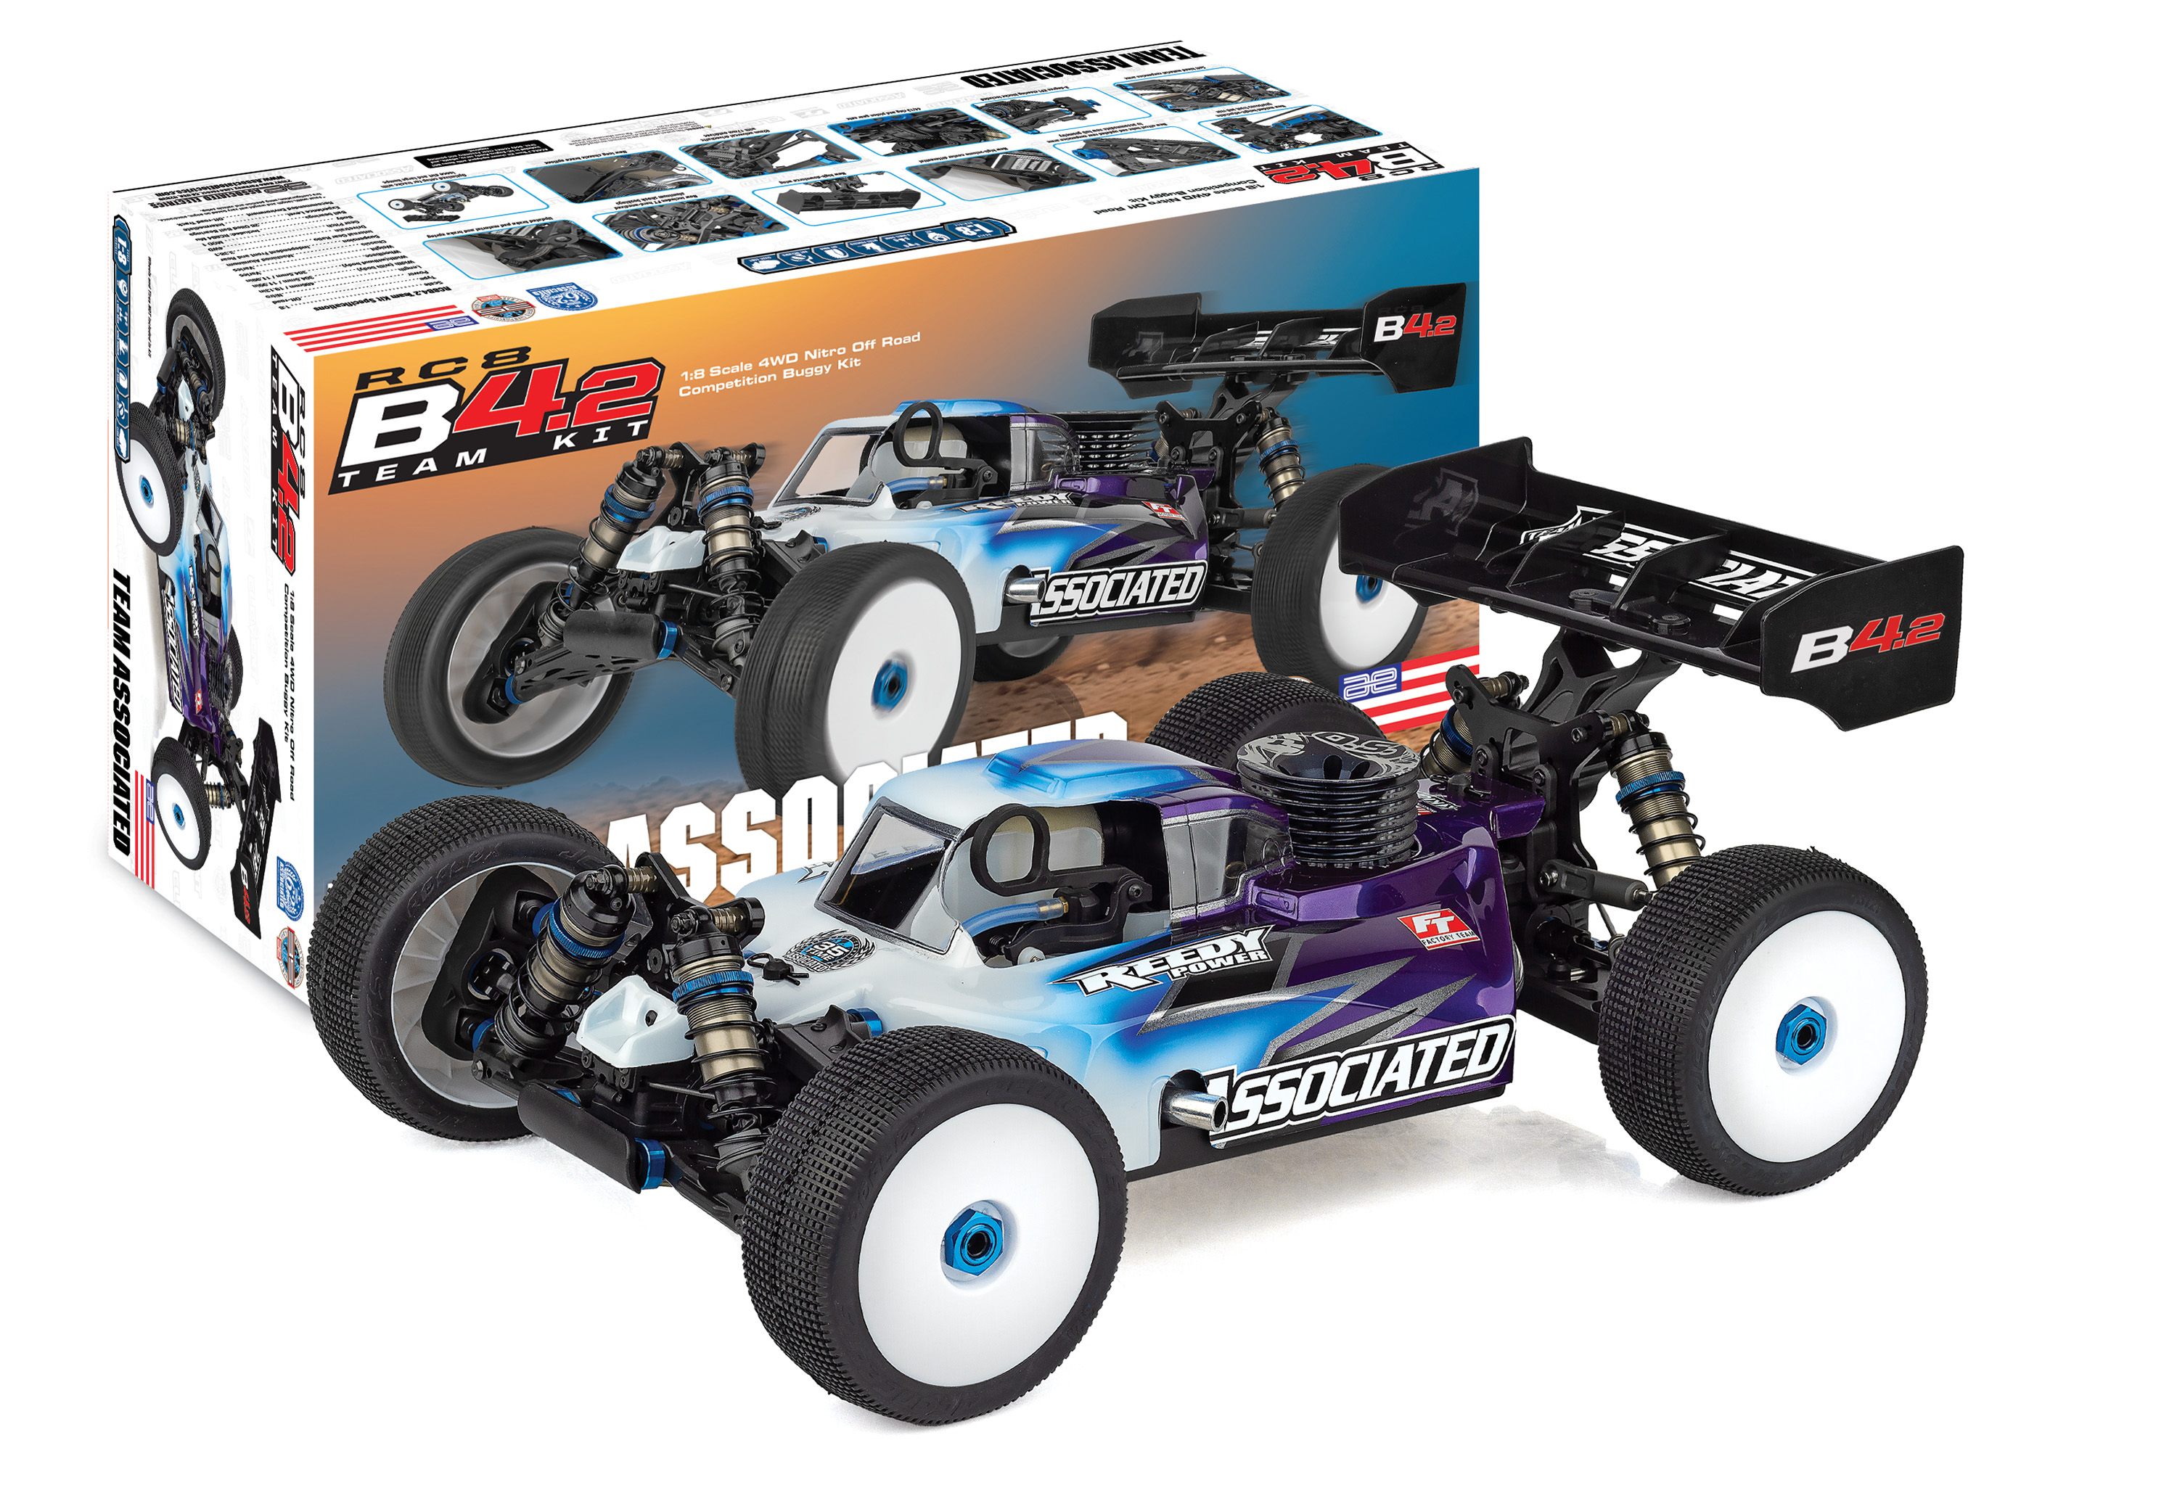
1:8 scale off road racing is one of the hobby’s most challenging disciplines; it requires a high standard and demands attention to detail.

The latest development to come from Associated Electrics’ Area 51 is designed to push boundaries of performance and build upon the number of accolades accumulated by the RC8 series.

PUSHING THE BOUNDARIES
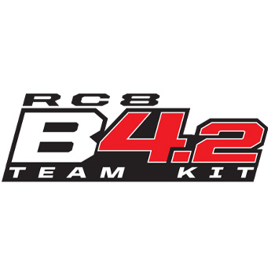

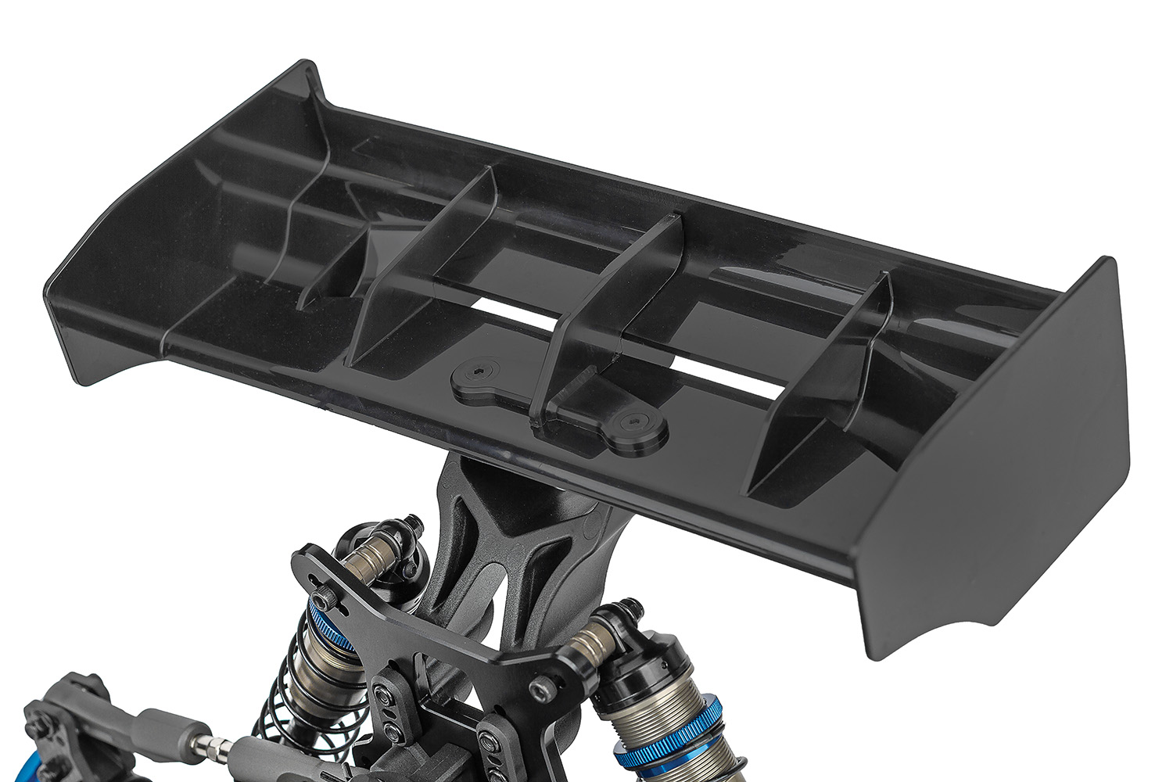
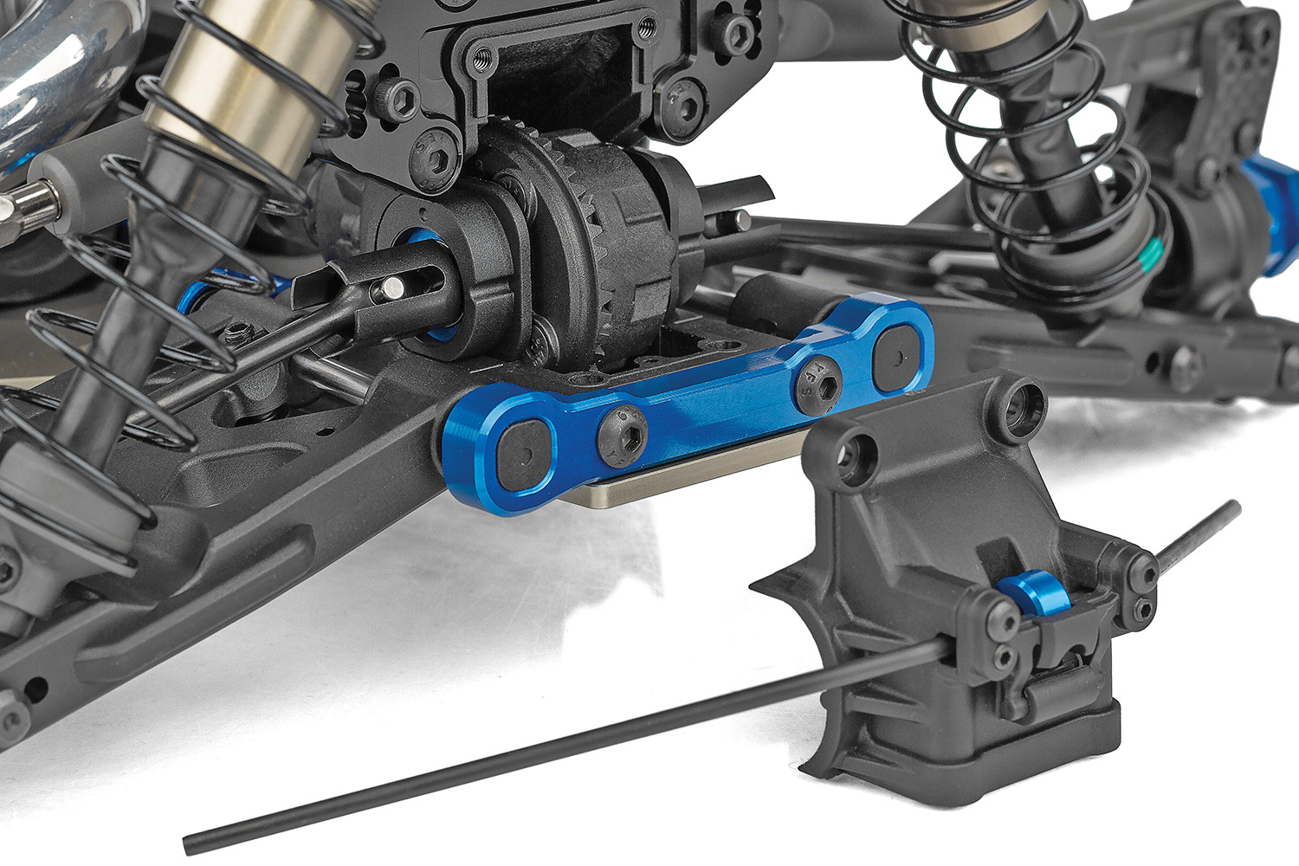

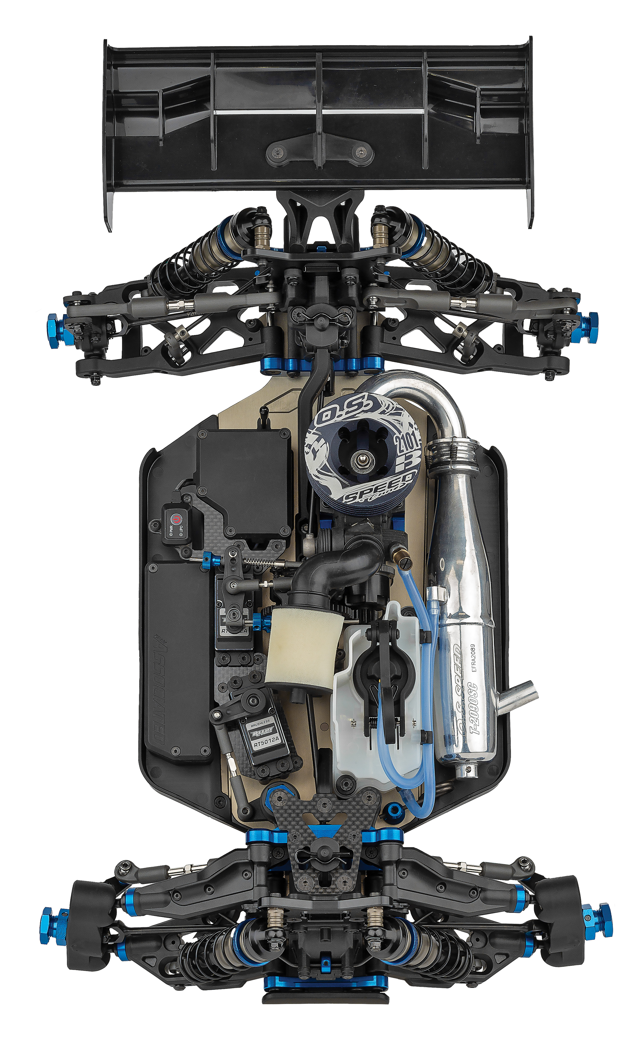

New high-downforce
wing
New molded height-adjustable gearboxes front and rear

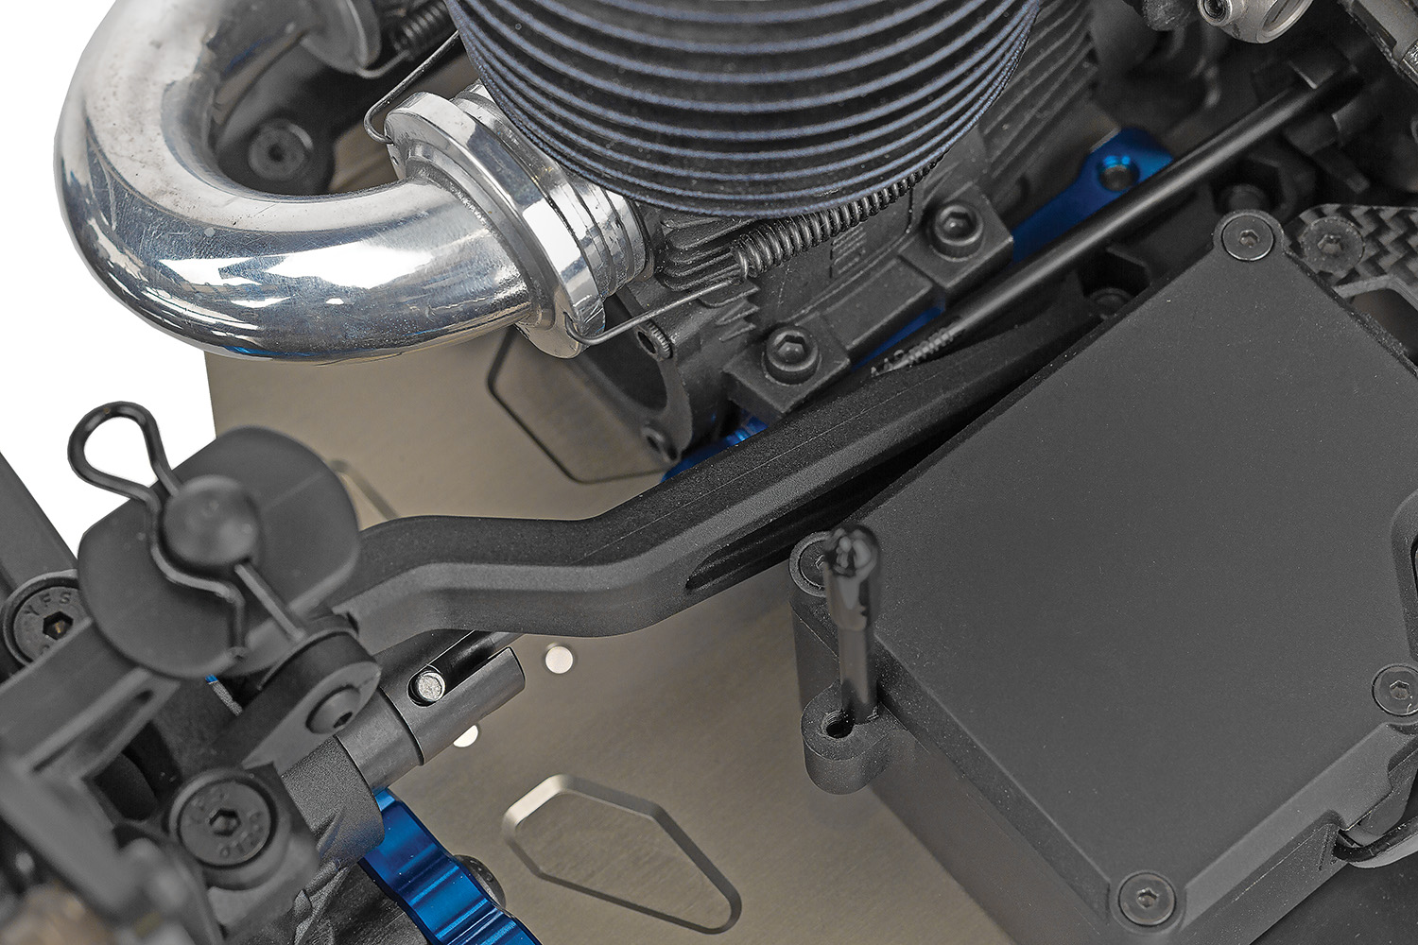
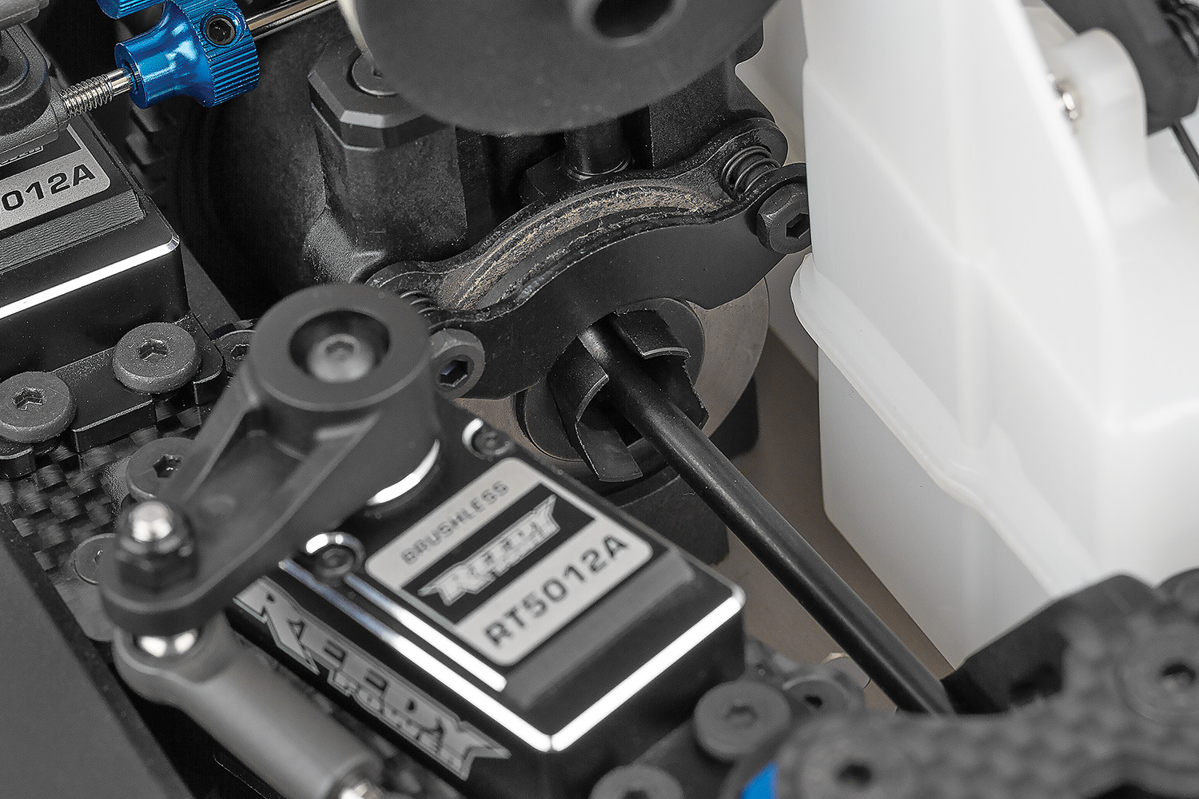

New high-volume center differential
New long chassis brace options

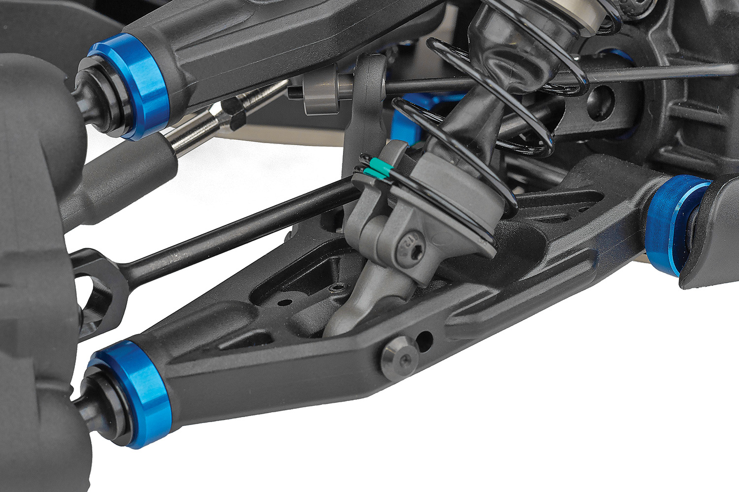
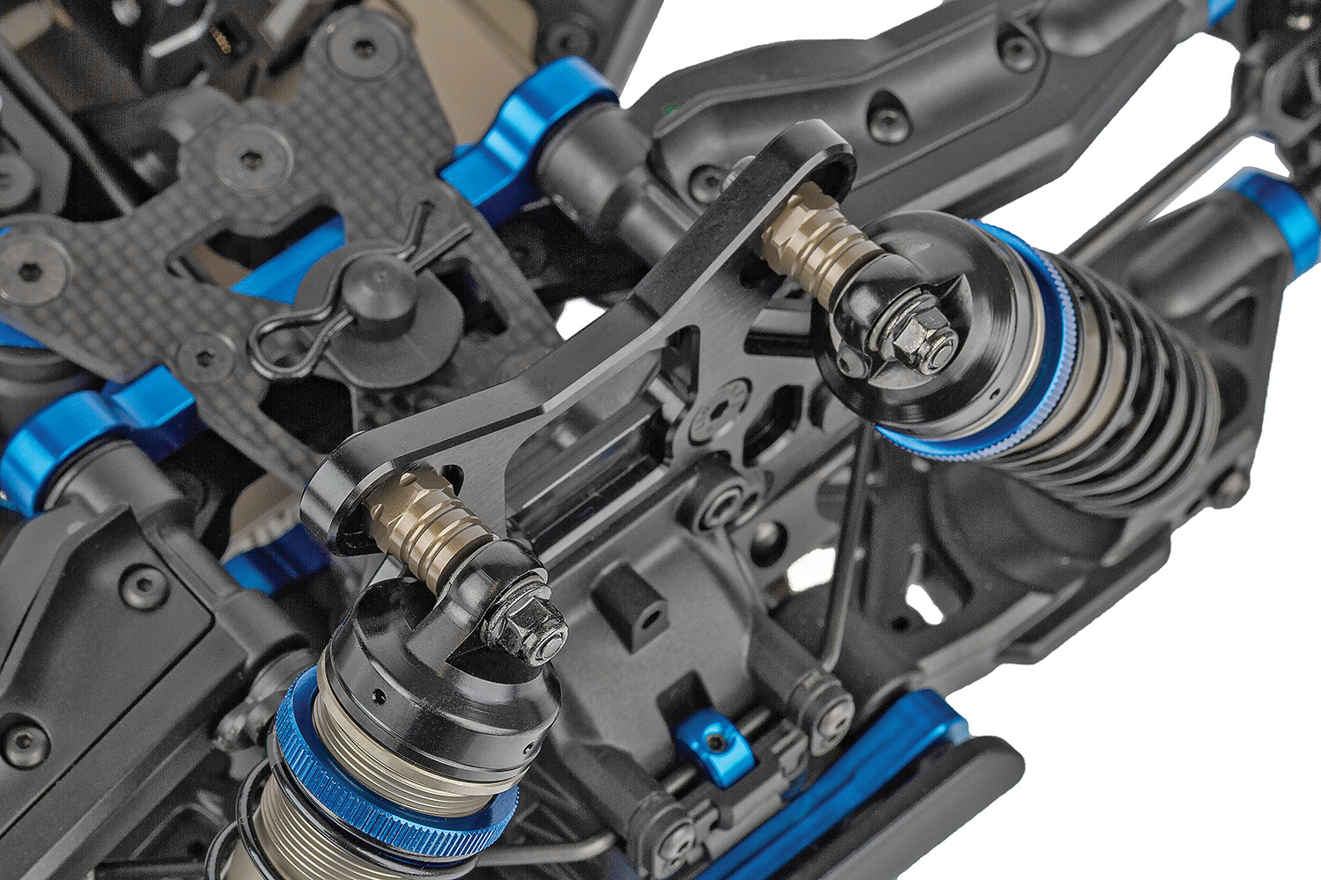

Soft blend material
suspension arms

FT hard-anodized aluminum shock bushings

Due to ongoing R&D, photos may not match final kit. Vehicle shown on these pages equipped with items NOT included in kit: engine, pipe and header, transponder, servos, receiver, wheels, tires. Assembly and painting required.
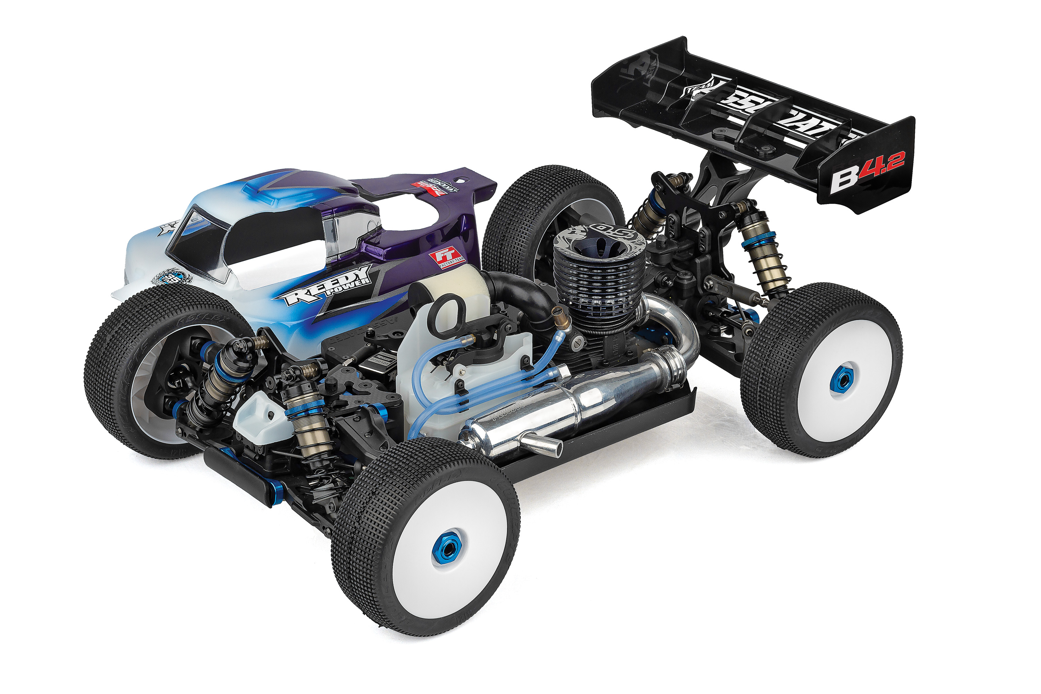
* Final width, length and weight will vary based on engine, electronics, tire configuration, wing position and vehicle setup.
- New molded height-adjustable gearboxes front and rear
- New offset hubs and updated rear suspension arms to accommodate new hub geometry
- New -4mm chassis in FWB configuration
- New high-volume center differential
- New long chassis brace options
- New high-downforce wing
- Now includes FT hard-anodized aluminum shock bushings
- Updated brake pad material and brake spring
- Soft blend material suspension arms
- 8-degree KPI steering blocks included
- 44/13 ring and pinion gear sets
- 92mm universal driveshafts with 17mm outdrives
- 19mm diameter HTC internal differential gear set
- Optimized setup for tracks with loose dirt and large bumps

FEATURES
  SPECS
Scale | 1:1:8
Type | Off-road
Power | Nitro
Length | 486mm / 19.13in
Width ​(with body)​ | 304.5mm / 11.99in
Weight | Varies*
Wheelbase | Varies*
Internal Gear Ratio | 3.38:1
Drivetrain | 4WD
Chassis | Machined Aluminum
Suspension | Independent Front and Rear
Gear Pitch | MOD 1
Body | Included: RC8B4 Mu
Ball bearings | 26 Oiled Ball Bearings
Experience Level | Intermediate
Recommended Environment: | Off-road Track

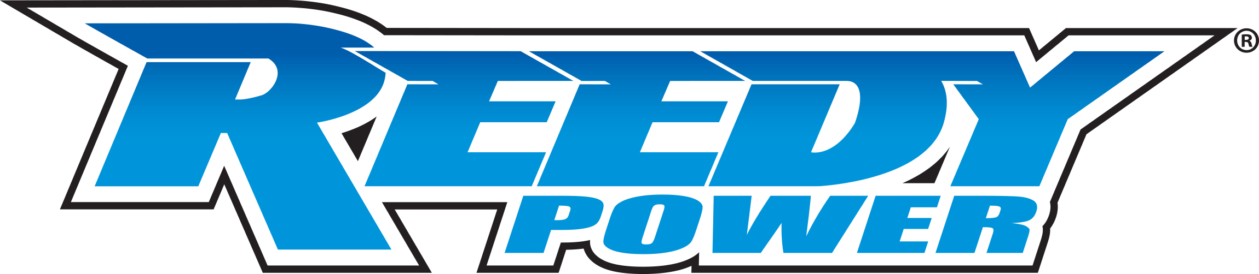
Recommended Electronics:

- Servo (#27168 REEDY RS4008A Hi-Speed HV Servo)
- Battery (#27313 Reedy LiPo Pro 2400mAh 7.4V TX/RX Battery, flat)
- Charger (#27203 Reedy 1416-C2L Dual AC/DC Competition Balance Charger)
- Accessories (#27035 Reedy Electronic Power Switch)
(#27377 Reedy Glow Igniter, 3000mAh)

Other Helpful Items:
- Body Scissors (AE Part # 1737)
- FT Wrench Set (AE Part #1519)
- Hobby Knife
- Needle Nose Pliers
- Wire Cutters
- Soldering Iron
- Calipers or a Precision Ruler

Items required for operation:

Engine, Nitro Gas, Servo, Receiver, Paint, Tires and Radio. Assembly and painting required.

CATALOG INFORMATION
Motor, battery, ESC, servo, receiver, paint, tires and radio. Assembly and painting required

CATALOG INFORMATION
UPC | Part No. | Description | MSRP | MAP | Pieces Per Case | Origin | Available
784695809543 | 80954 | RC8B4.2 Team Kit | $1089.99 | $719.99 | 4 | TW | June
Download all zipped photos here: https://www.rc10.com/RC8B42Images/ (12.54MB) Link is active for 30 days.
Please refer to our MAP Policy here: https://img2c.associatedelectrics.com/pdf/map-policy.pdf

