

**For Immediate Release: August**

**RC10GT Richard Saxton Edition**

**#7067**

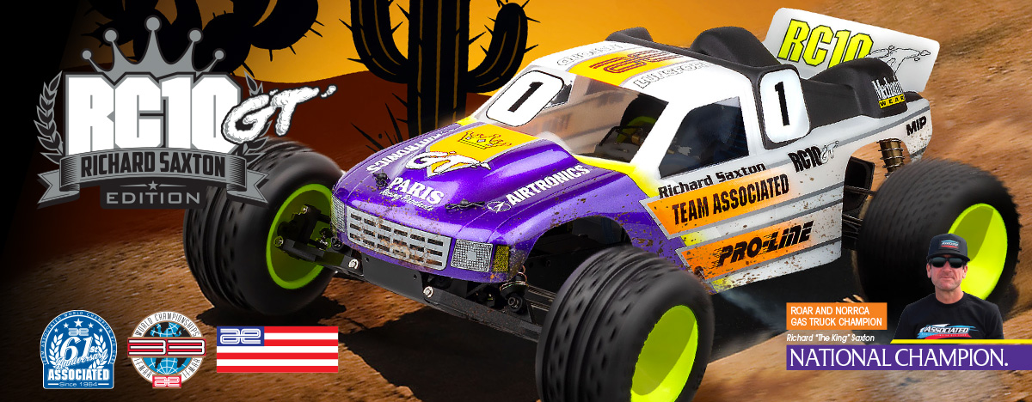

|  |
| --- |
| **GAS ■ OFF ROAD ■ 1:10 SCALE ■ 2 WHEEL DRIVE ■ KIT** |

Originally released in 1993 the RC10GT changed the world of RC Racing by introducing nitro engines into the competitive world of RC Racing. With more wins than we can count, the RC10GT has forged itself as the most iconic gas truck ever created. We are excited to announce the RC10GT lives on with this exclusive RC10GT Richard Saxton Edition.

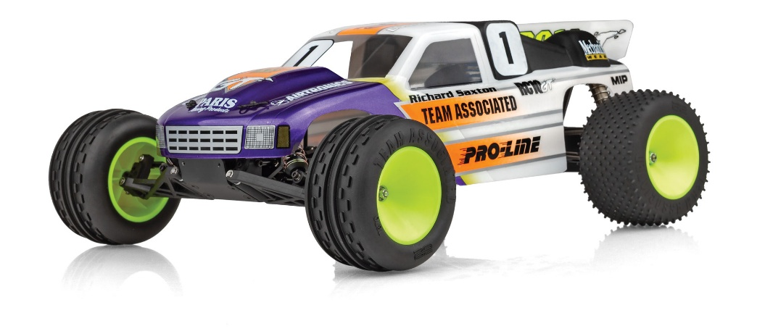

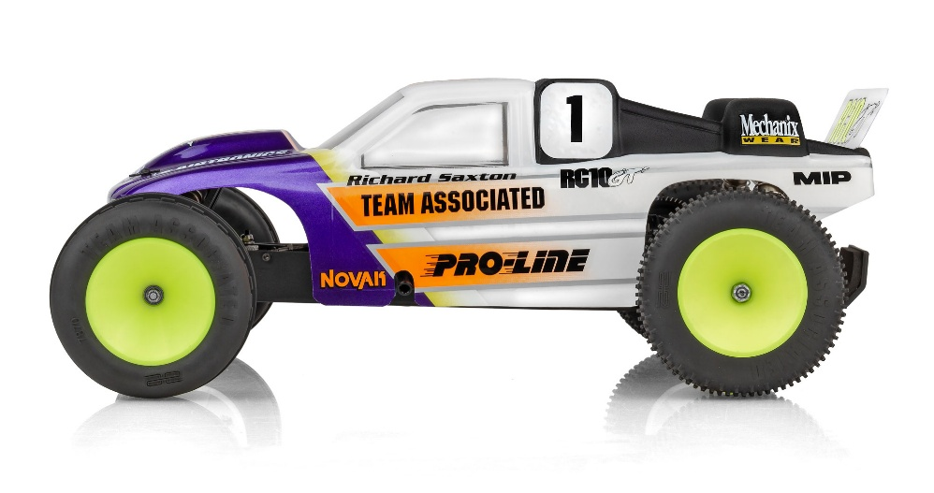

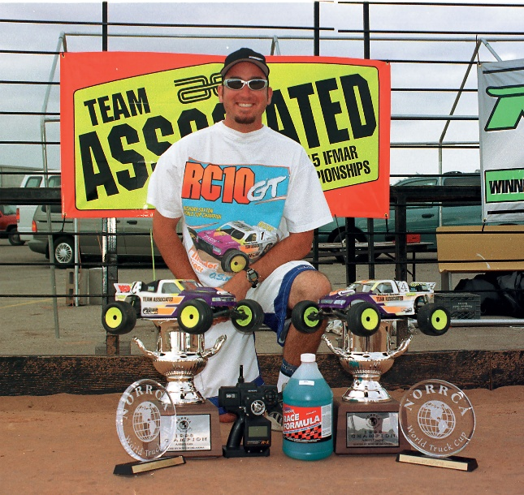

**RICHARD SAXTON:**

**“THE KING” AND THE**

**LEGACY OF THE RC10GT**

Richard Saxton is one of the most respected figures in the radio control (RC) racing world, with a career defined by precision, consistency, and championship-level performance. Known affectionately in the industry as “The King,” Saxton played a pivotal role in the dominance of the Team Associated RC10GT — a 1:10 scale gas-powered stadium truck that would go down in history as the only undefeated platform in ROAR (Remotely Operated Auto Racers) National Championship competition.

Saxton’s relationship with the RC10GT began in the early 1990s when gas truck racing was starting to gain popularity. Team Associated’s RC10GT debuted with a revolutionary design based on the proven RC10 platform, adapted for nitro power. With its durable chassis, precise handling, and superior suspension geometry, the RC10GT was an instant contender. But it was under the control of Richard Saxton that the truck became unbeatable.

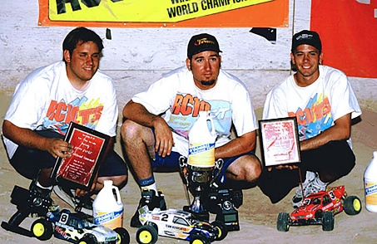

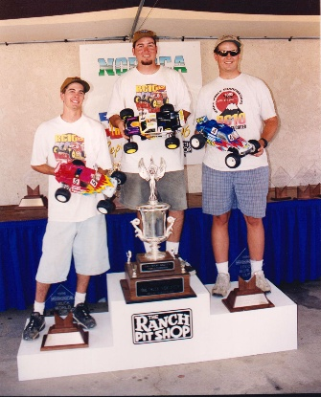

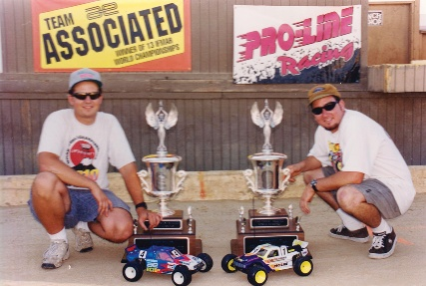

Between 1994 and the early 2000s, Saxton and the RC10GT dominated the ROAR Nationals, capturing multiple titles and cementing the GT’s status as the most successful nitro stadium truck ever produced. The RC10GT won every ROAR Gas Truck National Championship it entered during its production run — a feat no other RC platform has accomplished. Saxton’s driving was a major reason for that dominance, as his smooth, controlled style and deep mechanical knowledge helped refine the setup and performance of the truck at the highest levels.

In addition to his gas truck legacy, Richard Saxton is a multi-time ROAR National Champion across several classes, including 1:8 scale buggy and truggy. He also represented the United States in numerous IFMAR World Championships, where his consistent top-tier performances helped elevate the prestige of American RC racing on the global stage.

But Saxton’s influence goes far beyond his wins on the track. After retiring from full-time racing, he remained deeply involved with Team Associated, transitioning into a developmental and support role. As of today, he continues to work with the team, providing race support at major events, testing new vehicles, and mentoring the next generation of Team Associated factory drivers. His deep understanding of vehicle dynamics and his commitment to the Team Associated brand have made him an invaluable asset in both racing and product development.

Whether it’s dialing in suspension geometry or giving critical race-day advice to top drivers, Saxton’s presence is still felt throughout the pits. He remains a respected voice in the industry — one who helped shape the golden era of nitro racing and continues to influence its future.

The story of Richard Saxton and the RC10GT is not just about a man and a machine — it’s about setting a standard of excellence that still inspires racers today. Their undefeated legacy in ROAR Gas Truck competition remains one of the most iconic achievements in RC history, and with Saxton still active in the industry, his impact shows no signs of   
slowing down.

ENGINEERED FROM OVER 20 YEARS of GAS RACING EXPERIENCE.

Don’t confuse Team Associated’s RC10GT with aftermarket conversions or other gas-powered trucks. Our RC10GT is the real thing, designed and engineered by the same racers that brought you the first RC10, and has been winning RC gas championships for over two decades. Created to take full advantage of gas power, the RC10GT is the most advanced, high-performance vehicle of its kind. Like its electric cousin, the RC10T, the RC10GT features competition proven, four-wheel suspension with precision, gold anodized coil-over shock dampening. Our world-famous Team Associated Stealth ATC gearbox is also adapted to the RC10GT, to get all that nitro power to the ground, and our race-ready disc brake gets it all slowed down in a hurry. And like all our kits, hardware and materials are nothing but the best.

Enjoy the sound and power that makes gas RC racing come alive. The RC10GT is the ONLY RC gas truck with Team Associated’s total performance and reliability.

IFMAR World Champion factory drivers Brian Kinwald and Cliff Lett teamed with Curtis Husting in designing, track testing and racing Team Associated’s RC10GT prototypes.

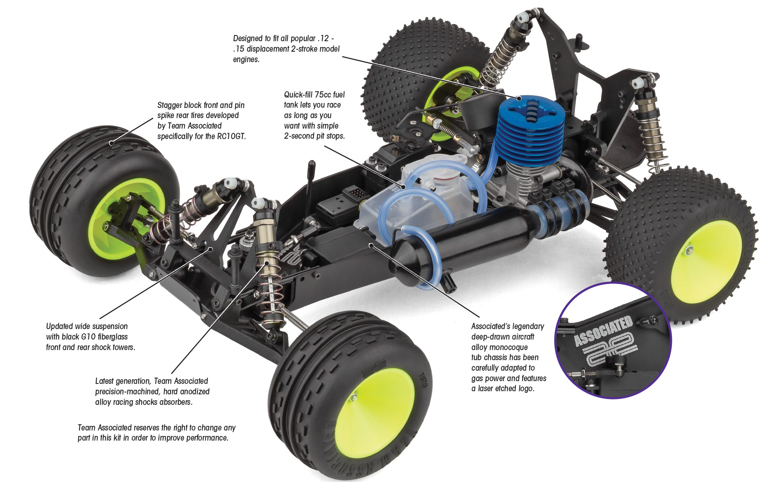

The radio control system pictured is required, but not included in this kit. PLEASE NOTE: RC10GT kit does not include an engine, but does include a manifold and exhaust pipe. It is VERY IMPORTANT that the engine and accessories are correctly matched.

|  |
| --- |
| **FEATURES** |

* GT II clear lexan body
* Hard anodized, oil filled shocks
* Ball differential
* Dual stage air filter system
* Precision bearings throughout
* Black plastic parts throughout
* Titanium RCPS style adjustable turnbuckles
* Black anodized shock caps
* Black anodized aluminum Engine manifold (Non pull start)
* Black anodized polished aluminum exhaust pipe (Non Pull Start)
* 4 Shoe clutch and flywheel system (non pull start)
* Richard Saxton King decals and livery decals included
* Black laser etched aircraft aluminum tub chassis
* Stealth ATC transmission, optimized for gas truck racing, 2.6:1 reduction
* Nickel plated, chrome rear CVA drive shafts
* Powerful rear disk brakes
* Inline steering blocks and front axles
* 30 degree caster blocks
* Adjustable slipper clutch
* 2-second, quick fill fuel tank with filter
* Updated black T2 front and rear arms
* Reversible bellcrank / servo-saver steering
* Vintage multi-surface wide front tires
* Vintage spike rear tires
* New lightweight dish style wheels

|  |  |  |
| --- | --- | --- |
| **ITEMS NEEDED TO COMPLETE** |  | **SPECIFICATIONS** |

* .12 or .15 non-pull start engine (O.S. type crank)
* Radio control battery charger
* Starter box
* Nitro fuel
* 2-channel RC surface transmitter and its batteries
* 2-channel receiver
* Receiver battery pack

|  |  |
| --- | --- |
| **Scale** | 1:10 |
| **Power** | Nitro |
| **Length** | 400mm (15.7”) |
| **Width** | 315mm (12.4”) |
| **Weight** | Varies |
| **Wheelbase** | 287.02mm (11.30”) |
| **Internal Ratio** | 2.6:1 |

Available

|  |
| --- |
| **CATALOG INFORMATION** |

|  |  |  |  |  |  |  |  |
| --- | --- | --- | --- | --- | --- | --- | --- |
| **UPC** | **Part No.** | **Description** | **MSRP** | **MAP** | **Pieces Per Case** | **Origin** | **Available** |
| 784695070677 | 7067 | RC10GT RICHARD SAXTON EDITION | $705.99 | $479.99 | 6 | TW | Sept |

Download all zipped photos here: <https://www.rc10.com/RC10GTSaxtonEdition/> (9.81 MB) Link is active for 30 days.

