For Immediate Release: October 2026

RC28F Team Kit #20195
1:28 Scale 2WD Electric On Road Competition Kit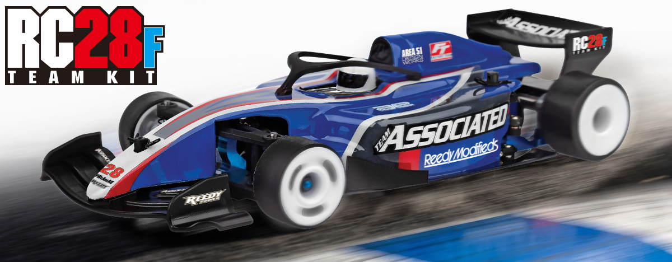

ELECTRIC ■ 1:28 SCALE ■ 2 WHEEL DRIVE ■ ON-ROAD ■ KIT
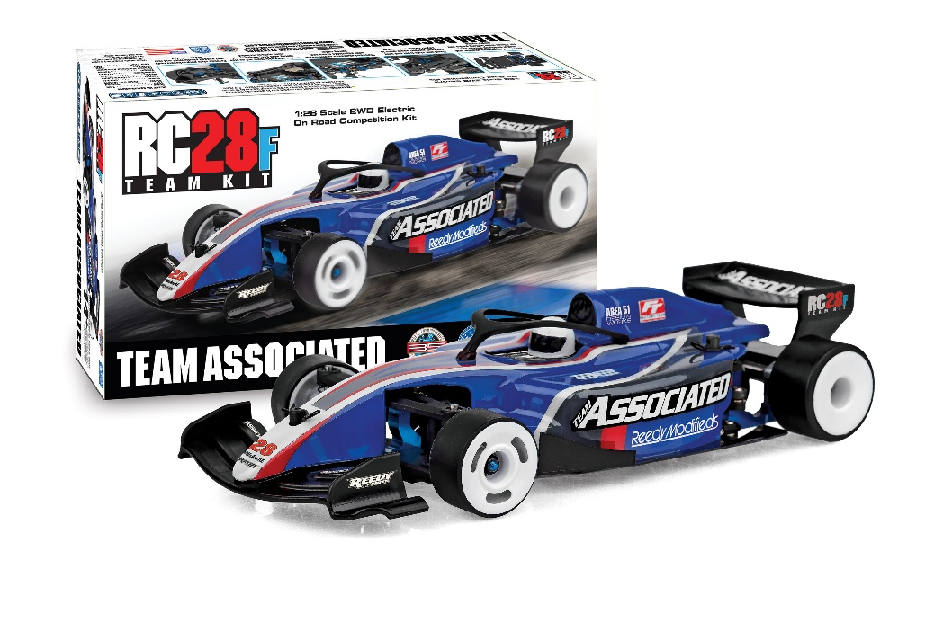
The new aluminum chassis and center bulkhead allows wider 24mm battery packs and electronic mounting space while keeping overall weight to a minimum. The pitch, roll and droop can further be tuned/Adjusted with the threaded aluminum center shock, spring collars and side damper tubes. The two-piece rear pod allows quick axle height adjustment utilizing Factory Team carbon fiber shims. This RC28F is compatible with all 28th scale Reedy Electronics. Compact, tunable, and designed to race, the RC28F is built for high performance and fun, even in tight spaces.

Full-scale F1-style racing is considered one of the most elite forms of racing in existence, with technology and looks off the chart. Though small in scale, the RC28F delivers big performance in an easy to set up package. Featuring a F1-style polycarbonate body and molded plastic wings, ample space for mounting electronics and overall weight reduction. A new F1-style inspired fixed arm style front end with optional molded upper arms to adjust caster and camber. The torsion side links (soft, medium, and hard included) replace the need for a side spring making setup easy while adding performance in areas a conventional spring does not.

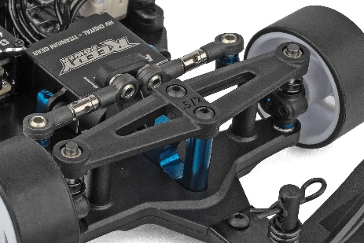
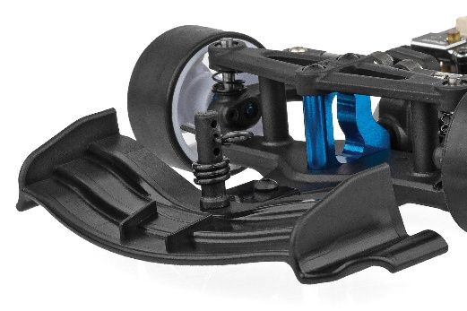

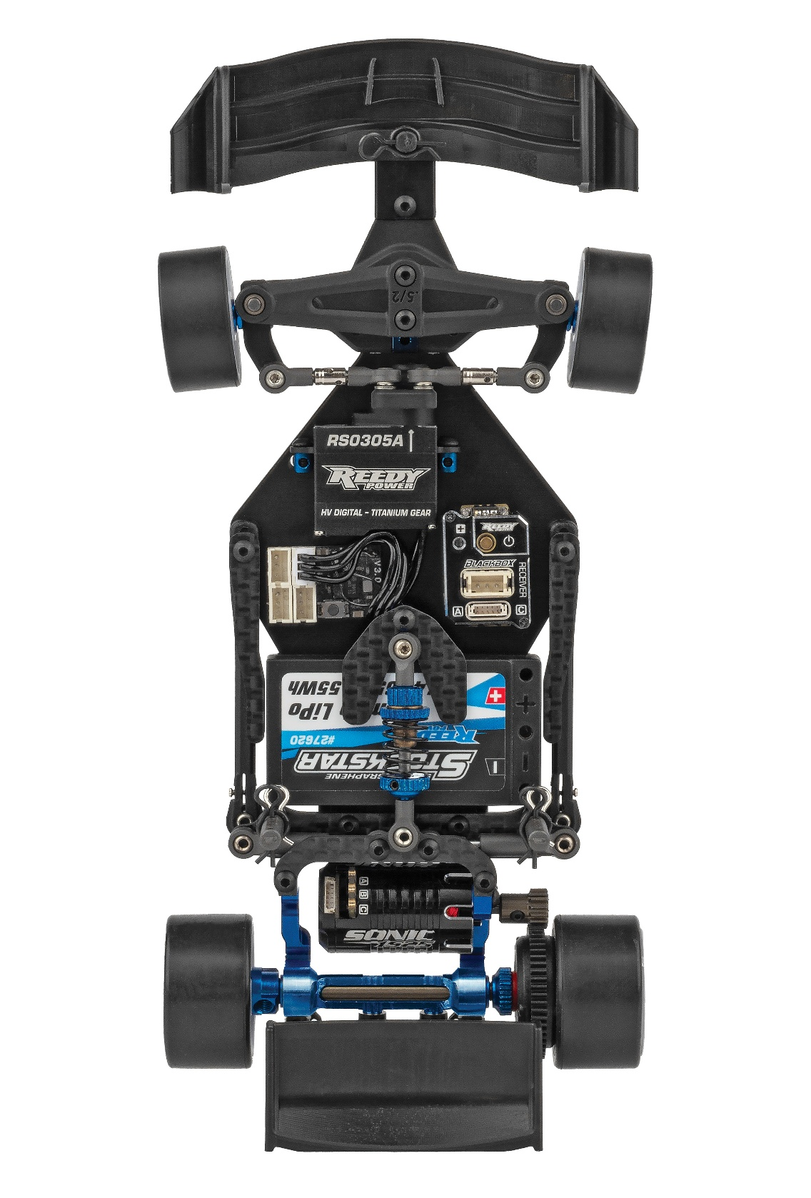

Fixed arm style front end with optional molded upper arms to adjust caster and camber
Front bulkhead design allows for quick upper arm changes with consistent fitment and alignment

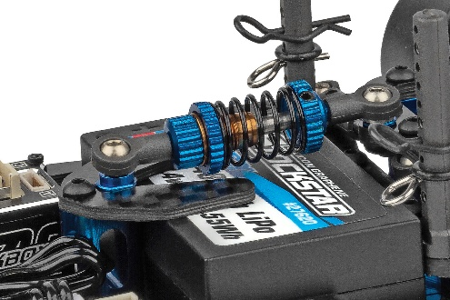
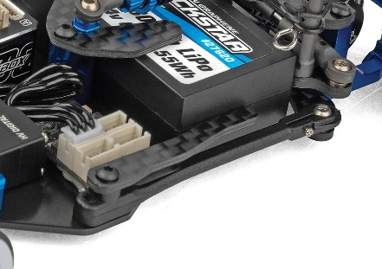

Threaded aluminum center shock with adjustable droop and spring collar
Torsion style side links act as side spring with soft, medium, and hard options included

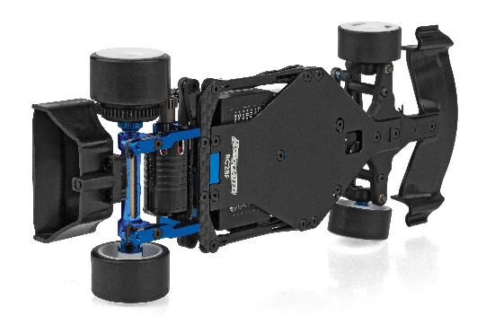
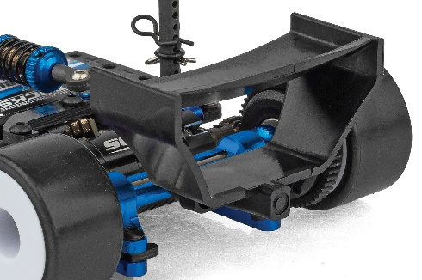

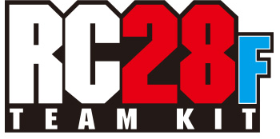
Machined aluminum chassis and center bulkhead design
F1-style polycarbonate body and molded plastic wings included
FEATURES
  SPECS
Scale | 1:28
Type | On-road
Motor: | Up to 16mm Dia. Motors
Power | Electric
Length | 176mm/6.93in
Width | Varies*
Weight | Varies*
Wheelbase | 110mm
Chassis Material | Machined Steel
Gear Pitch | 64p
Drivetrain | 2WD
• Machined aluminum chassis and center bulkhead design allows for 24mm wide battery packs and ample space for mounting electronics while also reducing overall weight
• Fixed arm style front end with optional molded upper arms to adjust caster and camber
• Front bulkhead design allows for quick upper arm changes with consistent fitment and alignment
• F1-style polycarbonate body and molded plastic wings included
• Torsion style side links act as side spring with soft, medium, and hard options included
• Adjustable rear pod roll center inserts to tune roll characteristics to grip level
• Optimized roll geometry with side damper tubes
• Team carbon fiber shims
• Gear differential included but can fit other aftermarket options currently available
• V2 White wheels included that fit optional front wheel flanges to tune steering feel
• Team Associated’s quality, distribution, support, and customer service

*Final width, length and weight will vary based on electronics, tire configuration, wing position and vehicle setup.


Recommended Electronics:

- Motors (#27503 SONIC 1525 2500kV Micro Brushless Motor) (#27504 SONIC 1525 3500kV Micro Brushless Motor)
(#27505 SONIC 1525 4500kV Micro Brushless Motor)
- Battery (#27620 REEDY Stockstar 480mah 65c 7.4v 1:28 Stick)
(#27610 REEDY POWER 400mAh 60C 7.4V 1:28 Stick Battery)
- Servo (#27175 REEDY RS0305A Micro Hi-Speed Servo)
- ESC (#27045 REEDY BLACKBOX 300R Competition
Micro ESC)
- Charger (#27203 Reedy 1416-C2L Dual AC/DC Competition Balance Charger)

Other Helpful Items:

• Body Scissors (AE Part # 1737)
• Reamer / Hole Punch
• Hobby Knife
• Needle Nose Pliers
• Wire Cutters
• Soldering Iron
• FT 4.5mm Short Nut Driver (AE Part #21694)
• FT 28th Scale Ride Height Gauge (AE Part #21693)
• Calipers or a Precision Ruler

CATALOG INFORMATION

UPC | Part No. | Description | MSRP | MAP | Pieces Per Case | Origin | Available
784695201958 | 20195 | RC28F Team Kit | $404.99 | $269.99 | 20 | TW | October
Download all zipped photos here: https://RC10.com/RC28FKitImages/ (7.9MB) Link is active for 30 days.
Please refer to our MAP Policy here: https://img2c.associatedelectrics.com/pdf/map-policy.pdf

