

**For Immediate Release:** Sept 2025

**RC10T7 Team Kit** #70005

1:10 Scale Electric 2WD Off-Road Competition Stadium Truck Kit

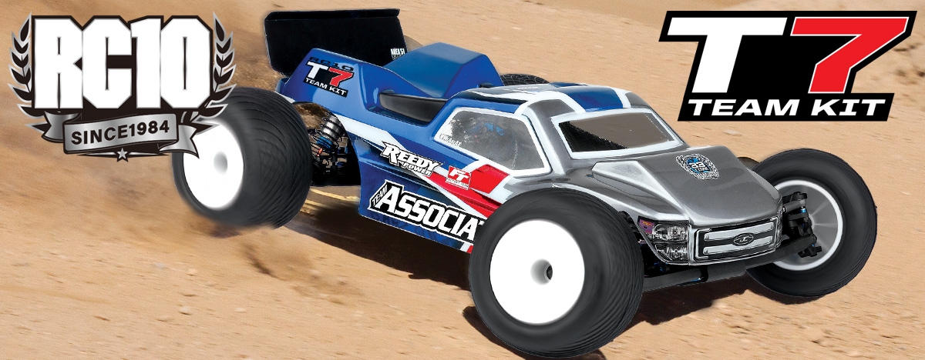

|  |
| --- |
| **ELECTRIC ■ 1:10 SCALE ■ 2 WHEEL DRIVE ■ OFF-ROAD ■ KIT** |

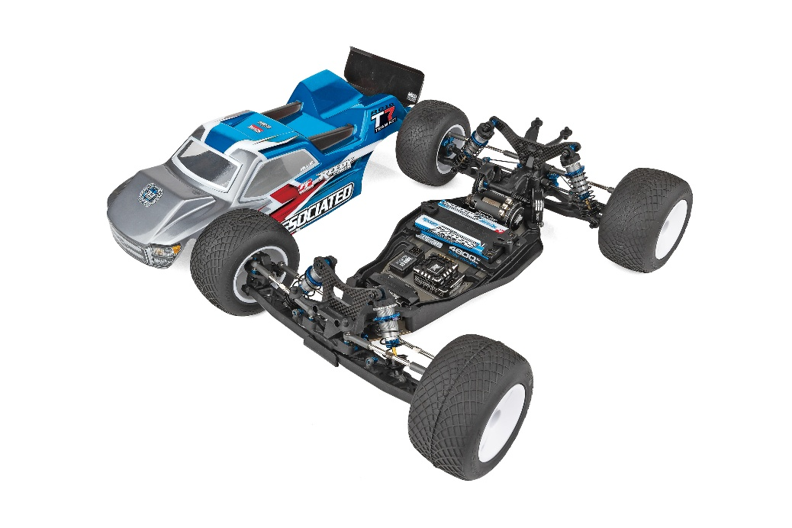

**Race-winning heritage.**

Based on Team Associated’s RC10B7 platform, the RC10T7 Team Kit is the next iteration of the successful truck platform. Design goals were to lower CG, add durability, and incorporate the RC10B7 adjustability and performance. Engineers inside Team Associated’s Area 51 first priority was the design of the new 3-gear laydown transmission to reduce drag and transfer all of the power to the larger truck tires.

Champions by Design. The RC10T7 shares key components with the RC10B7 and RC10B7D Team Kits, making it easier than ever to run multiple classes at the same time. The primary suspension update is to lower the CG with shorter 25mm long front and 31mm long rear 13mm big bore shocks. The new chassis design is a stronger truck version of the RC10B7 buggy design and gets a new truck specific gull wing long arm suspension to improve grip and predictability in all conditions. On top of that, the kit includes updated zero KPI steering blocks and updated caster blocks, along with the legacy B7 features for tuning the front end feel. The new steel front inner hinge pin brace and updated B7 V2 caster block add to front end durability. The new RC10T7 offers the same mounting locations along with anti-roll bar hardware as the RC10B7 while pairing nicely with wide mount anti-roll bars that fit the new suspension arms.

The RC10T7 updated specs give racers an edge over the competition.

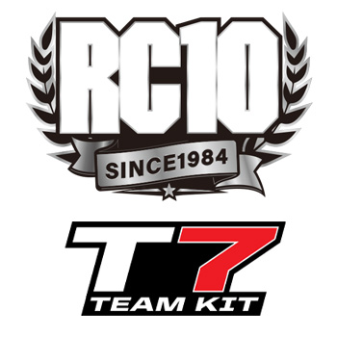

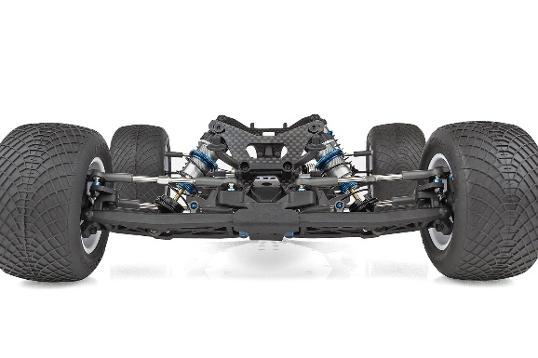

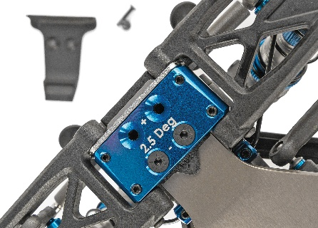

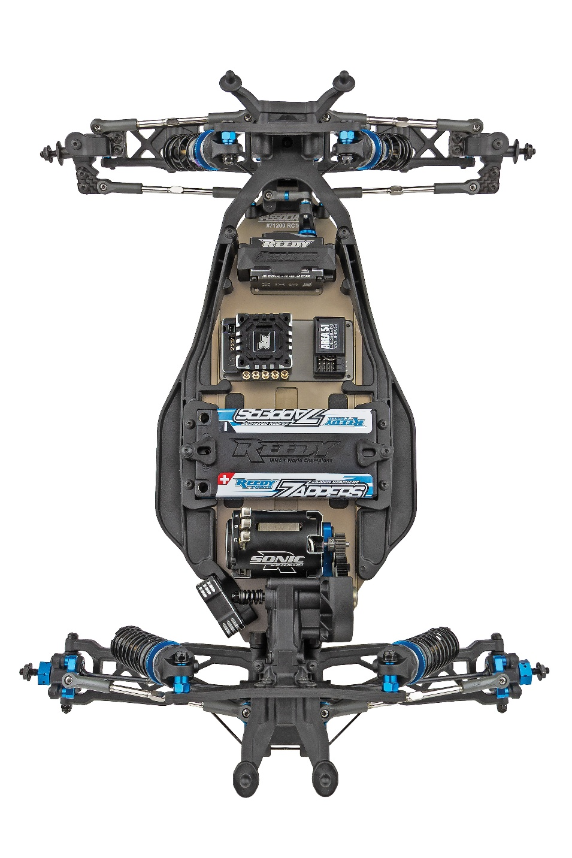

New truck specific gull wing long arm suspension with low CG truck shocks

Aluminum front bulkhead and steel hinge pin brace included in updated front-end design

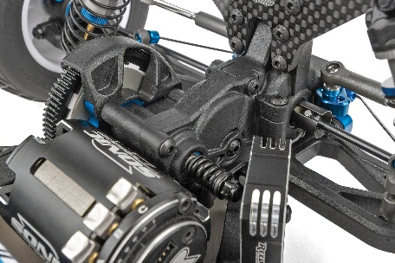

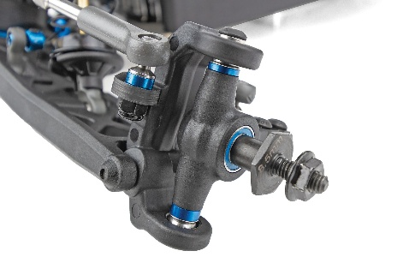

New 3-Gear laydown transmission

New updated B7 V2 caster block for added stiffness and strength. 0 KPI options included

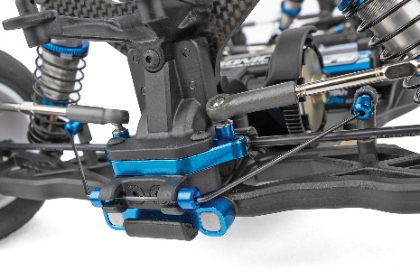

Includes anti-roll bars front and rear, accessible design based on RC10B7

Updated differential height inserts and RC10B7 ball differential included

|  |  |  |  |  |
| --- | --- | --- | --- | --- |
| **FEATURES** | |  |  | | --- | --- | | **SPECS** |  | |  |

• New 3-Gear laydown transmission

- Durable new split case design for secure gear mesh

- Large 10mm aluminum idler shaft integrates

into transmission structure

- Added durability and stability of 54 tooth idler with 10x15mm idler bearings

- Responsive power delivery with reduced lag and lower temps for spec racing

- Gearbox retrofits B7 buggy

* New truck specific gull wing long arm suspension improves grip and predictability in all conditions
* New updated B7 V2 caster block for added stiffness
* New 0 KPI steering blocks with 3mm and 4mm trail
* Aluminum front bulkhead and steel hinge pin brace included in front-end design
* RC10B7 ball differential included (compatible with B7 gear differential)
* New low CG 25mm and 31mm length 13mm big-bore shock bodies
* TiN gold 3x24mm and 3x29mm shock shafts
* Included anti-roll bars front and rear, accessible design based on RC10B7

|  |  |
| --- | --- |
| **Scale** | 1:10 |
| **Type** | Off Road |
| **Power** | Electric |
| **Drive:** | 2WD |
| **Length** | Varies* |
| **Width** | Varies* |
| **Weight** (Chassis only) | Varies* |
| **Wheelbase** | Varies* |
| **Chassis** | Machined aluminum |
| **Suspension** | Independent Front and Rear |
| **Internal Gear Ratio:** | 2.60:1 |

* Final weight will vary depending on the electronics used to complete the kit.

|  |  |
| --- | --- |
| **OTHER HELPFUL ITEMS** |  |

• Silicone shock fluid (refer to catalog for complete listings)

• Silicone diff fluid (refer to catalog for complete listings)

• Body scissors (AE part # 1737)

• Reamer (AE part # 1499) / Hole punch

• FT wrench set (AE part #1519)

• Hobby knife

• Needle nose pliers

• Wire cutters

• Soldering iron

• Calipers or a precision ruler

**Items required for operation:** Motor, battery, ESC, servo, receiver, paint, tires, lexan body, and radio. Assembly and painting required.

|  |  |  |  |  |  |  |  |
| --- | --- | --- | --- | --- | --- | --- | --- |
| **CATALOG INFORMATION** | | | | | | | |
| **UPC** | **Part No.** | **Description** | **MSRP** | **MAP** | **Pieces Per Case** | **Origin** | **Available** |
| 784695700055 | 70005 | RC10T7 TEAM KIT | $629.99 | $429.99 | 6 | TW | Sept |

Download all zipped photos here: <https://www.rc10.com/t7imagespr/> Link is active for 30 days.

Please refer to our MAP Policy here: <https://img2c.associatedelectrics.com/pdf/map-policy.pdf>

