

**For Immediate Release:** July 2025

**RC28 Team Kit #20165**

1:28 Scale 2WD Electric On-Road Competition Kit

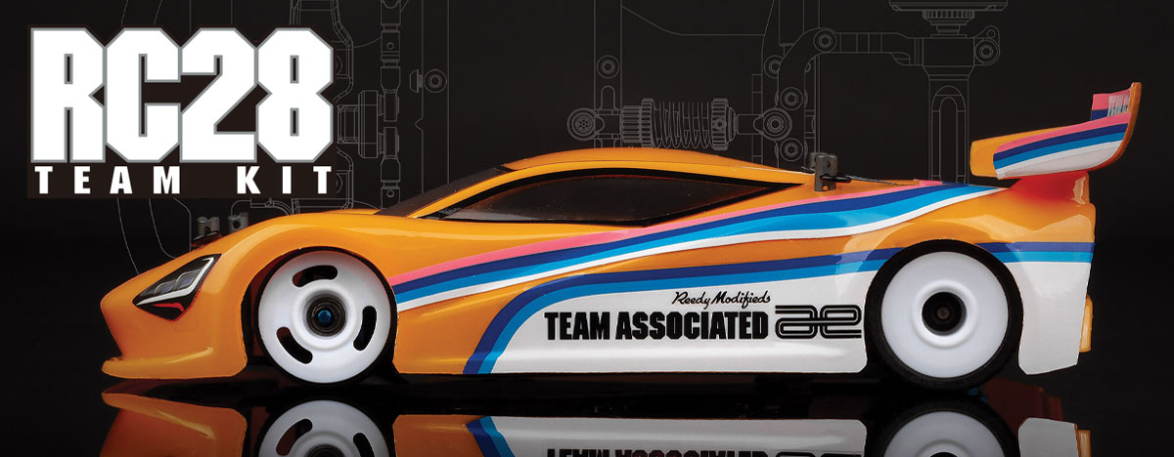

|  |
| --- |
| **ELECTRIC ■ 1:28 SCALE ■ 2 WHEEL DRIVE ■ ON-ROAD ■ KIT** |

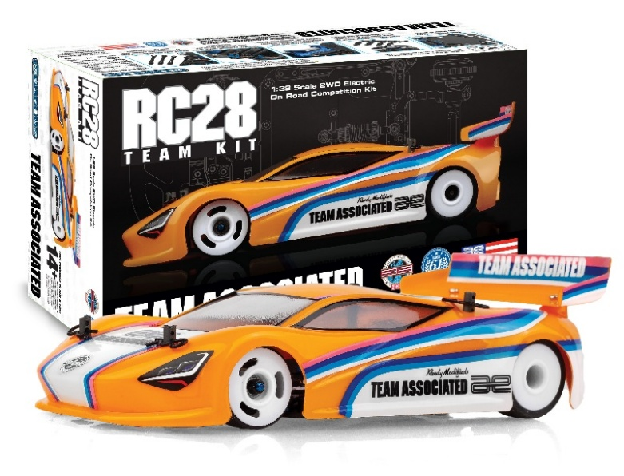

Introducing the Team Associated **RC28 Team Kit**. This compact on-road race car is designed with the same engineering precision found in every AREA 51-developed product. Though small in scale, the RC28R delivers big performance in an easy to set up package. Featuring a fixed-arm front suspension with included optional molded upper arms for tuning caster and camber. The torsion side links (soft, medium, and hard included) replace the need for a side spring making setup easy while adding performance in areas a conventional spring does not. The battery holder design ensures quick access without disturbing the

center shock.

The steel chassis plate provides a low center of gravity while the insert adjustable roll center enables chassis roll adjustment based on the grip level. The pitch, roll and droop can further be tuned/Adjusted with the threaded aluminum center shock, spring collars and side damper tubes. The two-piece rear pod allows quick axle height adjustment utilizing Factory Team carbon fiber shims. Fine-tune Ackermann on the fly with the adjustable servo mount. Compact, tunable, and designed to race, the RC28R is built for high performance and fun—even in tight spaces.

Steel chassis plate for low center of gravity

Fixed arm style front end with optional molded upper arms to adjust caster and camber

Threaded aluminum center shock with adjustable droop and spring collar

Torsion style side links act as side spring with soft, medium, and hard options included

Two-piece rear pod with adjustable axle heights for different tire diameters and ride heights utilizing Factory Team carbon fiber shims

Easily removable battery holder to access the battery without removing center shock

|  |  |  |  |  |
| --- | --- | --- | --- | --- |
| **FEATURES** | |  |  | | --- | --- | | **SPECS** |  | |  |

• Steel chassis plate for low center of gravity

• Fixed arm style front end with optional molded upper arms to adjust caster and camber

• Front bulkhead design allows for quick upper arm changes with consistent fitment and position

• Optimized steering geometry with adjustable servo mount to tune ackerman on the fly

• Easily removable battery holder to access the battery without removing center shock

• Torsion style side links act as side spring with soft, medium, and hard options included

• Adjustable rear pod roll center inserts to tune roll characteristics to grip level

• Optimized roll geometry with side damper tubes

• Threaded aluminum center shock with adjustable droop and spring collar

• Two-piece rear pod with adjustable axle heights for different tire diameters and ride heights utilizing Factory Team carbon fiber shims

• Gear differential included and can fit other aftermarket options currently available

• Hard plastic and polycarbonate body mounting options included

• White wheels included that fit optional front wheel flanges to tune steering feel

• Universal front bumper included

|  |  |
| --- | --- |
| **Scale** | 1:28 |
| Type | On-road |
| Motor: | 16mm Dia. Motors |
| **Power** | Electric |
| **Length** | 140mm/5.51in |
| **Width** | Varies |
| **Weight** | Varies* |
| **Wheelbase** | 98mm |
| Chassis Material | Machined Steel |
| Suspension | Independent A-arm suspension |
| Gear Pitch | 64p |
| Drivetrain | RWD |

Not Included: Body

|  |  |
| --- | --- |
| **OTHER HELPFUL ITEMS** |  |

• Silicone Shock Fluid (Refer to catalog for complete listings)

• Silicone Diff Fluid (Refer to catalog for complete listings)

• Body Scissors (AE Part # 1737)

• Reamer / Hole Punch

• FT Wrench Set (AE Part #1519)

• Hobby Knife

• Needle Nose Pliers

• Wire Cutters

• Soldering Iron

• Calipers or a Precision Ruler

• 1.5mm hex, .050” hex, 1.3mm hex, 0.9mm hex, 4.5mm nut, and PH00 drivers

|  |
| --- |
| **CATALOG INFORMATION** |

|  |  |  |  |  |  |  |  |
| --- | --- | --- | --- | --- | --- | --- | --- |
| **UPC** | **Part No.** | **Description** | **MSRP** | **MAP** | **Pieces Per Case** | **Origin** | **Available** |
| 784695201651 | 20165 | RC28 Team Kit | $367.99 | $249.99 | 20 | TW | Aug |

Download all zipped photos here: <https://www.rc10.com/rc28rimages/>. Link is active for 30 days.

