
For Immediate Release: August 2026

New! RC10B7 FT caged thrust bearing slipper conversion and FT 3-pad
slipper hubs

Factory Team presents the RC10B7 FT caged thrust bearing slipper conversion and FT 3-pad slipper hubs! The caged thrust slipper greatly reduces the chances of your slipper nut loosening over the course of your run. A subtle touch of our signature blue to this assembly gives a touch of elegance and lets everyone know you value consistency both on and off the track. The 3-pad slipper is more consistent as well due to its better heat dissipation over the traditional 2-pad system. Be sure to use the bigger diameter spring adapters (#91891). This allows everything to fit properly due to the spring having a shorter length and the three slipper hubs taking up more space than the typical two slipper hubs.

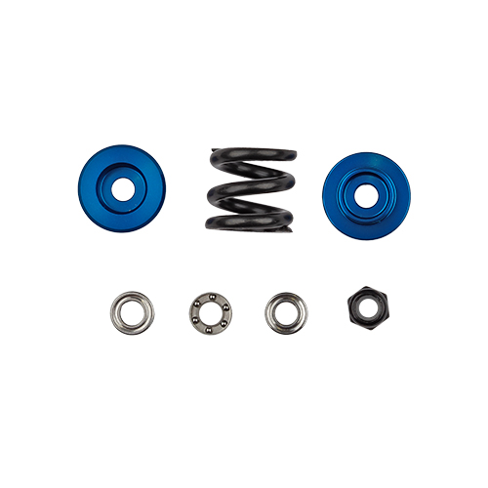

#92594
RC10B7 FT Caged Thrust Bearing Slipper Conversion

Compatible with:
90041/90042/90046/90047

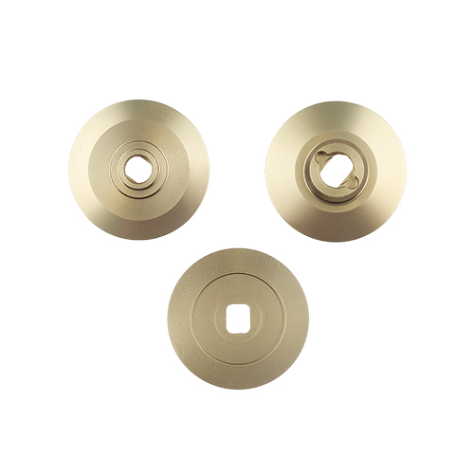

#92595
RC10B7 FT 3-Pad Slipper Hubs

Compatible with:
90041/90042/90046/90047

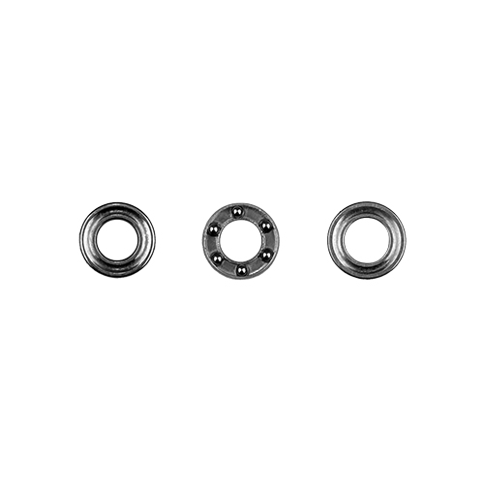
#92460
Caged Thrust Bearing, Slipper

Compatible with:
90041/90042/90046/90047

UPC | Part No. | Description | MAP | MSRP | Origin | Available
784695925946 | 92594 | RC10B7 FT Caged Thrust Bearing Slipper Conversion | $16.99 | $19.99 | TW | 
784695925953 | 92595 | RC10B7 FT 3-Pad Slipper Hubs | $29.74 | $34.99 | TW
784695924604 | 92460 | Caged Thrust Bearing, Slipper | $7.99 | $7.99 | TW

