**Marcus Kaerup Wins Team Associated’s 35th IFMAR World Championship Driving the B84D**

**Dates: October 4 – 6, 2025 Location: Hills Off-Road RC – Castle Hill, NSW, Australia**

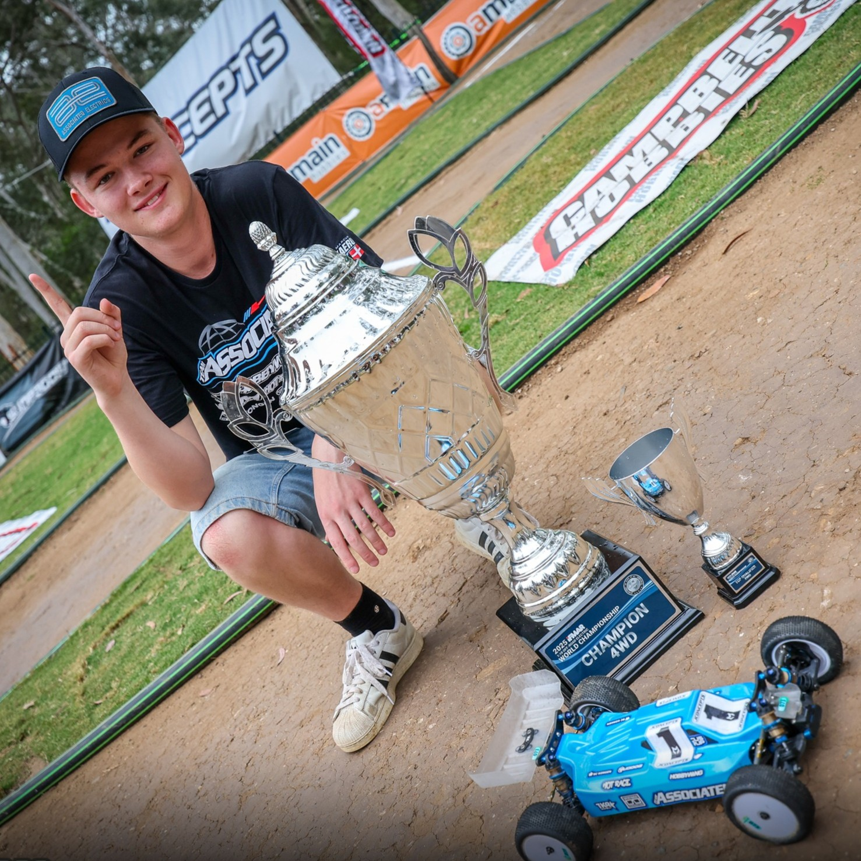

*Marcus Kaerup - IFMAR World Champion*

Kaerup does it again! Congratulations to now two-time IFMAR World Champion Marcus Kaerup on his 1:10 4wd off-road world championship victory at Hills Off-Road RC driving the B84D. This is Marcus’ second IFMAR World title in just over a month’s time.

With a rich history of hosting epic World Championship events, Australia last hosted the IFMAR 1:10 Off-Road World Championships in 1989 that saw Masami Hirosaka win Team Associated’s 8th IFMAR World Championship. Fast forward 36 years and Hills Off-Road RC now plays host to the 2025 event less than 30 km from the iconic St. Ives facility. Nestled amongst the trees of Castle Hill in Fred Caterson Reserve and boasting one of the top outdoor racetracks in the world, Hills Off-Road RC set the stage for an epic event.

After securing the 2wd TQ with Marcus Kaerup, earning 7 out of 10 A-main positions, and just missing out on the overall 2wd title the event shifted to 4wd with a change in track direction. From the first practice, the B84D buggies of Davide Ongaro and Marucs Kaerup found their way to the top of the time sheets. Then as qualifying began, the duo again rose to the top with Kaerup securing three TQs out of five and Ongaro taking one TQ. This saw Kaerup line up first for the triple A-mains with teammate Ongaro in the second grid position. From the start of the first main, Kaerup controlled the pace with Ongaro right behind. While Kaerup led every lap in A1 and A2, the racing was close and intense with Ongaro making multiple pass attempts at the challenging jump landings. In the end, Kaerup took victories in A1 and A2 with Ongaro winning A3, thus securing a Team Associated 1-2 finish and a 35th IFMAR World Championship.

Thank you to the entire Hills Off-Road staff, the team members and customers who traveled far and wide to compete in this truly unique world championship event.  And congratulations to Denmark star, Marcus Kaerup on an outstanding 2025 proving once again that WeAreAE and Champions by Design.

Photos courtesy of Circus RC

Associated Electrics - Champions By Design