For Immediate Release: December 2025

RC28 ZOOM RTR #20166
1:28 Scale 2WD Electric Ready-to-Run Buggy

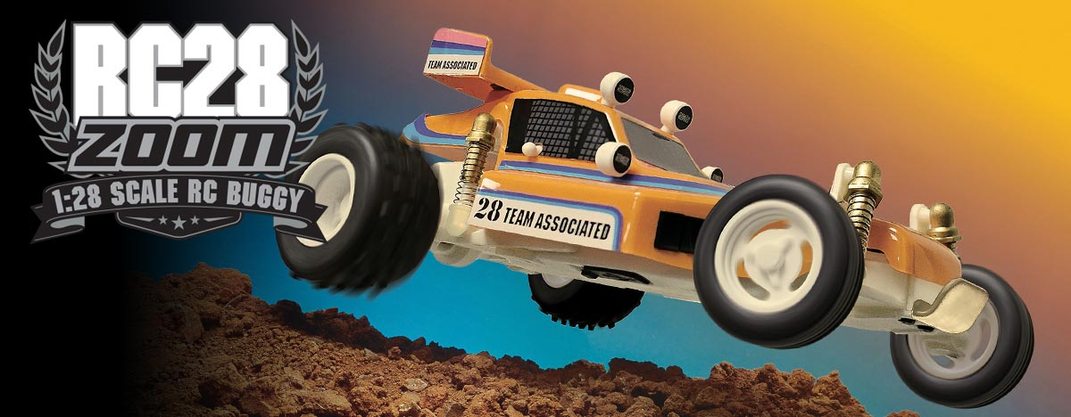
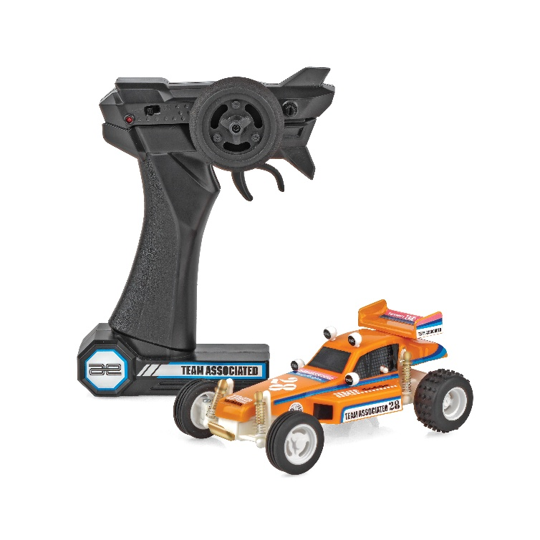
ELECTRIC ■ 1:28 SCALE ■ 2 WHEEL DRIVE ■ READY-TO-RUN
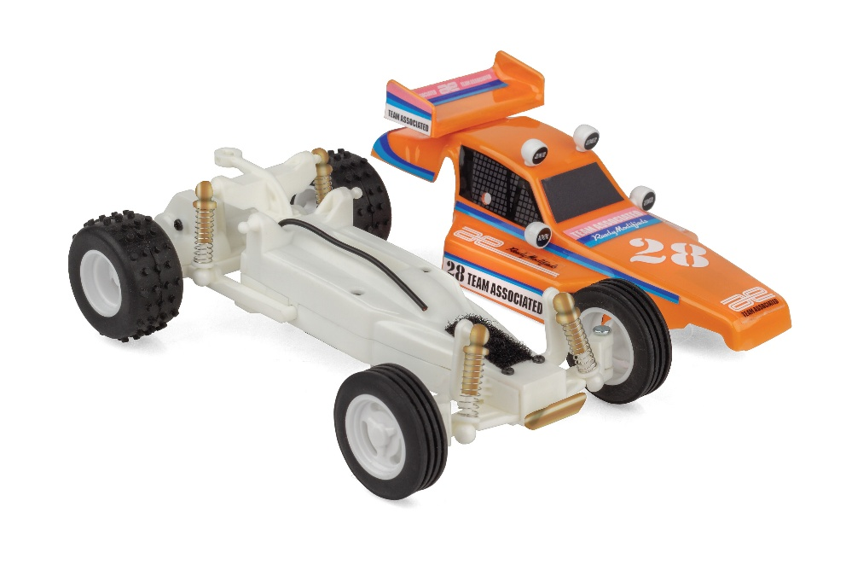
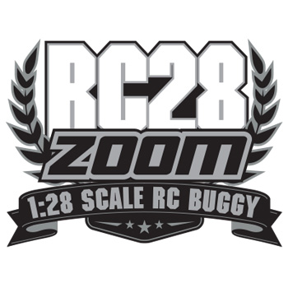
The NEW Team Associated RC28 ZOOM is a scale replica of the iconic RC10 Classic Kit! This RC28 ZOOM looks great and drives smooth thanks to a powerful electric motor and capable drivetrain.

The included 2.4 GHz transmitter allows complete control enabling you to navigate around, through and over obstacles with ease! With its off-road stance and rubber tires, the RC28 ZOOM handles like no other vehicle in its category.

The vehicle’s integrated battery is easily recharged with the included USB-C cord. So the RC28 ZOOM is ready to go right out of the box! Just charge and drive!
FEATURES
  SPECS
• 2.4GHz transmitter Included
• Included USB-C charging cord to charge the integrated battery
• Fully pre-printed and decaled RC10 buggy
replica body
• Realistic wheels and rubber tires
• Everything included in the box -- just charge and go!

Scale | 1:28
Body Style: | Buggy
Power | Electric
Length | 143mm (5.63in)
Width | 86mm (3.39in)
Weight | 76.2g (0.17lbs)
Wheelbase | 101.5mm (4in)
Drivetrain | 2WD
Assembly Level: | Ready-To-Run*

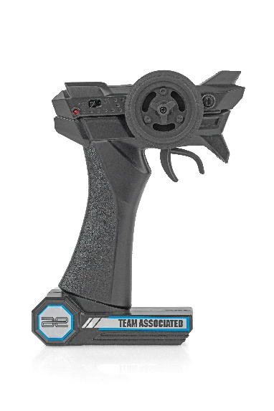

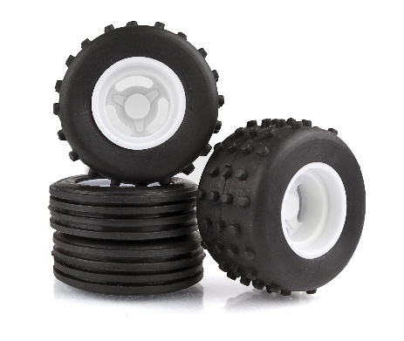

* This vehicle is fully assembled and ready to run right out of the box.

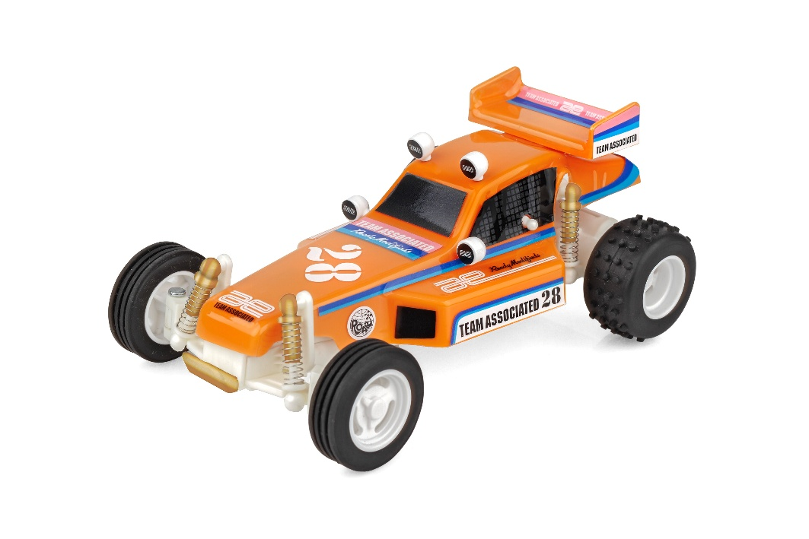

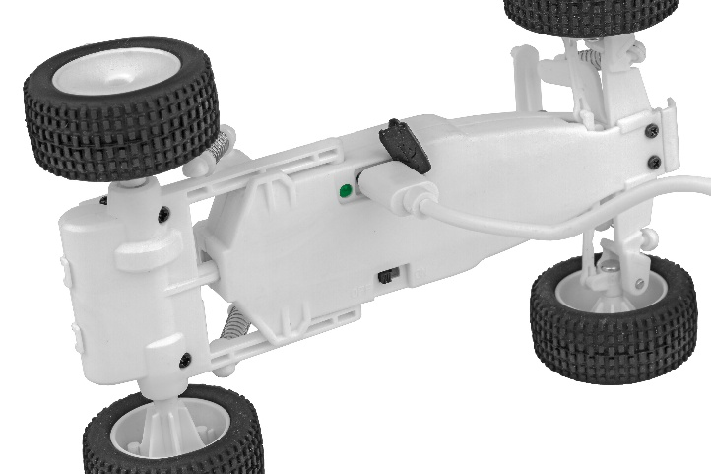

CATALOG INFORMATION

UPC | Part No. | Description | MSRP | MAP | Pieces Per Case | Origin | Available
784695201668 | 20166 | RC28 Zoom RTR | $99.99 | $59.99 | 12 | TW | January

Download all zipped photos here: https://www.rc10.com/RC28RC28TImageszip/(4.47MB). Link is active for 30 days.
Please refer to our MAP Policy here: https://img2c.associatedelectrics.com/pdf/map-policy.pdf

