For Immediate Release: December 2025

#40138 RC10 Trail Truck Cattleman Kit
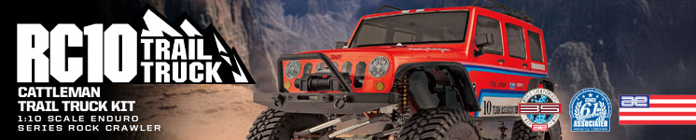

ELECTRIC ■ OFF-ROAD ■ 1:10 SCALE ■ 4 WHEEL DRIVE ■ KIT

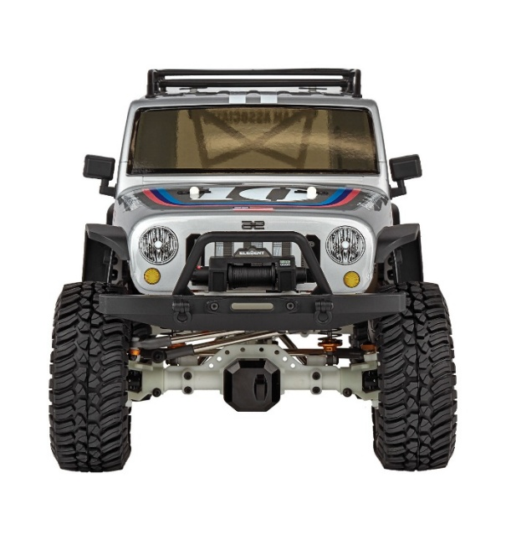
A performance rig built to endure. When hitting the trail, you want to do it with confidence, and the answer is the RC10 Trail Truck Cattleman Kit from Team Associated Element RC.

At the heart of the Trail Truck Cattleman Kit is our revolutionary Stealth® X gearbox. Although the exterior appears to have a conventional 3-gear transmission look, the inside is far from conventional. The Stealth® X features the ability to adjust the rear drive ratio independently of the front drive across three levels: stock overdrives the front end 5.7%, option 1 provides a one-to-one drive ratio front-to-rear (available separately), and option 2 overdrives the front end 11.83%. Feeding the power to the tires are 3-piece telescopic driveshafts with an extruded aluminum center section, universal front drive axles, and hardened steel ring and pinion gears. With the Enduro drivetrain, delivering useful power will not be an issue.

With all this packed in one box, we know the Cattleman Rock Crawler Kit is ready for the trail – Are you?

Ch

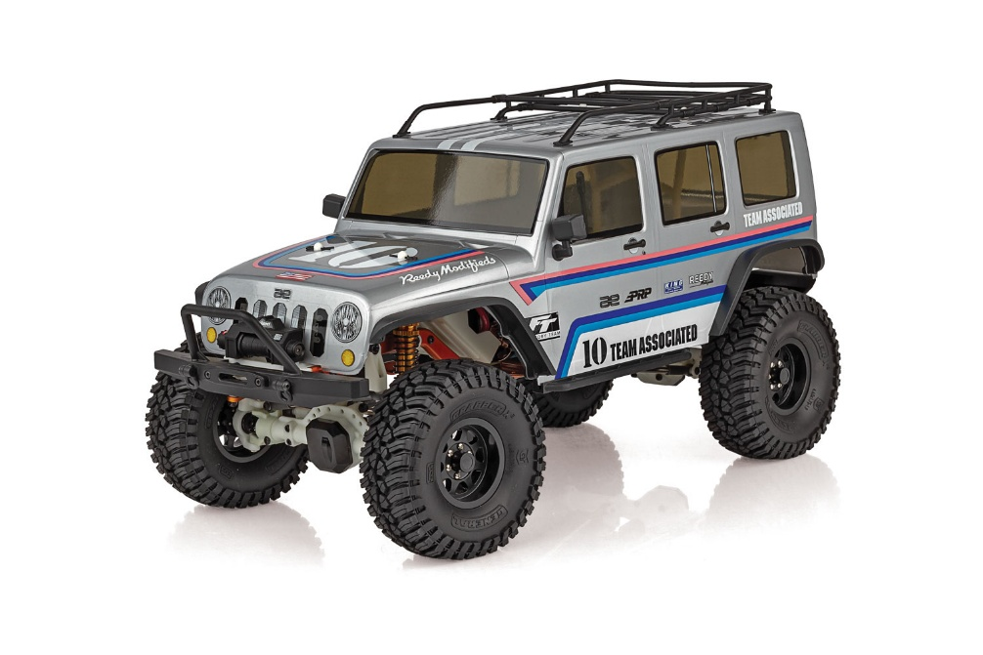

CHASSIS FEATURES:

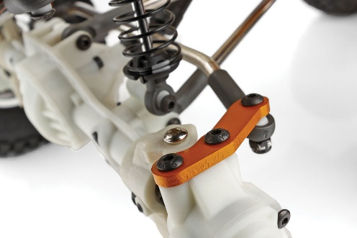
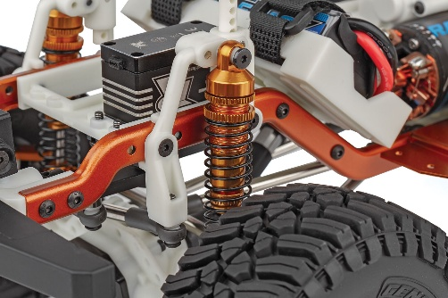
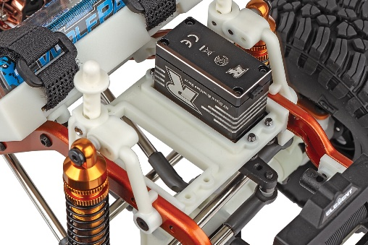

Integrated servo
winch mount:

Mounting a winch directly to the chassis is the strongest and most reliable spot on any trail rig, positioned alongside the steering servo for overall chassis balance and weight distribution.
BTA steering & Aluminum steering plates:

Behind-the-axle steering provides better approach angles, more clearance, and a cleaner look. Bolt-on aluminum steering plates allow for more adjustments, strength, and future modifications.

Threaded aluminum shock bodies:

Threaded gold anodized aluminum and fluid-filled, these shocks keep the vehicle stable on the trail and retain oil even in the roughest terrain.

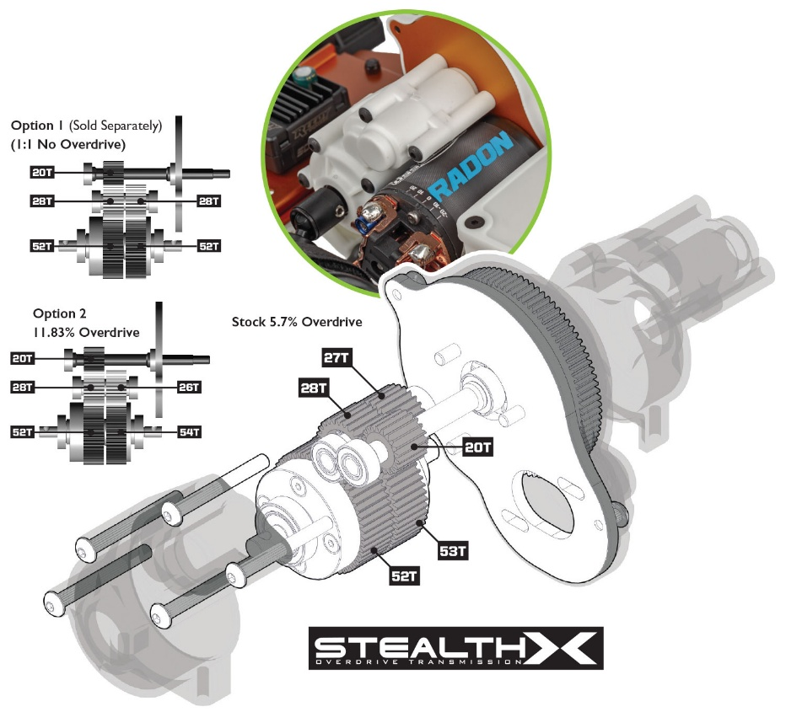
Stealth® X gearbox with adjustable overdrive gears:

At the heart of the Enduro is our revolutionary Stealth¨ X gearbox. Although the exterior appears to have a conventional 3-gear transmission look, the inside is far from conventional. The Stealth¨ X features the ability to adjust the rear drive ratio independently from the front drive in 3 levels. Stock overdrives the front end 5.7%, option 1 provides a one-to-one drive ratio front to rear and option 2 overdrives the front end 11.83%.

*Due to ongoing R&D, photos may not match production components

ADDITIONAL FEATURES

- CMS [Chassis Mounted Servo]  - Adjustable front track bar  - Universal front drive axles  - Gold colored stamped steel frame rails  - Enclosed receiver box  - 12mm wheel hexes  - Adjustable front and rear bumper mounts  - Adjustable width rock sliders  - Two battery boxes  - Gold anodized aluminum motor plate  - Adjustable body posts | - Optimized ball cups for more fluid axle articulation  - Adjustable rear shock tower mount positions  - Telescopic driveshafts front and rear  - Extruded aluminum driveshaft splines  - One-piece rear axle design  - Splined front axle with adjustable caster  - Metal gears throughout axles  - Machined steel top shaft  - Heavy duty 5mm diameter steel links  - Metal ball bearings included  - Factory Team #42390 Steel Diff Covers 43g  (Front and Rear)

BODY FEATURES
All in the details. No trail truck would be complete without a detailed and realistic looking body. The RC10 Trail Truck Cattleman is just that, with inspired styling from the classic Team Associated RC10.

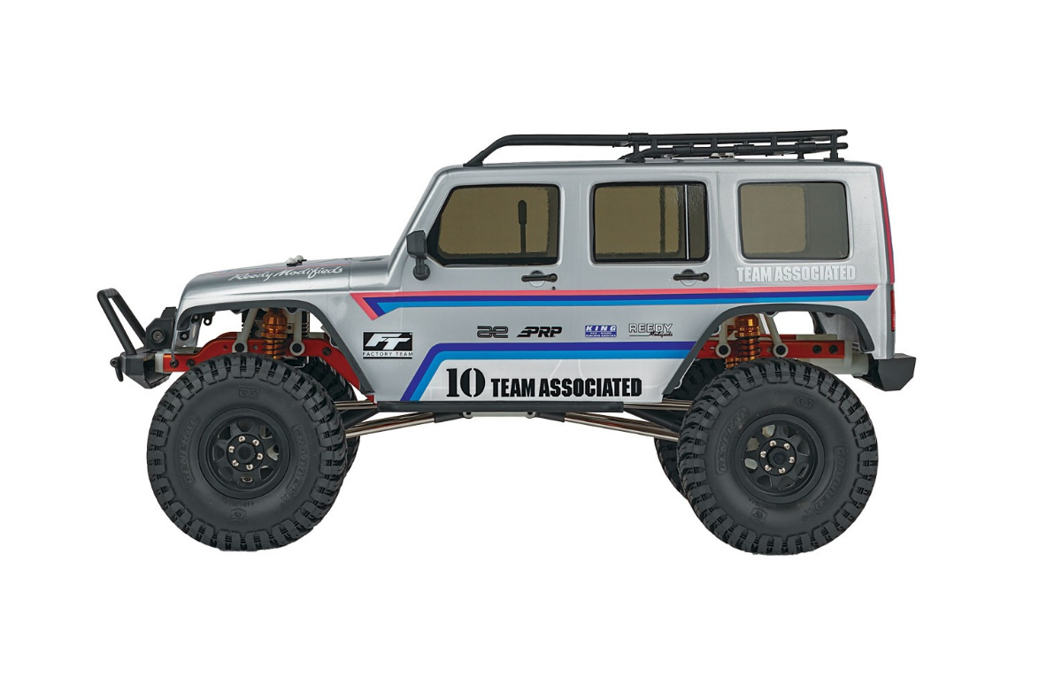
The RC10 Trail Truck Cattleman Kit is heavily inspired by the classic look of the original Team Associated RC10 off-road buggy released in 1984. This tribute trail truck kit features a full color decal sheet emulating the legendary livery. The chassis comes complete with natural color plastic, black wheels, and gold anodized aluminum accents.

The RC10 Trail Truck Cattleman body is made from high-strength polycarbonate and comes clear so you can paint it the traditional Camel Yellow or the color of your choice. This body was designed for both looks and function, featuring a single-piece design with injection-molded roof rack, bumpers, mirrors.

Out of the box, the RC10 Trail Truck Cattleman kit is ready to tackle the elements; just build it and go – your journey begins here!

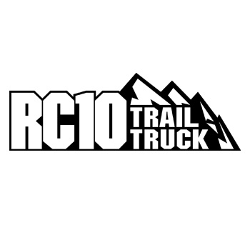





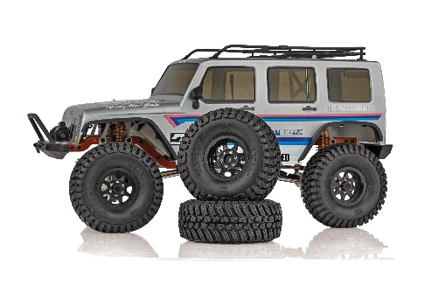
Officially Licensed Wheels and Tires: Gripping the trail is a set of officially licensed General Grabberª X3 tires molded in a high-performance, soft compound rubber. The General Grabberª X3 tires are mounted on officially licensed black Method 701 Trail Series beadlock wheels. The combination of industry leading General Tiresª and Method Wheels make the Enduro RC10 Trail Truck look and perform great.

Scale | 1:10
Type | Off-Road
Length | 462mm (18.18”)
Power | Electric
Width | 260mm (10.2”)
Wheelbase | 313mm (12.3”)
Weight | Varies
Chassis | Stamped Steel
Suspension | 3-Link Front / 4-Link Rear
Internal Gear Ratio | Varies
Drivetrain | 4WD
Tire | 1.9” General Grabber™ X3
Gear Pitch | 48 Pitch
Wheel size | 1.9” Method Wheels
Build type | KIT
Shock type | Threaded, Aluminum Shock Bodies
Body | Cattleman
Ball bearings | 24 Metal Ball Bearings
Experience Level | Beginner to Advanced
Recommended Environment | Mother Earth
MORE BODY FEATURES |  | SPECIFICATIONS

- RC10 single-piece Cattleman clear trail truck body thermoformed in high-strength polycarbonate

- Injection-molded mirrors and roof rack
- RC10 decal sheet
- Adjustable injection-molded front and rear bumpers
- Realistic styling
- Licensed 1.9”x4.65” General Grabber™ X3 tires
- Licensed 1.9” Method 701 Trail Series beadlock wheels

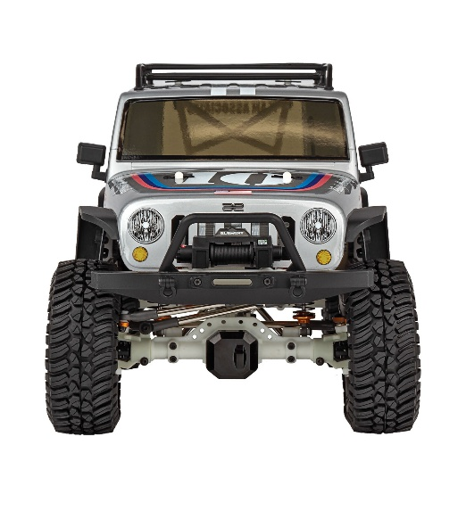



UPC | Part No. | Description | MSRP | MAP | Pieces Per Case | Country of Origin | Available
784695401389 | 40138 | RC10 Trail Truck Cattleman Kit | $549.99 | $369.99 | 2 | TW | December

Download all zipped photos here: https://rc10.com/RC10CattlemanImagesZip/ (3.5MB). Link is active for 30 days.
Please refer to our MAP Policy here: https://img2c.associatedelectrics.com/pdf/map-policy.pdf

General Grabber™ is a trademark of CONTINENTAL TIRE NORTH AMERICA, INC. CORPORATION

