

**For Immediate Release: 2025**

**Parts for the RC10 Kinwald Edition Kit**

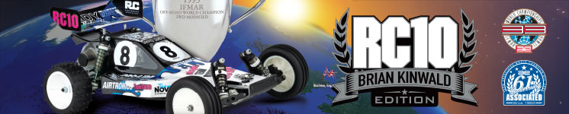

Parts for the # **6041** RC10 Kinwald Edition Kit

Available June

|  |  |  |  |  |  |  |  |
| --- | --- | --- | --- | --- | --- | --- | --- |
| UPC | Part No. | Description | Origin | MSRP | MAP | S, O, A | Available |
| 784695041844 | 4184 | Nylon Locknuts, 4-40 | TW | $5.99 | $5.99 | S | Soon |
| 784695065697 | 6569 | Idler Gear | TW | $7.99 | $7.99 | S | Soon |
| 784695065642 | 6564 | Transmission Case | TW | $15.99 | $13.59 | S | Soon |
| 784695067509 | 6750 | BK Front Shock Tower, Car | TW | $25.99 | $22.94 | S | Soon |
| 784695067516 | 6751 | RC10 BK Rear Shock Tower, Iridium Carbon Fiber | TW | $34.99 | $29.74 | S | Soon |
| 784695067523 | 6752 | RC10 BK Battery Hold Down Strap | TW | $15.99 | $13.59 | S | Soon |
| 784695067530 | 6753 | RC10 Bk Transmission Brace, Carbon Fiber | TW | $9.99 | $9.99 | S | Soon |
| 784695067547 | 6754 | RC10 BK Chassis And Nose Plate | TW | $139.99 | $118.99 | S | Soon |
| 784695067554 | 6755 | RC10 BK Motor Mount Plate | TW | $31.99 | $27.19 | S | Soon |
| 784695067561 | 6756 | RC10 BK Front Tires | TW | $21.99 | $18.69 | S | Soon |
| 784695061644 | 6164 | RC10 Mirage Ss Body, Clear | TW | $34.99 | $29.74 | S | Soon |
| 784695067578 | 6757 | RC10 BK Decal Sheet | TW | $17.99 | $15.29 | S | Soon |
| 784695072220 | 7222 | FT Wide Front Axles | TW | $11.99 | $11.99 | S | Soon |

S = Spare Part. A replacement for the same part that comes with the vehicle.

O = Optional. A part that does not come with the vehicle.

A = A tool or part to help build or set up the vehicle.

