**For Immediate Release:** **Sept 2025**

*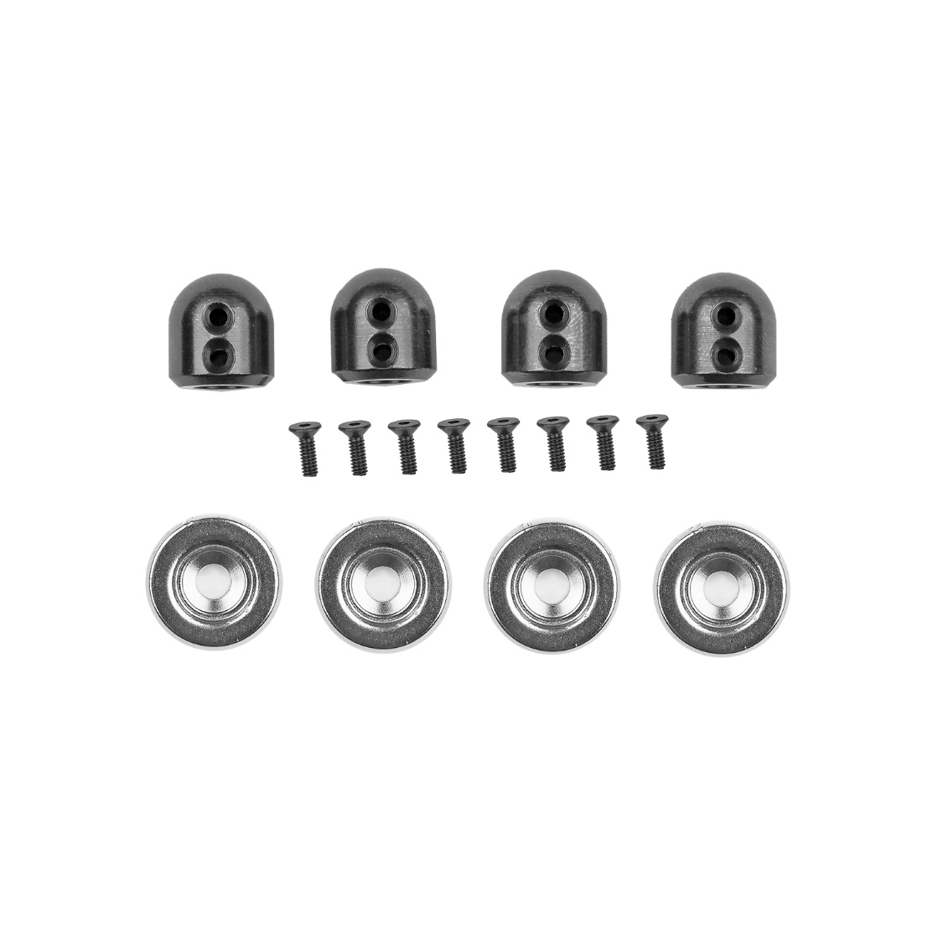***#72284 Factory Team DC10 Magnetic Body Mount Set**

(Pictured:#72284 Factory Team DC10 Magnetic Body Mount Set)

All new from Factory Team by Associated Electrics is our high-quality magnetic body mounts for Drift cars.

These high strength magnetic mounts will secure your drift body with ease while maintaining that stealth look.

Upgrade your Drift car with Factory Team Magnetic Body Mounts.

**Compatible with:** DC10 Kit and DC10 RTR

|  |  |  |  |  |  |  |
| --- | --- | --- | --- | --- | --- | --- |
| **UPC** | **Part No.** | **Description** | **MAP** | **MSRP** | **Origin** | **Available** |
| 784695722842 | 72284 | DC10 FT Magnetic Body  Mount Set | $21.24 | $24.99 | TW | [button-buy-now-200px](https://60years.associatedelectrics.com/dc10-ft-magnetic-body-mount-set/) |