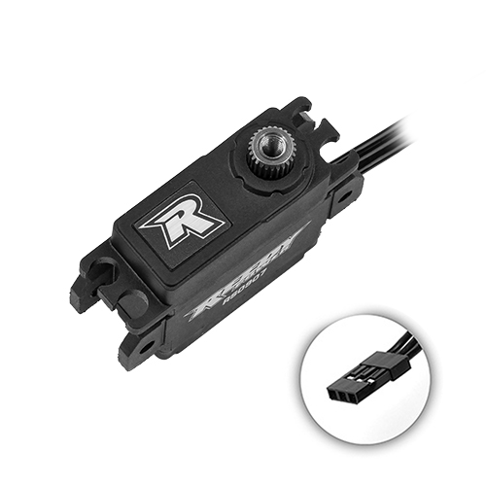
For Immediate Release: November 2026

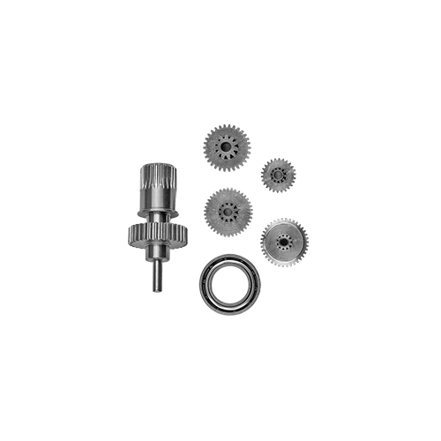
New! Reedy Power RS0907 1:12 Hi-Speed Servo & Gear Set

A pioneer and innovator in 1:12 racing, Reedy Power continues its commitment to high-quality racing electronics with the RS0907 1:12 Hi-Speed Servo. Combining a powerful coreless motor with a precision gearset, the RS0907 delivers fast, precise steering response in a compact package weighing just 18.0 grams. High-voltage compatibility supports operation from 6.0 to 8.4V, with transit speeds as quick as 0.065 seconds per 60 degrees at 8.4V. Built with quality and precision at its core, the RS0907 brings responsive control to the demands of competitive 1:12 racing.
Model Number | 27177
Input (V) | 6.0 – 8.4
Motor | Coreless
Speed (sec/60) 6.0V  7.4V  8.4V | 0.085  0.073  0.065
Torque (kg-cm) 6.0V  7.4V  8.4V | 6.4/87.5  7.5/104.2  8.5/118.0
Dimensions (mm) | 27.2 x 12.1 x 28.2
Weight (g) | 18.0
Spline | 25
.
Specifications
Features
- Powerful coreless motor
- Precision gearset
- High-voltage compatible

UPC | Part No. | Description | MSRP | MAP | COO | Available
784695271777 | #27177 | Reedy Power RS0907 1:12 Hi-Speed Servo | $155.99 | $92.99 | CN | Now
784695271784 | #27178 | Reedy Power RS0907 Gear Set | $47.99 | $39.99 | CN | Now

