

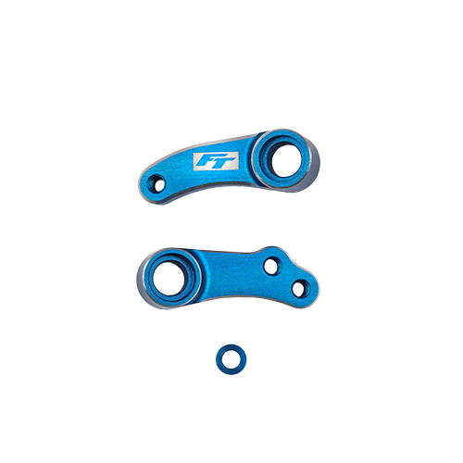
For Immediate Release: November 2025

RC10B84 FT aluminum steering bellcranks, blue

Factory Team is proud to introduce the new RC10B84 aluminum steering bellcranks, blue! Precisely machined and anodized with our signature blue color to stand out from the crowd. A nice chamfer is added after anodizing to add a subtle touch of silver for a luxurious look. This part adds rigidity and leads to more precise steering input. Use the included 1mm ballstud washer to retain the previous geometry from the original kit plastic bellcranks.
All parts compatible with:

90050, 90051

UPC | Part No. | Description | MSRP | MAP | Origin | Available
784695925618 | 92561 | RC10B84 FT Aluminum Steering Bellcranks, Blue | $25.99 | $22.09 | CN | Now

Please refer to our MAP Policy here: https://img2c.associatedelectrics.com/pdf/map-policy.pdf

