

**For Immediate Release: July**

**RC10 ‘89 STEALTH CAR MASAMI EDITION #6043**

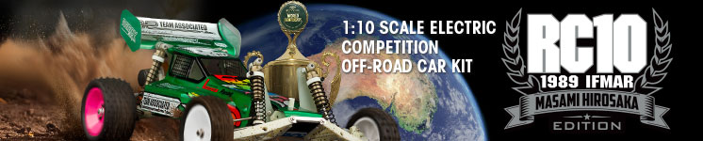

|  |
| --- |
| **ELECTRIC ■ OFF ROAD ■ 1:10 SCALE ■ 2 WHEEL DRIVE ■ KIT** |

**THE SECRET WEAPON THAT SHOOK THE 1989 WORLDS**

At the 1989 IFMAR 1/10 Off-Road World Championships in St. Ives, Australia, Masami Hirosaka drove the groundbreaking RC10 “Stealth” car to victory. This prototype from Team Associated featured a revolutionary Stealth® 3-gear transmission, offering smoother and more efficient power delivery compared to the standard 6-gear setup. Built around a lightweight chassis and equipped with a specially tuned Reedy motor, Masami’s RC10 combined cutting-edge technology with his signature smooth, aggressive driving style.

Masami’s win in Australia didn’t just earn him another world title — it changed RC racing forever. The success of the Stealth RC10 set a new standard for off-road design, and the Stealth transmission would later become the foundation for future Team Associated vehicles. Hirosaka’s performance, driving a car most competitors hadn’t even seen before, remains one of the most iconic moments in RC history.

A Full race-tuned rear suspension includes durable Universal drive axles and dish wheels with aluminum adapters. Long-arm independent suspension with hard anodized coil-over shocks help smooth out the bumps. Low profile Stealth® transmission and slipper is protected by an integrated motor/heat sink. A-Arm/Ball joint design permits static camber, camber rise, caster, ride height and spring rate tuning to suit every type of track.



**MASAMI HIROSAKA:**

**THE MOST SUCCESSFUL**

**AND LEGENDARY RC RACER**

**OF ALL TIME**

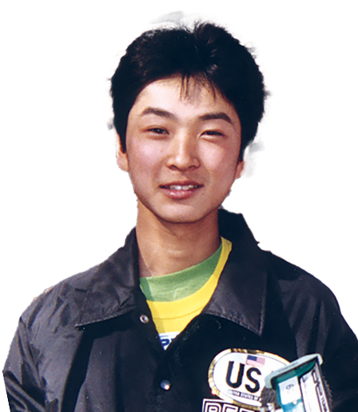

Masami Hirosaka is considered the most successful RC car racer of all time, with a record that still stands unmatched today. Born in Japan in 1970, Masami dominated the RC racing world for more than two decades, earning an incredible 14 IFMAR World Championship titles across multiple classes. His world titles include victories in 1:10th scale electric off-road (2WD and 4WD), 1:12th scale electric on-road, and touring car categories, showcasing his remarkable versatility and technical skill.

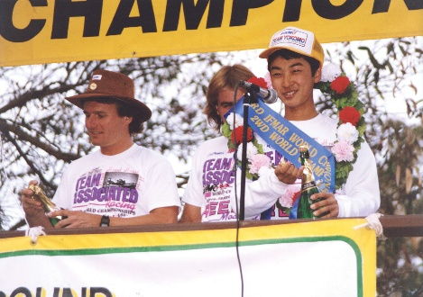

In addition to his world championships, Masami claimed over 50 Japanese National Championships, another record that highlights his dominance on both the national and international stages. His ability to consistently perform at the highest levels across so many different disciplines helped cement his reputation as a true legend in the RC community.

Masami first captured global attention when he won the 1987 IFMAR 4WD Off-Road World Championship at just 17 years old. Throughout his career, he was known not only for his smooth, precise driving style but also for his deep technical understanding of RC car setup and design. Working closely with brands like Yokomo and Team Associated, he helped advance RC technology and vehicle performance, leaving a lasting impact on the industry.

Masami Hirosaka’s fame extended far beyond Japan — he became a global icon for RC racers everywhere. His races were featured in magazines around the world, and many aspiring drivers studied his techniques in hopes of replicating even a fraction of his success. Even after stepping away from top-level competition in the late 2000s, Masami remains active in the RC scene as a mentor, team manager, and ambassador for the sport.

Today, Masami Hirosaka is remembered as the gold standard in competitive radio-control car racing — a true legend whose achievements may never be equaled.

THE TEAM DOES IT DOWN UNDER.

A RACE CAR, NOT A TOY.

The 1989 Team Associated Stealth Car prototype was a radical evolution of the RC10 platform, purpose-built for top-tier competition at the IFMAR World Championships in Sydney, Australia. Designed in secrecy, it featured a number of innovative elements that set a new benchmark in 2WD off-road buggy performance. Most notably, it introduced the Stealth transmission—a compact, three-gear unit with internal slipper clutch. Unlike the bulkier six-gear design of the original RC10, the Stealth transmission offered smoother, more efficient power transfer and a lower center of gravity.

The prototype also utilized a narrowed and milled aluminum chassis for reduced weight and improved agility. The front end was modified with new geometry for better steering response, while the rear featured longer suspension arms and revised shock positioning to improve traction and stability. Lightweight materials such as carbon fiber and titanium were used extensively, showcasing a design philosophy that prioritized speed, balance, and durability.

The Stealth Car had a lower profile body and sleek, streamlined aesthetics that matched its high-performance internals. Though never sold as a complete kit, the design innovations of the 1989 Stealth Car directly influenced future Associated models and reshaped competitive RC buggy engineering for years to come.

|  |
| --- |
| **FEATURES** |

* CNC machined aluminum chassis
* Laser etched chassis logo
* Carbon fiber top plate
* Hard anodized shock bodies
* Hard anodized shock caps
* Universal driveshafts
* Ball bearings
* 89’ Stealth® car front bulkhead
* 89’ Stealth® car rear arm mounts
* Stealth® car wide front suspension arms
* CNC chassis standoffs
* Stealth® transmission
* Titanium turnbuckles
* 89’ Stealth® car world championship replica tires
* 89’ Stealth® car rear suspension arms
* Adjustable battery mounts (shorty or standard)
* 89’ Stealth® car front and rear shock towers
* 89’ Stealth® car pink rear wheels
* 89’ Stealth® car rear wheel adaptors
* 89’ Stealth® car style wing mount system
* 89’ Stealth® car rear bulkhead
* 89’ Stealth® car style rear wing with side panels
* 89’ Masami world championship livery decal sheet
* Replica Masami battery strap and ESC mount
* 89’ Stealth® car long stroke shock springs

|  |  |  |
| --- | --- | --- |
| **ITEMS NEEDED TO COMPLETE** |  | **SPECIFICATIONS** |

* 6-cell NiMH or 2S LiPo for radio-controlled car
* Radio control battery charger
* 1:10 scale radio control electronic speed control
* 1:10 scale 540-size electric RC car motor
* 2-channel RC surface transmitter and its batteries
* 2-channel receiver
* Pinion gear
* Steering servo
* Lexan paint for body
* Glue for tires.
* Tools

|  |  |
| --- | --- |
| **Scale** | 1:10 |
| **Power** | Electric |
| **Length** | 381mm (15in) |
| **Width** | 226.8mm (8.93in) |
| **Weight** | Varies |
| **Wheelbase** | 267.7mm (10.54in) |
| **Internal Ratio** | 2.25:1 |
| **Power Source** | Electric |
| **Terrain:** | Off-Road |
| **Assembly Level** | Kit |
| **Drive** | 2WD |
| **Body Style** | Buggy |

|  |
| --- |
| **CATALOG INFORMATION** |

|  |  |  |  |  |  |  |  |
| --- | --- | --- | --- | --- | --- | --- | --- |
| **UPC** | **Part No.** | **Description** | **MSRP** | **MAP** | **Pieces Per Case** | **Origin** | **Available** |
| 784695060432 | 6043 | RC10 '89 STEALTH CAR MASAMI EDITION | $631.99 | $429.99 | 6 | TW | July |

Download all zipped photos here: <https://rc10.com/RC10Masamiimages/>(1.2MB). Link is active for 30 days.

