For Immediate Release: August 2026

New! Factory Team, Drift CNC Aluminum Flex Chassis
Area 51 Factory Team engineers have developed the next generation Flex Chassis for competitive 1:10 scale Drifting.
After testing various materials, we've developed the most consistent Flex Chassis on the market. Most Flex Chassis in the market provide an aggressive rebound that can make the car unpredictable. Using high grade aluminum with strategic flex design, the all-new Factory Team Flex Chassis provides consistent flex, stability and rebound for snappy corners under full control. Available in Team Associated's iconic Gold or Blue.
Take your DC10 drift car to the next level with the all-new Factory Team, CNC Aluminum Flex Chassis.
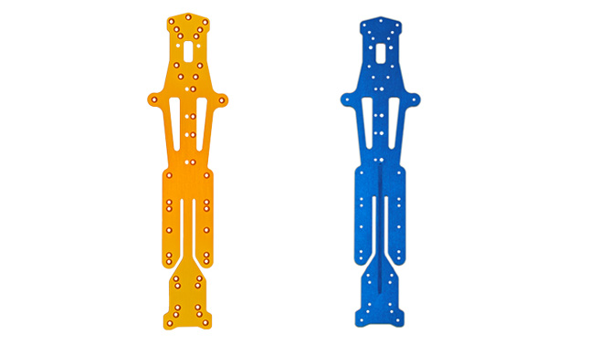

(Pictured left to right: 72300 Gold DC10 Chassis & 72306 Blue DC10 Chassis)

Compatible with:
30134/30133/30135

UPC | Part No. | Description | MAP | MSRP | Origin | Available
784695723009 | 72300 | DC10 Chassis, Gold | $93.49 | $109.99 | TW | 
784695723061 | 72306 | DC10 FT Aluminum Flex Chassis, Blue | $93.49 | $109.99 | TW

