For Immediate Release: January 2026

New! RC10B84 & RC10B7 FT Parts
Factory Team would like to announce some new parts for the current generation tenth scale cars!

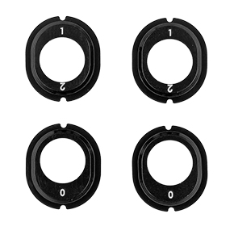
#92567
RC10B7 FT Aluminum Differential
Height Inserts, Notched

The new RC10B7 FT aluminum differential height inserts allow users the option to run aluminum differential height inserts in their new
RC10B7 3-gear gearbox. These inserts also fit in the gearbox of the RC10B84, RC10T7, RC10SC7, and are backwards compatible to fit in the RC10B7 5-gear gearbox.
Compatible with:
RC10B7, RC10B7D, RC10B84, RC10B84D, RC10T7, RC10SC7

#92568
RC10B84 FT 39/17 Ring and Pinion Overdrive Gear Set, Steel
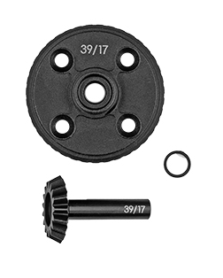

The RC10B84 overdrive gear set is for use in the front gearbox to allow for more equal tire rollout when the front tires are much smaller than the rear tires. This is common on surfaces like carpet.
Compatible with:
RC10B84 and RC10B84D

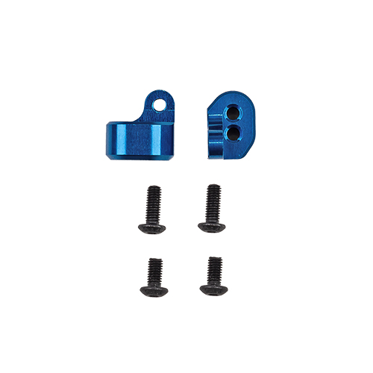
#92569
RC10B84 FT Vertical Rear
Ballstud Mount

Compatible with:
RC10B84, RC10B84D

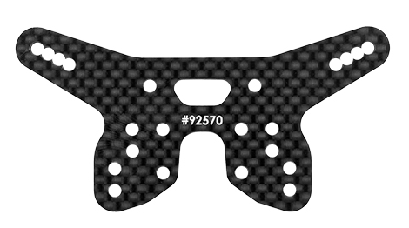
#92570
RC10B84 FT Vertical Rear Ballstud Mount Shock Tower

Compatible with:
RC10B84, RC10B84D

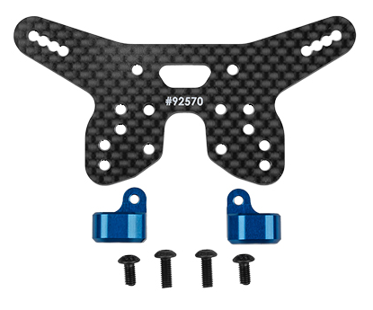
#92571
RC10B84 FT Vertical Rear Ballstud Mount Kit

The FT vertical rear ballstud mount kit allows for more fine adjustment when tuning roll center on your RC10B84.
Compatible with:
RC10B84, RC10B84D

UPC | Part No. | Description | MAP | MSRP | Origin | Available
784695925670 | 92567 | RC10B7 FT Aluminum Differential Height Inserts, Notched | $33.14 | $38.99 | TW | 
784695925687 | 92568 | RC10B84 FT 39/17 Ring And Pinion Overdrive Gear Set, Steel | $45.89 | $53.99 | TW
784695925694 | 92569 | RC10B84 FT Vertical Rear Ballstud Mount | $19.54 | $22.99 | TW | Soon
784695925700 | 92570 | RC10B84 FT Vertical Rear Ballstud Mount Shock Tower | $27.19 | $31.99 | TW
784695925717 | 92571 | RC10B84 FT Vertical Rear Ballstud Mount Kit | $45.89 | $53.99 | TW | Soon

