For Immediate Release: March 2026

FT RC8 DROOP GAUGE, 70-135mm #1536
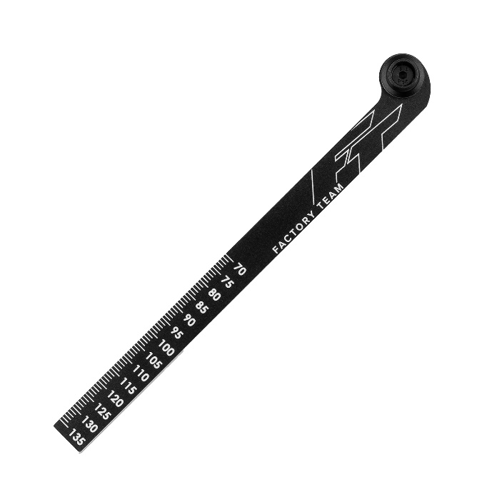

(Pictured: FT RC8 Droop Gauge, 70-135mm #1536)

Introducing the new FT RC8 droop gauge, 70-135mm! Conveniently slip the top of this item over the top shock nut and line up the bottom with the shock pin to give yourself an easy measurement. No need to fiddle with calipers that are often cumbersome to use for this application. This product features laser etched text to make reading each measurement clear and simple. Laser etched measurements range from 70 to 135mm. Machine cuts are made after anodizing to add a touch of silver that gives a nice clean and luxurious look.

Compatible with:
80945/80946/80949/80950/80951/80952
UPC | Part No. | Description | MAP | MSRP | Origin | Available
784695015364 | 1536 | FT RC8 Droop Gauge, 70-135mm | $24.64 | $28.99 | TW | 

