For Immediate Release: February 2026

#92573 RC10B7 UNIVERSAL DRIVESHAFT SET, 67mm

Introducing the new RC10B7 universal driveshaft set, 67mm! This product is great for those that
have the -4mm hubs with the 81mm arms and want to try universal driveshafts in their vehicles.
These driveshafts can also be used for times where the 69mm universal driveshafts are too long for
your specific configuration.

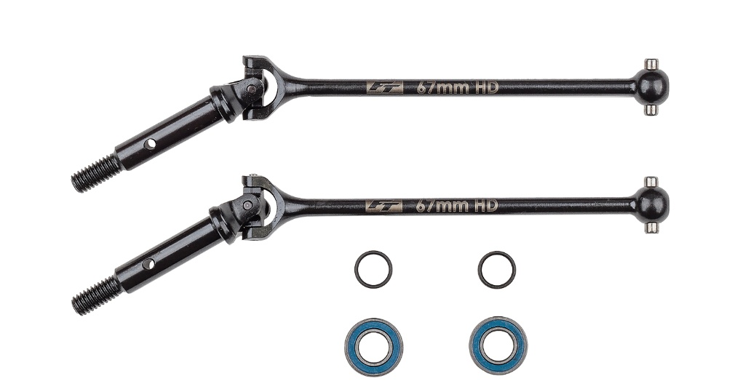
Compatible with:
RC10B7
RC10B7D
RC10B7.1
RC10B7.1D
RC10B84
RC10B84D

UPC | Part No. | Description | MAP | MSRP | Origin | Available
784695925731 | 92573 | RC10B7 UNIVERSAL DRIVESHAFT SET, 67MM | $59.49 | $69.99 | TW | Now

