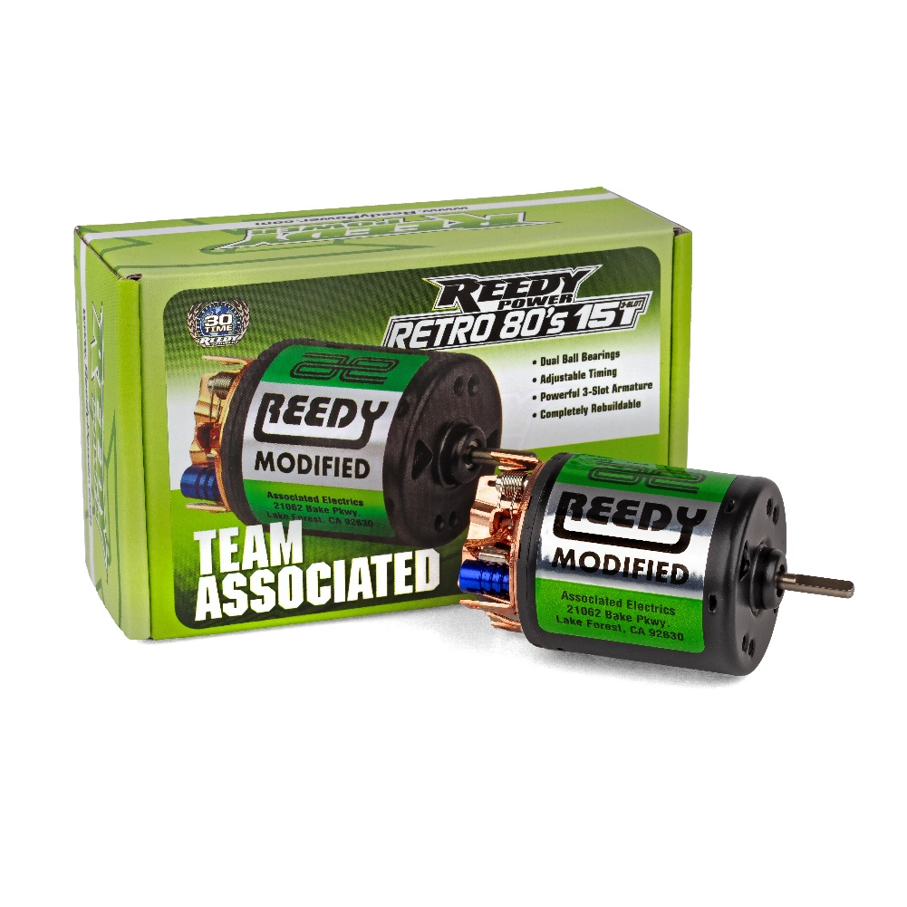
For Immediate Release: May 2026

New! Reedy Power Retro '80s 15-Turn Brushed Motor

Reedy Power, winner of over 30 IFMAR World Championships, unveils the Retro '80s 15-Turn Motor, a faithful tribute to Mike Reedy and the iconic Reedy Modifieds Ultra Series motors that dominated RC racing in the late 1980s.

This new motor captures the spirit of the original Ultra Series brushed motors, known among racers for their legendary performance and role in countless victories on and off road. With its classic 15-turn machine-wound armature, the Retro '80s model delivers strong performance that echoes the high-output modified motors racers fondly remember from R/C’s golden era.

“Reedy Modifieds powered race winners around the world in a wide variety of racing classes” said Rick Hohwart, Reedy Department Manager. “We wanted to create something that feels true to that heritage whether it’s installed to race or to complete a replica that looks and runs just like the real thing from that period.”

Key features include:

- Retro-inspired design – Classic aesthetics that complement vintage Team Associated models and other period-correct builds.
- Versatile performance – Excels either as a powerful, reliable runner in vintage setups or as a finishing touch for static display “shelf queen” replicas.
- Durable construction – Built with the quality and attention to detail Reedy Power is known for, ensuring long-lasting enjoyment whether on the track or on the shelf.

The Reedy Power Retro '80s 15-Turn Motor is ideal for enthusiasts restoring or building period-correct RC cars and pairs perfectly with Team Associated’s growing line of vintage-inspired vehicles. They are now available for purchase at hobby shops, online retailers, and at www.ReedyPower.com.

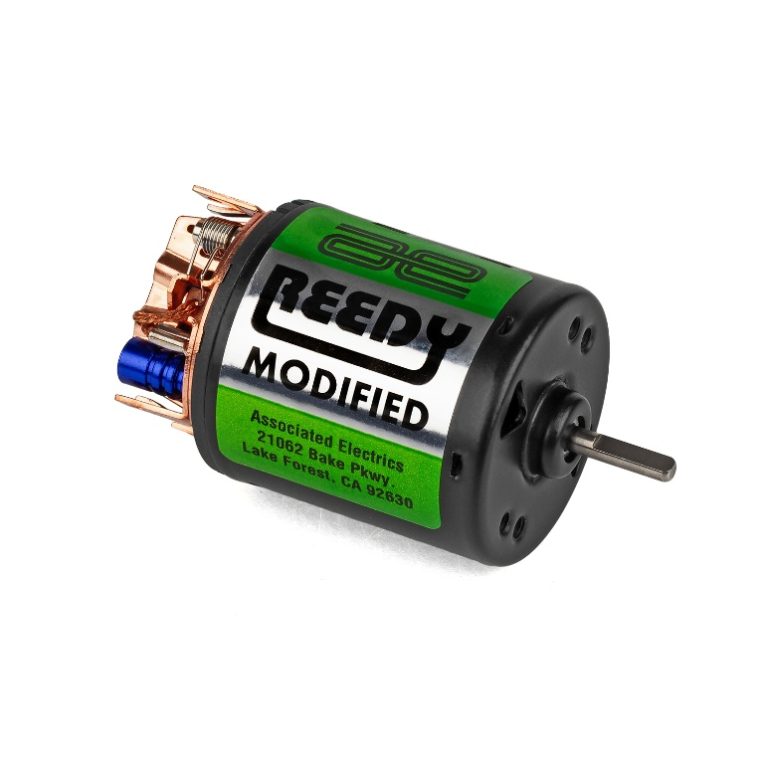
Specifications
Feature | Specification
Voltage Input | 2S LiPo/6-7 cell NiMH
Suggested Application | 1:10 off-road/on-road
Configuration | Machine wound, 3-pole
Diameter (g) | 36.0
Length (g) | 53.0
Shaft Dia. (mm) | 3.175
Weight (g) | 169

UPC | Part No. | Description | MSRP | MAP | COO | Available
784695 275089 | 27508 | Reedy Retro 80's 15T Brushed Motor | 45.99 | 26.99 | CN | 

