

**For Immediate Release: October**

**RC10 4WD Team Car #6046**

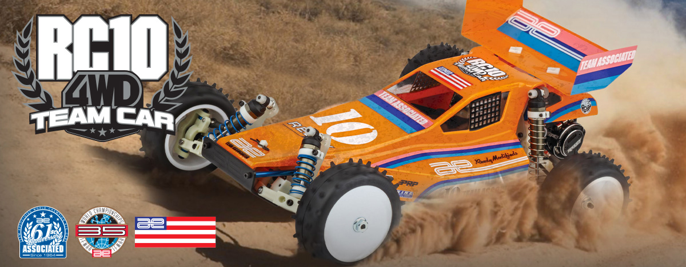

|  |
| --- |
| **ELECTRIC ■ OFF ROAD ■ 1:10 SCALE ■ 4 WHEEL DRIVE ■ KIT** |

BEYOND THE ICONIC

2WD RC10

The RC10 started as the vision of Team Associated’s founder Roger Curtis (RC) and became one of the most iconic RC cars in history.

At the inaugural IFMAR Off Road World Championships, Jay Halsey took first place with his RC10 in the 2WD class, but did you know he also raced a prototype 4WD RC10 in the 4WD class and took second place?

Team Associated never advanced that prototype 4WD and instead focused on 2WD. But what if Team Associated had developed a 4WD RC10? You’d get the RC10 4WD Team Car off road buggy!

Our team of engineers took the iconic RC10, the knowledge of 4WD racing from the B74, and created the RC10 4WD. No more having to buy an RC10 kit, a conversion kit, and random parts. Now you can have a genuine Team Associated RC10 4WD that is meant to be raced, with all the parts in one box. All you need to do is add electronics and hit the track!

IT STARTED FROM

THE BEGINNING!

Going all the way back to 1985 at the very first IFMAR Off Road World Championships, Team Associated had always been interested in entering the 4WD buggy market. That’s why at that race, in Del Mar, California, Jay Halsey drove a prototype 4WD RC10. After taking first place in the 2WD Stock class earlier that day, Jay was poised to take first in the 4WD class as well. As fate would have it though, Jay finished a close second driving that prototype 4WD RC10 buggy.

It wouldn’t be until many years later that Team Associated would finally produce a 4WD off road kit, the B44. To fill in the gap between that first IFMAR Off Road Worlds and the release of the B44, many aftermarket companies designed and produced their own RC10 4WD conversion kits.

With the release of the Team Associated RC10 4WD Team Car kit you no longer have to piece a 4WD buggy together and hope everything fits. With our genuine Team Associated parts, everything you need to assemble a 4WD kit comes in one box!

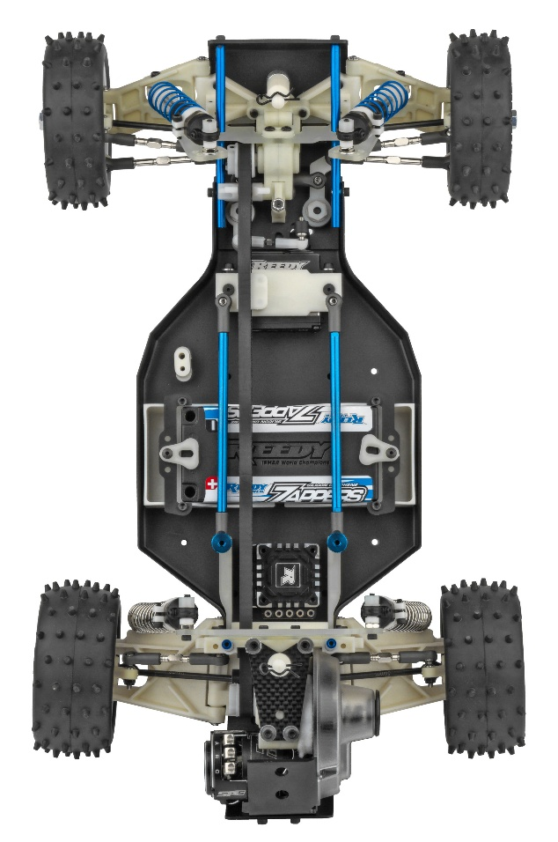

THE LEGEND JUST GOT BETTER

A COMPLETE 4WD RC10 TEAM CAR KIT

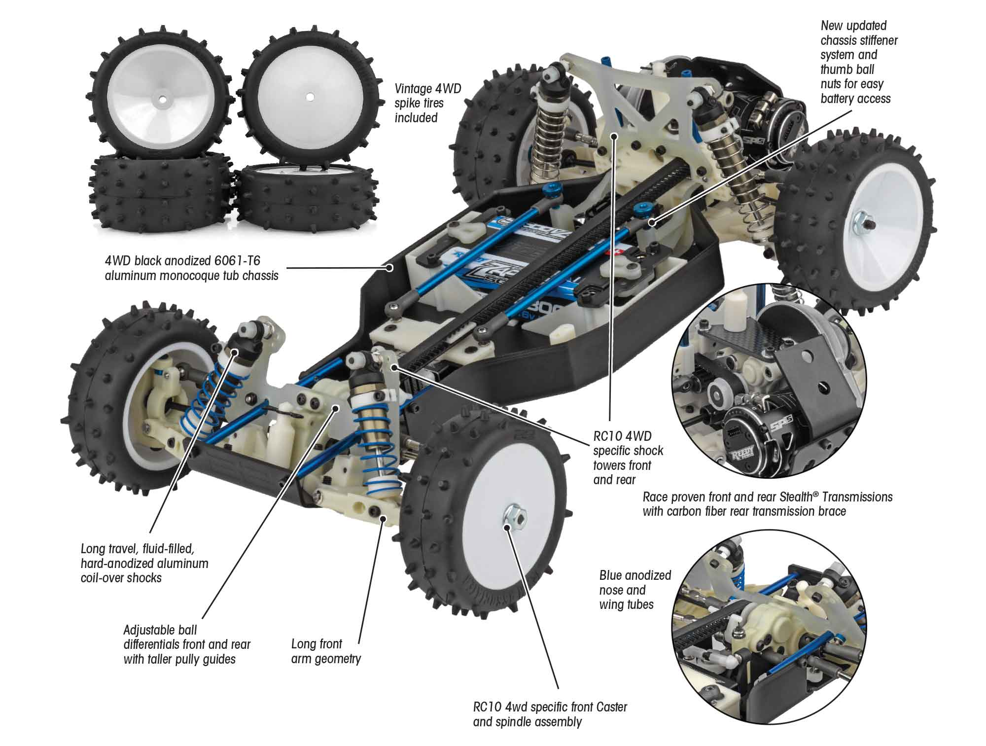

The iconic RC10 is now available as a 4WD race buggy with everything included in one box. No need for a conversion kit or sourcing rare parts. Build a high-performance race buggy from the 90s that is meant to be raced, using the latest electronics of your choice (electronics not included; fits 6-cell NiMh and 2S LiPo batteries).

*This updated kit includes clear polycarbonate Viper body, 5.5” high-downforce wing, full ball bearings,*

*CVA driveshafts, vintage front and rear 4WD spike tires, all on a black anodized 6061-T6 monocoque*

*tub chassis.*

|  |
| --- |
| **FEATURES** |

* Exceptional ground clearance with low center of gravity
* Vintage 4WD spike tires included
* Clear Viper body with driver figure
* 4WD specific shock towers front and rear
* Precision bearings throughout
* Fits 6-cell NiMh and 2S LiPo battery packs
* Adjustable 3.5mm turnbuckles all around
* Front and rear CVA driveshafts
* Durable low friction center belt and tension system
* Long front arm geometry
* All new front caster and spindle assembly designed for RC10 4WD
* Updated rear bulkhead and chassis stiffener
* Carbon fiber rear transmission brace
* Front 2.2” 12mm hex wheels included
* All new 4WD specific bell crank system
* 5.5” high-downforce polycarbonate race wing included
* New updated belt guide
* New updated chassis stiffener system
* New thumb ball nuts allow for easy battery access
* New taller pulley guides
* 4WD black anodized 6061-T6 aluminum monocoque tub chassis
* Black anodized noseplate and motor plate
* Updated bleeder shock caps
* Fully adjustable four-wheel independent suspension
* Protech clear body with gas cutout template
* Long travel, fluid-filled, hard-anodized aluminum coil-over shocks Powerful rear disk brakes
* Race proven front and rear Stealth™ transmissions
* Adjustable ball differentials front and rear
* Rear 2.2” wheels included
* HD metric ball studs throughout
* Race proven V2 slipper clutch system

|  |  |  |
| --- | --- | --- |
| **ITEMS NEEDED TO COMPLETE** |  | **SPECIFICATIONS** |

|  |  |
| --- | --- |
| **Scale** | 1:10 |
| **Power** | Electric |
| **Length** | 381mm (15”) |
| **Width** | 241mm (9.49”) |
| **Weight** | Varies |
| **Wheelbase** | 273mm (10.75”) |
| **Internal Ratio** | 2.6:1 |
| **Terrain** | Off-Road |
| **Body Style** | Buggy |
| **Drive** | 4WD |
| **Assembly Level** | Kit |

* 1:10 scale 540-size electric RC car motor
* 1:10 scale radio control electronic speed control
* 7.4V-7.6V 2S LiPo with "shorty" battery dimensions (standard or low-profile height)
* Battery charger (for one of the batteries mentioned above)
* 2-channel RC surface transmitter and its batteries
* Lexan specific spray paint for body
* Steering Servo

**Other helpful items:** Silicone Shock Fluid, Silicone Diff Fluid, Body Scissors (#1737), Reamer (#1499) or Hole Punch, FT Wrench Set (#1519), Hobby Knife, Needle Nose Pliers, Wire Cutters, Soldering Iron, Calipers or a Precision Ruler.

|  |
| --- |
| **CATALOG INFORMATION** |

|  |  |  |  |  |  |  |  |
| --- | --- | --- | --- | --- | --- | --- | --- |
| **UPC** | **Part No.** | **Description** | **MSRP** | **MAP** | **Pieces Per Case** | **Origin** | **Available** |
| 784695060463 | 6046 | RC10 4WD TEAM CAR KIT | $675.99 | $459.99 | 6 | TW | Oct/early Nov |

Download all zipped photos here: <https://www.rc10.com/RC104WDImagespr/> (1.76MB) Link is active for 30 days.

Please refer to our MAP Policy here: <https://img2c.associatedelectrics.com/pdf/map-policy.pdf>