For Immediate Release: April 2026

NEW! Factory Team Diff Fluid expands to fine increment oil offerings 8,000 to 400,000 cSt

Factory Team expands the pure silicone diff fluid line to answer the call from racers for more fine-tuning increments. New offering 8,000 and 9,000, which fit between the existing 7,000 and 10,000 fluids. Also, between the increments of 10k and 20k, we now offer 12,500 and 17,500. 40k now fits in between the existing 30k and 60k, with 300k and 400k to fit in with 200k and 500k. These fluids now offer a wide range of tuning options that do not overlap production tolerances.

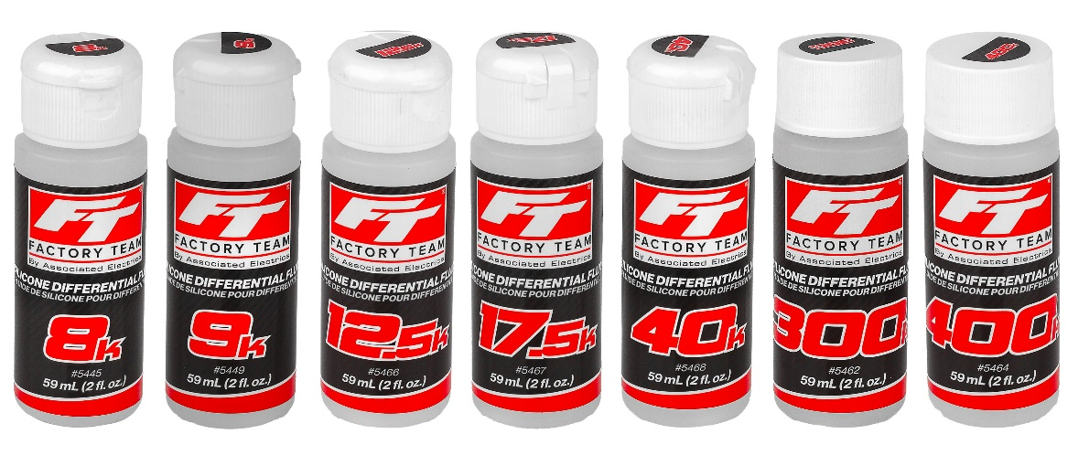
New weights and
part numbers:
Weights | Part #
8000 cSt | #5445
9000 cSt | #5449
12,500 cSt | #5466
17,500 cSt | #5467
40k cSt | #5468
300k cSt | #5462
400k cSt | #5464

(Pictured: Left to Right - Differential Fluid 8000 cSt, 9000 cSt, 12,500 cSt, 17,500 cSt, 40K cSt, 300K cSt, 400K cSt)

UPC | Part No. | Description | MAP | MSRP | Origin | Available
784695054455 | 5445 | Differential Fluid 8,000 cSt | $9.99 | $9.99 | TW | 
784695054493 | 5449 | Differential Fluid 9,000 cSt | $9.99 | $9.99 | TW
784695054660 | 5466 | Differential Fluid 12,500 cSt | $9.99 | $9.99 | TW
784695054677 | 5467 | Differential Fluid 17,500 cSt | $9.99 | $9.99 | TW
784695054684 | 5468 | Differential Fluid 40,000 cSt | $10.99 | $10.99 | TW
784695054622 | 5462 | Differential Fluid 300,000 cSt  W/Open Cap | $13.59 | $15.99 | TW
784695054646 | 5464 | Differential Fluid 400,000 cSt w/Open Cap | $15.29 | $17.99 | TW

