For Immediate Release: December 2025

RC10B84 Classic Kit #90055
1:10 Scale 4WD Electric Off Road Competition Buggy Kit



ELECTRIC ■ OFF ROAD ■ 1:10 SCALE ■ 4 WHEEL DRIVE ■ KIT
The Team Associated RC10B84 is Engineered for Victory!

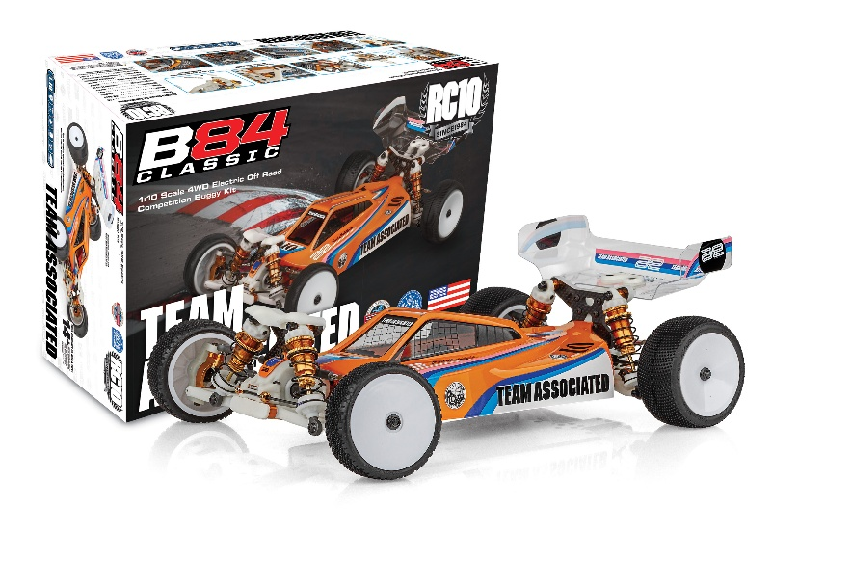
Unleash unparalleled performance with the RC10B84, a 1/10-scale 4WD buggy engineered for precision, speed, and racetrack victories.

RC10 Classic-inspired livery, premium composite plastics, and aluminum parts. Designed with cutting-edge features, this competition machine delivers superior handling and control. Its molded height-adjustable gearboxes ensure optimized drivetrain efficiency. The long-arm suspension geometry enhances grip and predictability, while the optimized steering bellcranks and rack provide exceptional bump steer control, keeping your lines tight at every corner.

Fine-tune your setup with chassis bracing adjustments, giving you the flexibility to adapt to each track you race on. The RC10B84 allows for precise weight distribution and chassis balance, letting you push the limits with confidence.

Enhanced aerodynamics come standard with a low-profile body and two rear wing mount heights. The RC10B84 is finished with shock tower covers, 3.5mm turnbuckles and ballcups, and 13mm big-bore shocks, providing the ultimate blend of strength, precision, and performance, the RC10B84 is your key to place top of the podium!

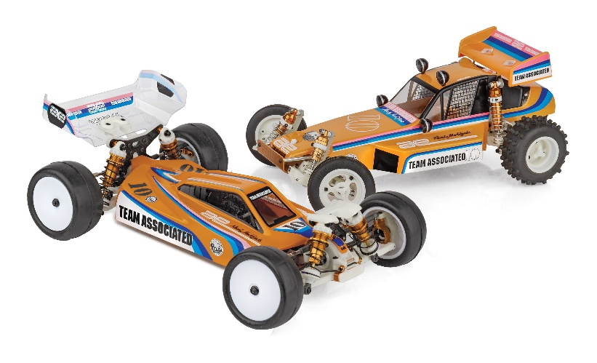

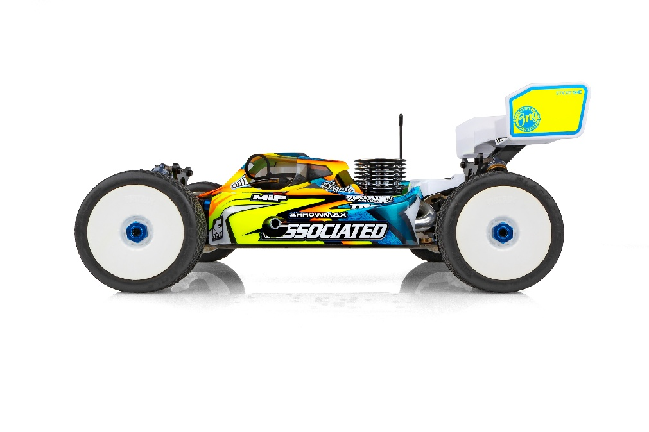



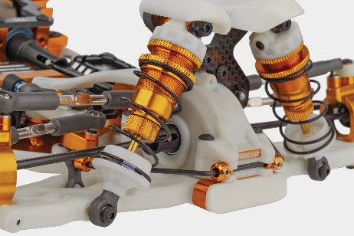
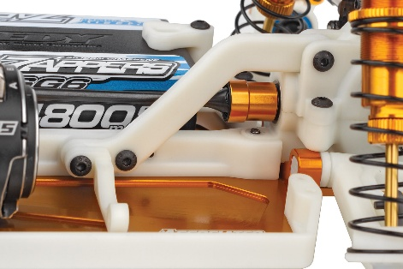

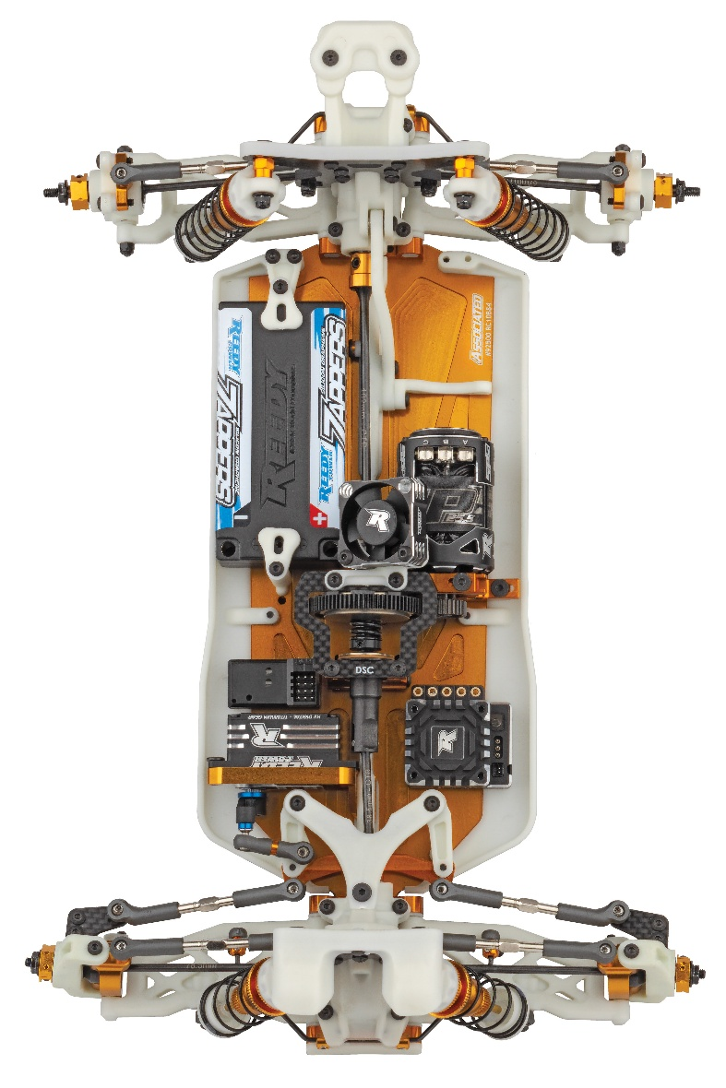

Long-Arm Suspension Geometry: improves grip and predictability in all conditions

Chassis Bracing: fine tune chassis flex characteristics with upper and lower chassis bracing front and rear

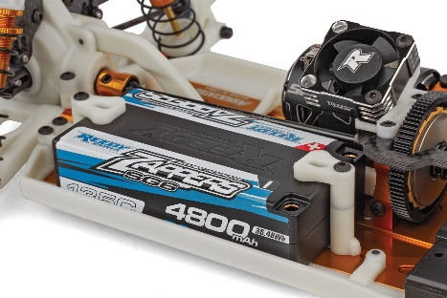
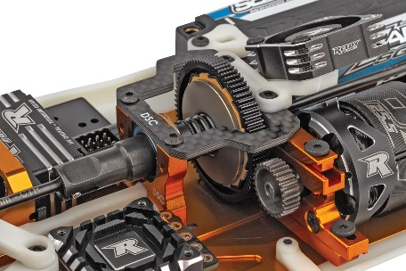

Forward and Back Motor Positions: used for further weight bias adjustment

Highly Adjustable Battery Holder with Thumb Tabs: allows for easy battery removal and fine tuning of weight bias

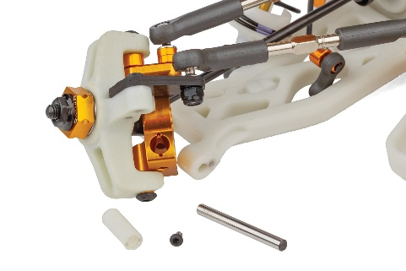
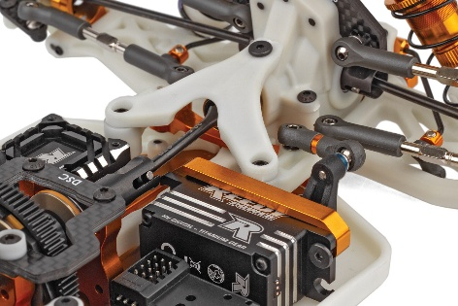

Optimized Steering Bellcranks and Rack: improved bumpsteer control at all ride heights

Insert adjustable caster block with 0, +/-1, and +/-2 degree inserts included

Scale | 1:10
Power | Electric
Drive | 4WD
Length (w/Wing): | 395mm/15.55 in.
Width | Varies*
Weight | Varies*
Wheelbase | Varies*
Internal Gear Ratio: | 2.50:1
Type: | Off Road
Chassis: | Machined aluminum
Suspension: | Independent Front and Rear

ITEMS NEEDED TO COMPLETE

- Motor
- Pinion Gear
- ESC
- Servo
- Transmitter and Receiver
- Tires
- Wheels
- Polycarbonate specific paint

OTHER HELPFUL ITEMS |  |  | SPECIFICATIONS

- Silicone Shock Fluid (Refer to catalog for complete listings)
- Silicone Diff Fluid (Refer to catalog for complete listings)
- Body Scissors (AE Part # 1737)
- Reamer / Hole Punch
- FT Wrench Set (AE Part #1519)
- Hobby Knife
- Needle Nose Pliers
- Wire Cutters
- Soldering Iron
- Calipers or a Precision Ruler

- Molded Height-Adjustable Gearboxes Front and Rear with Additional +2 Rear Gearbox for High-Grip Conditions

- Long-Arm Suspension Geometry: improves grip and predictability in all conditions

- Optimized Steering Bellcranks and Rack: improved bumpsteer control at all ride heights

- Chassis Bracing: Fine tune chassis flex characteristics with upper and lower chassis bracing front and rear

- Standard and HRC (High Roll Center) Rear Hubs Included

- Insert adjustable caster block with 0, +/-1, and +/-2 degree inserts included

- Forward and Back Motor Positions: used for further weight bias adjustment

- Highly Adjustable Battery Holder with Thumb Tabs: allows for easy battery removal and fine tuning of weight bias

- 2.5mm Thick Tapered 7075-T6 Aluminum Chassis with 10 Degrees of Kickup and Improved Departure Angle

- Decoupled Slipper Clutch Included

- Aluminum Center-Mounted Servo Mount

- Two heights Included for Rear Wing Mount

- 7-inch Rear Wing

- Low-Profile Body

- Shock Tower Covers Front and Rear

- 3.5mm Turnbuckles and Ballcups

- 13mm Big-Bore Shocks

- RC10 Classic-inspired livery, premium composite plastics, and aluminum parts

FEATURES |  | SPECIFICATIONS
UPC | Part No. | Description | MSRP | MAP | Pieces Per Case | Origin | Available
784695900516 | 90055 | RC10B84 Classic Kit | $939.99 | $639.99 | 6 | TW | Jan

Download all zipped photos here: https://www.rc10.com/RC10B84DImages/ (9.4MB). Link is active for 30 days.
Please refer to our MAP Policy here: https://img2c.associatedelectrics.com/pdf/map-policy.pdf

