
For Immediate Release: July 2025

New Factory Team HT1 line of
steering block arms for the RC10B7.1

Factory Team presents the new HT1 line of steering block arms! This product brings the comfort and stability that we have seen for years with the introduction of the HT+1 plate. The HT1 name indicates we have moved the ballstud position rearward by one step. These plates can also add extra steering throw to certain configurations that experience interference with the steering plate and caster block assembly.

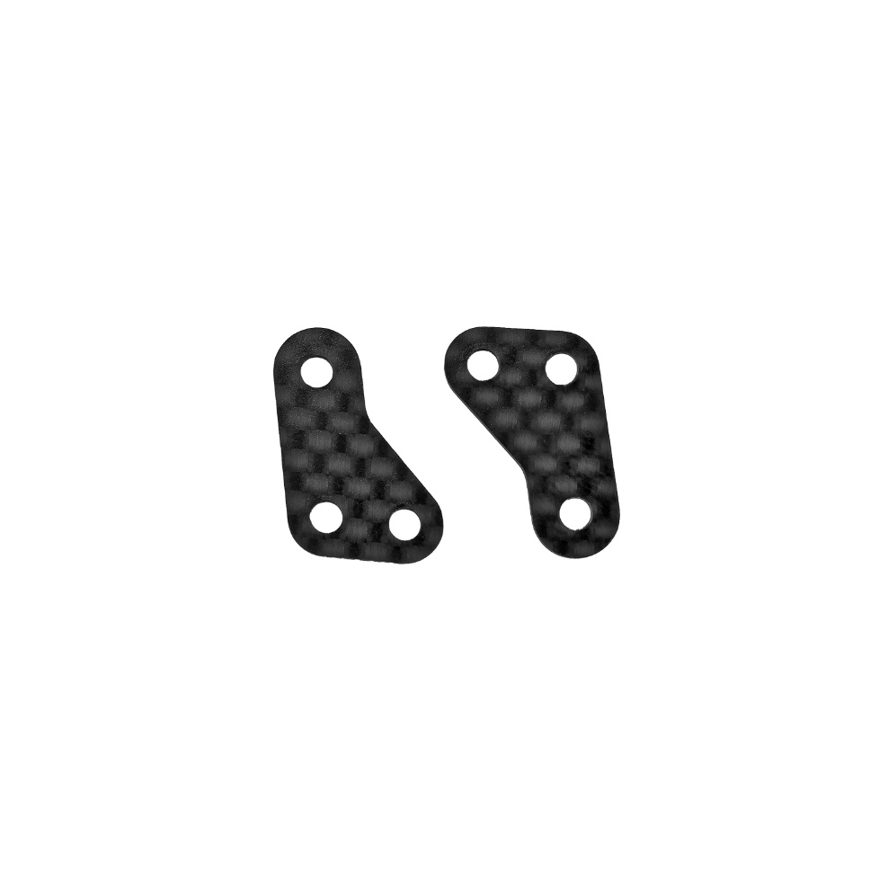

#92629
RC10B7.1 FT Carbon Fiber Steering Block Arms, HT1 +1

Compatible with:
90041/90042/90047/90046/70005/70010

#92630
RC10B7.1 FT Carbon Fiber Steering Block Arms, HT1 +2

Compatible with:
90041/90042/90047/90046/70005/70010
UPC | Part No. | Description | MAP | MSRP | Origin | Available
784695926295 | 92629 | RC10B7.1 FT Carbon Fiber Steering Block Arms, HT1 +1 | $9.99 | $9.99 | TW | 
784695926301 | 92630 | RC10B7.1 FT Carbon Fiber Steering Block Arms, HT1 +2 | $9.99 | $9.99 | TW

