

**For Immediate Release:** Sept 2025

**RC10 F6 Classic Kit #8024**

1:10 Scale Electric 2WD On Road Competition Race Car

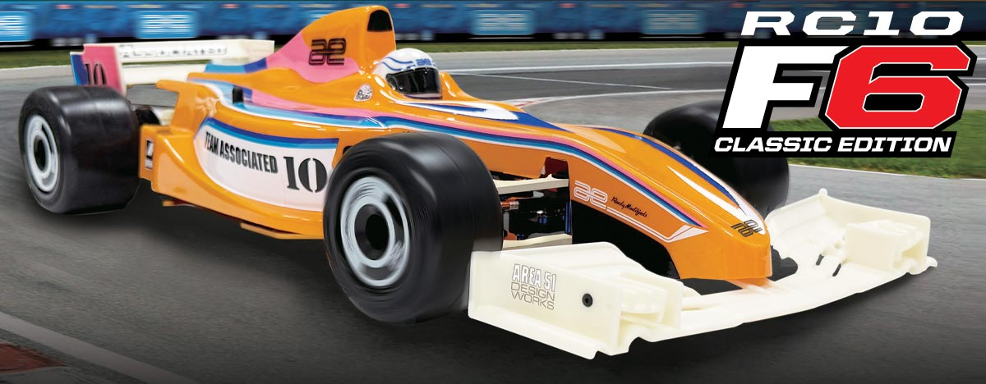

|  |
| --- |
| **ELECTRIC ■ 1:10 SCALE ■ 2 WHEEL DRIVE ■ ON-ROAD ■ KIT** |

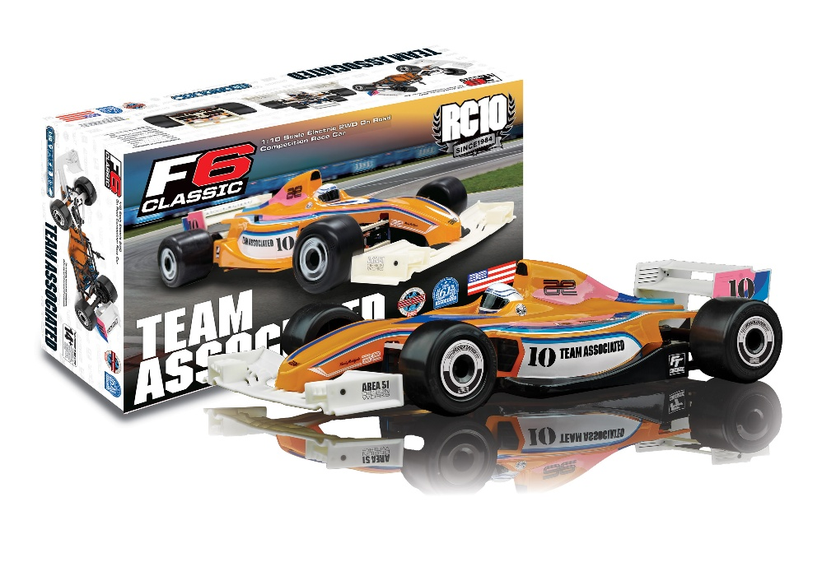

Champions by Design

Full-scale Formula racing is considered one of the most elite forms of racing in existence, with technology and looks off the chart. AE engineers have assembled a modern re-imagining of the classic RC10F6 FT Kit, introducing fresh elements into a race-proven design, ushering the platform into a new era. With a full cast of setting options, an ultra-low center of mass, and sleek styling, the RC10F6 FT is designed to put you at the front of the Formula grid.



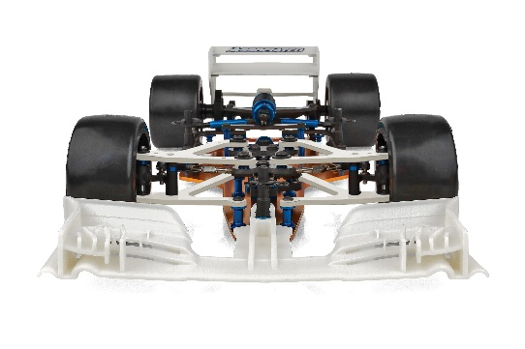

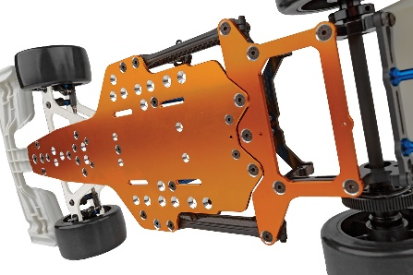

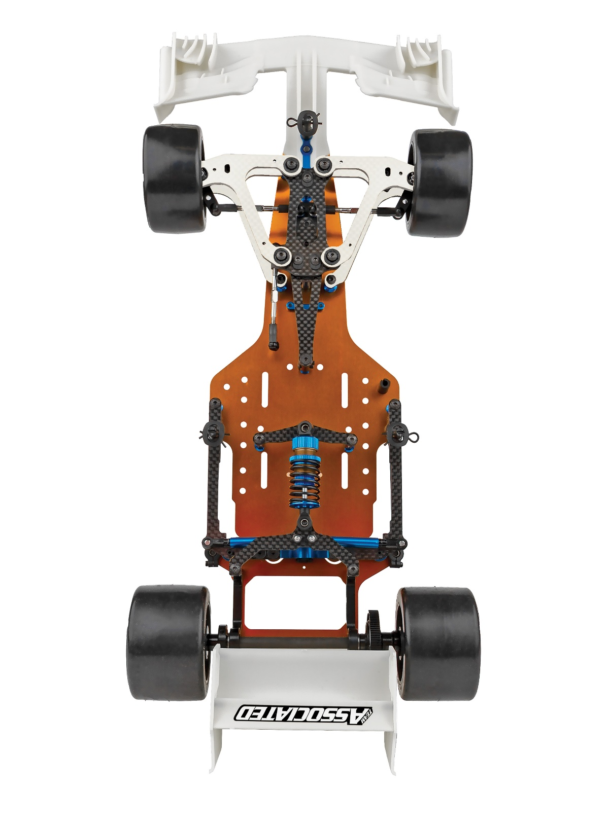

Front wings modeled after Formula rules

Machined countersunk Aluminum Gold Chassis and lower bracket

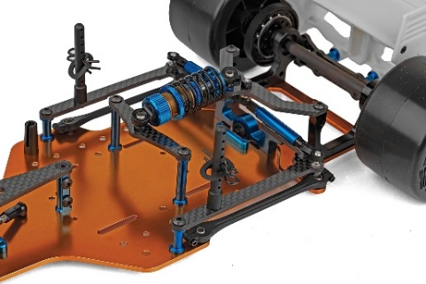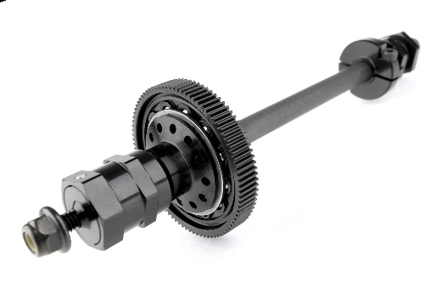

FOX® Genuine Kashima Coat center shock for minimal friction and extended wear

Rear axle accepts all standard spur gears without adapter

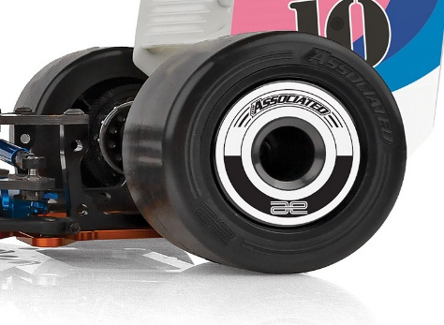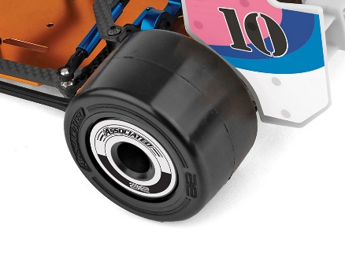

All new Belted Medium wear High grip front and rear F1 Tires included.

All New F1 style front and rear wheels with optional wheel decals

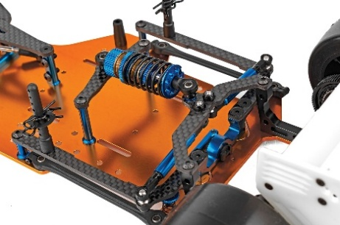

Rear wings modeled after

Formula rules

Integrated droop posts for adjusting droop without disassembly

|  |  |  |  |  |
| --- | --- | --- | --- | --- |
| **FEATURES** | |  |  | | --- | --- | | **SPECS** |  | |  |

• Anodized gold chassis

• Front and rear wings modeled after Formula rules included

• FOX® Genuine Kashima Coat center shock for minimal friction and extended wear

• Chassis design allows for multiple battery configurations

• New center pivot design for optimized rear pod assembly

• Lightweight graphite axle for increased durability and rigidity

• Differential thrust bearing assembly for smooth action and extended life between rebuilds

• Rear axle accepts all standard spur gears without adapter

• Two steering bellcrank options for fine tuning Ackermann and steering rate

• Servo mounts can be switched from “fixed” to “floating” to allow more flex in the front of the chassis

• Integrated droop posts for adjusting droop without disassembly

• New F1 style front and rear wheels with wheel decals

• New Belted Medium wear High grip front and rear F1 Tires included

• Formula 1 accurate clear lexan body with RC10 classic livery included

|  |  |
| --- | --- |
| **Scale** | 1:10 |
| Type | On-road |
| **Power** | Electric |
| **Length** | 432.5mm/17”* |
| **Width** | Varies (Fits 190mm racing class)* |
| **Weight** | 345g/0.76lbs.* |
| **Wheelbase** | 265-266mm/10.4”-10.5” |
| **Internal Gear Ratio** | 1:1 (no internal gears) |
| Drive: | 2WD |

* Final weight will vary depending on the electronics used to complete the kit.

|  |  |
| --- | --- |
| **OTHER HELPFUL ITEMS**   * Body Scissors (AE Part # 1737) * Reamer / Hole Punch * FT Wrench Set (AE Part #1519) * Hobby Knife * Needle Nose Pliers * Wire Cutters * Soldering Iron * Calipers or a Precision Ruler * Lexan paint for the body * Glue for the tires |  |

**Items required for operation:**

Kit only: All electronics are required. Four AA batteries for radio, suitable NiMh or 2S/3S LiPo battery for vehicle, and a charger. ESC Speed Control, Steering Servo, motor, Transmitter and receiver.

|  |  |  |  |  |  |  |  |
| --- | --- | --- | --- | --- | --- | --- | --- |
| **UPC** | **Part No.** | **Description** | **MSRP** | **MAP** | **Pieces Per Case** | **Origin** | **Available** |
| 784695080249 | 8024 | RC10F6 Classic  Edition Kit | $602.99 | $409.99 | 10 | TW | Sept |

|  |
| --- |
| **CATALOG INFORMATION** |

Download all zipped photos here: <https://www.rc10.com/RC10F6LegacyImages/> Link is active for 30 days.

