For Immediate Release: September 2026

RC10 4WD Jay Halsey Chain Drive Edition Kit #6056

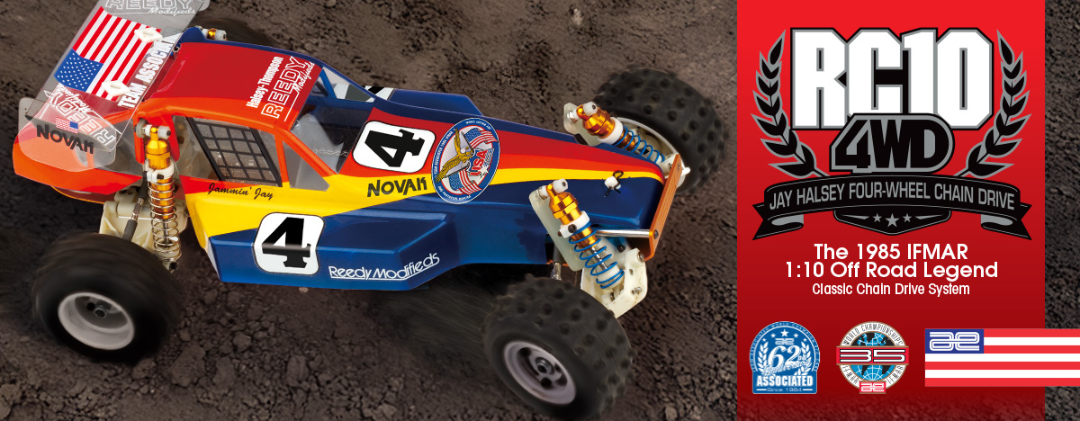
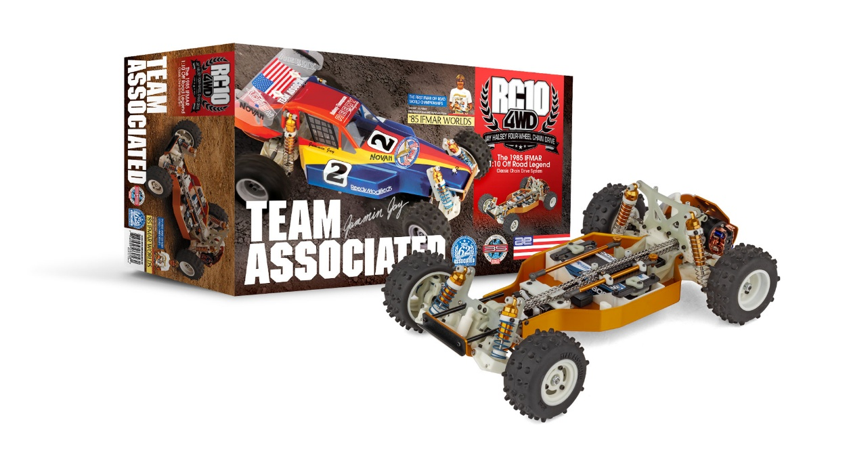
ELECTRIC ■ OFF ROAD ■ 1:10 SCALE ■ 4 WHEEL DRIVE ■ KIT
Vintage Looks.
Championship
Performance.

The RC10 Jay Halsey Chain Drive 4WD blends vintage styling with proven performance through a host of carefully engineered features.

A heavy-duty stainless-steel chain, hardened sprocket gears, carbon fiber chain separator, and adjustable chain tension system deliver reliable drivetrain performance, while front CVA axles, hardened driveshafts, and high-torque ball differentials enhance durability. Short front arm geometry, Worlds-style steering bell cranks, and long-travel fluid-filled aluminum shocks provide precise handling over rough terrain. Completing the package are a classic gold chassis, natural shock towers, RC10 Classic Protech body, Jay Halsey-style wing, full ball bearings, and compatibility with both 6-cell NiMH and 2S LiPo battery packs.

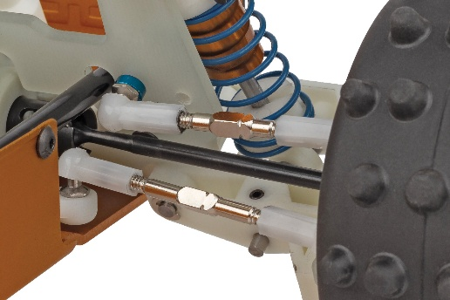
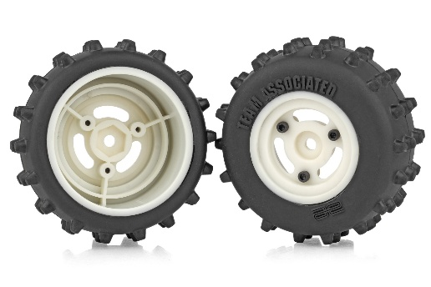
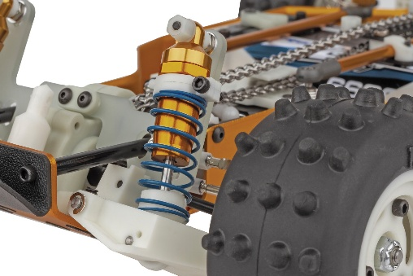
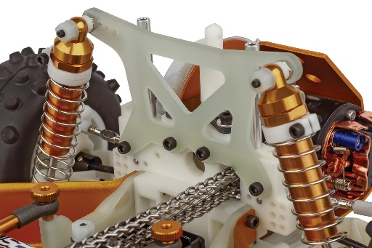
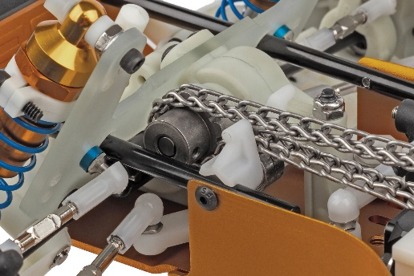
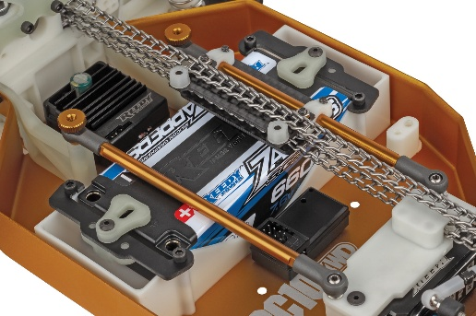
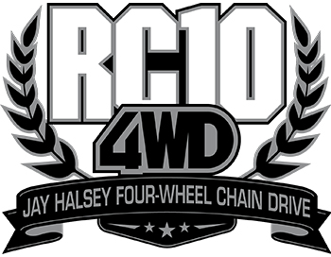
New front CVA axles and tapered front
dog bones
Short front arm geometry and fluid filled anodized aluminum coil over shocks
New hardened chain sprocket gears
New carbon fiber chain separator system
New front and rear natural shock towers
New wide front hex wheel
and tires

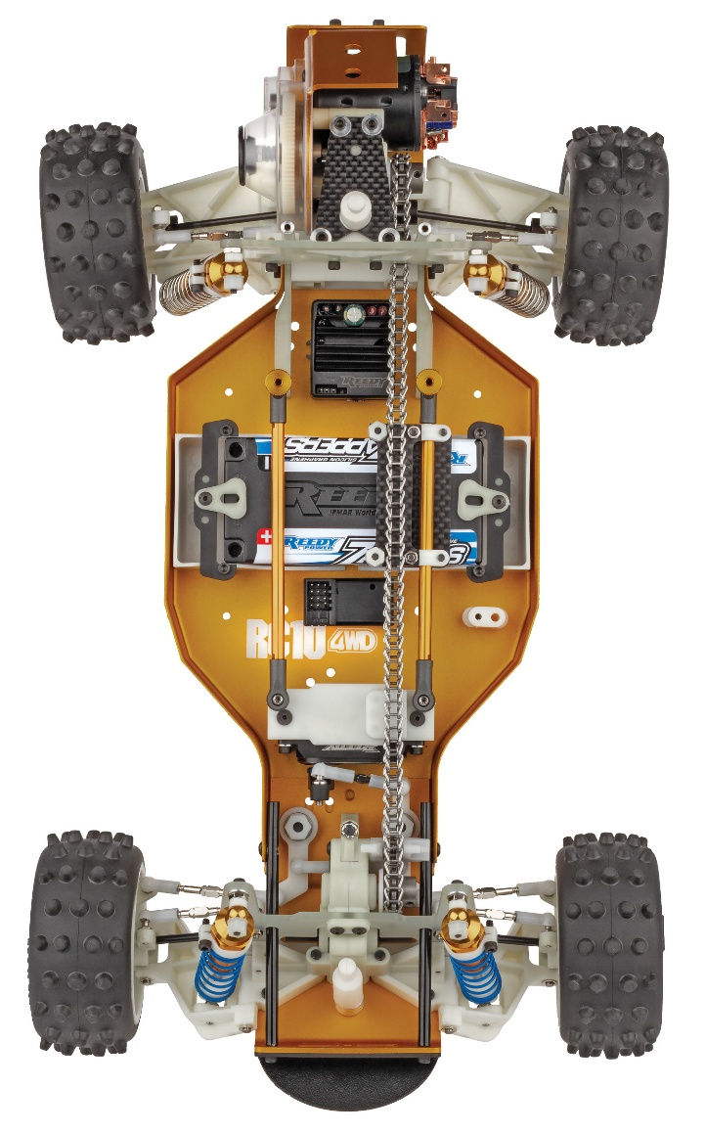

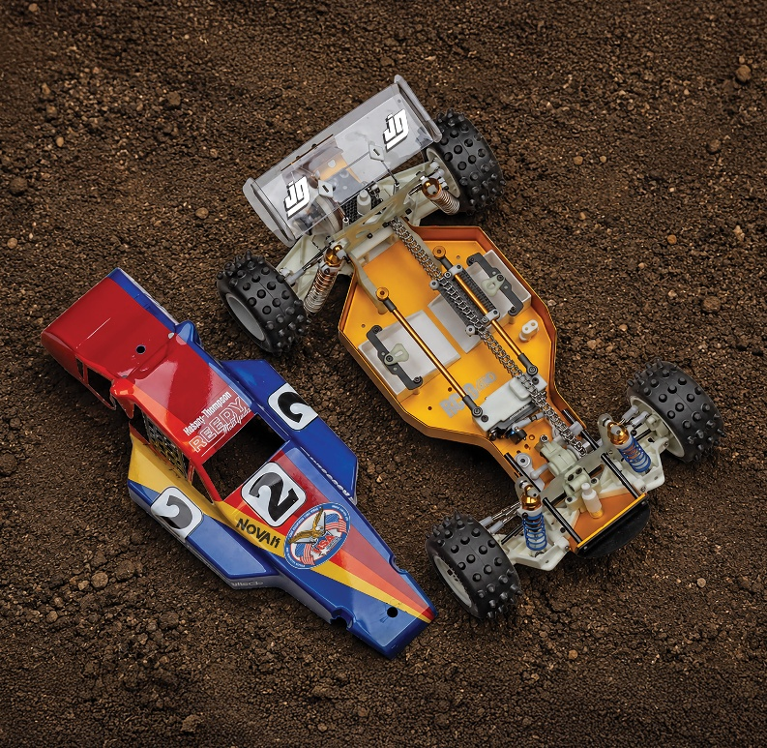

Classic gold chassis, nose plate and motor plate provide exceptional ground clearance and low center of gravity. Fits 6 cell and 2S Lipo battery packs. Also has a Jay Halsey style Clear wing & RC10 Classic Protech body.

”

Photos may differ from actual model. Motor, battery, servo, electronic speed control, and radio are not included.

A Tribute to a 4WD Racing Legend

The RC10 Jay Halsey Chain Drive 4WD celebrates one of the most memorable cars in Team Associated history, inspired by the prototype chain-driven buggy raced by Jay Halsey at the inaugural 1985 IFMAR Off-Road World Championships in Del Mar, California. After winning the 2WD World Championship, Halsey drove the experimental 4WD buggy to an impressive second-place overall finish, showcasing the potential of Team Associated’s innovative four-wheel-drive design.

Though not an exact replica of Halsey’s original race car, this special edition combines the proven vintage RC10 4WD platform with the classic short-arm suspension and a nostalgic chain drivetrain. Blending classic styling with modern vintage engineering, it delivers an authentic driving experience while honoring one of the most influential machines in the history of competitive off-road RC racing.

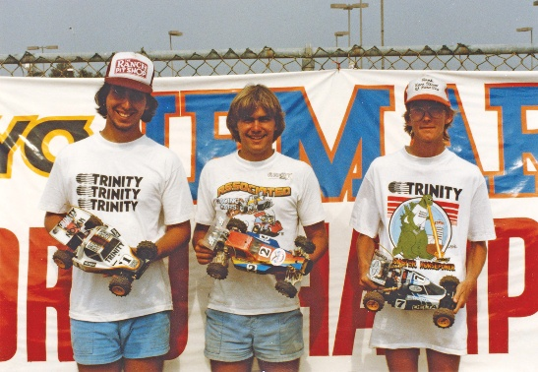
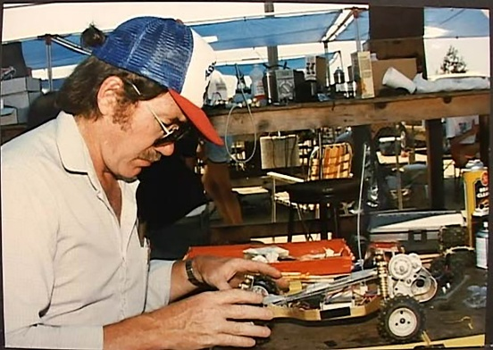
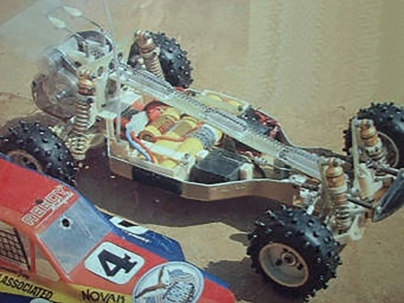

A Milestone in 4WD Racing History

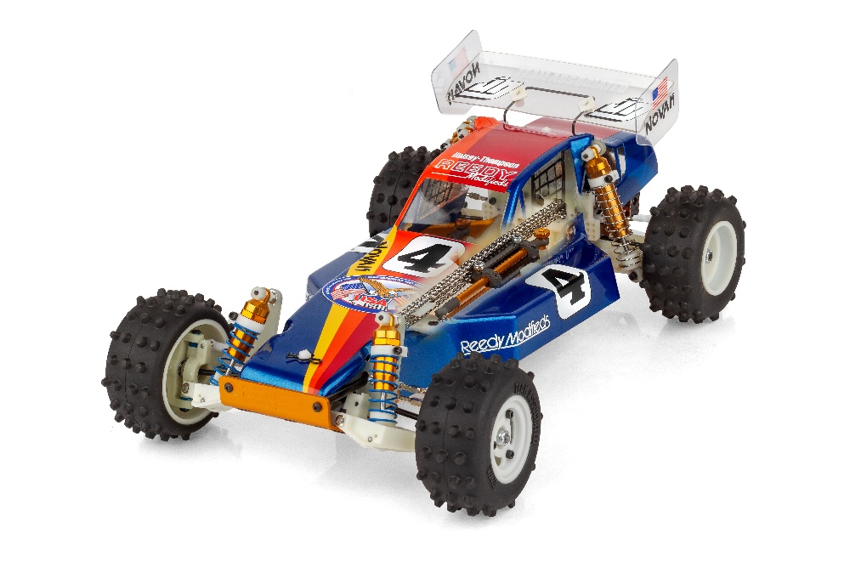
The inaugural 1985 IFMAR Off-Road World Championships in Del Mar, California, marked a defining moment in the evolution of four-wheel-drive electric racing. Team Associated entered the event with an experimental chain-driven 4WD prototype piloted by newly crowned 2WD World Champion Jay Halsey.

Built to explore the advantages of four-wheel-drive traction and performance, the innovative buggy showcased impressive speed, handling, and durability against the world’s top competitors. Halsey’s exceptional driving earned him a second-place overall finish in the 4WD class, proving the potential of Team Associated’s ground-breaking design. While still a prototype, the chain-drive buggy became an important milestone in RC racing history and helped inspire the continued development of high-performance four-wheel-drive competition vehicles.

FEATURES
SPECIFICATIONS

Power | Electric
Terrain | Off-Road
Body Style | Buggy
Scale Size | 1:10 Scale
Length | 381mm (15in)
Width | 226.8mm (8.93in)
Wheelbase | 267.7mm (10.54in)
Weight: | Varies
Internal Gear Ratio: | 2.25:1
Drive | 4WD
- New Stainless steel heavy duty chain
- New hardened chain sprocket gears
- New carbon fiber chain separator system
- New front CVA axles and tapered front dog bones
- New wide front hex wheel and tire
- Short front arm geometry
- Jay Halsey style clear wing
- Worlds style steering bellcranks
- Adjustable Chain tension system
- Clear driver included
- Heavy duty turnbuckles and ball studs
- Classic gold chassis, nose plate and motor plate
- New front and rear natural shock towers
- Hardened driveshafts and dogbones
- RC10 Classic Protech body
- Long Travel, fluid filled anodized aluminum coil over shocks
- Sealed 3 gear Stealth A.T.C. transmissions
- High torque ball differentials
- Exceptional ground clearance with low center of gravity
- RC10 Classic wheels and tires
- Full metal ball bearings
- Fits 6 cell and 2S Lipo battery packs

* Final length, width and weight will vary depending on the electronics, body, wheels and tires used to complete the kit.


Recommended Electronics:

- Servo: #27172 (Reedy RT2007HD Low-Profile Brushless
Hi-Torque Servo)
- Battery: #27612 (STOCKSTAR 5800mAh 7.4V 160C Shorty)
- ESC: #27016 (Blackbox 610R Competition ESC)
- Motor: #27481 (Sonic 540-SP5 13.5T Brushless Motor)
- Charger: #27203 (Reedy 1416-C2L Dual AC/DC Competition Balance Charger)

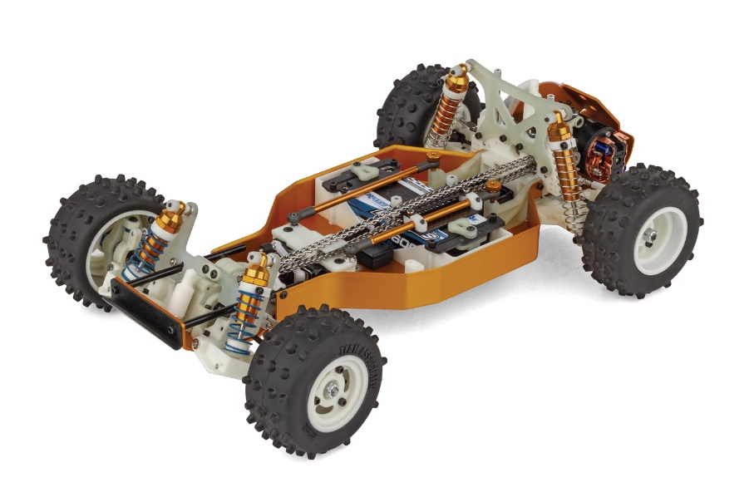
Other Helpful Items:

- Body Scissors (AE Part # 1737)
- FT Wrench Set (AE Part #1519)
- Hobby Knife
- Needle Nose Pliers
- Wire Cutters
- Soldering Iron
- Calipers or a Precision Ruler

Items required for operation:
Motor, Battery, Charger, Servo, ESC, Radio. Assembly and painting required.

CATALOG INFORMATION
Motor, battery, ESC, servo, receiver, paint, tires and radio. Assembly and painting required

UPC | Part No. | Description | MSRP | MAP | Pieces Per Case | Origin | Available
784695060562 | 6056 | RC10 4WD Jay Halsey Chain Drive Edition Kit | $699.99 | $459.99 | 6 | TW | October

Download all zipped photos here: https://rc10.com/RC10JayHalseyChain4WDImages/ (7.56MB). Link is active for 30 days. Please refer to our MAP Policy here: https://img2c.associatedelectrics.com/pdf/map-policy.pdf

